
- Start screen.
- Choose Apps.
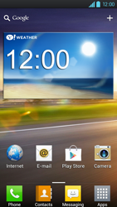
- Scroll to the right.
- Choose Settings.
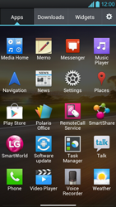
- Choose More…
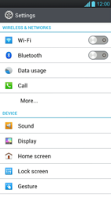
- Choose Mobile networks.
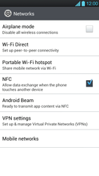
- Choose Data enabled, and tick this option.
- If prompted, choose OK.
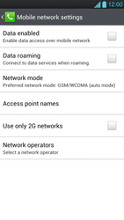
- Choose Access point names.
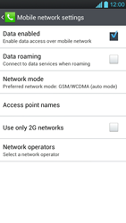
- Remove all current APN settings except ProximusMMS: Choose the APN, choose the menu key, and choose Delete APN.
- Choose the menu key, and choose New APN
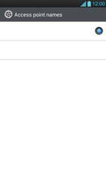
- Under Name, enter MYGLOBECONNECT.
- Under APN, enter www.globe.com.ph
- 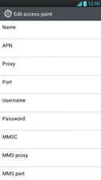
- Under Proxy, 203.177.042.214
- Under Port, 8080
- Under Username, enter nothing.
- Under Password, enter nothing.
- Scroll down.
- Under MCC, enter 515
- Under MNC, enter 02
- 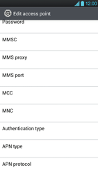
- Under Authentication type, choose PAP.
- Under APN type, enter default. (Note: in lower case)
- Choose the menu key.
- Choose Save.
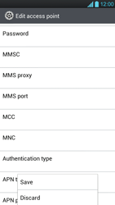
- Choose myglobeconnect and tick this option.
- Return to Start screen.
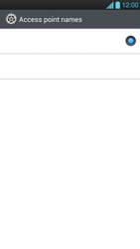
- Start screen.
- Choose Apps.
- Choose Internet.
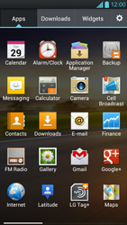
- Choose the menu key, and choose Settings.
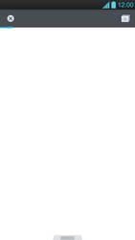
- Choose General.

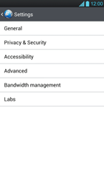
- Choose Set homepage.

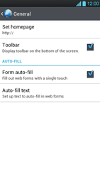
- Choose Other, and tick this option.
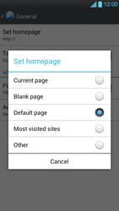
- Enter http://www.globe.com.ph/globe.asp and choose OK.
- Return to Start screen

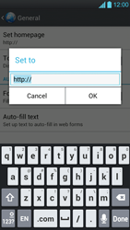-
- Start screen.
- Switch off the LG Optimus 4X HD and restart it in order to activate the settings.
- You can now start using the internet.

