How can I set up my Internet connection?
1.Please go to menu-> “Settings”-> "Wireless & networks”
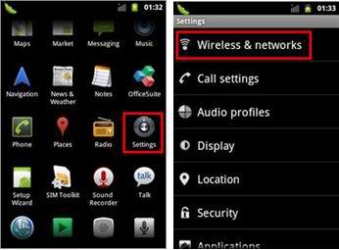
2. Select “Mobile networks” -> “Access Point Names” ->you can select a corresponding APN or press “Menu” key-> Create a “New APN”
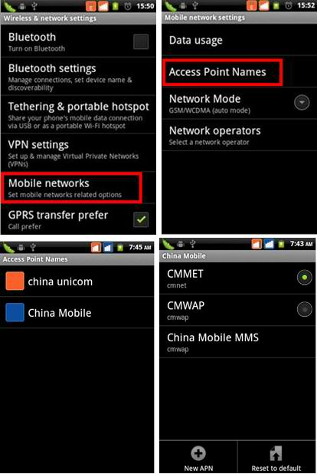
3. Please input the data according to local network parameters.
NAME: my globe connect
APN: www.globe.com.ph
PROXY: 203.177.042.214
PORT: 8080
USERNAME: not set
PASSWORD: not set
SERVER: http://www.globe.com.ph/globe.asp
MMSC: Not set
MMS PROXY: not set
MMS PORT: not set
MCC: 515
MNC: 02
AUTH TYPE: PAP
Apn Protocol: Ipv4
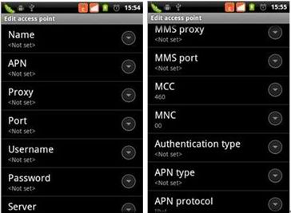
4. After above parameters have been entered and saved, please go to “Menu” key on home screen ◊ “Settings” -->“SIM management” -->“Data connection” -->Select your operator. 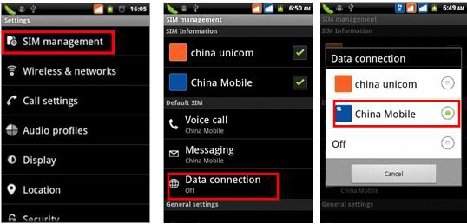
After the above steps are done, you can access Internet. (just a sample but select GLOBE)

