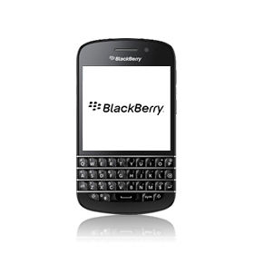
- Go to the Start screen.
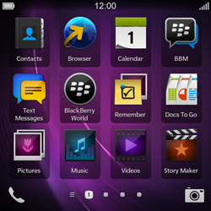
- Scroll to the right.
- Choose Settings.
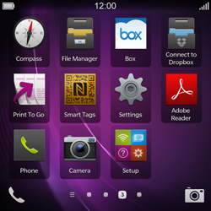
- Choose Network Connections.
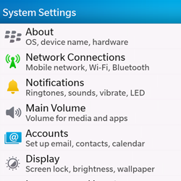
- Choose Mobile Network.
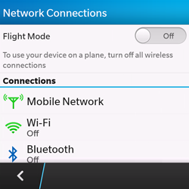
- Enable Data Services.
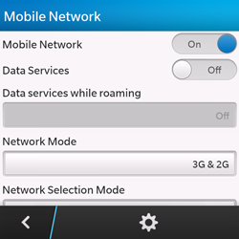
Choose the settings symbol
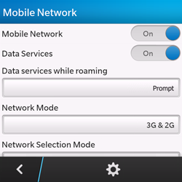
- Under Access Point Name (APN), enter www.globe.com.ph
- Under Proxy, 203.177.042.214
- Under Port, 8080

- Under Username, enter nothing.
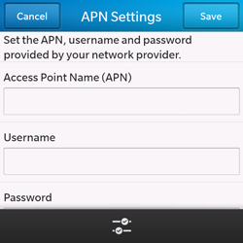
- Scroll down.
- Under Password, enter nothing.
- Under Authentication Type, choose PAP
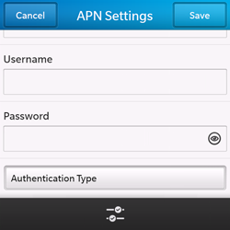
- Choose Save.
- To return to the Start screen, swipe up from the keyboard.
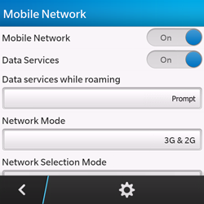
- Choose the cross symbol.
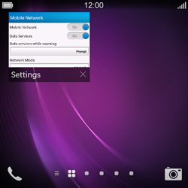
Choose Browser
- Choose the options symbol.
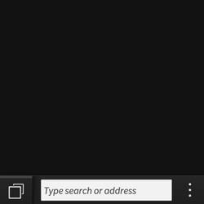
- Choose Settings.
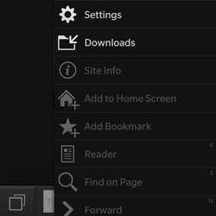
- Choose Display and Actions.
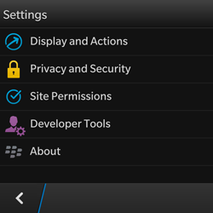
- Choose the text box under Home Page.
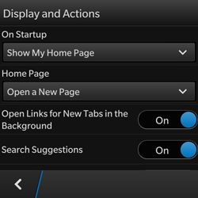
- Choose Open a Specific Page.
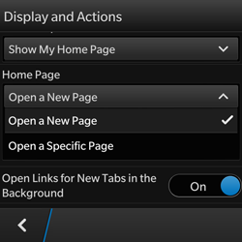
Enter http://www.globe.com.ph/globe.asp

- Return to the Start screen.
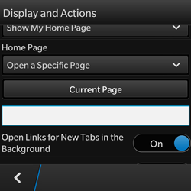
- Start screen.
- Switch off the BlackBerry Q10 and restart it in order to activate the settings.
- You can now start using the internet.\

