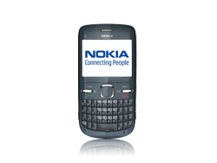
- Start screen.
- Choose *Menu*.
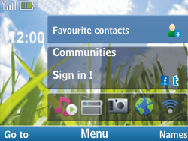
- Choose Settings, and then Select.
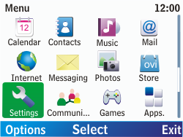
- Scroll down.
- Choose Configuration, and then Select.
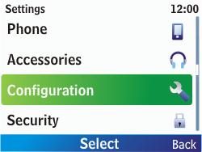
- Scroll down.
- Choose Personal settings, and then Select.
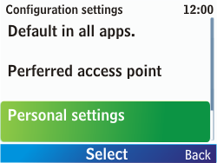
- If this screen appears, choose Add.
- If this screen does not appear, choose Options, Add new, and then Select.
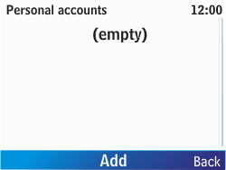
- Choose *Web* and choose *Select.*
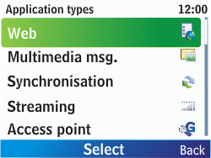
- Choose Account name, Select, enter myglobeconnect, and choose OK.
- Choose User name, Select, enter nothing, and choose OK.
- Choose Password, Select, enter nothing, and choose OK.
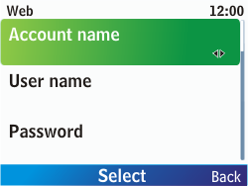
- Choose Use preferred access pt., Select, yes, and then Select.
- Choose Access point settings, and then Select.
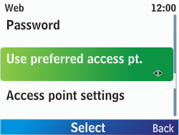
- Choose Proxy, Select, enable, and then Select.
- Choose Proxy, enter 203.177.042.214
- Under Port, 8080
- Choose Bearer settings, and then Select.
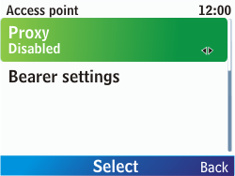
- Choose Packet data access pt., Select, enter www.globe.com.ph, and choose OK.
- Choose Authentication type, Select, Normal, and then Select.
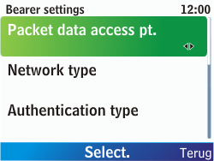
- Choose User name, Select, enter nothing, and choose OK.
- Choose Password, Select, enter nothing, and choose OK.
- Choose Back three times.
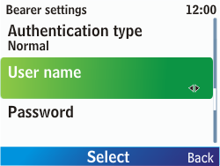
- Choose myglobeconnect, Options, Activate, and then Select.
- Return to the Start screen.
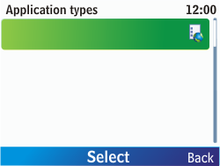
- Start screen.
- Switch off the Nokia C3 and restart it in order to activate the settings.
- You can now start using the internet.

