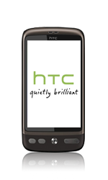
- Start screen.
- Choose the arrow symbol.
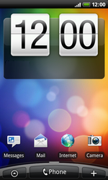
- Choose Settings.
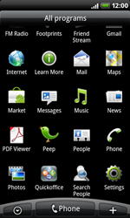
- Choose Wireless & networks.
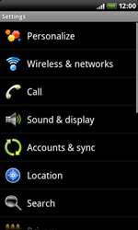
- Choose Mobile network, and check this option.
- Choose Mobile networks.
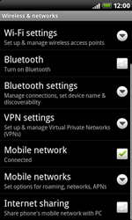
- Choose Access Point Names.
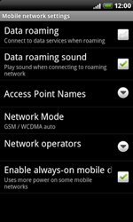
- Remove all current APN settings except Proximus MMS by choosing the APN, choosing the menu key, and choosing Delete APN.
- Choose the menu key, and choose New APN.

- Under Name, enter myglobeconnect
- Under APN, enter www.globe.com.ph
- Under Proxy, 203.177.042.214
- Under Port, 8080
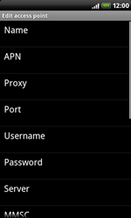
- Under Username, enter nothing.
- Under Password, enter nothing.
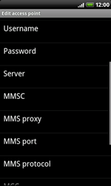
- Scroll down.
- Under MCC, enter 515.
- Under MNC, enter 02.
- Under Authentication type, choose PAP.
- Under APN type, enter default.(Note: in lower case)
- Choose the menu key.
- Choose Save.

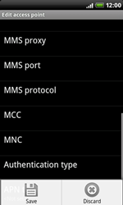
- Choose myglobeconnect and check this option.
- Return to the Main menu.
- 
- Choose Internet.
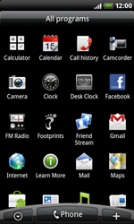
- Choose the menu key.
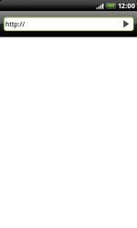
- Choose More.
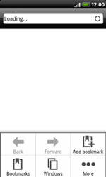
- Choose Settings.
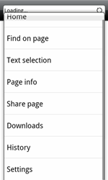
- Choose Set home page.
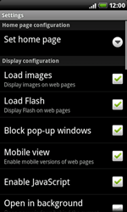
- Choose Set home page.
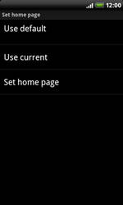
- Enter http://www.globe.com.ph/globe.asp and choose OK.
- Return to the Start screen.
- 

