
- Start screen.
- Choose the arrow symbol.
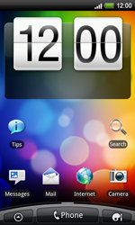
- Choose Settings.
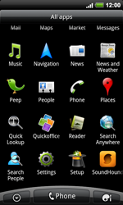
- Choose Wireless & networks.
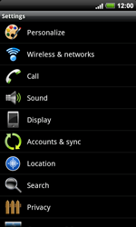
- Choose Mobile network, and check this option.
- Choose Mobile networks.
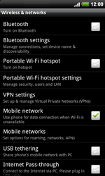
- Choose Access Point Names.
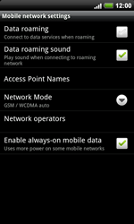
- Remove all current APN settings except Proximus MMS by choosing the APN, choosing the menu key, and choosing Delete APN.
- Choose the menu key, and choose New APN.

- Under Name, enter MYGLOBECONNECT
- Under APN, enter www.globe.com.ph
- Under Proxy, 203.177.042.214
- Under Port, 8080
- Under User name, enter nothing.
- Under Password, enter nothing.
- 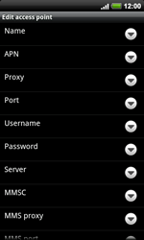
- Scroll down.
- Under MCC, enter 515
- Under MNC, enter 02
- Under Authentication type, choose PAP.
- Under APN type, enter default. (Note: in lower case)
- Choose the menu key.
- 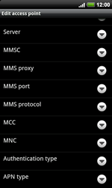
- Choose Save.
- 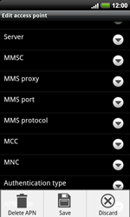
- Choose myglobeconnect, and check this option.
- Return to the Main menu.



- Choose Internet.
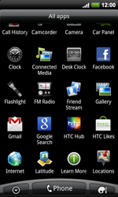
- Choose the menu key, choose More, and thenSettings.


- Choose Set homepage.
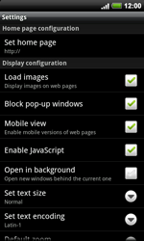
- Choose Set home page.
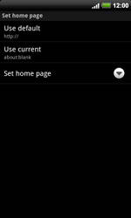
- Enter http://www.globe.com.ph/globe.asp and choose OK.
- Return to the Start screen.
- 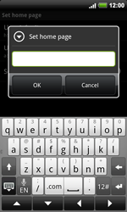
- Start screen.
- Switch off the HTC Desire HD and restart it in order to activate the settings.
- You can now start using the internet.
-

