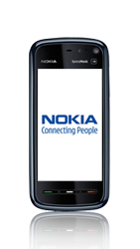
- Start screen.
- Go to the Main menu.
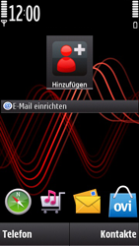
- Choose Settings.
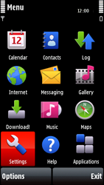
- Choose Connectivity.
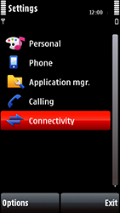
- Choose Destinations.
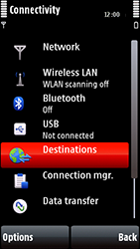
- Choose Internet.
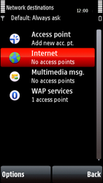
- Choose Options, New Access point, and thenSelect.
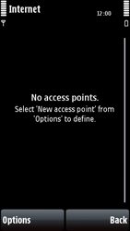
- Choose No.
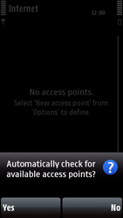
- Choose Packet data, and then Select.
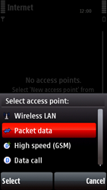
- Enter MYGLOBECONNECT and choose OK.
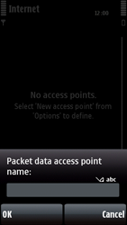
- If MYGLOBECONNECT has Priority 1, skip the next step.
- If not, choose Options, Organise, Select, and go to the next step.
- 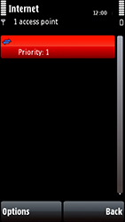
- Choose Change priority, Select, choose the highest position, and choose OK.
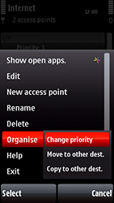
- Choose* MYGLOBECONNECT *Options, and then Edit.
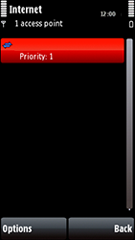
- Choose Connection name, enter MYGLOBECONNECTand choose OK.
- Choose Access point name, enter www.globe.com.ph, and choose OK.
- Choose User name, enter nothing, and choose OK.
- Choose Prompt password, No, and then OK.
- Scroll down.
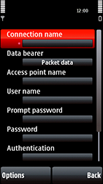
- Choose Password, enter nothing, and choose OK.
- Choose Authentication, Normal, and then OK.
- Choose Homepage, enter http://www.globe.com.ph/globe.asp and choose OK.
- Choose Use access point, Automatically, and then OK.
- Choose Proxy enter, 203.177.042.214,
- Choose Port enter, 8080
- Return to the Main menu.
- 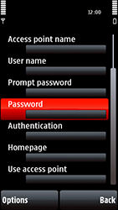
- Choose Internet.
- 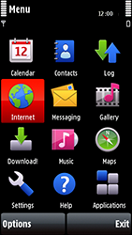
- Choose Web.
- 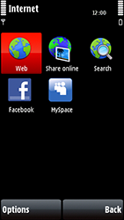
- Choose Options.
- 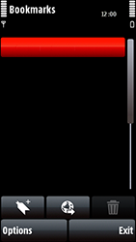
- Choose Settings.
- 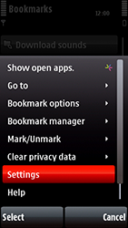
- Choose General.
- 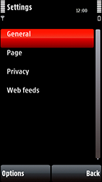

- Choose Access point
- 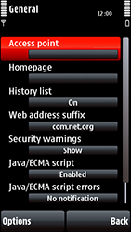
- Choose Internet, Options, and then Select.
- 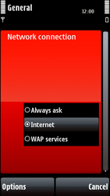
- Choose Homepage.
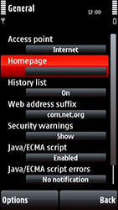

- Choose Default, and then OK.
- Return to the Start screen.
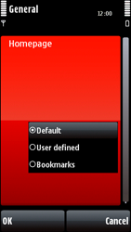
- Start screen.
- Switch off the Nokia 5800 Xpress Music and restart it in order to activate the settings.
- You can now start using the internet.

