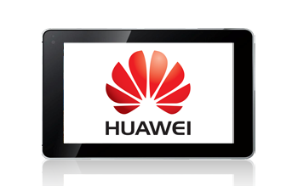
- Start screen.
- Choose Apps.
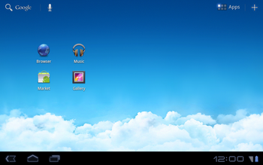
- Choose Settings.
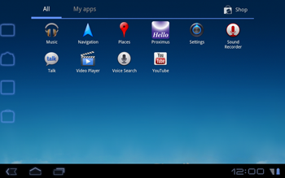

- Choose Wireless & networks.
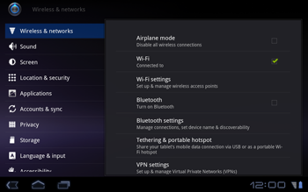
- Scroll down.
- Choose Mobile networks.
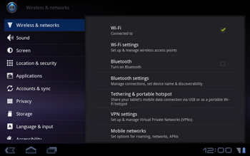
- Choose Data enabled, and check this option.
- Choose Access Point Names.
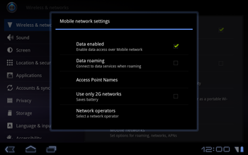
- Remove all current APN settings except Proximus MMS by choosing the APN, choosing the menu key, and choosing Delete APN.
- Choose the menu key, and choose New APN.
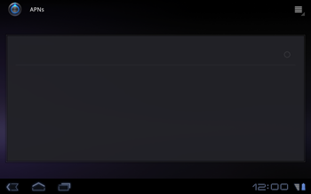
- Under Name, enter myglobeconnect
- Under APN, enter www.globe.com.ph
- Under Proxy, enter 203.177.042.214
- Under Port, 8080
- Under Username, enter nothing.
- Under Password, enter nothing.
- 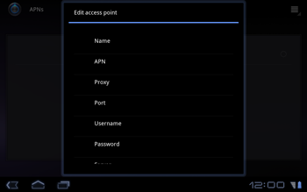
- Scroll down.
- Under MCC, enter 515
- Under MNC, enter 02
- Under Verificatietype, choose PAP.
- Under APN-type, choose internet.
- Choose the back symbol.
- 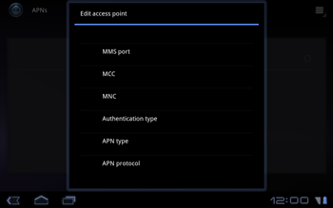
- Choose myglobeconnect and check it.
- Return to the main menu.
- Choose Browser.
- 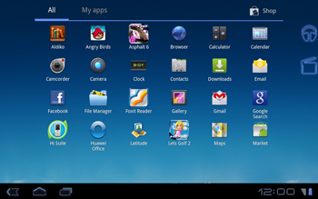
- Choose the menu key, ant then Settings.
- 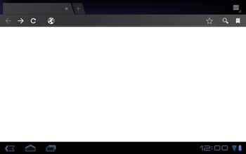
- Choose Set homepage.
- 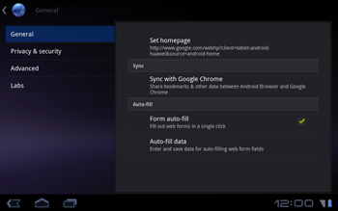
- Enter http://www.globe.com.ph/globe.asp and choose OK.
- Return to the Start screen.
- 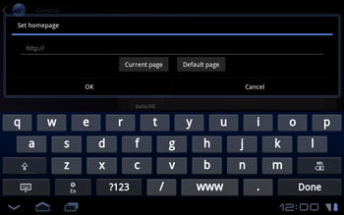
- Start screen.
- Switch off the Huawei Mediapad and restart it in order to activate the settings.
- You can now start using the internet.

