1. Turn on your mobile phone then go to Settings. Once in, tap on the following to start the setup process:
More>Mobile Networks>Access point names>Select SIM.
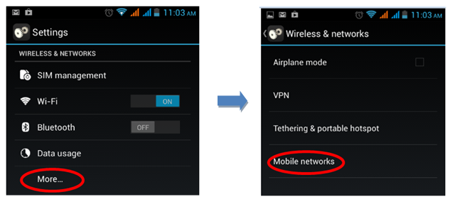
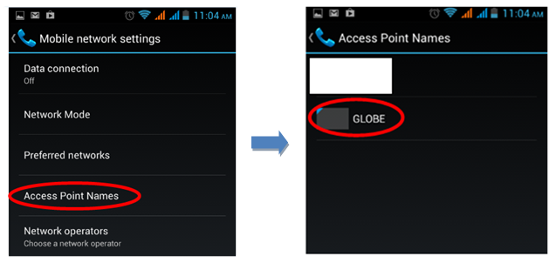

If in case your phone has no access point names (APN), you have the option to create one. Here are the steps on how to create an APN for your Globe mobile account.
Manual Setup:
1. Go to Settings>More>Mobile networks>Access point names>Select SIM Globe
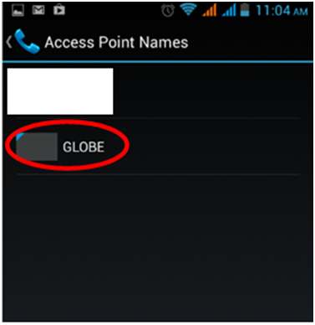
2. Press the Menu button on your phone, then select New APN.
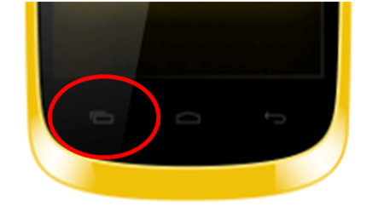
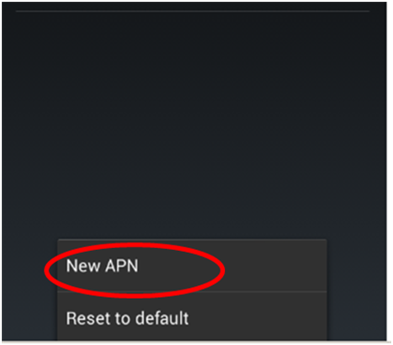
3. Refer to the table shown for the parameters needed to complete the Internet/GPRS/MMS settings for your phone, then apply them to the necessary fields as shown in the screen shot after it.

NAME: my globe connect
APN: www. globe.com.ph
PROXY: 203.177.042.214
PORT: 8080
USERNAME
PASSWORD:
SERVER: http://www.globe.com.ph/globe.asp
MMSC: Not set
MMS PROXY: not set
MMS PORT: not set
MCC: 515
MNC: 02
AUTH TYPE: PAP
Apn Protocol: Ipv4
Apn ENable/dis: Apn enable
Bearer: Unspecified
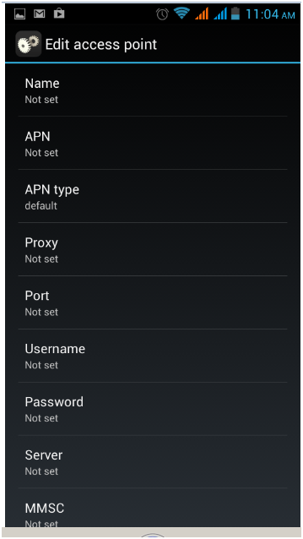
You have successfully completed the set up steps.
You can now enjoy mobile services on your O+ phone!
Top of Form
Bottom of Form

