Samsung S5260 Star II

- Start screen.
- Choose the menu key.

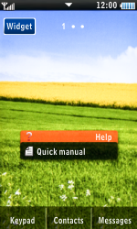
- Choose Settings.
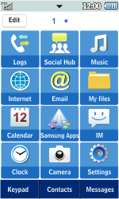
- Choose Connectivity.
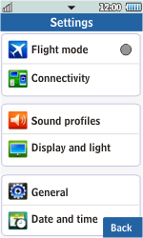
- Choose Network.
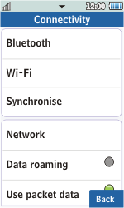
- Choose Connections.
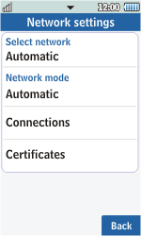

- Choose Yes.

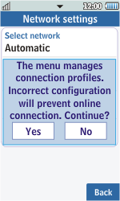

- Choose Create.
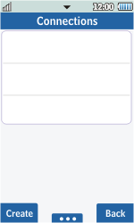
- Under Set name, enter my globe connect
- Under Access name, enter www.globe.com.ph
- Choose Auth type, and then PAP.
- Under User ID, enter nothing.
- Under Password, enter nothing.
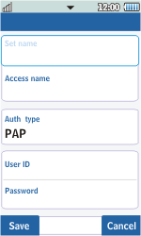
- Scroll down.
- Choose Protocol, and then HTTP.
- Under Home URL, enter http://www.globe.com.ph/globe.asp
Under Proxy address, enter 203.177.042.214:80

- Choose Save.
- Return to the Start screen.
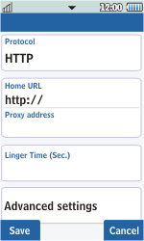
- Start screen.
- Switch off the Samsung Star 2 and restart it in order to activate the settings.
- You can now start using the internet.

