1. Find "Access Point Names"
- Tap the menu icon.
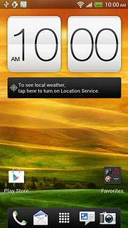
- Tap Settings.
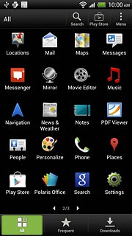
- Tap Mobile network.
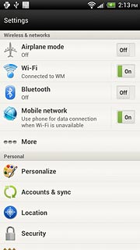
- Tap Access Point Names.
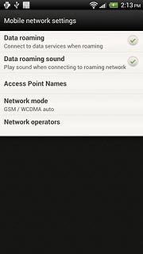

2. Create new data connection
- Tap Menu.
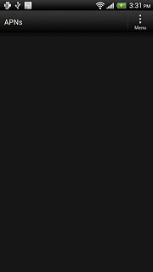
- Tap New APN.
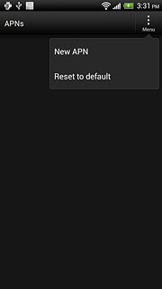

3. Enter data connection name
- Tap Name.
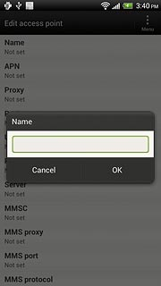
- Key in myGlobeConnect and tap OK.

4. Enter APN
- Tap APN.
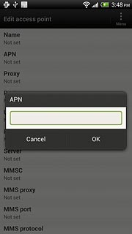
- Key in www.globe.com.ph and tap OK.
5. Enter Proxy
- Tap Proxy
- Key in 203.177.042.214
6. Enter Port
- Tap Port
- Key in 8080
7. Enter Server
- - Key in http://www.globe.com.ph/globe.asp

8. Enter country code
- Tap MCC.
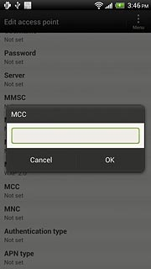
- Key in 505 and tap OK.

9. Enter network code
- Tap MNC.
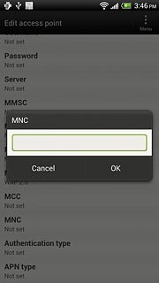
- Key in 02 and tap OK.

10. Select authentication type
- Tap Authentication type.
- Tap PAP.
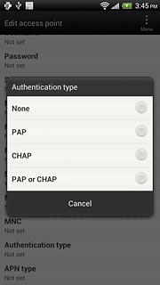

11. Select APN type
- Tap APN type.
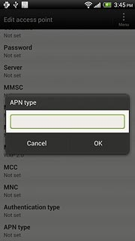
- Key in defaultand tap OK.

12. Save and activate data connection
- Tap Menu.
- Tap Save.
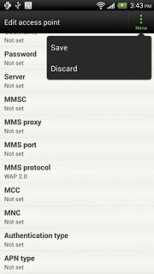
- Tap the field next to myGlobeConnect- to fill in the field.
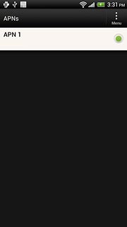

13. Exit
- Tap the Home key to return to standby mode.

