1. Find "APN"
- Slide your finger down the display starting from the top edge of your mobile phone.
- Tap Settings.
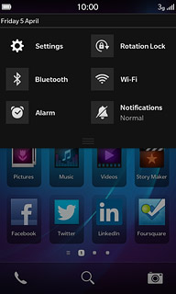
- Tap Network Connections.
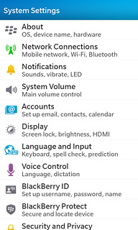
- Tap Mobile Network.
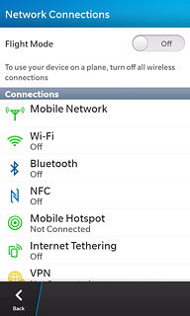
- Tap APN.
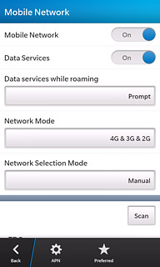

2. Enter APN
- Tap the field below Access Point Name (APN).
- Key in www.globe.com.ph
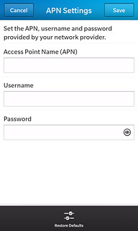
3. Enter Proxy
- Tap Proxy
- Key in 203.177.042.214
4. Enter Port
- Tap Port
- Key in 8080
5. Enter Server
- - Key in http://www.globe.com.ph/globe.asp

6. Save and exit
- Tap Save.
- Slide your finger up the display starting from the bottom edge of your mobile phone to return to standby mode.

