Want to set up your mobile phone for internet? Follow these easy instructions.
SAMSUNG GALAXY S2

1. Find "Access Point Names"
- Tap Applications.
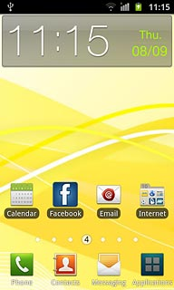
- Tap Settings.
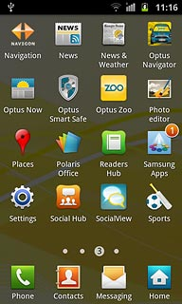
- Tap Wireless and network.
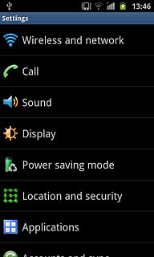
- Tap Mobile networks.
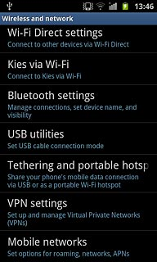
- Tap Access Point Names.
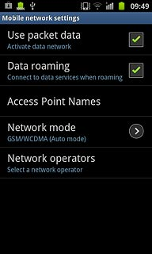

2. Create new data connection
- Tap the Menu key.
- Tap New APN.
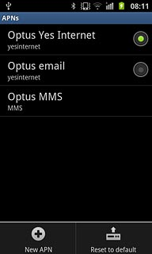

3. Enter data connection name
- Tap Name.
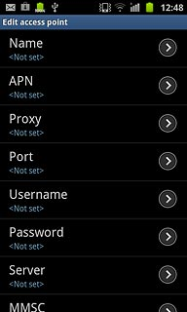
- Key in myGlobe Connet and tap OK.

4. Enter APN
- Tap APN.
- Key in www.globe.com.ph and Tap OK.

5. Enter Proxy
Tap Proxy
Key in 203.177.042.214
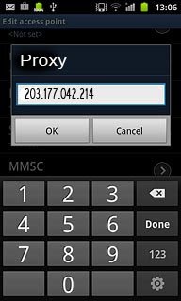

6. Enter Port
Tap Port
Key in 8080
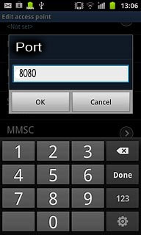
7. Enter Server
- Key in http://www.globe.com.ph/globe.asp

8. Enter country code
- Tap MCC.
- Key in 505 and tap OK.
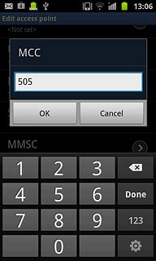

9. Enter network code
- Tap MNC.
- Key in 02 and tap OK.
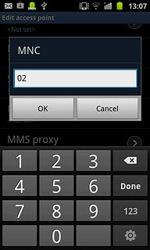

10. Select authentication type
- Tap Authentication type.
- Tap PAP.
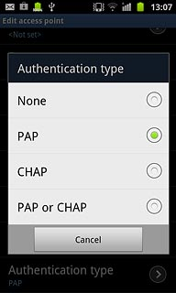

11. Select APN type
- Tap APN type.
- Tap Internet.
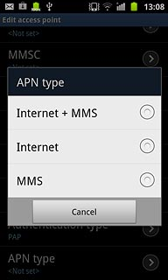

12. Save and activate data connection
- Tap the Menu key.
- Tap Save.
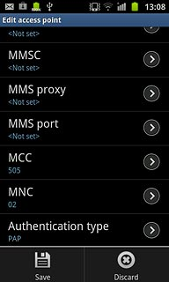
- Tap the field next to myglobe connect to fill in the field.
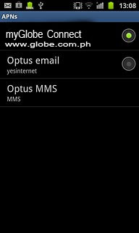

13. Exit
- Tap the Home key to return to standby mode.

