1. Find "Access Point Names"
- Tap the time in the bottom right corner of the display.
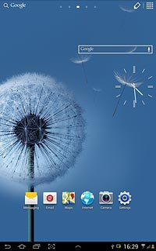
- Tap Settings.
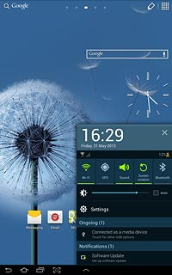
- Tap More settings.
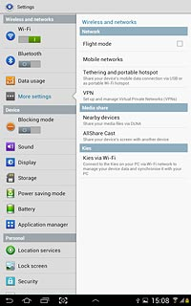
- Tap Mobile networks.
- Tap Access Point Names.
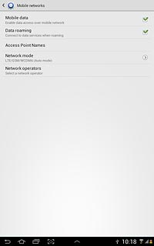

2. Create new data connection
- Tap the menu icon.
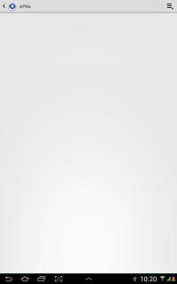
- Tap New APN.
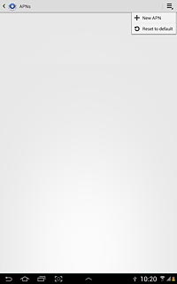

3. Enter data connection name
- Tap Name.
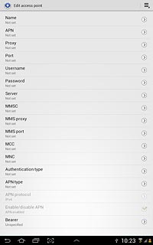
- Key in myGLobe Connect and tap OK.
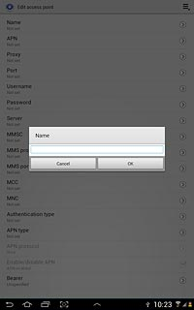

4. Enter APN
- Tap APN.
- Key in www.globe.com.ph
- Tap OK.
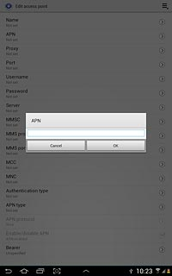
5. Enter Proxy
- Tap Proxy
- Key in 203.177.042.214
6. Enter Port
- Tap Port
- Key in 8080
7. Enter Server
- - Key in http://www.globe.com.ph/globe.asp

8. Enter country code
- Tap MCC.
- Key in 505 and tap OK.
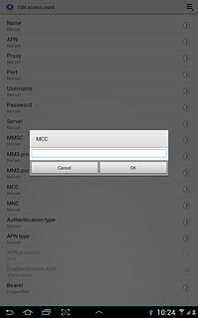

9. Enter network code
- Tap MNC.
- Key in 02 and tap OK.
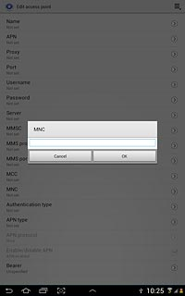

10. Select authentication type
- Tap Authentication type.
- Tap PAP.
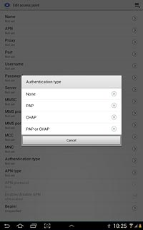

11. Select APN type
- Tap APN type.
- Key in default or internet and tap OK.
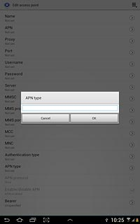

12. Save and activate data connection
- Tap the menu icon.
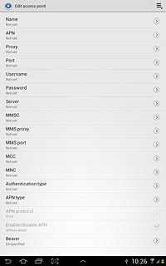
- Tap Save.
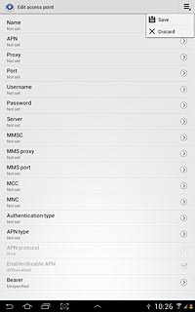
- Tap the field next to the data connection to fill in the field.
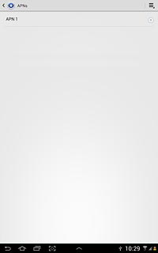

13. Return to the home screen
- Tap the home icon to return to the home screen.

