1. Find "Access points"
- Tap the Menu key.
- Scroll to Tools and tap the Navigation key.
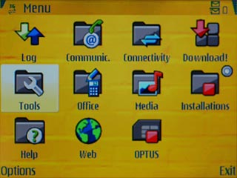
- Scroll to Settings and tap the Navigation key.
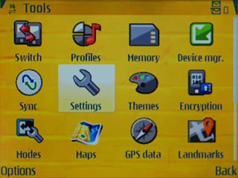
- Scroll to Connection and tap the Navigation key.
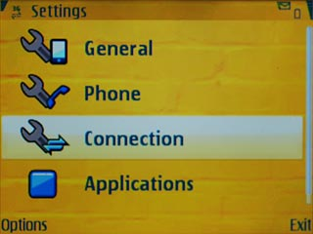
- Scroll to Access points and tap the Navigation key.
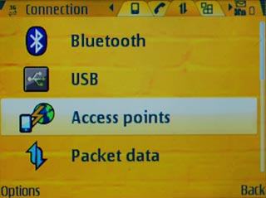

2. Create new data connection
- Tap Options.
- Scroll to New access point and tap the Navigation key.
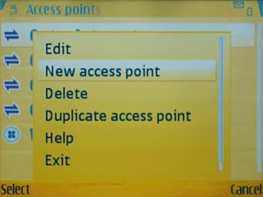

3. Enter data connection name
- Scroll to Connection name and tap the Navigation key.
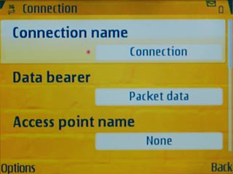
- Key in myGlobe Connect and tap the Navigation key.
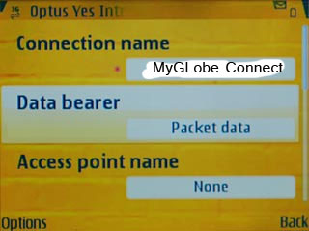

4. Select data bearer
- Scroll to Data bearer and tap the Navigation key.
- Scroll to Packet data and tap the Navigation key.
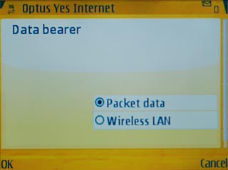

5. Enter APN
- Scroll to Access point name and tap the Navigation key.
- Key in www.globe.com.ph and tap the Navigation key.
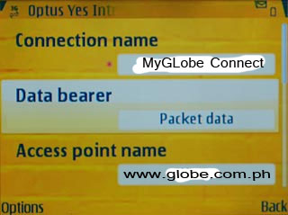
6. Enter Proxy
- Tap Options
- Tap Proxy Server
- Key in 203.177.042.214
7. Enter Port
- Tap Port
- Key in 8080

8. Save data connection
- Tap Back to save the settings and return to the list of data connections.
- Tap the Menu key to return to standby mode.

9. Find "General"
- Tap the Menu key.
- Scroll to Web and tap the Navigation key.
- Tap Options.
- Scroll to Settings and tap the Navigation key.
- Scroll to General and tap the Navigation key.

10. Select data connection
- Scroll to Access point and tap the Navigation key.
- Scroll to User defined and tap the Navigation key.
- Scroll to Myglobe Connect and tap the Navigation key.

11. Save and exit
- Tap Back to save the settings.
- Tap the Menu key to return to standby mode.

