- You can configure your phone manually for mobile internet. Follow the step-by-step instructions below.
- Start screen.
- Go to the Main menu.
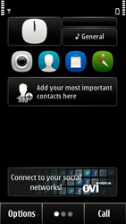
- Choose Settings.
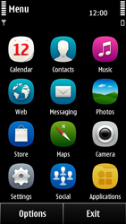
- Choose Connectivity.
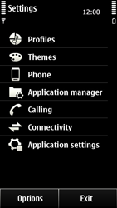
- Choose Settings.
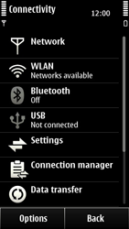
- Under Data use in home country, choose Automatic.
- Choose Destinations.
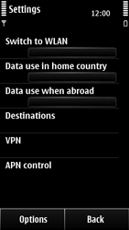
- Choose Internet.
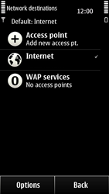
- Choose Options, and choose New access point.
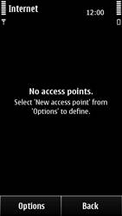
- Choose No.
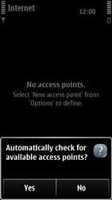
- Choose Packet data.
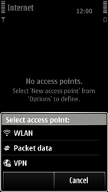
- Enter myGlobe Connect, and choose OK.
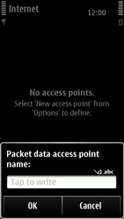
- Choose myGlobe Connect
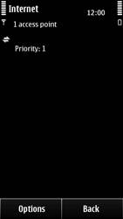
- Choose Connection name, enter myGlobe Connect, and choose OK.
- Choose Access point name, enter www.globe.com.ph (be aware of the dots), and choose OK.
- Choose Username, enter base, and choose OK.
- Under Prompt password, choose No.
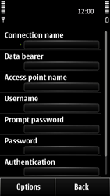

- Choose Authentication, and choose Normal.
- Choose Homepage, enter http://www.globe.com.ph/globe.asp and choose OK.
- Tap Options, Choose Port and enter Key in 203.177.042.214
- Enter Port = 8080
- Return to the Main menu.

- Choose Web.
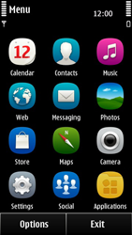
- Choose Options, and choose Settings.
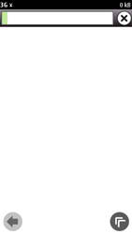
- Choose General.
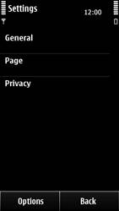
- Choose Access point, Internet and then OK.
- Return to the Start screen.


