

De La Salle University – Manila
Ramon V. del Rosario College of Business
Management and Organization Department

Collaborative

Action Research Project

In partial fulfilment
of the requirements for
HRM612M Organizational Development
3rd Trimester 2018-2019

Submitted to:
Dr. Divina Edralin

Submitted by:
Alcala, Angelo Miguel
Montilla, Vian Nikki Blance

August 19, 2019

Table of Contents
Abstract 3
Background of the Study/Context 4
Statement of Organizational Change issue, objectives and goals 5
OD Framework / Model 5
Intervention implementation and its outcome 8
Meta-learning 9
Reference 9
Appendix A: Process flow and the employee in charge per task 10
Appendix B: Employee Profile 13

Abstract

Background of the Study/Context

Agile Link Forwarding Services is a family owned brokerage company that was established in February 2010. The company offers air and sea freight services, clearing of goods in Bureau of Customs, and delivery of those goods to the client’s warehouse. Because the firm is only composed of few staff, individual roles are very critical to their operation. Not to mention that the overall job design is sequential in nature, which means tasks are completed in succession. Given that the company employs a very small number of manpower, an absence of one would definitely tremble the business. Some of the ideas of this study was taken from International Organization for Standardization (ISO), particularly ISO 22301:2012, which defines business continuity as the capability of the organisation to continue delivery of products or services at acceptable predefined levels following a disruptive incident. Every organization, may it be local or global, recognize that business continuity management is of paramount importance and is very critical regardless of the industry (Faertes, 2015).

According to value chain framework of Michael Porter (1985), logistics can be either the distribution of raw materials from a supplier to a manufacturing plant to be used in the production process (inbound), or distribution of the final product to consumers (outbound). As a logistics brokerage firm, Agile Link Forwarding Services plays a very critical role in the value chain of their customers. A particular study confirms that each supply chain process can be affected by a serious disruption (Wieteska, 2018). Hence, they believe these unnecessary business interruptions will cause ripple effects throughout the succeeding elements of the value chain, which in turn could delay the processing of necessary documents as well as the delivery itself. The delays in the delivery could entail revenue losses to its clients respective businesses. Given that this domino effect is a common phenomenon, organizations should anticipate worst case scenarios and come up with a policy so as to minimize the negative effect of a particular disturbance.

While there are many reasons for a service disruption, this study will only focus on the event of manpower and staff shortage, given that this is one of the major concerns raised by the owner to the researchers during the initial inquiry. They are aware that the risk is present, and they mentioned that the impact will be significant when a staff member has to pull himself out from the assembly line stream nature of work.

Statement of Organizational Change issue, objectives and goals

The management of the firm raised a concern about how they can implement critical business processes to keep the transactions flowing despite barely having enough manpower. They advised that their firm does not have a standard procedure yet in place when this happens. Hence, the objective of this project is to come up with a standard operating procedure primarily with regard to their staffing schedule. This will serve as the organization’s guide so they can minimize the delay by ensuring business continuity when a staff took his/her time-off, whether it be personal leave, or business related trips.

OD Framework / Model

In this section, the researchers discussed how they utilize necessary frameworks in Data collecting, Diagnosis, Data Analysis, Feedback, and Action-planning process phase of organizational development.

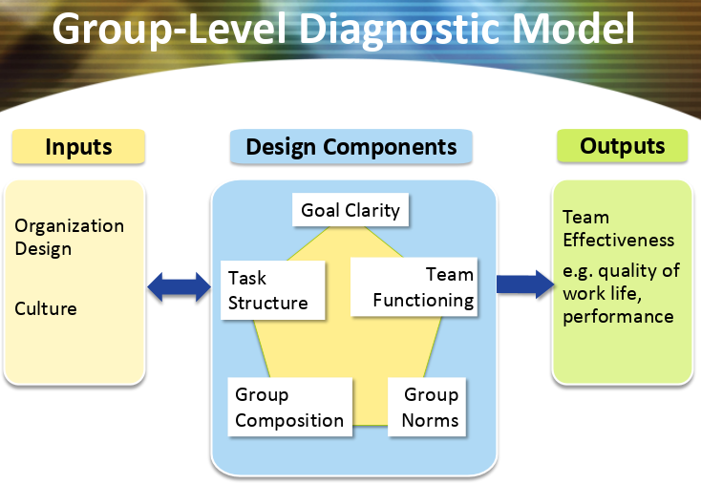
Diagnosis
With the existing number of members of Agile Link Forwarding Services as the primary reason, the researchers believe that it would be fitting to conduct a group-level type of diagnosis instead of organization-level. According to Cummings and Worley (2015), group-level of diagnostic is suitable in dealing with small number of people that work hand in hand to complete a common task.
The researchers analyzed the organization’s major input to group design. The consultants looked onto the team’s organization design, particularly their task structure systems or the level of coordination required in the group. Here, the consultants gathered information on the sequence of events or processes, and the employees involved. After a series of interviews, the consultants were able to come up with the process flow of their transactions (Appendix A) along with the primary point of contact for each task. The consultants were also able to gather key information about each employee like their strengths and level of experience (Appendix B). It was also determined during the interview that other functions relevant to the business such as a licensed customs broker, delivery personnel and their vehicles, and accountants are outsourced.
The output is expected to manifest team effectiveness. The aim is for the team to still function and complete transactions even at times of short staffing.

Data Collection
To fully understand the nature of the business, the external consultant attempted to gather unobtrusive data like their standard procedures for their daily transactions. However, given that the firm is relatively small and straightforward, the management of Agile Link Forwarding Services was not able to provide from their archive any diagrams or flow chart of their business processes. Thus, the consultant resorted to collecting needed data by interviewing all four employees. The goal is to come up with a process flow as well as the profile of each employee.
Questionnaires were not used as a method of data gathering because consultants preferred to collaborate personally with each employee. Also, observation of organizational behavior during normal business hours was not conducted given the schedule constraints of the consultants.
Data Analysis Process
In the first interview with the employees, the consultants gathered information about the employees as well as their current workload and responsibilities. The consultants learnt the following after the interview:
The manager of the company was in the industry for almost 28 years now. In 2010, she decided to put up a business of her own, and decided to employ her relatives because she wanted the business to run within the family. Other than the operations, she is responsible for meetings with the client and decides on all the major decisions for the company.
Employee A was the pioneer among the employees of the business. With this length of experience, she can handle both air and sea shipments in processing and releasing stages. For the documentation, she handles documentation of sea shipments, and have little knowledge of air shipments.
Employee B works in the business for five years now. She handles air shipments only, and have little knowledge on documentation stage in the process. She also has no knowledge on how the sea shipments work.
Employee C works in the business for three years now. She handles air shipments, have knowledge on all the process, from documentation up to the release of the cargo. However, she has little knowledge on handling sea shipments.
Other than this information on the employees, the consultants have learned that almost all of their job is air shipments. Also, they encounter problems in the operations side particularly when one has to have leave of absence because there are certain tasks that are assigned to one employee. There were also no proper or formal training when they were employed to do the job. From the start, the manager was the one to do the documentation and checking of documents because she was the one knowledgeable in the field. But since the business is growing, the load doubled.
The crucial and time consuming part in the business is the documentation, specifically the computation of duties and taxes, tariff classification, and lodgement of entries in the service providers of Bureau of Customs. However, the process of doing it is the same, so it will be easy for the employees to learn. In terms of processing, it is easier to process documents of air shipments than sea shipments.
After a series of interviews, the consultants were able to come up with the process flow of the firm’s transaction. They have it analyzed, and created sample scenarios

Staffing Scenarios:
https://docs.google.com/spreadsheets/d/14K08SJ9-RZZrlHStAJAK8fSnw7HTGDfRpPWh2OJSGtk/edit?usp=sharing

Feedback Process
After the consultants gathered the needed data, they set up a meeting with the manager along with the employees and presented to them the proposed standard procedure and its advantages, and the recommended interventions to meet the objectives. It was also briefly discussed the content of the proposed OD program, mainly what the project is all about, its goal and expected outcome. Concerns and suggestions were addressed at once.

-- yung feedback nila dun sa implementation

Action-planning Process
to properly start the formulation of ideas on actions to be taken, target dates of completion or time duration for each phase of actions, the pertinent data should a particular situation requires, and the ultimate result or the intervention and the indicators of a successful intervention.

Intervention implementation and its outcome

The consultants tapped 2 interventions: Human Resource Management intervention

- Employee B need additional training in tasks 4-6:
-- If the documents are checked and verified complete, will compute duties and taxes and apply proper tariff headings to the items in the invoice.
-- The computation of duties and taxes will be sent to the client for their approval.
-- Once approved, representative will proceed with lodgement of entry in the Bureau of Customs’ service provider (e2m, intercommerce, etc).

- Knowledge and experience transfer across employees
  - Giving of tips on how to handle specific tasks

Based on the concerns raised by the owner during the initial inquiry, the consultant recommends to have a Strategic Change intervention towards the expected change. The consultant will revisit the organization design to see the group and individual practices, and how each work adds value to their offered services. After the assessment, the consultant will come up with a proposal for an integrated strategic change policy that will prepare the operations in the event of unexpected disruptions. Trainings like knowledge transfers and hands-on job rotation will be considered if needed. This is to equip each member with enough skill set so everyone will be able to step up and take over the task on the absence of their peers.

Meta-learning

Reference

Wieteska, G. (2018). The Domino Effect - Disruptions in Supply Chains. LogForum, 14(4), 495–506. https://doi.org/10.17270/J.LOG.2018.302

Faertes, D. (2015). Reliability of Supply Chains and Business Continuity Management. Procedia Computer Science, 55, 1400–1409. https://doi.org/10.1016/j.procs.2015.07.130

https://www.iso.org/news/2012/06/Ref1602.html

Appendix A: Process flow and the employee in charge per task

The business has three major processes namely Documentation, Processing, and Releasing. The most crucial of all is the documentation part, where the declaration of tariff and computation of duties and taxes take place. The table below shows the three processes and its sub processes:

TASK | Employee in charge
TASK | Warehouse A (Main) |  | Warehouse B (U-freight) |  | Warehouse C (Pair Pags)
 | Air | Sea | Air | Sea | Air | Sea
The client sends pre alert documents through email. | Manager, | Manager, | Manager, | Manager, | Manager, | Manager,
Check with airlines or consolidators if the cargo arrived at the port. | Employee C | Employee A, | Employee B | Employee A, | Employee A | Employee A,
Once available, representative will pick up documents (airway bill, invoices) in the airlines or consolidators and pay necessary charges. | Employee C | Employee A, | Employee B | Employee A, | Employee A | Employee A,
If the documents are checked and verified complete, employee will compute duties and taxes and apply proper tariff headings to the items in the invoice. | Manager | Employee A, | Manager | Employee A, | Manager | Employee A,
The computation of duties and taxes will be sent to the client for their approval. | Manager | Employee A | Manager | Employee A | Manager | Employee A
Once approved, representative will proceed with lodgement of entry in the Bureau of Customs’ service provider (e2m, intercommerce, etc). | Employee C | Employee A | Employee C | Employee A, | Employee C | Employee A,
If the entry is already approved by the Bureau of Customs, the representative will go to the respective port to process the papers. (Air shipments - Port of NAIA; Sea shipments - MICP, MIP). | Employee C | Employee A, | Employee B | Employee A, | Employee A | Employee A
PROCESSING OF DOCUMENTS | Employee C | Employee A, | Employee B | Employee A, | Employee A | Employee A,
RELEASING OF CARGO IN THE WAREHOUSE | Employee C | Employee A, | Employee B | Employee A, | Employee A | Employee A

Appendix B: Employee Profile

There are four employees that handle the operations of Agile Link Forwarding Services.

Employee | A | B | C | Manager
Age | 32 | 31 | 25 | 48
Gender | F | F | F | F
Civil Status | M | S | S | M
House location | Cavite | Cavite | Manila | Manila
Driving Skills | N | Y | Y | Y
Yrs in the Co. | 9 | 5 | 3 | 9
Air Processing | Y | Y | Y | Y
Sea Processing | Y | N | N | N
Connections/Experience | Both | Air | Air | Both
Tariff classification | Y | N | Y | Y
MS office | Y | Y | Y | Y
Lodging | Y | N | Y | Y
Client F2F | N | N | N | Y
Decision Capability | N | N | N | Y
Usual Reason | Child | Family | School | Business Meetings

