- Start screen.
- Choose Menu.
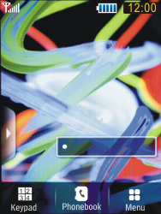
- Choose Settings.
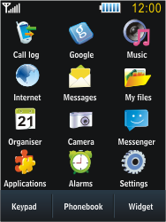
- Choose Application settings.
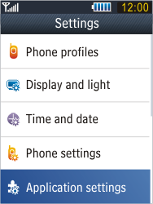
- Choose Internet.
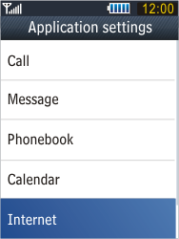
- Choose Internet profiles.
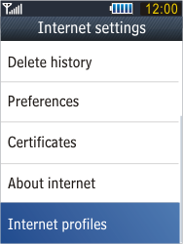
- If this screen appears, choose Create.
- If this screen does not appear, chooseMore, and then Create.
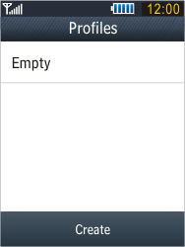
- Under Set name, enter myGlobe Connect
- Under Home URL, enter http://www,globe.com.ph/globe.asp
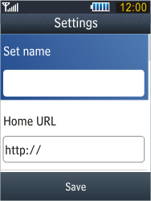
- Scroll down.
- Under Bearer, choose GPRS only.
- Under Proxy, choose on
- Enter Proxy, Key in 203.177.042.214
- Enter port, Key in 8080

- Scroll down.
- Choose GPRS settings
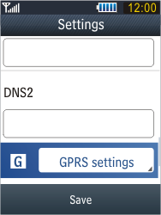
- Under Access name, enter www.globe.com.ph (be aware of the dots)
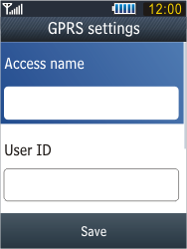
- Choose myGlobe Connect, and check this option.
- Choose Save.
- Return to the Start screen.


