MODULE ONE – Introduction 4
Acknowledgements 4
Introduction 5
MODULE TWO – External Environment Analysis 6
Definition of Industry 6
Analysis of Present Task Environment 6
Bargaining Power of Buyers 6
Bargaining Power of Suppliers 6
Threat of Substitutes 7
Threat of New Entrants 7
Rivalry and Competition 8
Analysis of Potential Changes in the Macroenvironment 8
Political Factor 8
Economic Factor 9
Sociocultural Factor 9
Technological Factor 9
Environmental Factor 10
Legal Factor 10
Threats and Opportunities 10
Industry and competitive analysis 11
Strategic Map 11
Market Definition 12
Market Size 12
Broader Societal Expectations 12
Corporate Social Responsibility 12
MODULE THREE – Analysis of Internal Environment 13
Overview of the Company 13
Business Segments 14
Mobile Business 14
Fixed-line 14
Financial Ratio Analysis 14
Value Chain Analysis 14
Primary Activities 14
Supply Chain Management (page 20 FS) 14
Operations 15
Wireless Network Operations 15
Wireline Network Operations 15
Distribution 15
Sales and Marketing 15
Services 15
Secondary Activities 15
Technology Development 15
Legal 15
Human Resource Management 15
General Administration 15
Firm Infrastructure 15
Strengths and Weaknesses 15
Personal Values of Key Implementers 16
MODULE FOUR – Strategic Plan 16
Vision 16
Objectives 16
Evaluation of Present Corporate Strategies 16
Proposed Corporate Strategies 16
Competitive Advantage 16
MODULE FIVE – Functional Area Strategies 16
Marketing 16
Operations 16
Finance 16
Information Management 16
Human Resources 16
MODULE SIX – Strategy Execution 16
Analysis of company’s capabilities to execute STRATEGY 16
Managing internal organization for strategic execution 16
Managing Strategic Change 16
MODULE SEVEN – Financial Projections 16
Minimum of 5 year projection 16
Notes to Financial Statements 16
Sources: 17

MODULE ONE – Introduction

Introduction
Globe Telecom was incorporated in January 15, 1935 as Globe Wireless Limited, inheriting the license of Robert Dollar Company to operate telecommunication service in the Philippines. In 1992, it was renamed as Globe-MackayCable and Radio Corporation. Later in the same year, it merged with Clavecilla Radio Corporation which gave the company capacity to serve international and domestic customers by providing any possible means and forms of telecommunication; Afterwards, it was renamed Globe Telecom Inc.
The company's principal shareholders are Ayala Corporation (AC) and Singapore Telecommunications (SingTel), and is listed on the Philippine Stock Exchange (PSE) with the ticker symbol of GLO. Its huge market capitalization, roughly around two percent (2) of the total index market cap, makes the company be included to the thirty (30) companies under the Philippine Stock Exchange Index (PSEi).
The company is one of the two major players that run the telecommunications sector here in the Philippines. Headquartered in Bonifacio Global City, Taguig, Globe Telecom operates one of the largest and most technologically advanced mobile, fixed line and broadband networks in the country. It also provides reliable, high-speed internet communications and private data network services to individual customers, small and medium-sized businesses, and corporate and enterprise clients. Other offerings include services for internal applications, internet protocol-based solutions and multimedia content delivery.
I am currently working as a Senior Network Operations Engineer in Verizon Communications, Inc., but unfortunately our management team refuses to allow me to use our company for this research. Their reason was that it is hard for them to risk the non-disclosure agreement which may compromise the business once violated. Furthermore, the quantity of confidential customer proprietary information that I handle on a daily basis is quite extensive. Hence, I opted to choose Globe Telecom as the subject organization since it is also in the same industry with Verizon, not too mention that I am also familiar with its external environment.

MODULE TWO – External Environment Analysis

Definition of Industry
The telecommunication industry is composed of companies wherein their line of business is to provide communications infrastructure and platform between two or more parties located anywhere in the world. Data or voice, may it be audio or video, are being transmitted either through wireline or wireless. Some of the popular technologies that this industry used were Public Switched Telephone Network (PSTN) -- the legacy telephony system, and Internet service -- the interconnection of computer networks and servers.
Globe Telecom is one of the two companies that enjoy the benefits of duopoly in the Telecommunications Industry here in the Philippines.

Analysis of Present Task Environment

Bargaining Power of Buyers
The bargaining power of the buyers, which in this sector are called subscribers, tend to be weak. This is because of the duopoly in the industry, and this very large number of subscribers have a very limited option. Because of this very high demand but limited supply, telco can be complacent and can let go a single customer. Even though the cost of switching from is low, the quality of these two telco being almost at par makes no sense for an individual to shift from one telco to another.

Bargaining Power of Suppliers
The bargaining power of suppliers are seen to be strong in this industry because of two factors: (1) Telco players does not pose a threat on its supplier as it can be hard for the former to integrate backward, and (2) some suppliers has a differentiated input, and it would be costly for the telco players to switch to alternative suppliers.
Telco players focus to provide customers the needed telecommunication infrastructure to reach as many potential subscribers as possible. It is not part of their core business to research and develop hardware and software that they could use instead of buying network devices from their suppliers.
On the other hand, network device suppliers have certain differentiated features against its rival suppliers. Depending on the telco’s strategic priority, one could settle to a cheaper supplier (i.e. Huawei) or to a more expensive and higher quality supplier (i.e. Cisco). Some of these devices have compatibility issues with other vendors. Take for example Cisco: this vendor has a lot of proprietary technologies which will not work when partnered with other vendor’s devices. If a telco opted to take advantage of the features of a proprietary technology, it could not operate on a multi-vendor setup. Hence, they are bound to only use a single vendor. In addition, if the telco decided to switch to another vendor, it would mean that most, if not all of their devices needs to be replaced as well, and this will eat up a lot of capital expenditures.

Threat of Substitutes
With the continuous modernization of communications, telco players is slowly eating up the industry of its substitute -- the snail mail. It is seen that this threat of substitute is slowly fading away. Because of the proliferation of modern communications via social media and email powered by these telco players, the snail mail industry is gradually dying. Philippine Postal Corp. (PHLPost), for example, said there is already a minimal number of personal mails circulating in their industry. It is only business letters like statement of accounts and monthly bills that still use this communication, however, a threat is also seen with the emergence of paperless billing.

Threat of New Entrants
Originally, the threat of new entrants in this industry is really low because of large capital needed to be at par with the incumbents, not to mention the strict regulation that governs the sector. However, it is gradually becoming easier to enter the market with the help of political will. This started when the newly elected President Duterte wanted to break the duopoly to further increase competition, thus improving customer service. He urged the Department of Information and Communications Technology to look for the third telco player as soon as possible. In 2018, after public bidding of local and international companies, DICT named Mislatel Consortium as the third telco player. This 2019, with the entry of Gregorio Honasan III as the new DICT Secretary, he said he will push for the entry of a possible fourth or even a fifth player.

Rivalry and Competition
The rivalry and competition between the two telco players is perceived to be weak mainly because of (1) buyer demand is growing rapidly, (2) cost of switching to other alternative is low, and (3) the difference of the service of the two players is weak.
The rivalry and competition between the two telco players is perceived to be weak because buyers’ demand is growing rapidly. With an inflating population resulting to increase in the number of smartphone users, the demand for connectivity services grows exponentially, and they are option is just to choose between Smart (PLDT’s mobile subsidiary) and Globe. Furthermore, the cost of switching is very low. With less than a hundred pesos, subscriber can easily move from one telco to another. Lastly, their quality of service is almost the same, hence buyers’ will not take much time in choosing who to choose between the two. Especially now that the Philippine government implemented regulations that allows subscribers keep their mobile number permanently, and mandating telco to unlock mobile phones and devices after their customers’ “lock-in” period, subscribers now have a greater freedom and flexibility to switch providers, which makes the rivalry weaker.

Analysis of Potential Changes in the Macroenvironment

Political Factor
It is the directive of President Rodrigo Roa Duterete to call out and seek for more players in the telecommunications industry. His intention is to disrupt the duopoly which could result to a better internet communication infrastructure available to Filipinos. On November 9, 2018, the administration named the Mislatel Consortium as the third player and it is expected to have its first subscribers before the end of 2019. Also, the entry of Gregorio Honasan III as the new DICT Secretary open doors for the possibility of a fourth or even fifth player. This poses a threat to the duopoly being enjoyed by PLDT and Globe as political will of people in the current administration makes it easier for potential players to enter the market.

Economic Factor
Because of low labor cost, and Filipino talents have a very high proficiency and fluency in english, the Philippines is now becoming the world’s leading destination for business process outsourcing (BPO) companies. According to the Department of Trade and Industry (DTI), by 2020, the BPO industry is expected to be at $48 billion enabling the Philippines to account for 20 percent of the projected $250 billion global industry. It increases the demand not only for office spaces, but also for network connectivity since their primary business is to serve customers remotely. This is a good opportunity for the telecommunications company.

Sociocultural Factor
According to a study, since the year 2016, Filipinos remain to be on the top spot when it comes to the number of hours spent on the internet, especially on social media. On the average, Filipinos spend 10 hours via any device. This change in lifestyle disrupts multiple discipline: from radio commercials to internet marketing (marketing); from free TV to on-demand, live streaming (broadcasting); from over the counter transaction to e-payment (finance); from standalone stores to e-commerce (sales); from on-site work to telecommuting (human resource). Everybody is enjoying the benefit of the internet connectivity, thus the demand for more network capacity is increasing exponentially - an opportunity for the telco players.

Technological Factor
Advancement in networking technologies are very popular this 2019: commercialization of 5G technology, and the gradual movement from hardware-based to software-defined networking.
5G is the next generation of mobile broadband that will succeed our 4G LTE connection. With this new technology, subscribers will see exponentially faster download and upload speeds. 5G speedtest can reach more than 1Gbps, compared to 4G top speed of 300Mbps Round-trip delays in the communication on a wireless domain, will also drastically decrease.
On the other hand, the booming technology of software-defined networking (SDN) disrupts the traditional hardware-based networking. Before, separate hardwares are needed to a certain function, say a company employs two core routers and three distribution switches. With the introduction of SDN or virtualization, the images or softwares of these previously separate devices can now be virtually compressed in a single device, which is normally a server. Inside this single server, the five network functions can now logically operate, on independent instances. This technology can save not only office spaces but also costs for the company.
These technological advancements are an opportunity to the telco players as these could establish their competitive advantage against their competitors if implemented efficiently.

Environmental Factor
Philippine is geographically situated in the region that is prone to earthquakes and typhoons. Wet submarine fiber cables are likely to be damaged when tectonic movements occur, thus the need for link redundancy is strong to avoid network isolation. In addition, cellular towers tend to collapse and overhead cables to break during very strong storms. These environmental disasters pose a threat to existing infrastructure of telco players and needs to be taken into consideration during the strategic planning.

Legal Factor
February 2019, President Duterte signs into law the Republic Act 11202 or the "Mobile Number Portability Act." This law paves the way for a subscriber, may it be prepaid or postpaid, to preserve his existing cell phone number for free when he decided to shift to another telco provider. In relation to this Lifetime Cellphone Number Act, National Telecommunications Commission’s (NTC) also issued Memorandum Circular 01-05-2019 which mandates telco players to unlock the mobile phones of their subscribers after the “lock-in” period, the applicable service contract or if the subscriber pays an early termination fee. By these two new regulations of the current administration, it became easier for consumers to switch to their preferred telco provider. These pose an external threat to the telco players.

Threats and Opportunities
Below are a summary of the external threats and opportunities within the telco industry. These are sorted in a table along with their respective weights, ratings and weighted score which is called External Factor Evaluation(EFE) Matrix.
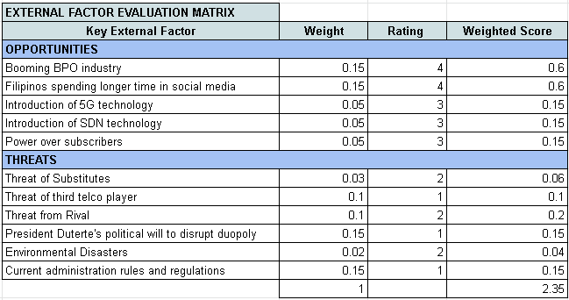

Industry and competitive analysis

Strategic Map
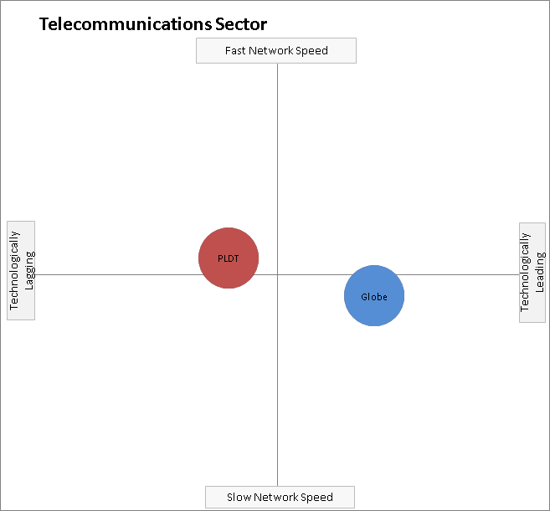
Technological Advancement versus Network Speed

Market Definition
Because telecommunications sector is a service industry, its customers are called subscribers. These subscribers are divided into two depending on their mode of payment:either prepaid or postpaid. These telco players cater to individual customers when latter avail SMS services, home broadband, digital mobile communication or internet-on-the-go services. Another target market are small and medium-sized businesses, corporate and enterprise clients. The services available to them are fixed line voice and corporate data.

Market Size
One way to obtain the market share is to base it on total sales revenue of all competing companies. Since this sector is considered in duopoly type of competition, the total revenue is the sum of the revenues of the two major telco player. According to the research by COL Financial Group, Inc. as of fiscal year 2018, the total revenue for the telecommunications industry is roughly P294 billion, in which 47.63% of it is Globe’s cut on the pie while its major competitor PLDT has 52.37%.
In addition, the total subscriber count within the mobile space, both prepaid and postpaid, has also been taken into account. Based from the first quarter of 2019 research of COL Financial, the total mobile subscriber count reached 147.4 Million. Globe’s number of mobile subscriber sits around 83.5 million users, or 56.65% of the total subscribers, while PLDT has 63.9 million, or 43.35%

Broader Societal Expectations

Corporate Social Responsibility
Globe Telecom also has a Corporate Social Responsibility arm that oversee the sustainability efforts of the company. As their businesses continue to grow, the company would want to contribute in building the nation by engaging and empowering its workforce to be committed in doing a Globe of Good. The company also listed on their website their sustainable development goals: (1) protection of life on land and below water, (2) raise climate awareness and responsible consumption and production, (3) promotion of good health and well being, (4) quality education, and (5) big impact to industry, innovation, infrastructure and economic growth.
As the country progress through digital transformation, Globe Telecom contributes to the advance learning and education across different public schools. They value education, and they believe that every child has his or her rights to access quality education. The company sponsors public schools with new gadgets, critical infrastructure, reliable internet access, collaborative learning spaces, and training for teachers to be competent in Information and Communications Technology (ICT). Some of their workshops include cyber security and safety, and online responsibility and etiquette.
The company also commits itself in building greener world. Their environmental initiatives target to support sustainable and clean programs that could benefit every Filipino and eventually the mother earth. Old mobile phones and broken chargers are made sure not to end up in landfills by having it recovered and recycled. Moreover, their CSR arm partners with foundations to help save rainforest in some provinces in the Philippines. Not only to restore its beauty, but to help educate the public and raise awareness about the state of Philippine rainforest.
Furthermore, Globe also shows its care for the people, especially the FIlipinos. The company aspires to provide opportunities within its value chain. Through the AutoLoadMax program, small retail stores were able to generate additional income from the large volume of their prepaid subscribers. In addition, their employment facilitation program aims to provide job seekers from the marginalized sector a technical-vocational opportunities within Globe, its partner subsidiaries, third-party contractors, and vendors nationwide. At the end of the day, we Filipinos will benefit to the further growth of our own economy.

MODULE THREE – Analysis of Internal Environment

Overview of the Company
Globe Telecom operates as one of the largest and most technologically advanced mobile, fixed line and broadband networks in the country. It provides reliable, high-speed internet communications and private data network services to individual customers, small and medium-sized businesses, and corporate and enterprise clients. Other offerings include services for internal applications, internet protocol-based solutions and multimedia content delivery.

Business Segments

Mobile Business
Globe provides digital mobile communication and internet-on-the-go services nationwide using a fully digital network based on the Global System for Mobile Communication (GSM), 3G, HSPA+, and LTE technologies. It provides voice, SMS, data, and value-added services to its mobile subscribers through three major brands: Globe Postpaid, Globe Prepaid and TM (including fully mobile, internet-on-the-go service).
Globe’s Mobile Short Message Service (SMS) includes local and international offerings. The company also offers various bucket and unlimited SMS packages to cater to the different needs and lifestyles of its postpaid and prepaid subscribers.
For the company’s Mobile voice service, it is offering local, national and international long distance call. It has one of the most extensive local calling options designed for multiple calling profiles. In addition to its standard, pay-per-use rates, subscribers can choose from bulk and unlimited voice offerings for allday or off-peak use, and in several denominations to suit different budgets.
Lastly, Globe’s Mobile Data services allow subscribers to access the internet using their internet-capable handsets, devices or laptops with USB modems. Data access can be made using various technologies including LTE, HSPA+, 3G with HSDPA, EDGE and GPRS. This second quarter of 2019, the company rolled-out the next-generation 5G network technology.

Fixed-line and Broadband Business
Globe Telecom offers a full range of fixed line communications services, wired and wireless broadband access, and end-to-end connectivity solutions customized for consumers, SMEs (Small & Medium Enterprises), large corporations and businesses.
For its fixed line voice services, the company offers local, national and international long distance calling services in postpaid and prepaid packages through its Globelines brand. Subscribers get to enjoy toll-free rates for national long distance calls with other Globelines subscribers nationwide. For corporate and enterprise customers, Globe offers voice solutions that include regular and premium conferencing, enhanced voice mail, IP-PBX solutions and domestic or international toll free services. With the Company's cutting-edge Next Generation Network (NGN), Globe Business Voice solutions offer enterprises a bevy of fully-managed traditional and IP-based voice packages that can be customized to their needs.
The company also offers Corporate Data Services which include end-to-end data solutions customized according to the needs of businesses. Globe’s product offerings include international and domestic leased line services, wholesale and corporate internet access, data center services and other connectivity solutions tailored to the needs of specific industries.
Globe’s international data services provide corporate and enterprise customers with the most diverse international connectivity solutions. Globe’s extensive data network allows customers to manage their own virtual private networks, subscribe to wholesale internet access via managed international private leased lines, run various applications, and access other networks with integrated voice services over high-speed, redundant and reliable connections.
For the company’s domestic data services, it includes data center solutions such as business continuity and data recovery services, 24x7 monitoring and management, dedicated server hosting, maintenance for application-hosting, managed space and carrier-class facilities for co-location requirements and dedicated hardware from leading partner vendors for off-site deployment. Other corporate data services include premium-grade access solutions combining voice, broadband and video offerings designed to address specific connectivity requirements. These include Broadband Internet Zones (BIZ) for broadband-to-room internet access for hotels, and Internet Exchange (GiX) services for bandwidth-on-demand access packages based on average usage.
Globe offers wired and fixed wireless broadband services, across various technologies and
connectivity speeds for its residential and business customers. Globe Home Broadband consists of wired or DSL broadband packages which can be bundled with voice, content, and devices, or broadband data-only services which are available with download speeds ranging from 1 Mbps up to 15 Mbps. Globe also expanded its Long Term Evolution (LTE) footprint through LTE @Home offerings, bringing the latest internet technology to households and allowing subscribers to surf the internet at ultrafast speeds to watch high-definition videos, downloading and uploading large files, seamless music streaming, and voice-over-internet-protocol (VOIP) calling with clear quality. This LTE service is backed by the largest 4G network in the country deployed by Globe.

Financial Ratio Analysis
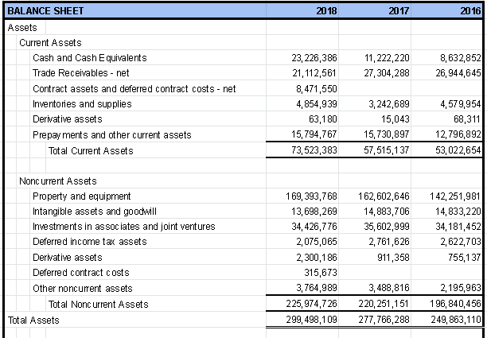
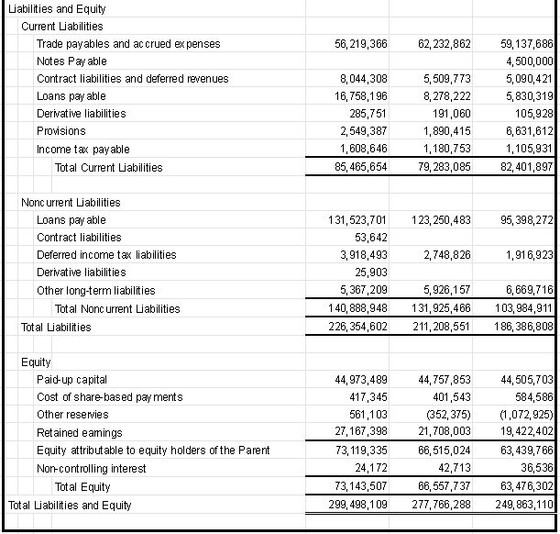
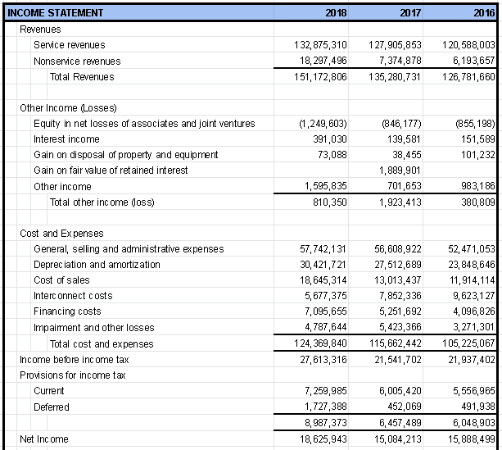
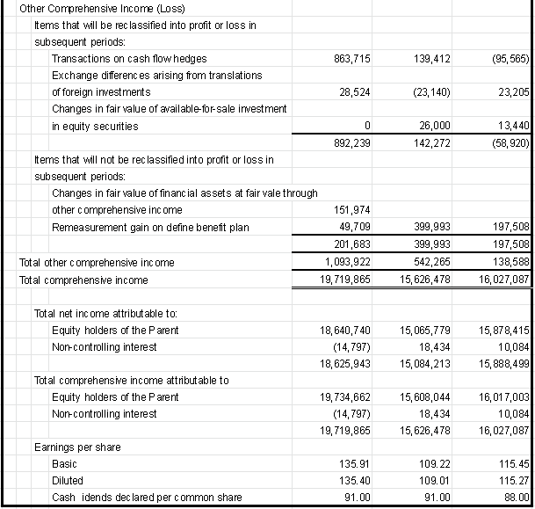
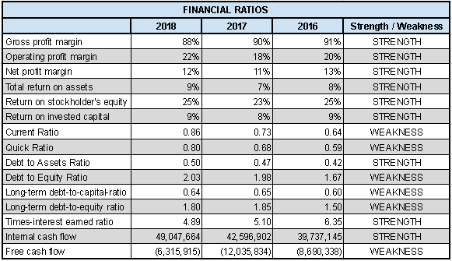

Value Chain Analysis

Primary Activities

Supply Chain Management (Inbound Logistics)
Their principal suppliers for their mobile, transmission, IP equipment, fixed line and fixed broadband services are Huawei Technologies Co., Ltd. (China) and Nokia Corporation (Finland). Other suppliers include NEC (Japan), ECI Telecom, Ltd. (Israel), Aviat Networks (USA), FiberHome Telecom Tech (China), Juniper Networks (USA), ZTE Corporation, and Tellabs (USA/Singapore). For WiFi service, Globe Telecom tapped partnership with Aruba Networks (USA) and Ruckus Networks (USA), while for Network Management and Operational Support Systems, Globe’s primary solution provider includes IBM (USA), Mycom OSI (United Kingdom), Incognito (Canada), Netcracker (USA), Radcom (Israel) among others.

Operations
The core business of telecommunications provider is to connect two or more segments by any means necessary; may it be wireless using microwave or satellite communications, or wired using copper or fiber optic cable system. Big global telecommunications provider rolled out high capacity submarine cable system that connects countries and continents with one another. Currently, Globe has two (2) international cable landing stations situated in different locales to ensure redundancy and network resiliency. Furthermore, since the Philippines consists of thousands of island, Globe also established two (2) geo-redundant Fiber Optic Backbone Network (FOBN) linking the Luzon, Visayas and Mindanao island groups. This network are now the primary national transmission backbone for Globe to support all of the different telecommunication services they offer to its customers. In addition to these two (2) FOBNs, Globe also operates and maintains a Digital Microwave (MW) Terrestrial network for a wireless, high bandwidth, point-to-point connection.
The network devices and transport equipment purchased by the company use these cable systems to be able to peer with their fellow telecommunications providers here and abroad. These interconnections is the way for their respective customers to reach anything and anyone they desire. These providers have peerings between them that advertises their respective learned-routes to each other. Case in point, internet users can access billion numbers of contents Google servers have because of its peering with their internet provider. Additionally, here in the Philippines, a Globe customer can reach a business website hosted by PLDT because the two providers are peered. This concept is true to any of the business segment being offered by the company, may it be voice, data, or multimedia..

Distribution (Outbound Logistics)
By its wide and expanded network coverage, Globe subscribers can enjoy the services the company has to offer mostly anywhere in the Philippines. The company has invested and rolled out infrastructures needed to establish strategic footprints in the country. In terms of cell sites, the Company has about 8,000 physical cell site locations providing 2G, 3G and 4G coverage nationwide. As the Company continues to expand its network, Globe intends to lease more space for additional cell sites as they strive to set up 100% mobile network coverage. As of the year ended 2018, Globe Telecom’s 4G LTE service has already been deployed to cover 95% of cities and municipalities nationwide.

Sales and Marketing
Globe has various sales channels to address the diverse needs of its subscribers. As of December 31, 2018, the company has a total of 224 Globe Stores all over the country where customers are able to inquire and subscribe to wireless, broadband and fixed line services, reload prepaid credits, and pay bills. They also utilize a number of independent dealers throughout the Philippines to sell and distribute its prepaid wireless services. Additionally, Globe also relies on its distribution network of over 1.2 million AutoloadMax retailers nationwide who offer prepaid reloading services to Globe and TM subscribers. This also includes consumer distribution channels such as convenience stores, gas stations, drugstores and bookstores. Lower denomination prepaid loads are also available in public utility vehicles and street vendors.

Services
Globe has been trying its best to provide a customer service as excellent as possible. For inquiries, technical assistance and complaints, the company made multiple channels available to the customers so they can reach out to their customer-facing representative. On their website, they have listed Frequently Asked Questions (FAQ) so the customer can easily find solutions to recurring queries. For further concerns, customer can still get in touch with Globe representative via phone call. Online support is available as well via chat on Facebook messenger or tweet on Twitter. They also established Globe community forum wherein a dedicated space per category is available for knowledge transfers and sharing of their insights about Globe products.

Secondary Activities

Procurement
Globe works with both local and foreign suppliers and contractors. Equipment and technology required to render telecommunications services are mainly sourced from foreign countries, hence, the company’s capital expenses are exposed to the fluctuation of foreign currency exchange risks
.

Technology Development
Globe Telecom has partnered with Huawei Technologies for the planning and design of a mobile broadband network as well as the establishment of mobile innovation center for research and development of the 5G technology. Globe incurred market research costs amounting to ₱150 million in 2018, 10% lower versus 2017 spend.

Human Resource Management
Globe Telecom considers all its employees to be significant partners and contributors to the business. It currently has 7,729 active regular employees as of December 31, 2018. Globe is exposed to risks in staffing critical functions with competent management and technical expertise. Globe’s greatest asset is its people and the company’s success is largely dependent on its ability to attract highly skilled personnel and to retain and motivate the best employees.

Firm Infrastructure
Globe has strong corporate governance. It recognizes its importance in realizing its vision, carrying out its mission, and living out its values to create and sustain increased value for all stakeholders. The impact of global conditions and challenges further underscores the need to uphold high standards of corporate governance to strengthen our structures and processes. Good governance standards must be present and experienced outside and inside the company such that the principles of fairness, transparency, integrity, sustainability, and accountability should also be experienced among employees.
In addition, Globe telecom also has sustainable, resilient and reliable infrastructures and operating systems that will ensure continuity of their services before, during and after any disaster. At the core of their Business Continuity Management (BCM) is a robust enterprise architecture that will protect the integrity of customer data and transactions at all times. Existing network infrastructure is designed to ensure service disruptions are at a minimum or at best none, with strategic redundancies embedded within its architecture. Standby resources, may it be physical, financial and manpower augmentations are available to overcome large-scale business disruptions and disastrous events so that customers will continually be served with mobile, data and other telecommunications services. It is management’s primary objective, including their critical business partners to meet this commitment.

Strengths and Weaknesses
Below are a summary of the Globe Telecom’s strength and weakness. These are sorted in a table along with their respective weights, ratings and weighted score which is called Internal Factor Evaluation (EFE) Matrix. The strength and weakness of the company are based on the previously mentioned result of financial and value-chain analysis

Personal Values of Key Implementers

MODULE FOUR – Strategic Plan

Vision

Core Purpose
To provide reliable, superior communications services to individual customers, small and medium-sized businesses, and corporate and enterprise clients.

Core Ideologies
Corporate Value:
- Putting customers first
- Valuing people and together, and making the difference
- Acting with integrity
- Caring like an owner
- Keeping things simple
- Moving fast and better everyday

Big Hairy Audacious Goal (BHAG)
To bring the Philippines within the top 20 world’s fastest internet speed by the year 2030

Suggested Vision
“We see a Philippines where families are highly satisfied with their digital lifestyle, and where businesses are nurtured by different reliable channels.”

Objectives

Financial Objective
- To continue achieving double-digit revenue and bottomline around 15% annually

Strategic Objective
- To improve network coverage to 100% of cities and municipalities in the country by the end of 2019
- To improve average internet speed by 5% annually

Social Objective
- To decrease greenhouse gas emissions by at least 5% annually

Evaluation of Present Corporate Strategies
Below are the present corporate strategy the company has disclosed on their annual report:

1. BUILD THE NETWORK OF CHOICE
To be an admired nation by providing mobile services to about 95% of cities and municipalities in the Philippines by end of 2018.

2. EMPOWER CONSUMERS
To be the purveyor of the digital lifestyle by providing affordable world-class entertainment available to all.

3. OBSESS ABOUT THE CUSTOMER
To create the best experiences for every digital Filipino through a technology driven and customer-centric approach on customer service, education, engagement, and rewards.

4. BRING WONDERFUL EXPERIENCES TO THE HOME
To make leading-edge network technology available to two million homes in 20,000 barangays by end of 2020.

5. PUT PEOPLE FIRST
To create a high performing organization through a purpose-driven workforce with a culture of empowerment, collaboration, and innovation.

Proposed Corporate Strategies

Competitive Advantage

MODULE FIVE – Functional Area Strategies

Marketing

Operations

Finance

Information Management

Human Resources

MODULE SIX – Strategy Execution

Analysis of company’s capabilities to execute STRATEGY

Managing internal organization for strategic execution

Managing Strategic Change

MODULE SEVEN – Financial Projections

Minimum of 5 year projection

Notes to Financial Statements

Sources:
https://www.investopedia.com/ask/answers/070815/what-telecommunications-sector.asp
https://ph2.colfinancial.com/ape/FINAL2_STARTER/researchcompupdates/downloads/2019-04-16-PH-S-Telecom.pdf
https://ph2.colfinancial.com/ape/FINAL2_STARTER/researchcompupdates/downloads/2019-05-24-PH-S-Telecom.pdf
https://www.globe.com.ph/about-us/sustainability.html
https://www.gmanetwork.com/news/money/companies/699609/dict-chief-honasan-eyes-4th-and-5th-telco-players/story/
https://www.bworldonline.com/let-the-third-telco-come-naturally/
https://www.pna.gov.ph/articles/1060433
https://technology.inquirer.net/83588/duterte-signs-into-law-lifetime-cellphone-number-act
https://www.philstar.com/business/2019/06/05/1923643/phone-unlocking-now-mandatory-ntc
http://citem.gov.ph/index.php/industry-news-list/917-ph-on-track-to-get-20-of-250-b-global-bpo
https://news.abs-cbn.com/focus/01/31/19/filipinos-still-worlds-top-social-media-user-study
https://www.techradar.com/news/what-is-5g-everything-you-need-to-know
http://www.chinacablesbuy.com/sdn-vs-traditional-networking-which-leads-the-way.html

