TABLE OF CONTENTS

Module One 2
Acknowledgements 2
Introduction 3
Definition of Industry 5

Module Two 5
Analysis of Present Task Environment 5
Analysis of Potential Changes in Macroenvironment 10
Threats and Opportunities 14
Industry and Competitive Analysis 18
Strategic Map 18
Market Definition 19
Market Size 19
Broader Societal Expectations 21

Module Three 21
Company Overview 21
Financial Statements and Financial Ratios 24
Value Chain 27
Summary of Strengths and Weaknesses 31
Personal Values of Key Implementers 33

Module Four 34
Strategic Plan 34
Vision 34
Objectives 36
Proposed Corporate Strategies 36
Corporate Strategies and Objectives 44
Competitive Advantage 46

References 48

Module One

I.

II. Introduction

Digital Walker is major retail company of consumer electronics in the Philippines. It currently has 30+ stores nationwide, and sells variety of consumer electronic goods such as, but not limited to smartphones, smartphone accessories, cases, screen protectors, speakers, headphones, drones, cameras, home automation, car accessories, and many more.
Digital Walker was founded by Charles Paw, a technology and gadget enthusiast, an entrepreneur, and also a restauranteur. Charles Paw has a strong natural business mindset, and a sense of belongingness to a community. He started young, by selling pieced together PCs during the 90s to his school peers, realizing the potential of having a business, Charles pursued business over formal tertiary education. In the later days of running small businesses Charles, being fond of the newest technology, buys his gadgets and accessories abroad, to reduce cost, he purchases items in bulk and sells the excess to his peers. He then realized that what he does is profitable thus the birth of several of his companies. He then founded Digits Trading Corporation, an importer of products and brands from US, Europe, and China, and also Digital Walker, his own retail store to sell imported consumer electronic products to Filipino consumers.
These companies were born not just to earn profits, but also for the Filipino community who shares the same passion of Charles, to have access to newest technology products.

Currently, Digital Walker is still privately owned by Charles, and his family with no clear intention whether to go public or not in the near future. Control and decision making over the company and its direction are all dependent on the vision of the founder but enabled by the thoughts and insights of its managers.
Majority of the workforce of Digital Walker Stores are supplied by a manpower agency, most of the direct hires are head office managers, and area sales managers. Most of its support functions are coming from the shared services of the parent company, Digits Trading Corporation. The support functions from the shared services are Accounting, Audit, IT, etc.
The current tagline of Digital Walker is “Walking you into the future” it does not have a formal Vision and Mission because the current management assumes that it carries the same Vision and Mission as the parent company, Digits Trading Corporation, the importer, and supplier of products of Digital Walker.
I am the current head of After Sales, and Information Systems of both Digits Trading Corporation, and Digital Walker, and was the former Corporate Strategist and as part of the middle management of the organization, it would be an honor to conduct research to help the organization grow and become competitive in the market.
Geographic Scope:

Digital Walker has many stores nationwide, in total they have more than

30 stores scattered in different major cities of the country. Majority of its stores

are still located in Metro Manila, but continues to expand more in different islands of the country.
Products:

Digital Walker sells consumer electronic goods, mostly revolving around the smartphone category. Here are some of the product categories that they sell: Gadgets and Accessories
● Smartphones

● Smartphone cases

● Headphones / Earphones

● Speakers

● Screen Protectors

● Drones

III. Definition of Industry

Digital Walker is in the industry of retail, specifically retailing consumer electronics to the Philippines consumer market. Digital Walker sells products imported by Digits Trading Corporation.

Module Two

IV. Analysis of Present Task Environment

Competition

Digital Walker has a lot of competition but majority has the same business setup as of the moment. Here are some of the competitors of Digital Walker

● Power Mac Center (PMC) - An Apple Premium Reseller, Majority of products are Apple units and Apple Unit Accessories.
● Beyond the Box (BTB) - Also an Apple Premium Reseller, similar to Power

Mac Center. BTB is Digital Walker’s sister company.

● The Loop - a non apple focused technology lifestyle retailer of Power Mac

Center. Product categories are very similar to Digital Walker

● Octagon - Computers and peripheral store with wide range of products not limited to smartphones
● CD-R King - Fast growing computer accessories retailer known for its very cheap prices, but low quality goods.
There are a lot more that can compete in consumer electronics retail but there’s one thing in common amongst all of these, they sell similar product categories and fighting over the market in the physical retail space.
The threat to this industry is not the substitute of the products being sold, because as retailer they can just easily swap product categories in line with the market meets, but the alternative way of doing retail, like social marketplaces, or e-commerce.
Consumers

Consumer electronics industry is fast growing, but demands are also fast changing. Here are some top trends of consumers when in comes to consumer electronics.

1. The Booming Demand for Smart Appliances - “demand is booming for smart home appliances. Indeed, the global smart home market is expected to reach an estimated $107.4 billion by 2023” (Corbett, 2018)
2. Every Consumer Touchpoint Matters - “Omnichannel retail continues to gain traction in consumer electronics. And not for nothing: a study by the Aberdeen Group revealed companies with strong omnichannel strategies experienced an average 9.5% YOY increase in annual revenue, a 7.5% YOY decrease in cost per customer contact, and a healthy 89% customer retention rate versus companies with poor omnichannel engagement.” (Corbett, 2018)
Regulatory Agencies

All business in the Philippines are governed by SEC, DTI, and BIR. Those are common regulatory agencies that affects how business are established and sustained in the country. But for those who deal with consumer electronics, specially wireless, and storage devices they have to deal with addition regulatory agencies such as the following:
1. Optical Media Board (OMB) - businesses need to secure certain permits to sell / repair / manage storage devices such as hard drives, disk drives, etc.
2. National Telecommunications Commission (NTC) - businesses needs to secure NTC permits in order to import, sell, distribute, wireless devices, this includes smartphones and other bluetooth devices.

Substitutes

Nowadays, consumers, Instead of going to their good old reliable physical shops inside the malls are able to transact in the comfort of their homes. As I mentioned in the earlier part of this analysis, products sold inside these retail stores can be easily swapped out. The substitute that is threatening this industry is the alternative ways of doing retail such as e-commerce, m-commerce, or social media marketplace.
Potential Substitute to Physical Consumer Electronics Retailing

● E-Commerce

○ Lazada

○ Shoppee

○ Kimstore

● Social Marketplaces

○ Carousell

○ Facebook Marketplace

● Unregistered Market

○ Individual Online Sellers

Five Forces Analysis

● Barrier to New Entrants - Barrier to new entrants is high in the industry of physical retail of consumer electronics here in the Philippines because most of the fast selling electronic devices are wireless and have storage devices installed, like the smartphone, and before you even operate you

need huge capital to build stores, pay permits, and import products. Some are reliant on local supplier of imported electronic products but that takes away huge chunk of the margins that allows businesses to ROI quickly, or to earn profits.
● Bargaining Power of Suppliers - Bargaining power of supplier is high.

Usually fast selling electronic consumer goods are dependent on the brand. Big brands tend to have command over the retailers and their actions towards selling goods, or even the margins. This is very evident with Apple and its partners.
● Bargaining Power of Buyers - Bargaining power of buyers is high, most retailers sell the same thing and it all differs in how retailers market their products. Switching cost is not too high because consumers can opt to go to other stores if service is not good, or prices are too high.
● Substitutes - Threat of Substitutes is moderate, despite maintain low cost to operate while covering the entire nation by operating online without the high cost of maintaining rent, majority Filipino consumers have yet to trust the online marketplace world. Another concern for the substitute industry is the preferred payment method of Filipinos, cash. Credit card penetration is low, and even if the institutions are ready to offer cash on delivery, operational and financial risks are getting higher because payment are not secured upon order. Nevertheless, the industry is fast growing despite its low take up in the present and could be a real threat in the future.

● Rivalry Amongst Competitors - Rivalry amongst competitors is strong.

Products are weakly differentiated, the number of competitors are increasing, and buyers switching cost is low.
V. Analysis of Potential Changes in Macroenvironment

Political

President’s Political Will

“Rodrigo Duterte’s Blueprint To Spearhead the Economic Transformation of the Philippines Bodes Well for Consumer Electronics One of the numerous goals of Rodrigo Duterte’s government is to transform the Philippines into a competitive business hub and a high-middle-income country by 2022, when his term will expire. His administration has pledged to reform labour market policies by enforcing the prohibition of illegal contracting and subcontracting in an effort to improve worker benefits and job security. This means that Duterte’s policies, if implemented properly, would have a trickle down effect on the consumer electronics industry. Implementing measures which improve employment in the Philippines will result in stronger consumer purchasing power. This would also likely lead to stronger demand for more premium-priced products with specific features, ultimately driving a shift in the buying behaviour of local consumers, who are generally known for their price sensitivity.” (Euromonitor, 2018) Government Agencies
Many have seen the rise of online selling, a lot of individuals have entered the industry to earn extra profits. This however, became and avenue to sell

counterfeit products, or smuggled goods. The government's inaction towards the sellers of this illegally acquired inventories are discouraging the legitimate business from aggressively competing because theses small or big businesses can get away with tax, business, and other regulatory permits that are required from the legit businesses.
Economic

● Exchange Rate
Philippine Peso is getting weaker and weaker, forecasts shows that it will continue to dip in value for the next 3 years.

Philippines
Markets Last Q4/18 Q1/19 Q2/19 Q3/19 2020

Currency 53.86 54.53 54.74 54.95 55.16 56

Stock Market 6966 7121 7021 6923 6826 6452

Government Bond
10y 8 7.56 7.93 8.32 8.72 10.55

Table 1. Exchange Rate Forecast of Philippine Peso. (Trading Economy, 2018)

● Inflation
Inflation rate is at its all time high for the Philippines, but forecasts shows that it should not be the case for the next three years and is set to correct itself.

Philippines Prices Last Q4/18 Q1/19 Q2/19 Q3/19 2020

Inflation Rate 6.7 5.3 5.2 4.2 3.9 3.3

Inflation Rate Mom 0.8 0.6 0.9 0.7 0.5 0.2

Consumer Price

Index CPI

Core Consumer
Prices
120 119 122 122 124 128

117 116 118 119 121 126

Core Inflation Rate 4.7 3.8 3.5 3.4 3.6 4.1

GDP Deflator 184 190 183 185 188 193

Producer Prices 133 134 134 135 134 135

Producer Prices

Change
-0.04 1.3 1.1 0.7 0.8 0.3

Food Inflation 9.7 6.9 5.5 4.9 4.5 3.9

Import Prices 118 121 117 118 122 128

Export Prices 92.52 110 105 95.8 93.5 111

CPI Housing Utilities 112 113 115 115 116 121

CPI Transportation 107 106 108 109 111 113

Table 2. Inflation Rate Forecast of the Philippines. (Trading Economy, 2018)

Social

Social Media Is Not Just A Fad But A Must

“According to a report by Gartner L2, in 2016, 95% of social interactions for consumer electronics brands in the US were on Instagram, and 3% on Facebook. In 2017, these figures changed to 78% for Instagram, and 19% for Facebook.” (Corbett, 2018)
Technological

Fintech can serve the unbanked of the country, or those who are afraid to deal with big credit card companies.
“The unmet need for basic banking services is significant across much of Southeast Asia. Only 27% of the region's 600 million inhabitants had a bank account in 2016, according to consulting firm KPMG. And herein lies opportunity to find meaning and impact through fintech.
"I am convinced that fintech's greatest achievement will be not just helping the unbanked, but also the underbanked — individuals who have insufficient access to financial services—to live a better life,” - Spiros Margaris” (Chin, 2018)

Environmental

Increasing environmental responsibilities for distributors or producers of electronic materials that in time turns into e-waste.
“According to the group EcoWaste Coalition, a local waste and pollution watchdog, among the hazardous substances that make up electrical and electronic equipment and their waste are heavy metals, such as cadmium, hexavalent chromium, lead and mercury, and persistent organic pollutants (POPs) such as polybrominated diphenyl ethers (PBDes) and polychlorinated biphenyls (PCBs), among dozens of other toxic chemical compounds.

E-waste includes a wide range of products—almost any household or business item with circuitry or electrical components with power or battery supply.” (Mayuga, 2017)
Legal

TRAIN Law

Every workers rejoiced when the lower income taxes were announced and glorified by the finance sector of the government. This however turned on the consumers as soon as they realized that sectors that affects every move of the business are heavily impacted and passed the burden to the consumers. Oil prices increased drastically, and everything followed suit.

“While power distributors, oil companies, fuel retailers, and tobacco manufacturers are directly affected by TRAIN, First Metro Investments Corporation vice president Cristina Ulang said they have one thing going for them.

"The additional burden is something they can pass on to consumers," Ulang explained.” (Dela Paz, 2018)

VI. Threats and Opportunities

Threats

● Inaction of Government Agencies - If strict enforcement of consumers laws are not implemented towards small players that sells smuggled goods that can the damage the reputation of the legitimate distributors or retailers of the brands or products because the illegitimacy might be associated to the companies within the industry.
● Economic, Exchange Rate - Majority of the brands sold in the consumer electronics industry are imported outside of the country. Higher exchange rate is equivalent to higher cost of goods sold.
● Legal, TRAIN LAW - If oil prices continue to rise, most business will have to pass the burden to consumers. If prices increase because of the additional burden from the taxes, sales for non basic commodity might slow down.

● Higher Bargaining Power of Supplier - Most imported brands command the SRP of their products, and if retailers are dependent on the command of suppliers that has now deeper knowledge of the local market, the margins of the retailers might suffer and for them it will be lower profits.
● Technology, Fintech - This decreases the risk of consumers moving towards alternative marketplaces such as e-commerce. If more customers are able to have payment options that they prefer to shop online, market for physical retail might decrease.
● Threat of Substitutes, Online Sales - Big companies are working on developing systems and technology to mitigate the risk of e-commerce in the Philippines, and attract more users to purchase online.
Opportunities

● Political, President’s Political Will - The president’s political will, might benefit business sector and increase the number of middle class earners that might increase the demand for consumer electronics for their day to day use in office, or at home.
● Economic, Inflation Rate - The current inflation of the country is increasing, but if forecasts are accurate, it will correct, and normalize in the next three years. Nevertheless, retailers can still tap into the emotional side of the Filipinos and entice them to buy consumer electronic goods.
● Strong Rivalry Amongst Competitors - There’s an opportunity to easily differentiate amongst competitors

● Environmental, E-Waste management - Opportunity to differentiate amongst competitor by being responsible across the entire value chain.
● Social, Social Media Capital - Filipinos love to stay in social media for hours, this gives the entire industry to feature their products, stores, in a medium that is easily accessible, measurable, manageable, and cheaper compared to print ads.
● Technology, Fintech - This serves as an opportunity to retailers to sell to those who are unbanked. Prices of consumer electronics are not cheap, meaning consumers should have access to a financial safe keeping that they trust aside from the banks.
● High Barrier to New Entrants - It requires a lot of capital to be able to effectively and legally compete in the physical retail of consumer electronics. Competitors can focus on differentiating and getting shares from each other.
Assessment of External Factors - EFE
The external environment of the industry in which Digital Walker is a part of, needs to be assessed to determine whether Digital Walker is capable of mitigating risks from threats or maximizing opportunities.

Threats

Key External Factors Weight Score
Weighted
Score

Inaction of government agencies 0.05 3 0.15

Economic, increasing exchange rate

(low peso value)
0.2 1 0.2

Legal, TRAIN LAW 0.1 1 0.1

Higher bargaining power of supplier 0.1 2 0.2

Technology, FINTECH reduces risk of
online shopping, reduce traffic of brick and mortar
Threat of Substitute - Alternative sales channel, online
0.05 4 0.2

0.05 3 0.15

Opportunities

Political, President's political will, increase middle class earners

Economic, forecasted recovery of inflation rate

Environmental, increasing demand for responsible e-waste disposal

Strong rivalry between industry competitors
Technology, FINTECH decreases the number of unbanked, increases the number of customers

0.05 4 0.2

0.1 3 0.3

0.1 4 0.4

0.1 3 0.3

0.05 3 0.15

High barrier to new entrants 0.05 3 0.15

Total 1 2.5

Table 3. Digital Walker EFE Analysis

In this EFE Table, the total score is 2.5. Digital Walker is neither strong or weak in handling opportunities or threats. There are a lot of factors that are painfully uncontrollable not only by Digital Walker but for all business within the industry such as exchange rate, cooperation of LGUs, and laws involving business operations, in the case of Digital Walker, finance ratios (shown in Module Three) especially profits are not appealing to the eyes of the common public thus the ratings for the said external factor is low. In terms of weight, those items have higher weights compared to others because it can drastically increase the cost of the product because most products are imported.

Despite the increases in cost, the industry may look forward to the improving economy, and continuously increasing demand. As long as Digital Walker is able to supply the demand then the company can enjoy the growth of the economy.

VII. Industry and Competitive Analysis

A. Strategic Map

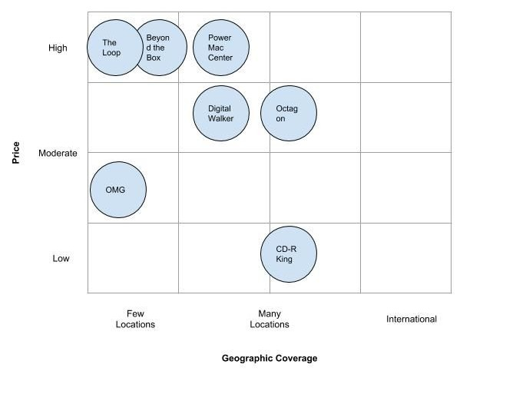

Figure 1. Strategic Map of Consumer Electronics Retailers

B. Market Definition

The industry is retailing of consumer electronics, thus the market are buyers of said goods. Philippines in general is still a third world country, and theoretically speaking, are impulsive buyers. Nevertheless, Filipino consumers can still be divided into two. One being the low cost seeker, others are buyers that prefer quality over quantity.
C. Market Size

Consumer electronics market in the Philippines is generally strong, this is in conjunction with the steady rise of smartphones. This however, brings down the market size of stand alone electronic devices that are slowly becoming obsolete because of smartphones. Examples of these are calculators, printers, and other imaging devices. Current the estimated volume of transactions for consumer retail is at 33 Million transactions, with a value of 385 Billion pesos. There was a slowdown in 2017 of figures of the industry but steadily went back to normal after a year.

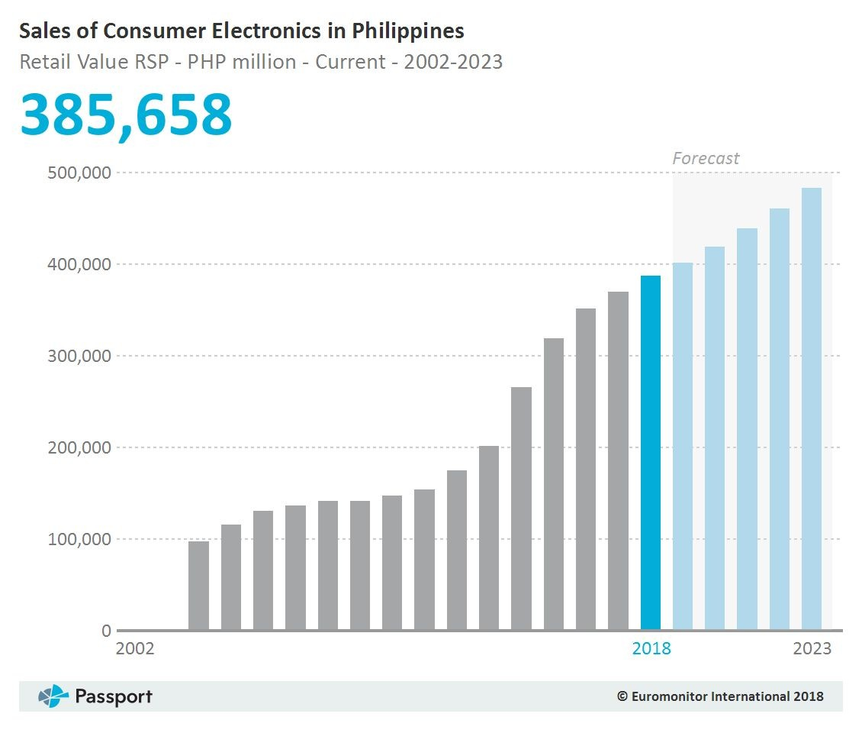
Figure 2. Sales of Consumer Electronics in Philippines (PHP). (Euromonitor, 2018)

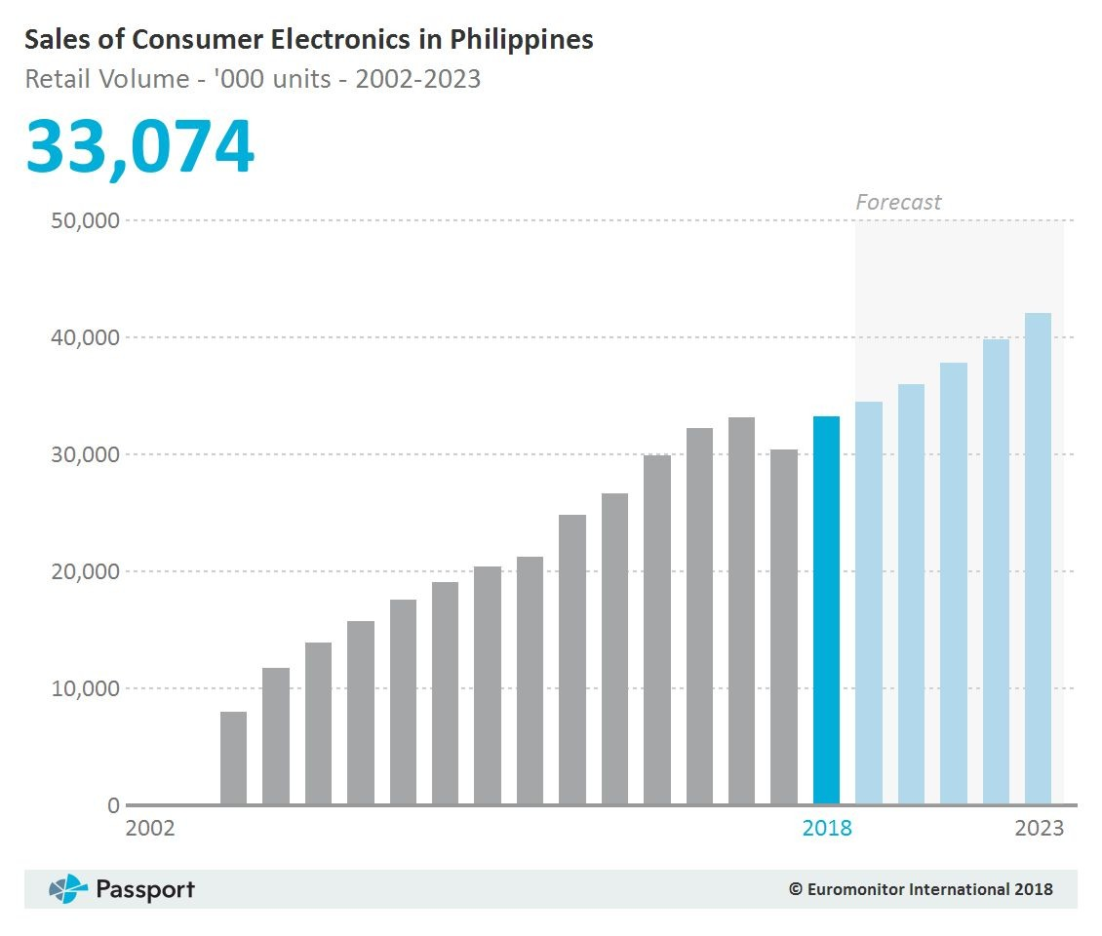

Figure 3. Sales of Consumer Electronics in Philippines (Volume). (Euromonitor, 2018)

VIII. Broader Societal Expectations

Recently, consumers are becoming influential in terms of ethical responsibility of companies across the supply chain. Social media becoming a tool for everyone to speak their minds to rally people of the same belief with them easily and influence people into supporting or boycotting certain organizations. Concerns by so called netizens are not limited to direct labor, sometimes people also question the choice of supplier if companies chooses suppliers that does not break ethical or moral codes, so sometimes up to the disposal part of the value chain.
As a retailer of consumer electronic goods, Digital Walker brings tons of electronic devices to the country. They however stops at the distribution of goods side to the consumer but fails to educate the market on the proper disposal of the goods that we sell. Electronic goods can be hazardous to the environment and needs to be properly disposed.
Module Three

IX. Company Overview

Digital Walker

Digital Walker is a fast growing gadgets retail chain located in different locations nationwide. It was founded by Charles Paw, an entrepreneur with love and passion about gadgets.

Leadership - President and CEO: Charles Paw

Charles’ success was built around passion, resiliency, community involvement, optimism, and his undeniably naturally gifted gut feel. He’s a low profile self made millionaire that loves engage communities and make them feel that they are heard and their opinions matters. Charles loves going to convention and personally selecting the products to be sold in his retail stores, his intentions are not only to sell these products to earn profits, but also for the community that he cherishes, and the Filipino to enjoy quality electronics and accessories products that normally could only be bought outside of the country.
Core Products

Digital Walker has a lot of products sold in their stores but is keeping several core products/brands that they sell the most. Those products are the following:
● Marshall - a european brand that flourished because of its traditional amplifiers used during band performances now entering the consumer electronics industry by producing headphones, and speakers.
● Fitbit - a popular fitness tracker device that monitors the wearers physical condition, especially during strenuous activities.
● Momax - a chinese brand known for producing mobile phone accessories such as cases, powerbanks, etc.
● OnePlus - Uprising smartphone known for its high spec, fast smartphones

● DJI - The first mover of the flying drone industry, known for its superior quality drones, not only in flight but also the video capture capabilities.
● Yeelight - Smart home automation, known for smart lights that are able to connect via wifi, and remotely controlled.
● There are many more products in Digital Walker, not limited to the list above.
Stores, Locations, and Employees
Digital Walker since its founding on 2005 already has 31 stores mostly located in Metro Manila, and a few stores located outside Metro, 1 in Nuvali (South Luzon), 2 in Cebu, and 2 in Mindanao.

# Digital Walker Stores City Region

1 Robinsons Ermita Manila City NCR

2 Alabang Town Center Muntinlupa City NCR

3 Estancia Pasig City NCR

4 SM Aura Taguig City NCR

5 VMall San Juan City NCR

6 Greenbelt 5 Makati City NCR

7 Powerplant Rockwell Makati City NCR

8 Glorietta 2 Makati City NCR

9 Century City Mall Makati City NCR

10 SM Mall of Asia Pasay City NCR

11 Conrad Pasay City NCR

12 Fisher Mall Quezon City NCR

13 Trinoma Quezon City NCR

14 Magnolia Quezon City NCR

15 UP Town Center Quezon City NCR

16 Gateway Quezon City NCR

17 Eastwood Mall Quezon City NCR

18 Robinsons Pioneer

19 Shangri-La Plaza

20 Podium
Mandaluyong
City NCR

Mandaluyong
City NCR

Mandaluyong
City NCR

21 Ayala 30th Pasig City NCR

22 Vertis North Quezon City NCR

23 SM North Edsa Quezon City NCR

24 Cloverleaf Quezon City NCR

25 One Bonifacio Taguig City NCR

26 Okada Pasay City NCR

27 Nuvali Laguna South Luzon

28 Centrio CDO Cagayan de Oro Mindanao

29 Abreeza Davao City Mindanao

30 SM Cebu Cebu City Visayas

31 Ayala Center Cebu Cebu City Visayas

Robinsons Galleria
32 Cebu Cebu City Visayas

Table 4. Digital Walker Store Locations

Digital Walker current has XX employees. The parent company Digits Trading Corporation takes care of the shared services such as Accounting, IT, HR, Merchandising, and Logistics, needed by Digital Walker to operate majority of their workforce are stores sales staff, retail support team, and their area managers.
X. Financial Statements and Financial Ratios

STATEMENT OF COMPREHENSIVE INCOME 2017 2016 2015

SALES 298,266,784.23 275,637,755.03 248,484,655.92

COST OF SALES 232,996,144.83 217,849,527.01 196,427,121.85

GROSS PROFIT (LOSS) 65,270,639.40 57,788,228.02 52,057,534.07

OPERATING EXPENSE 58,301,731.43 50,516,672.37 44,897,929.46

NET INCOME (LOSS) BEFORE INCOME TAX &
INTEREST EXPENSE 6,968,907.97 7,271,555.65 7,159,604.61

LESS: INTEREST EXPENSE 3,937,834.95 2,846,856.33 2,065,519.26

NET INCOME (LOSS) AFTER INTEREST
EXPENSE 3,031,073.02 4,424,699.32 5,094,085.35

LESS: PROVISION FOR INCOME TAX 1,449,623.87 1,627,480.69 2,065,519.26

NET INCOME (LOSS) 1,581,449.15 2,797,218.63 3,028,566.09

Table 5. Digital Walker Statement of Comprehensive Income (Digital Walker, 2018)

Balance Sheet 2017 2016 2015

Current Assets

Non Current Assets

Cash 10,528,947.70 13,227,215.57 14,811,956.03

Accounts
Receivable-Trade 31,830,711.68 30,015,431.00 27,871,074.75

Merchandise Inventory 11,785,842.90 14,521,072.25 8,383,666.93

Total Current Assets 54,145,502.28 57,763,718.82 51,066,697.71

Property & Equipment 8,863,000.44 7,962,682.08 2,830,071.41

Other Assets 21,687,315.14 17,660,589.21 15,904,448.74

Total Non Current Assets 30,550,315.58 25,623,271.29 18,734,520.15

Total Assets 84,695,817.86 83,386,990.11 69,801,217.86

Liabilities & Equity

Liabilities

Current Liabilities

Non-Current Liabilities

Accounts Payable-Trade 1,471,498.85 12,061,671.86 3,186,583.48

Income Tax Payable 190,797.85 186,710.01 48,798.98

Other current liabilities 574,909.03 461,445.26 235,891.05

Total Current Liabilities 2,237,205.73 12,709,827.13 3,471,273.51

Loan Payables 61,000,000.00 50,800,000.00 59,000,000.00

Total Non-current liabilities 61,000,000.00 50,800,000.00 59,000,000.00

Equity

Total Liabilities and

Share Capital 10,750,000.00 10,750,000.00 1,000,000.00

Cumulative Earnings 10,708,612.13 9,127,162.98 6,329,944.35

Total Equity 21,458,612.13 19,877,162.98 7,329,944.35
Equity 84,695,817.86 83,386,990.11 69,801,217.86

Table 6. Digital Walker Balanced Sheet (Digital Walker, 2018)

Financial Ratios 2017 2016 2015 S/W? Current Ratio 24.20 4.54 14.71 Strength Quick Ratio 18.93 3.40 12.30 Strength Long Term Debt to Equity 2.84 2.56 8.05 Weakness Inventory Turnover 25.31 18.98 29.64 Strength Total Assets Turnover 3.52 3.31 3.56 Strength
Accounts Receivable
Turnover 9.37 9.18 8.92 Strength Average Collection Period 38.95 39.75 40.94 Weakness Gross Profit Margin 0.219 0.210 0.209 Weakness Net Profit Margin 0.005 0.010 0.012 Weakness
Return on Total Assets
(ROA) 0.019 0.034 0.043 Weakness

Return on Equity (ROE) 0.074 0.141 0.413 Weakness

Table 7. Digital Walker Financial Ratios

Market Share

In the broad consumer electronics industry Digital Walker is just one of the many sellers / resellers, their current revenue is at 298 Million pesos, or approximately 300 Million pesos, the current market size of consumer electronics is at 385.658 Billion pesos. Digital Walker’s market share in the consumer electronics industry is only at 0.10%, not even close to 1%.

XI. Value Chain

Value Chain
Activities
Description Impact on Value Chain
Elements
Strength or
Weakness?

Primary Activities

Product
Selection
Digital Walker does not just bring in the known electronic brands to sell, their products are selected by the CEO himself and they choose products based on the current demand and on what they feel are going to be a hit in the Philippines.

They usually go to electronic conventions such as CES in the US, and other electronics expo in Germany, HK, and China.
Digital Walker’s product selection is based on the top management’s perception and gut feel. It works for now, but who knows if the same pattern will work in the future.

It seems like a gamble and going to be heavy in terms of cost to build brands that are not know in the country.
Weakness

Ordering Digital Walker’s retail operations support assists the business not only by providing sales analysis but also providing the ordering requirement per store to the merchandising department of the parent company for ordering overseas.
The ordering process is based on historical figures and does not involve any in depth analysis about the trends, season, forecast, etc. Most of the time the assessment of re ordering is based on quantity sold.
Weakness

Inbound
Logistics
Digital Walker relies on its mother company Digits Trading
Cost to operate should be minimal because of shared services setup.
Strength

Corporation to manage the importation of products from suppliers to our warehouses.

The mother company has multiple forwarding partners that allows them to

Warehouse
Operations
Another shared services that Digital Walker opts to maximize with its parents company. Warehouse operations are managed by the mother company,
Digits Trading
Corporation.
Digital Walker saves money to store products.
Strength

Outbound
Logistics
Another shared services that Digital Walker opts to maximize with its parents company. Logistics operations are managed by the mother company, Digits Trading Corporation.
Digital Walker has no control over deliveries and they are dependent on the service level of the parent company and they do not have
security if SLAs are not met because they are transacting with a
sister company
Weakness

Retail Brand and Advertising
Digital Walker has its own brand partner, that also manages individual product brands. Majority of the advertisements of Digital Walker are cascaded through social media.
Digital Walker does not have a dedicated group to study its market to help build and grow the brand by knowing its customers
Weakness

Sales Core of Digital Sales operations are Strength

Operations Walker’s own operations are from the sales operations team, they manage people from the store.

The physical store of Digital Walker is creatively retouched to appeal to its market.
focused on sales because most of the back end support work are provided by the parent company and the stores ambience is one of the best in the country

Service Digital Walker also relies on the head office returns merchandise team (RMA) to handle its after sales process, and warranty claims.
The warranty guidelines are straightforward and easily understood by stores staff because it is managed by a
dedicated team directly coordinating with suppliers
Strength

Support Activities

Human
Resources
Retail manpower of Digital Walker are mostly employed by manpower agencies.
It is a strategic move, however can be a target for regulatory agencies that addresses the cry of the nation regarding
contractualization. This also limits the
influence of management towards the culture of the people because by law, the contractual staff should not be managed by Digital Walker. Digital Walker also does not have
control over the quality of hires, it can only rely on the guarantee of
the agency.
Weakness

Information
Systems
Same as other department, the information systems part of Digital Walker is managed by the parent company, Digits Trading Corp.
Currently they use POS systems to monitor sales and inventory. However, the POS system is inconsistent in reflecting sales and inventory in the back end.
Automating the inventory management of stores, and sales transaction should decrease transaction time and cost. However, with the inconsistencies, it only incurs additional cost
to check for accuracy and parallel a manual transaction.
Weakness

Research and
Development
Digital Walker does not have a research and development department that looks
at the current trends of consumer electronics demands, and checks on potential profitable expansion areas
The leaders of the company are blinded from the opportunities that can be grabbed sooner and ahead of the competition or
save the business from sticking with products that are non moving
Weakness

Branch Expansion (Construction)
The construction team of Digital Walker is also a shared service
rendered by the parent company, all
expansion and construction projects are managed by this department
Digital Walker saves overhead cost by not directly hiring architects and engineers to manage their store constructions
Strength

Table 8. Digital Walker Value Chain

In summary, Digital Walker relies heavily on its parent company to do majority of the dirty work to have products that they can sell in their retail stores. It can save costs but restricts the Digital Walker leads in terms of direction, and overall control over the

retail chain’s way of operations, and restricts its movement in terms of growing the business.

XII. Summary of Strengths and Weaknesses

Strengths

● Liquidity - Because of its huge inventory and ability to sell fast, the company is liquid enough vs it’s current liabilities.
● Product Selection - the products that are available for purchase inside Digital Walker are imported goods from brands known to have superior quality.
● Shared services - this allows Digital Walker to save some money in terms by reducing a huge amount of fixed overhead and simply paying service fees
● Store coverage, Metro Manila - Digital Walker has a lot of stores to cover most of Metro Manila.
● Store Ambiance - the look and feel inside the store is very cozy and is suitable for gadget aficionados. People who wants to test devices are able to test demo units inside the store, each store are uniquely designed but with features that are distinct to Digital Walker.
Weaknesses

● Market Share - Digital Walker’s market share is a measly 0.10%

● Return on Asset (ROA) / Return on Equity (ROE) - Ratio is so low at less than 0.1. The company is not earning enough to get more from its invested assets
● Profit Margins - Companies profit margins are very low, gross margins are respectable at 20% but other expenses eat up the remaining margins that causes net profit margin to be just at 0.5%
● Store Coverage, Provincial (Outside Metro) - Digital Walker has low presence in other areas of Manila to cover different markets.
● Brand Awareness (Weak) - Because there are no dedicated team to look after the retailer’s brand, Digital Walker is less known by majority of the consumers in the Philippines.
● Business Model is Vulnerable (Retail / Importer) - The nature of business model can be disadvantageous because Digital Walker’s profitability reliant on the margins that the supplier will give, and very vulnerable to fluctuations of the exchange rate.
Assessment of Internal Factors - IFE

Key Internal Factors Weight Score

Weaknesses
Weighted
Score

Market Share - 0.10% 0.1 1 0.1

ROA / ROA - less than 0.1% 0.05 2 0.1

Profit Margins - Gross 20%, Net 0.5% 0.1 1 0.1

Provincial Coverage 0.1 1 0.1

Weak Brand Awareness (Retail Store) 0.1 1 0.1

Vulnerable Busines Model 0.1 1 0.1

Strengths

Liquidity 0.1 4 0.4

Product Selection (Wide range, quality) 0.1 4 0.4

Shared services 0.05 4 0.2

Store coverage (Manila) 0.1 4 0.4

Store ambiance (Experiential) 0.1 4 0.4

Total 1 2.4

Table 9. Digital Walker IFE Analysis

The IFE analysis of Digital Walker showed extreme ends results. The weaknesses are truly a major weakness, and strengths are major strengths. The result, an little below average score of 2.4. It only means that Digital Walker needs to address its weaknesses soon and capitalize on its strength before the weakness pulls the company down.

XIII. Personal Values of Key Implementers

One of the biggest item that the business needs to consider in suggesting, or implementing strategies is the behavior of the owner / CEO / President of the company, Charles Paw. Charles is very kind in nature and tends to avoid tension inside the meeting room, given his very kind nature, he usually agrees to what people suggests, and has the habit of saying yes most of the time, taking that into consideration, whenever someone from business suggests strategies, the story, and the journey of how to get there, the risks, and possible consequences of the recommendations should be well communicated and shared, so that Charles is well informed about the risks before making into a decision.

Module Four

XIV. Strategic Plan

Vision

● Core Purpose - Bring the best quality gadgets and accessories to the

Philippines for the Filipinos to enjoy.

● Core Ideologies

○ Values

■ Newest consumer technology and accessories

■ First to market

■ Particular to consumer’s gadget needs

■ Experiential Stores - Experience being walked into the future

■ Tech savvy staff

● Big Hairy Audacious Goal (BHAG) - to become the top of mind of Filipinos when it comes to consumer gadgets or accessories.
● Suggested Vision

“To become the top of mind technology store in the Philippines by delivering the best and newest gadgets and accessories in our stores for the Filipinos to try, buy, and enjoy.”
Current Corporate Strategies

Currently, Digital Walker does not have a concrete strategy plan, top of mind action items that were shared by the CEO and other executives are just to

remove non performing brands and expansion of stores which has no basis. This puts the myself, as the researcher in a good position to propose strategies that has a basis of study.
BCG Matrix

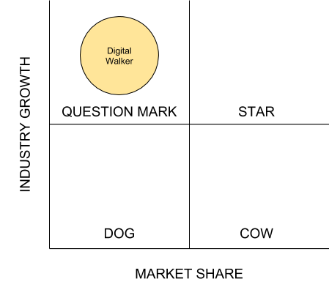

Figure 4. Digital Walker BCG Matrix

Currently, Digital Walker is in the Question Mark portion of the BCG Matrix. Ideally, we as a company would want to move somewhere where we have a portion of the market share. Since Digital Walker is involved in the fast growing consumer electronics industry, it will never be a cow or dog unless it

decides to shift industries. This can be a basis of our corporate strategies later in this document.
Objectives

● Financial

○ Increase the total revenue by 20% per year in 5 years (P746 Million

Pesos).

○ Increase the revenue of each store by 5% per year in 5 years

● Strategic

○ Hit at least a total of 0.20% of Market share in the next 5 years.

○ Double the number of stores after 5 years (61 stores).

○ Improve the brand awareness of Digital Walker, become one of the top 5 searches when searching about gadgets and accessories in the Philippines in 5 years.
● Social

○ Incorporate proper e-waste disposal in company value chain by disposing 100% of all e-wastes in proper disposal channels annually.
Proposed Corporate Strategies

To determine the best strategy suitable for Digital Walker, I have resorted to several frameworks that makes use of the company’s strength, weaknesses, and external situations as basis and avoid subjectivity in the selection, and baseless propositions.

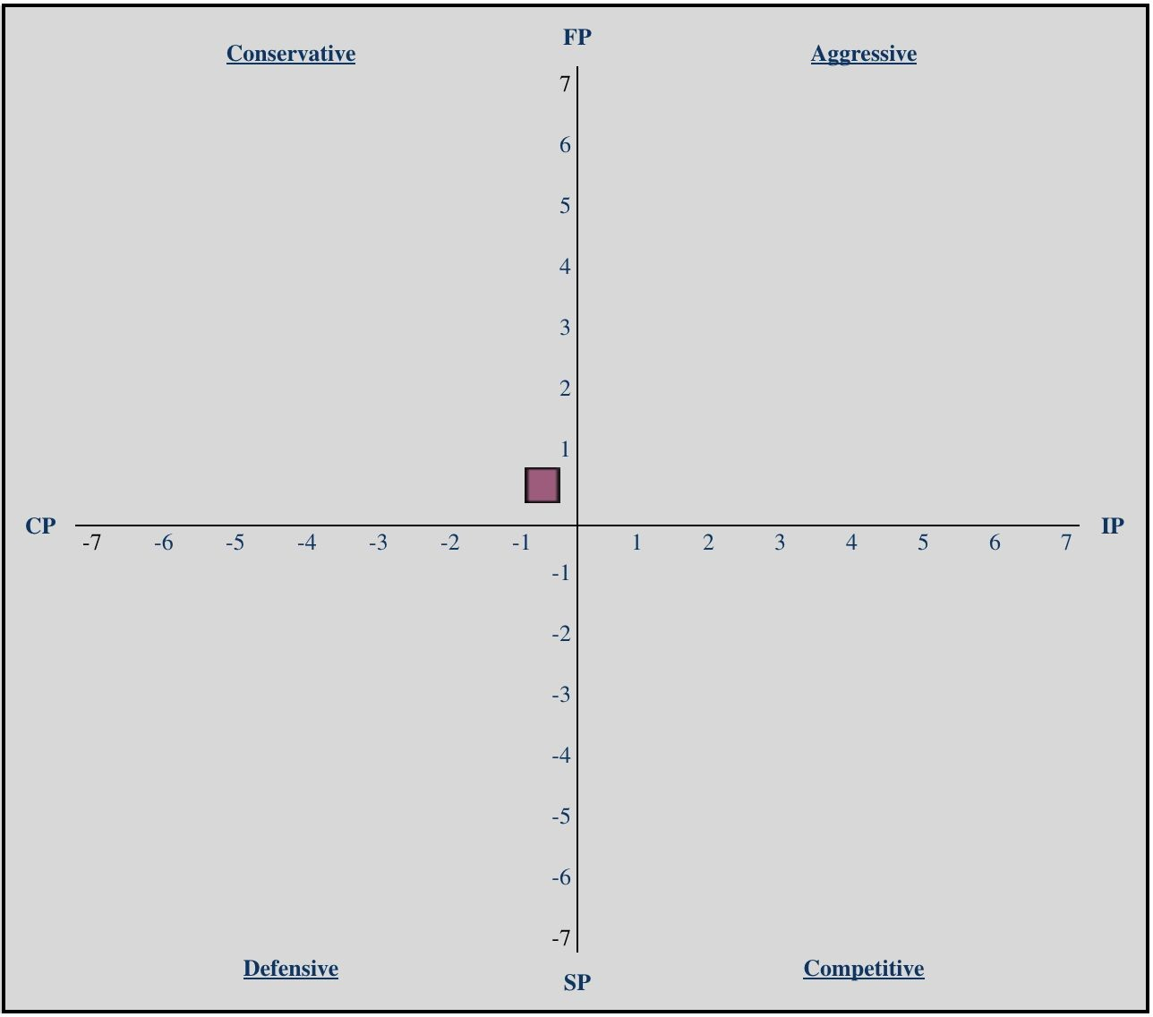Space Matrix

X-axis -0.2
Y-axis 0.2
Figure 5. Digital Walker Space Matrix

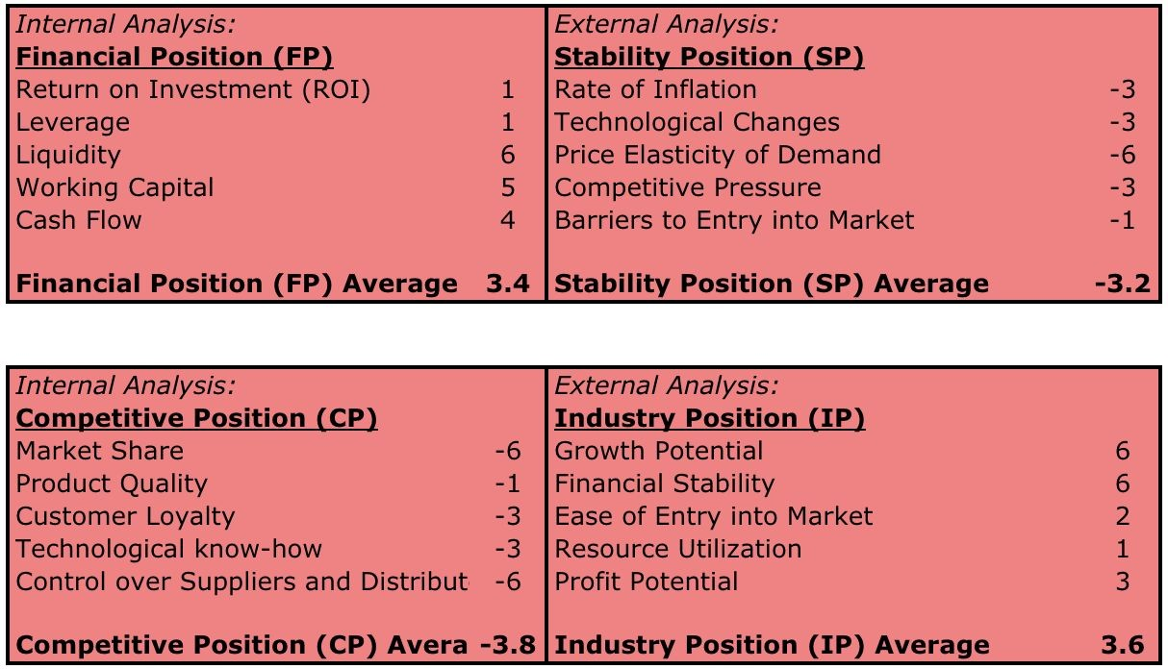

Figure 6. Digital Walker Space Matrix Assessment per Quadrant

Suggested Strategies of SPACE Matrix Conservative Quadrant

Digital Walker fell into conservative Quadrant of the SPACE Matrix, despite not having good profitability, the quick selling portion of their financial position proved to be slightly higher than the stability position. Their lackluster performance in versus the competition are clearly evident in the horizontal axis as the competitive position pulls the numbers to the conservative quadrant of the matrix. This means that the behavior of the firm in the industry should follow either of the suggested following suggested strategies:
● Market Development

● Market Penetration

● Product Development

● Horizontal Integration

● Divestiture

● Liquidation

These are a lot of strategies that were suggested strategies by the Space Matrix, to effective evaluate and choose the right strategies for Digital Walker, I will use the Quantitative Strategic Planning Matrix (QSPM). Before we start with the evaluation, there are a couple of strategies that I have taken out of consideration for Digital Walker, these are:
● Product Development - because the actual product of the company is the retail store itself, and there are no study yet if the branding is the problem or the ambience of the store, that is actually already a strength of the company and needs no drastic changes. Brand awareness is a problem but does not call for a revamp of the store. In terms of the products that Digital Walker sell, it is not static, and dynamic in depending on what is new and what the consumer demands and Digital Walker does not produce these products and simply imports them.
● Horizontal Integration - Managing its own brand is already challenging for Digital Walker, it gets assistance from the parent company and if we take it into consideration, the entire conglomerate already operates a lot of retail brand that operates in the same industry. The major issues of Digital Walker is its profitability and brand awareness, in addition, Digital Walker

does not have the financial capacity to acquire other firms as of the moment.
Going back to evaluating the remaining strategies, here’s the results of the

QSPM evaluation (Results are split into two tables but evaluated as one):

QSPM Market Development Market Penetration

Threats

Key External Factors Weight AS Score

Weighted
Score

AS Score

Weighted
Score

Inaction of government agencies 0.05 4 0.2 4 0.2

Economic, increasing exchange rate

(low peso value)
0.2 2 0.4 2 0.4

Legal, TRAIN LAW 0.1 4 0.4 4 0.4

Higher bargaining power of supplier 0.1 4 0.4 4 0.4

Technology, FINTECH reduces risk
of online shopping, reduce traffic of brick and mortar
Threat of Substitute - Alternative sales channel, online
0.05 4 0.2 4 0.2

0.05 4 0.2 4 0.2

Opportunities

Political, President's political will, increase middle class earners

Economic, forecasted recovery of inflation rate

Environmental, increasing demand for responsible e-waste disposal

Strong rivalry between industry competitors
Technology, FINTECH decreases the number of unbanked, increases the number of customers

0.05 4 0.2 4 0.2

0.1 4 0.4 4 0.4

0.1 2 0.2 2 0.2

0.1 2 0.2 2 0.2

0.05 4 0.2 4 0.2

High barrier to new entrants 0.05 4 0.2 4 0.2

Total External 1 3.2 3.2

Key Internal Factors Weight Score

Weaknesses
Weighted
Score

Score
Weighted
Score

Market Share - 0.10% 0.1 4 0.4 4 0.4

ROA / ROA - less than 0.1% 0.1 4 0.4 4 0.4

Profit Margins - Gross 20%, Net

0.5%
0.1 2 0.2 2 0.2

Provincial Coverage 0.1 4 0.4 1 0.1

Weak Brand Awareness (Retail

Store)
0.1 3 0.3 4 0.4

Vulnerable Busines Model 0.1 2 0.2 2 0.2

Strengths

Liquidity 0.1 3 0.3 3 0.3

Product Selection (Wide range,

quality)
0.1 4 0.4 4 0.4

Shared services 0.05 4 0.2 4 0.2

Store coverage (Manila) 0.05 1 0.05 4 0.2

Store ambiance (Experiential) 0.1 4 0.4 4 0.4

Total Internal 1 3.25 3.2

Total QSPM Score (AS Score) 2 6.45 6.4
Table 10. QSPM for Market Dev and Market Pen

QSPM Divestiture Liquidation

Threats

Key External Factors Weight AS Score

Weighted
Score

AS Score

Weighted
Score

Inaction of government agencies 0.05 2 0.1 2 0.1

Economic, increasing exchange rate

(low peso value)
0.2 2 0.4 4 0.8

Legal, TRAIN LAW 0.1 3 0.3 3 0.3

Higher bargaining power of supplier 0.1 1 0.1 1 0.1

Technology, FINTECH reduces risk
of online shopping, reduce traffic of brick and mortar
0.05 1 0.05 1 0.05

Threat of Substitute - Alternative sales channel, online

0.05 1 0.05 1 0.05

Opportunities

Political, President's political will, increase middle class earners

Economic, forecasted recovery of inflation rate

Environmental, increasing demand for responsible e-waste disposal

Strong rivalry between industry competitors
Technology, FINTECH decreases the number of unbanked, increases the number of customers

0.05 4 0.2 4 0.2

0.1 4 0.4 2 0.2

0.1 2 0.2 4 0.4

0.1 3 0.3 4 0.4

0.05 4 0.2 1 0.05

High barrier to new entrants 0.05 4 0.2 1 0.05

Total External 1 2.5 2.7

Key Internal Factors Weight Score

Weaknesses
Weighted
Score

Score
Weighted
Score

Market Share - 0.10% 0.1 1 0.1 1 0.1

ROA / ROA - less than 0.1% 0.1 1 0.1 1 0.1

Profit Margins - Gross 20%, Net

0.5%
0.1 1 0.1 1 0.1

Provincial Coverage 0.1 4 0.4 1 0.1

Weak Brand Awareness (Retail

Store)
0.1 2 0.2 1 0.1

Vulnerable Business Model 0.1 1 0.1 1 0.1

Strengths

Liquidity 0.1 4 0.4 4 0.4

Product Selection (Wide range,

quality)
0.1 4 0.4 1 0.1

Shared services 0.05 4 0.2 1 0.05

Store coverage (Manila) 0.05 3 0.15 1 0.05

Store ambiance (Experiential) 0.1 4 0.4 4 0.4

Total Internal 1 2.55 1.6

Total QSPM Score (AS Score) 2 5.05 4.3
Table 11. QSPM for Divestiture and Liquidity

Based on the QSPM, the strategy that got the highest score is Market Development with 6.45, and closely behind is Market Penetration at 6.4, the scores of Divestiture, and Liquidity are 5.05, and 4.03 respectively.
It is clear based on the results of the QSPM that Digital Walker should prioritize strategies that would improve its market standing. It is not necessary that Market Development is our only choice of strategy because it got the highest score, Market Penetration is relatively close and might be a viable strategy for the company. Given the close results of market development, and market penetration, it is ideal for Digital Walker to have both development and penetration strategies nationwide.
Looking at the figures from Divestiture and Liquidity, it made sense for those two to get low scores because Digital Walker does not have enough leverage for potential buyers(Liquidity), or potential franchisees (Divestiture) most probably because of its low profitability, weak brand equity, and low market share. Although, amongst the two low scores, Divestiture still got a score higher than 5, maybe because it is also a feasible strategy to bring down cost and improve profitability of the business, once the two high scoring strategies, Market Penetration and Development, improves the state of the company to be able to pursue potential franchisees.

Corporate Strategies and Objectives

To summarize, the proposed strategies for Digital Walker are the following:

1. Market Development

Definition:

Digital Walker should expand its reach nationwide and improve its customer base. There’s still a lot of untapped market outside of Metro Manila that could improve the company’s sales and brand equity in the entire country.
Objectives:

a. Increase the number of additional stores in new areas by 30 stores after 5 years.
b. Earn P12 Million per additional store per year at end of 5 years, total of P360 Million per year from the 30 additional stores .
c. Become at least top 5 searched company for gadgets and accessories in the new locations after 5 years.
2. Market Penetration

Definition:

Encourage the current market and reach of Digital Walker to buy more, or improve the trust of people towards the Digital Walker store brand. Digital Walker might already be present in desirable areas within the Metro but still needs to improve its awareness so that people will come to Digital Walker and buy.

Objectives:

a. Improving brand awareness by become at least top 5 searched company for gadgets and accessories in current locations after 5 years.
b. Improve sales of each existing stores from average of P9 Million to

P13 Million per store per year at end of 5 years, total of P403

Million per year from the 31 existing stores .

3. Divestiture, Franchising

Definition:

In parallel with the other two strategies, or after implementing the market strategies, Digital Walker could improve its sales and profitability by selling franchises in areas outside of their current reach. This will help Digital Walker develop markets with lesser risk in terms of cost as the burden of capital is passed to the franchisee.
Objective:

a. Reduce the cost of capital of putting up new stores by acquiring franchisees for 33% of planned store expansion (10 stores, approx. P8 Million per store)

These strategies are perfect for a company that has less financial standing. It might not yet bring Digital Walker to become a star in the BCG

matrix, but it will allow the company to move an inch closer towards that direction.

Competitive Advantage

Porter’s Competitive Advantage Matrix

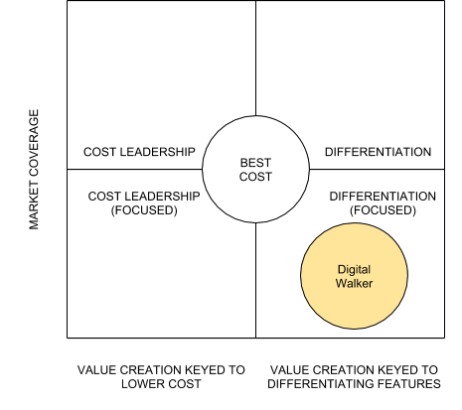

Figure . Digital Walker BCG Matrix

Current and Proposed Competitive Advantage

At present, Digital Walker is enjoying an advantage the focused differentiation, Digital Walker’s prices are not too low, and given the nature of the business model that prices and margins are controlled by the suppliers, Digital Walker will not be able to compete in terms of pricing, because if they attempt to

further lower their cost, it will mean lower profits than what they already have now, which is very low.
I am suggesting for Digital Walker to continue differentiating itself amongst other retailers and focus on its current market given its financial situation. Digital Walker revolutionizes retailing in the country by allowing its customers to experience using the products prior to purchase, this can be copied by the competition, but Digital Walker’s ambience allows users to enjoy these gadgets in a fun and cool environment, contrary to the traditional brick and mortar stores.

XV. References

Corbett, T. (2018). The Top Five Trends Defining Consumer Electronics in 2018.
Retrieved from: https://www.channelsight.com/the-top-five-trends-defining-consumer-elec tronics-in-2018/

Euromonitor International. (2018, August). Consumer Electronics in the
Philippines. Retrieved from https://www.euromonitor.com

Trading Economics. (2018, October). Philippine Peso - Forecast. Retrieved from https://tradingeconomics.com/philippines/currency/forecast

Trading Economics. (2018, October). Philippines Inflation Rate - Forecast.
Retrieved from https://tradingeconomics.com/philippines/inflation-cpi/forecast

Chin, C. (2018, April). It's time for more fintech in the Philippines. Retrieved from https://www.rappler.com/thought-leaders/199315-time-more-fintech-philip pines

Mayuga, J. (2017, December). No solution in sight for e-waste problem.
Retrieved from https://businessmirror.com.ph/no-solution-in-sight-for-e-waste-problem/

Dela Paz, C. (2018, January). How the tax reform law affects Filipino consumers.
Retrieved from https://www.rappler.com/newsbreak/iq/193170-train-tax-reform-law-effect
s-filipino-consumers-workers

Digital Walker. (2018, April). 2017 Digital Walker Financial Statements. Cubao, QC.

Digital Walker. (2017, April). 2016 Digital Walker Financial Statements. Cubao, QC.

