Media and Information Literacy
Interviewee #1

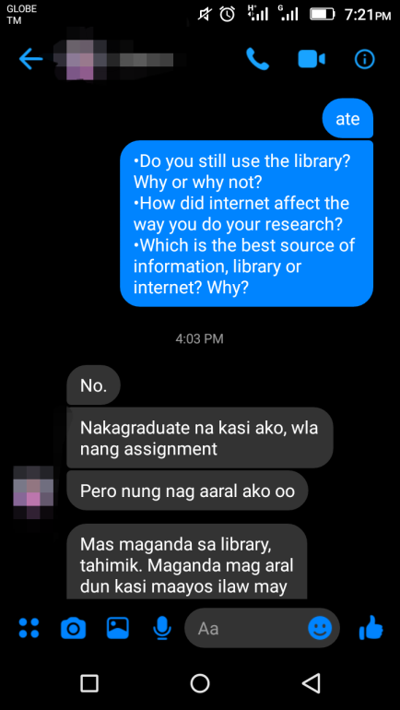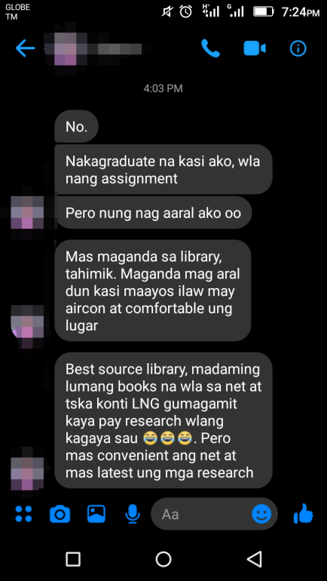

Interviewee #2

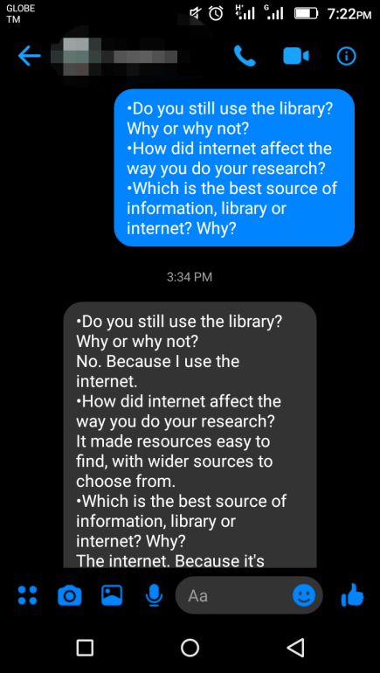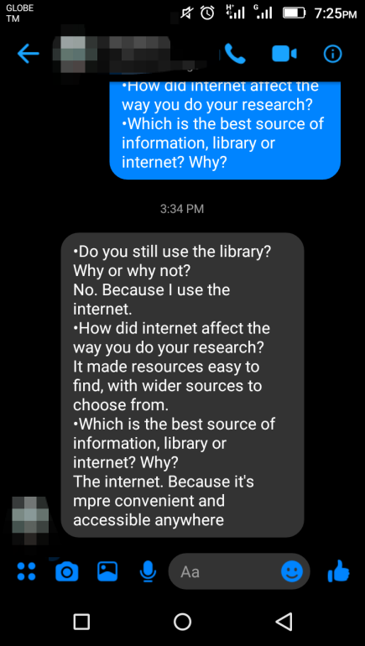

Interviewee #3

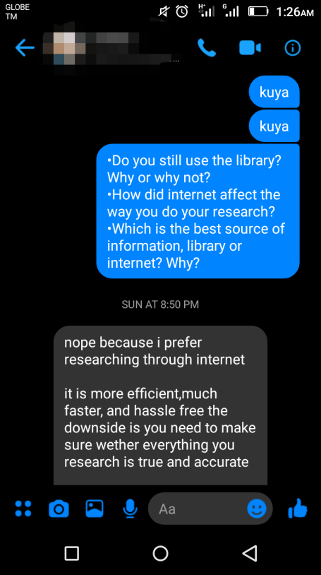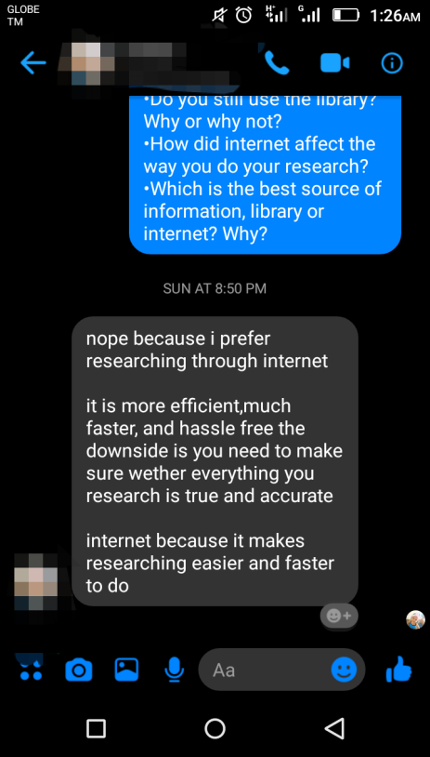

Submitted by: Adolf Jonnel F. Villaverde
11 – St. John Paul II

Submitted to: Mrs.Myla Logatoc

