it is very important to follow certain rules and display your superpowers in your resume effectively. I am going to share 5 tips that are followed by most of the recruiters. If you follow step by step instructions mentioned below, your chances of getting an interview call will increase multiple times.
- Keywords related to a job position: Every job position has specific keywords associated it. These keywords are mentioned in the job description. For example, communication skills, client experience, ability to code etc. While reviewing resume, recruiters make sure that they see these keywords AT FIRST GLANCE. If your resume don’t mention these keywords, your resume will surely be rejected.
How should I overcome this challenge? Good news is that there is an easy way to overcome this problem.
  - First, review job description closely and identify 10–15 prime keywords.
  - Now, modify your resume and make sure you include these keywords in your past experiences.
  - Finally, make these keywords BOLD, it will catch recruiters attention immediately. Don’t ignore this point, it is very important. See in below example, candidate has highlighted important keywords.
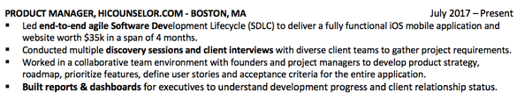
- Consistent story: Your resume should be telling a consistent story throughout. If a job position is related to Software Engineering, then your past experience and passion should talk about Software Engineering only. If you show that you did Marketing in previous job and now you are applying for Software Engineering, then you are preparing yourself for rejection. I would recommend not to show irrelevant past experience until and unless it is unavoidable.
- Use action verbs: Recruiters love action verbs. Yes, this is a secret that nobody will tell you. Whenever I review a resume, I want to see good use of action verbs. It helps me understand candidate’s experience better. Also, it is quick to read. As I mentioned earlier, time is super critical for recruiters. If you use tough or irrelevant language, you will piss-off recruiter and hence your chances of getting an interview call. Here is the list of action verbs, feel free to use it.
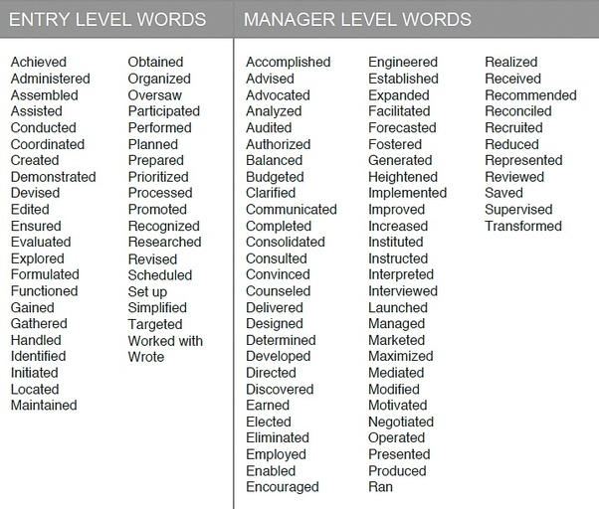
- Timeline in chronological order: If you successfully manage above three steps, now as a recruiter I would like to understand your journey so far. That means I want to see when did you complete your studies and when you started your job. I would highly recommend you to follow chronological order in your resume. That means you should mention your most recent experience at the top and then past experiences. Again the idea is to make recruiter’s life comfortable. If you cleanly display timeline on the right side of your resume, you will be way ahead than all other applicants.
- Quantify your achievements: Another way to impress a recruiter is to use numbers in your resume. What does it mean? Well, you have to provide straight facts in your prior experiences. Instead of saying “I helped my company make profit”, you should write “I created 3 new tools that helped my company save 20% cost”. Now, whenever you make resume, make sure you review every line and identify if there is any way you can mention numbers.
- Follow correct template: There are different templates for both entry-level and experienced positions. As a recruiter, I feel amazing when I see correct template at first glance. I feel like my journey of reviewing resume would be easy now. As per my experience and conversation with many other recruiters, here are the two templates that you can always use to impress recruiters and hiring managers.
  - Resume format for candidates without experience: If you are fresh out of college and applying for entry-level positions, you should focus on highlighting your internship experience, extra-curricular activities and skills. Here is the perfect format for freshers.
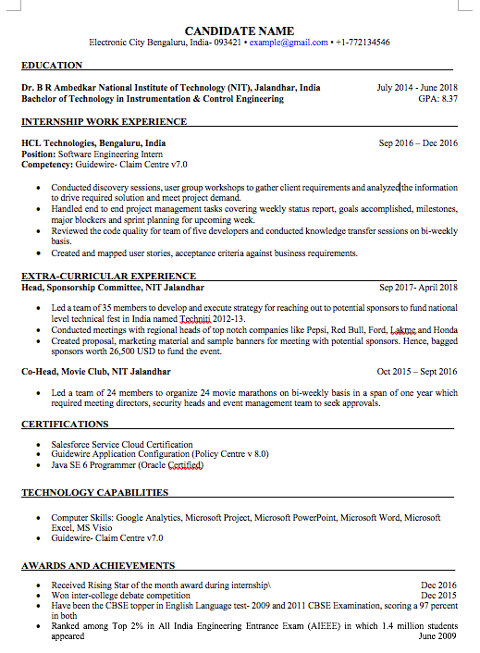
  - Resume format for experienced candidates: As a recruiter, I would like to see your actions and activities in previous job roles. If possible, highlight your leadership and team skills. Also, if you have done any innovation, it will be a great bonus. Please use this resume when you apply next time for experienced positions:
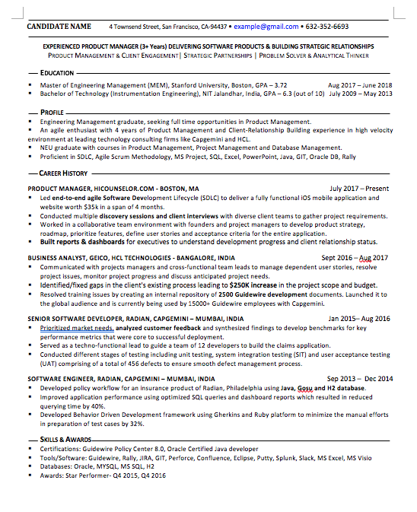
I meet candidates every other day and I see them struggling to get interview calls. Trust me it is not that tough. If you follow right resume structure and approach recruiter with prepared mindset, you can easily crack your dream job. Next time when you apply for any job position, use tricks that I have mentioned above and you will ace any interview.

