
Republic of the Philippines

Department of Education
Region XII
B.E.S.T. College of Polomolok Inc.
Tel. No. (083) 5002258

A DOCUMENTARY REPORT OF WORK IMMERSION
UNDERTAKEN AT B.E.S.T. COLLEGE OF POLOMOLOK INC.

Presented to Senior High School Department
B.E.S.T. College of Polomolok Inc.
Valencia Site, Polomolok South Cotabato

In Partial Fulfillment of the Requirement of
Work Immersion, Technical Vocational Livelihood Track
Information and Communication Technology

Reywell Sumalpong
MARCH 2019

ACKNOWLEDGMENT

To the teachers, I would like to thanks for their support, guidance, encouragement and inspirational advice.
To T. Clydell Adventijado, researchers adviser, for the untiring guidance, undying support and kindness in sharing her time and expertise and providing many suggestions for the concept of this study;
To the parents, thank you for being a good and supportive parents of me and for being my side and guiding me always, and for helping me out with expresses during my immersion and for their never ending love and strong support financially, physically, emotionally and most of all spiritually and for the advices the researcher had received;
Above all, the greatest contributor of this study, Almighty Father, Lord Jesus Christ for the knowledge and wisdom He has given to the researcher, for the family, friends and lovable adviser and panel of examiners that He has chosen to be their companion and for the infinite blessings every day the researchers have accepted, guidance and protection.

Table of Content
Introduction
Objectives of work immersion………………………………………………………….2
Duration and Place of work immersion……………………………………………….4
Training Area
History………………………………………………………………………………………5
Mission……………………………………………………………………………………..5
Vision……………………………………………………………………………………….5
Organizational Chart/Structure………………………………………………………..6
Company Rules and Regulation………………………………………………………6
Training Experience
Journal (activities performed)………………………………………………………….7
Observation and Insight………………………………………………………………..10
Overall Reflection and Appraisal……………………………………………………..11
Appendices
Resume & Application letter
Brgy. Clearance
Police Clearance
Mayor’s Certificate
Medical Certification
DTR (daily time Record)
Certificate of Completion
Evaluation Sheet
Documentation

INTRODUCTION
Work Immersion is one of the course requirements for graduation. A SeniorHigh School student has to undergo work immersion in a businessorganization/establishment whose work requirements are related to thespecialization. Through this work immersion, the students are exposed to andbecome familiarized with work-related environment related to their field ofspecialization.
“Work immersion is a key feature in the senior high school curriculum.
It can be conducted in different ways depending on the purposes and needs of the
learners,”
and to enable students to becomefamiliar with the workplace, experience workplace simulation and apply theircompetencies in areas of specialization.
“Work immersion will help develop among learners life and career skills, andwill prepare them to make decisions on postsecondary education or employment,”the guidelines read.“Through partnership building, DepEd hopes that partner
institutions will provide learners with work immersion opportunities, workplace orhands-
on experience, and additional learning resources,” it added.
The agency saidschools may partner with recognized institutions or organizations to come up withagreements on work immersion for students. As the students are still minors, DepEdsaid work immersion requires parental consent.the different government institutions involved in education,and Congress have since made K to 12 a reality rather than a mere ideal. As I looked over the paradigm created by the steering committee of the K to12 reform program, however, I suddenly realized that we had overlooked a majorgap in the system.The curriculum has been reengineered from pre-school to tertiary generaleducation. It is now seamless, without disruptions caused previously bytrifocalization and bureaucratic structures. We have firmly agreed on what studentsshould know and be able to do after 12 years of basic education or more (if they goto college).
What is missing is a clear idea of what the term “Immersion” implies.
In the approved latest draft of the Senior High School (SHS) curriculum,students that choose to take the Technical-Vocational-Livelihood are expected to spend 80 to 120 hours, doing
“Immersion.”

OBJECTIVES OF THE WORK IMMERSION
One of the goals of the K to 12 Basic Education Program is to develop inlearners the competencies, work ethic, and values relevant to pursuing furthereducation and/or joining the world of work. To achieve greater congruence between
basic education and the nation’s development targets, Work Immersion, a required
subject, has been incorporated into the curriculum. This subject will provide learnerswith opportunities:
1.To become familiar with the work place;
2.For employment simulation;
3.To apply their competencies in areas of specialization/applied subjects inauthentic work environments.To achieve the above objectives, Work Immersion is thus a requirement forgraduation from secondary education. Learners are immersed in actual workenvironments such as workshops offices and laboratories in which their prior trainingis relevant.
Work immersion will help develop among the learner’s life and career skills,
and will prepare them to make decisions on postsecondary education oremployment. Through partnership building, DepEd hopes that the Partner Institutionswill provide learners with work immersion opportunities, workplace or hands-onexperience, and additional learning resources. It aims to make the learners:
1. Appreciate the importance and application of the principles and theorieslearned in school;
2. Enhance their technical knowledge and skills;
3. Enrich their skills in communications and human relations; and
4. Develop good work habits, attitudes, appreciation and respect for work.By the time learners reach Senior High School, they would have alreadyacquired almost all the competencies and skills that would prepare them for thecurriculum exits (higher education, employment, middle-skills development, andentrepreneurship). Work immersion provides them with an avenue to test themselvesand apply what they have learned in a non-school scenario. In work immersion,learners are not only able to apply their previous training but are also able toexperience the social interactions in a work environment. Their experiences duringwork immersion will develop many skills and values that would help them as theytransition from high school to real life. To assure the achievement of the aboveobjectives of Work Immersion, this policy serves to guide schools in:
1. Creating flexible work immersion arrangements for their learners;
2.Providing options for work immersion that are relevant to learners’ purposes
and needs;
3. Organizing work immersion opportunities for learners that are consistentwith the diverse human resource requirements of partner institutions forwork immersion; and
4. Articulating the scope and limits of work immersion in the context of basiceducation when building relationships with work immersion partners.

Duration and Place of Work Immersion
A healthy workplace environment is ideal when it comes to maintaining a positive outcome in a stressful atmosphere. The most important thing that influences employee motivation and happiness, and how productive and efficient they can be, all goes down to their working environment. (Heryati R,2017)
The B.E.S.T College of Polomolok was built in the year 1995. The said school was offering Tertiary and K-12 Programs. B.E.S.T Polomolok is an institution accredited by TESDA that offers Technical and Vocational Education and Training Programs (TVET) under the Technical Education and Skills Development Authority (TESDA) and the Commission on Higher Education (CHED).
The said Institution can be found at Purok Sagrado Valencia site, Polomolok, South Cotabato. Since we started having a work immersion here, the experience and learnings that we learned with in that weeks is so remarkable and we can say that our 80-160 hours of working is worth it.

History

Training Area
Every company, institutions or school has it’s History. The B.E.S.T College of Polomolok was build in the year 1995. It was owned by the Ramos Family. The first location of the B.E.S.T school is along the national highway there was only few rooms . As the year’s passed by the said school was offering a tertiary and K-12 programs. The B.E.S.T College of Polomolok is the only school in the Polomolok that offers TESDA.
School’s Vision
The B.E.S.T College of Polomolok envisions a just truthful and enlighten society where everyone has equal rights in the full development of his/her mind and character in the service of God, nation and fellow person.
School’s Mission
To provide excellent and effective education that is always accessible and always available and valuable.

Goals
To offer the highest standard courses in basic tertiary and technical vocational that secures abundant life for everyone.
To transform the intellect and skills values and aspirations equipping him/her for the future
Organizational Structure
This is the organizational structure of the B.E.S.T College of Polomolok indicated in the next page.
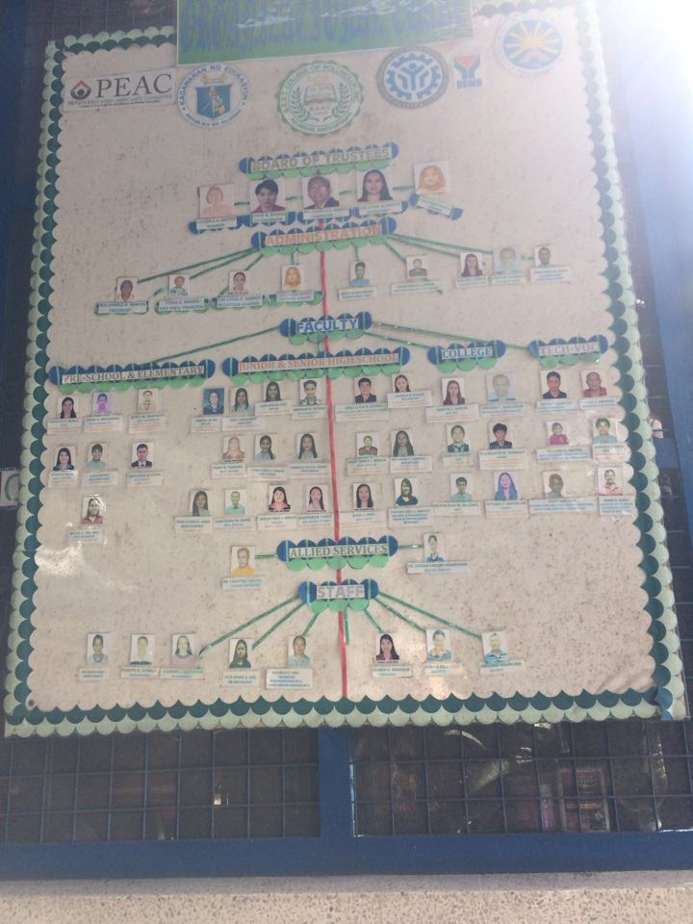

The Training Experience

MY JOURNAL
November 05, 2018
Our First day in B.E.S.T Polomolok as work immersion trainees at exactly 08:00am we started our orientation at the Computer Laboratory Office together with our work immersion head trainer Mr. Ronald Cedava the assigned teachers in School and the one who is assigned to evaluate our works and behavior inside the School. He discussed about the rules and regulation of the school and how their day goes while they are on work.

November 06, 2018
In this day we started the morning with a prayer and afterwards our trainer explained to us what kind of task we will do, and he assigned us to teach the other students that gonna assest here.

November 07, 2018
Sir ronald cedava assign me This day to teach the students from PNHS (Polomolok National Highschool) has come to BEST of College Polomolok to start their training for NCII and we teach To how install the windows 7 And connect Client to server to make a Internet and others

November 08, 2018
Sir Ronald Cedava assigned us and my co-immersion to assist the students from PPNHS about the formatting, installing windows and how to connect to internet.

November 09, 2018
Sir ronald cedava request to transfer the computer and other equipments to the other computer lab.To other students Can transfer to the other classroom.

November 12, 2018
Me and co-immersions helped encoding the documents of the students that training to our school from PNHS (Polomolok National Highschool)

November 13, 2018
Me and co-immersions teach them all of the lesson and process the past lessons because the next day is their assessment.
November 14, 2018
In this day We just observed and guard the students from PNHS (Polomolok National Highschool ) for their assessment.
November 15, 2018
Sir ronald cedava is giving me and co-immersions another task but this task is the same as he gave me in past days , another encoding but now it was easy because we know what to do and what strategy will do to finish our work faster. me and my 2 classmates make sure that we finished it and arranged in the proper place.
November 16 2018
in this day me and co-immersions helped the students in polomolok national high school to arranged properly the system unit and patch panel

November 19-23 2018
In this week is our last work in immersion is so intense its so many request from sir ronald cedava to help the satsun co-immersions and to arrange the computers and move to other room and cleaning the computer, formatting the computer, installing the os, installing some software, making wifi in networking and others
OBSERVATION AND INSIGHTS

As a student, empirical observation and acquision of knowledge are the first step of the learning process. In our work immersion, I observed a lot and gained a lot of insight in this activity, although in a short distant amount of time, bigger learning were acquired in this activity.
As what we have observed during our work immersion if you entered the computer laboratory you must be prepared not only the materials that we use, but also we prepared ourselves to have a self-confidence.
During our immersion I observed a lot of things. I observed that being a teacher is not easy. You have to follow the rules inside the school or in your workplace. Being a teacher is so busy because you have to follow the deadlines on checking your papers. We also observe that you need to interview the patients and ask her personal information in a serious way, and you must do your duty to take care the patients. We observe that you still to interview them in a nice way even if sometimes the patients are not in the mood.
I’ve learned a lot of things in doing our work immersion at B.E.S.T College of Polomlok, I learn on how to register and encode the name of the students in TESDA. I also learn on how to the computers step by step, I also learn to discipline my self during in work hours. It’s an honor to us to have the chance to experience and learned a lot of things, even though it is just a On the Job Training (OJT) we still gained a lot of learning.

Overall Reflection and Self Appraisal

Accomplishing this work immersion program of the K to 12 Curriculum for the Senior High School students was fulfilling and a fun activity to do. Being part of this program is an achievement to us students because we have the chance to experience a lot of things. There are many things in this work immersion program that is unforgettable, memorable and can be useful thing in our future.
First thing is the experience that we acquired in this program. They say experience is the best teacher, I might say, yes indeed! It was a great roller coaster ride with a lot of struggles and hard work with a fruitful learning. It was a great experience, you will conquer your fear, and you will learn a lot of things.
Second thing was the transformation and development that I attained during the work immersion. Learning to come early in the work place was very important because you need to prepare the things that you need to use during working hours and for you to prepare yourself so you can be presentable. My verbal skills were also developed back then in our work place, because in the real life industry, you must be confident enough to talk and communicate with other people. And I also developed finishing my task as early as possible as you can avoid delay and to have a good performance in the workplace.
After a few weeks of immersion, I also realized some things that will really be useful for my future. First, panctuality is very essential because in this simple way you know how to be serious to your job, next would be the patience. Patience when it comes to the tasks that they’re going to give you, as well as the time that you’re just waiting for the next tasks that will be given to you, even if you already got bored waiting for nothing. And lastly, always poses a good attitude. Because positivity is next to tranquility
Work immersion help me to face my fear, conquer my fear, it also help me to boost my self-confidence. It helps me to realize everything

