How to Revive Dead/HARD Brick Karbonn A9+/CM Flare
NOTE: THIS TUTORIAL IS ONLY INTENDED FOR BRICKED DEVICES, AND DO THIS AT YOUR OWN RISK

DO THIS AT YOUR OWN RISK!!! This may void your warranty, cause you will open your phone! In this tutorial you need a karbonn a9+/cm flare that’s already dead! Means that the phone doesn’t detect by pc, No power, or Detected but in Qualcomm HS-USB QDloader 9008 mode!!! This method revive my CM Flare, It died (no power/not detected by PC) when I try to update it from ICS to JB for testing purposes! I recover it using this method! And success I did it 2 times! Thanks to Google for searching the Chinese site and translating it! HEHEHE! And also thanks to the developer (Sorry I forgot your name) and his tutorial for upgrading ICS to JB. Now lets get started!
Things you need:
Dead/Brick Karbonn a9+/CM Flare of course
2 clips or anything you might need to press the vol – and power button
Any phone battery soldered with 2 aligator clips for positive and negative! Or your battery if you want to mess it up! mine is 3.7v 1650mah full charge.
1 wire with alligator clip for ground
Your usb cable
Software:
QPST.2.7.374
Driver for ICS and JB
flare repair files
BP firmware
EMMC_DownLoad_V1.2.4
QUALFAST2.0.5
Qualcomm_Modem_Tools V1.1.2
Stock JB Rom v31
jelly flare root (not my tool, I just rename the folder) for rooting..
And supper plenty of PATIENCE………
Lets get started:
First Install and extract all the softwares, open device manager , You need to open your phone (warranty voided). Follow the pictures below for the diagram. Clip the vol -, clip the power, clip the negative battery to negative terminal, clip the possitive battery to positive terminal, be careful not to short the two terminals, insert the usb cable, clip the ground cable and ground the JTAG connector (I cant find the force boot test point that’s why I ground the JTAG connector), and here you need a lot of patience of waiting to be detected by computer, it took me 4 to 8 hours of grounding in the JTAG connector to be detected by pc, then if your lucky you can make it in 10 mins or less.. that’s why you need a lot of patience! HEHEHE… sorry for the pics I have a bad camera.
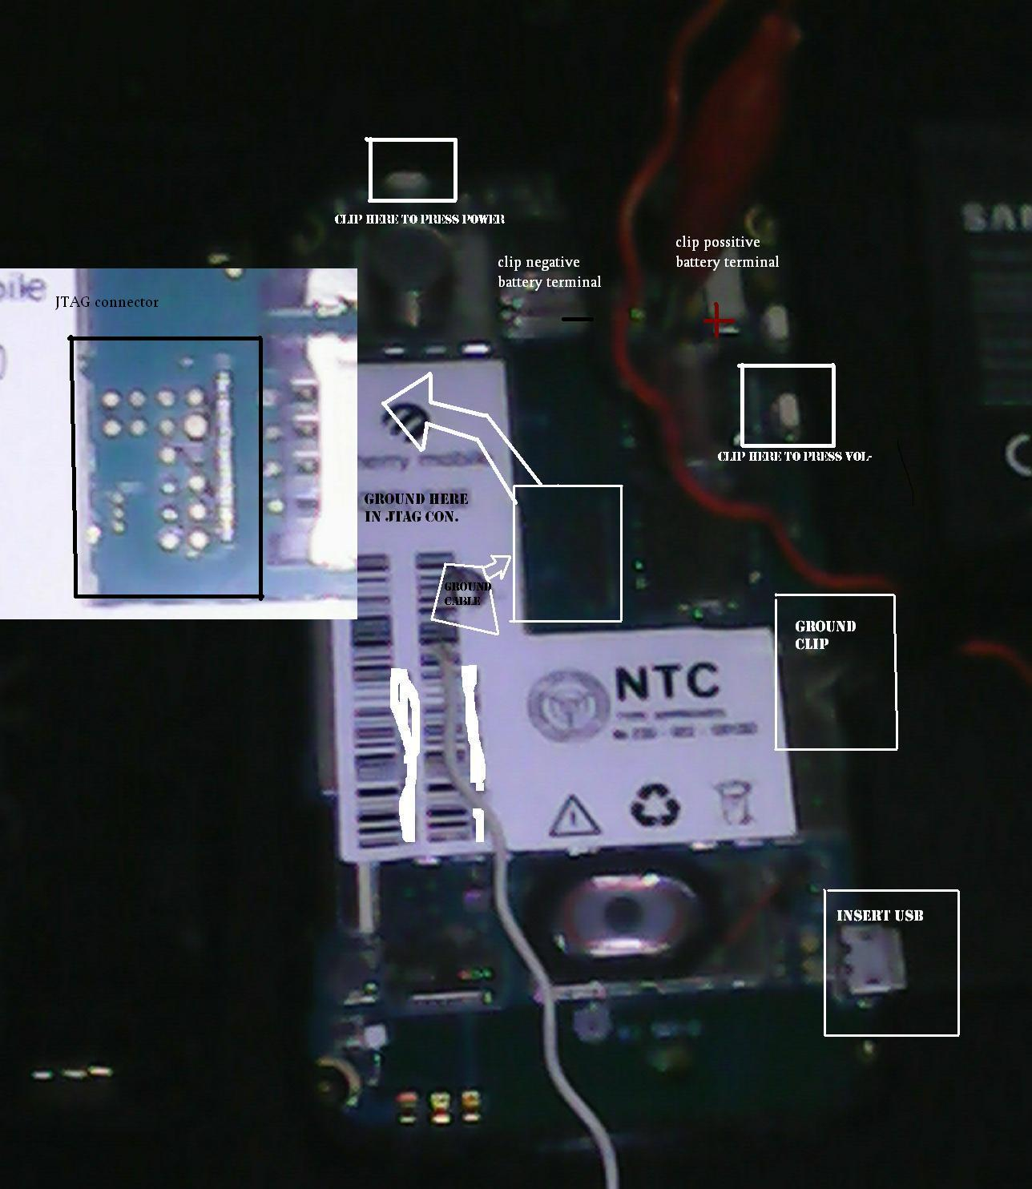
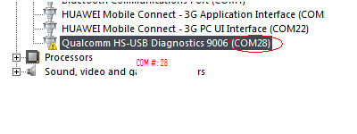
And if your lucky enough to be detected in minutes, your device manager should be open all the time to see if you are always connected, open the QPST /QPST configuration, in ports tab, click add new port, click the com ports detected and then ok then exit QPST config. 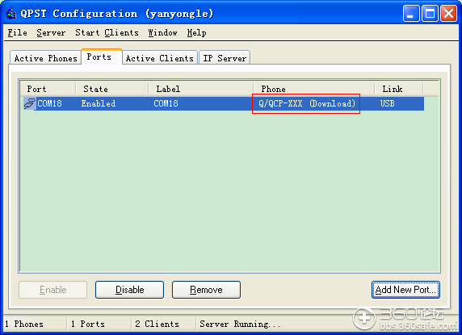
Extract flare repair files.7z in desktop, Open QPST/eMMC Software Download, check program boot loaders, browse for the com port, in flash programmer file name type MPRG8X25.hex, in Boot Image type 8X25_msimage.mbn, click Load XML def and browse for rawprogram0.xml in flare repair files folder, click Load Patch def and browse for patch0.xml in the same folder, now check the search path 2 and browse for the folder flare repair files, and now click download, wait for the download to finish (in my case it never finish but it also detects for a new driver, and that’s important) and it will search for the new hardware found, extract the ICS flare driver and install the driver… exit program but don’t disconnect the phone yet!..
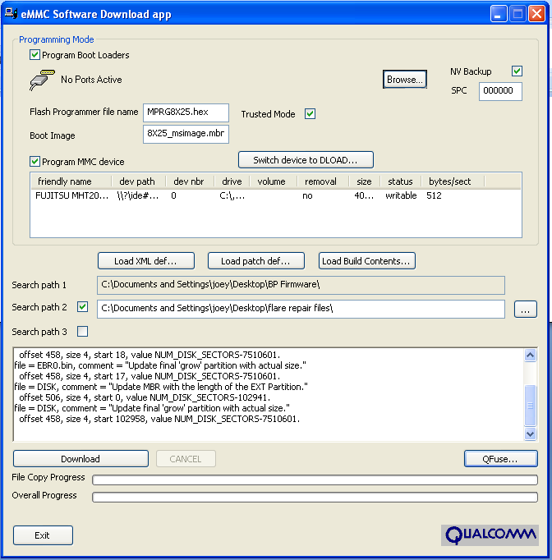
Extract the EMMC_DownLoad_V1.2.4.rar and BP firmware.rar, now open EMMC_DownLoad_V1.2.4.exe program click SELPATH and browse for BP Firmware folder, type in your com port, and click download! This will install FASTBOOT the green screen when you press vol + and power button when finish.. now you can remove all the hospital machine(The oxygen, dextrose) on your phone hahaha, put all the things together (assemble your phone), now boot in FAST BOOT mode (vol +, power) and connect to usb make sure you have enough power on your battery…
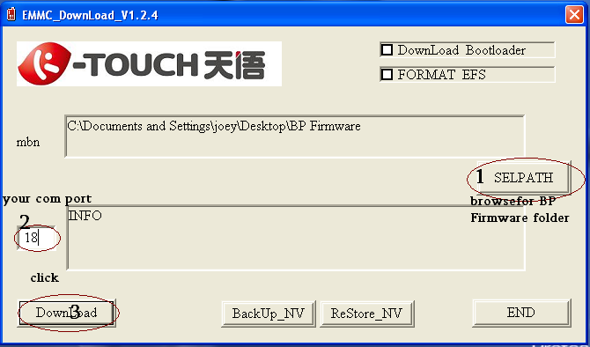
Now extract QUALFAST2.0.5.rar and Stock JB Rom v31.rar in desktop, now run QUALFAST2.0.5.exe, click SEL PATH and browse for the Stock JB Rom v31 folder, wait for it to load and click ok….. when finish you now have a working phone??? Hahaha were not done yet! Close the program..
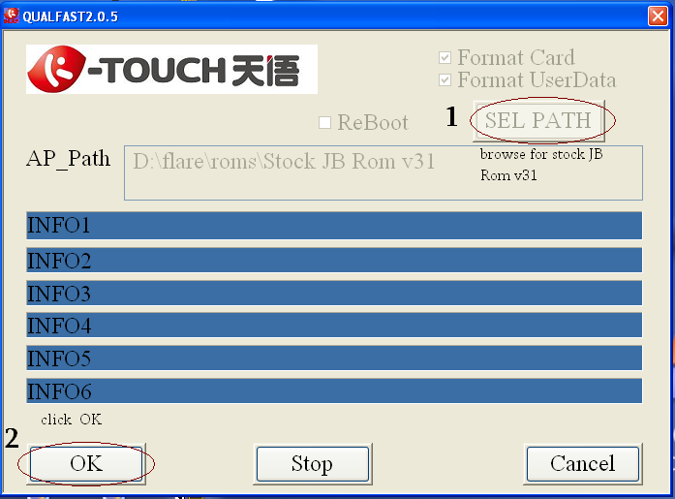
open your phone when it fully loads make sure the usb debugging is enable, connect to usb and install the driver using JB flare pcdriver, once the driver installation is done, Open EMMC_DownLoad_V1.2.4 folder and run EMMC_DownLoad_V1.2.4.exe, click ReStore_NV and browse for my bak.qcn (NV items of my phone) included in the EMMC_DownLoad_V1.2.4 folder, click ok. Wait for it to finish
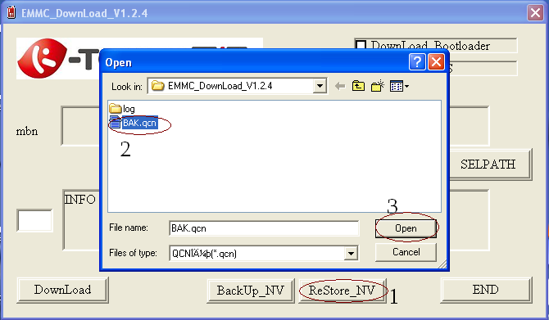
Open your phone (usb debugging enabled), extract Qualcomm_Modem_Tools V1.1.2.rar to desktop, open device manager and look for your Tianyu HS-USB Android Modem 9025 click properties, advance tab, advance port setting and look for com port number… now open Qualcomm_Modem_Tools_V1.1.2.exe, type the com port number of your phone modem, write your phone serial number and press write, same process in IMEI 1, IMEI 2, WIFIMAC, you can press read to verify, reboot and your done………
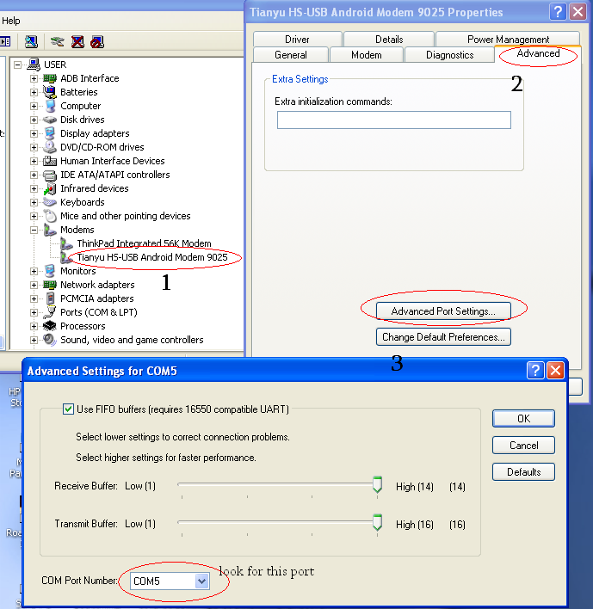
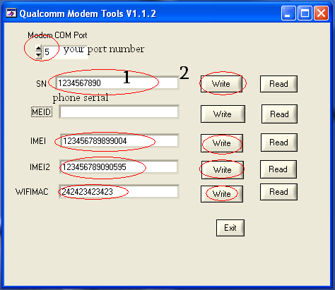
Now you can enjoy your new revived phone!
NOTE:
THIS PROCEDURE WORKS 200% ON MY PHONE CAUSE IT BRICK 2 TIMES WHILE ATTEMPTING TO UPGRADE FROM ICS TO JELLY BEAN….. HOPE IT WORKS FOR YOU TOO! HAPPY BRICKING!!!!

