**Make your laptop or PC as WiFi hotspot using CMD**

First, check your if your WiFi driver is supporting a Hosted Network to do that,
1. Run CMD as admin or open Command Prompt as admin , (I assumed you already know how to open it )
Then run this command:

netsh wlan show drivers

see screenshot
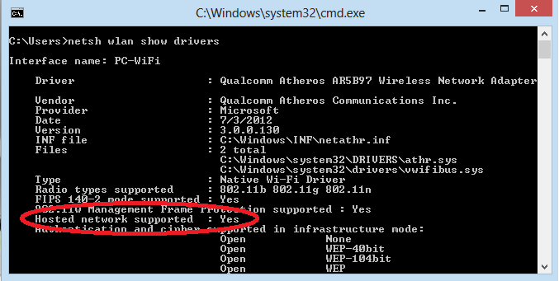
If Hosted Network Supported says YES, you are all good to go! If not, you have to update your wireless driver
Next Step!
2. Open CMD as Administrator and then run this command
netsh wlan set hostednetwork mode=allow ssid=MyOwnWiFi key=MyPassword
ssid -> Name of your WiFi
key -> Password of your Wifi
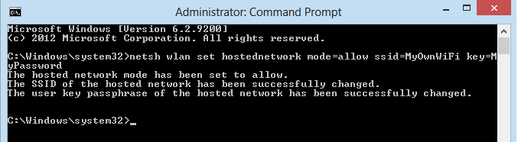
If it is successfully created, cheers! You are near

3. Now, your own wifi has been created, all you have to do is turn it on, just run this command
netsh wlan start hostednetwork
if it started successfully, run this next command to show your hosted network
netsh wlan show hostednetwork
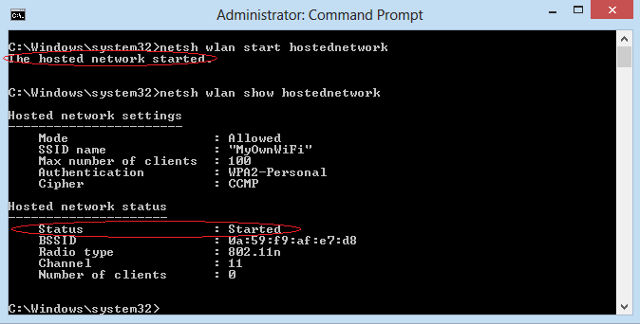

4. Now run ncpa.cpl this will open your network connections
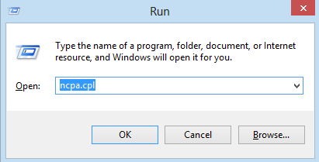

5. Right click on the adapter that has an internet connection
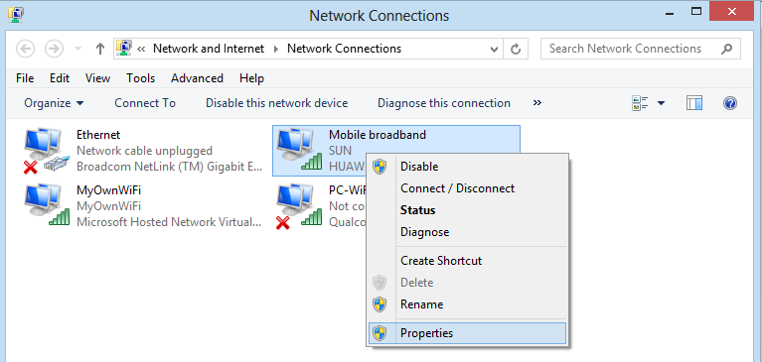

6. Click sharing tab and check on check the option “Allow other network users to connect through this internet’s connection" and select your recently created network name under Home networking connection.
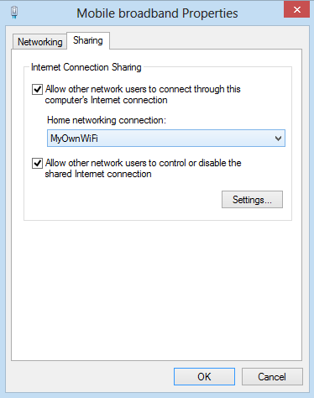
7. Alright! Now see if you already have internet connection on your created WiFi Hotspot!
Open Network and Sharing Center
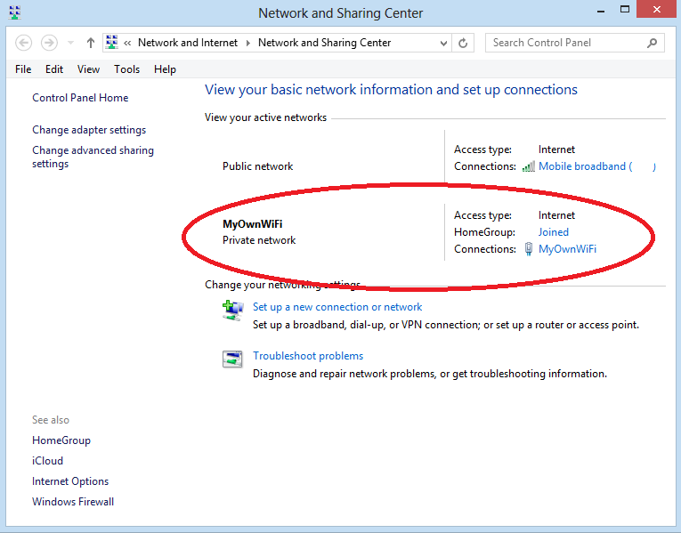

8. Don’t Forget to Feedback ^_^

Thanks!

