I've been trying to unlock it by following a guide for the E5573-609 and E5573-322. However, those did not help as the boot pin is located differently for this variant. Once I located the boot pin (by shorting out every single pin in the board, one at a time), I tried loading the generic E5573CS firmware (after running Balong USB Downloader) and would refuse to install (I get error 12). Given those obstacles, I gave up and hunted for the Globe's 933 firmware. The 933 firmware that I downloaded turned out to be an unbranded/generic, SIM unlocked firmware. From there I faced some more obstacles, mainly the WebUI and dashboard files are nowhere to be found, except on one website where you need to pay at least $15 for a paid account, to get access to the files. After pulling the trigger, I was able to unlock the device as well as remove Globe's branding in the process.
I decided to put all of the files you need in a one ZIP archive. So you won't have to spend hours searching for the files. I know you got better things to do.
Download:
E5773CS-933 Unlock
HXD Hex Editor
Also, I'm not respponsible if you screw/hard brick your modem. I've done this twice already (to unlock my modem (and then to replicate these step)
1. Install the both the FcSerialDrv and Mobile Partner drivers on "Drivers" directory.
2. Disassemble your modem using T5 torx screwdriver.
NOTE: This is the part where you'll have to break the seal and void your warranty. Sorry, there's no way to unlock without doing this. So either keep your warranty or unlock your modem.
3. Take out the board and flip it over.
4. Connect the board to the computer, and open Device Manager
5. Grab tweezers or similar device that's conductive. Then short out one of the pin/metal part (shown in the pic) near the SIM card slot.
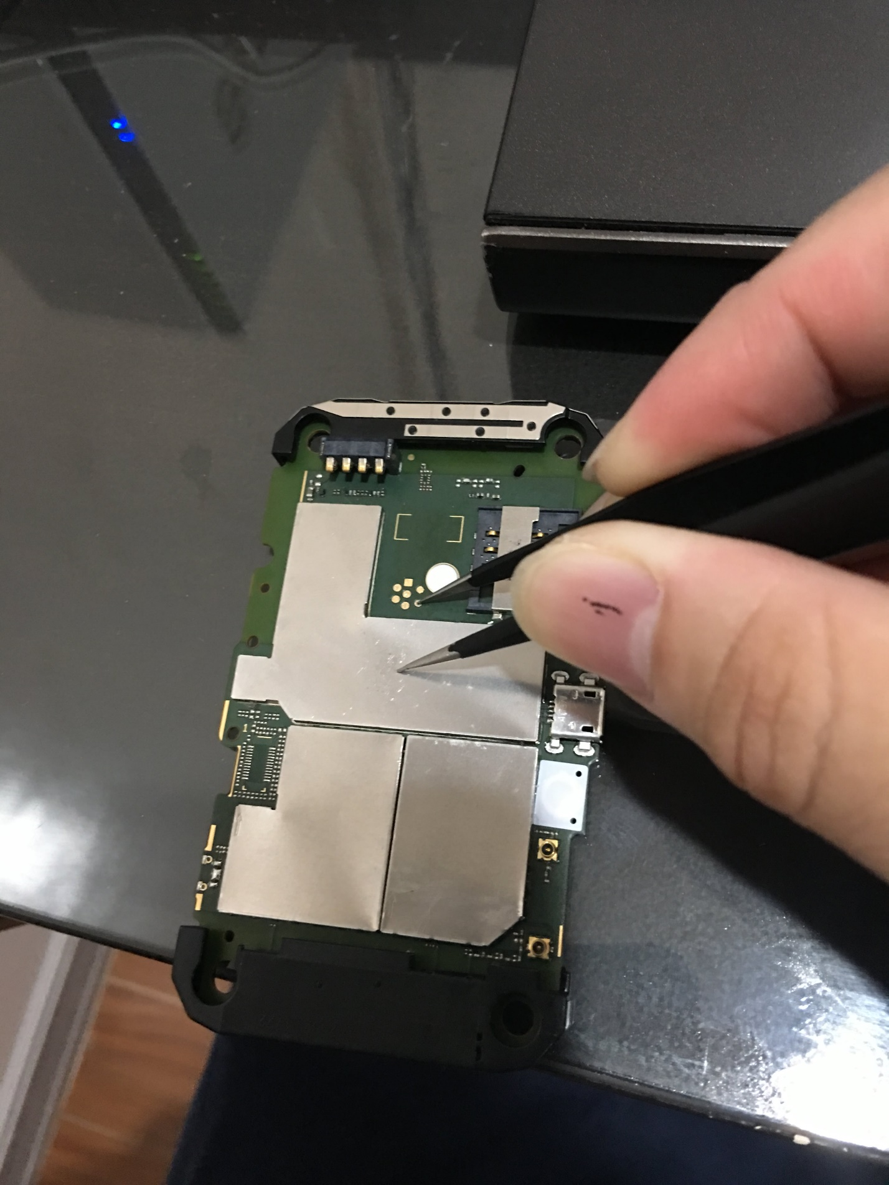

6. While keeping the pin/metal part shorted out. Go ahead and put the battery approximately 45-degree angle while keeping it in contacct witn the gold terminals. As shown in the pic.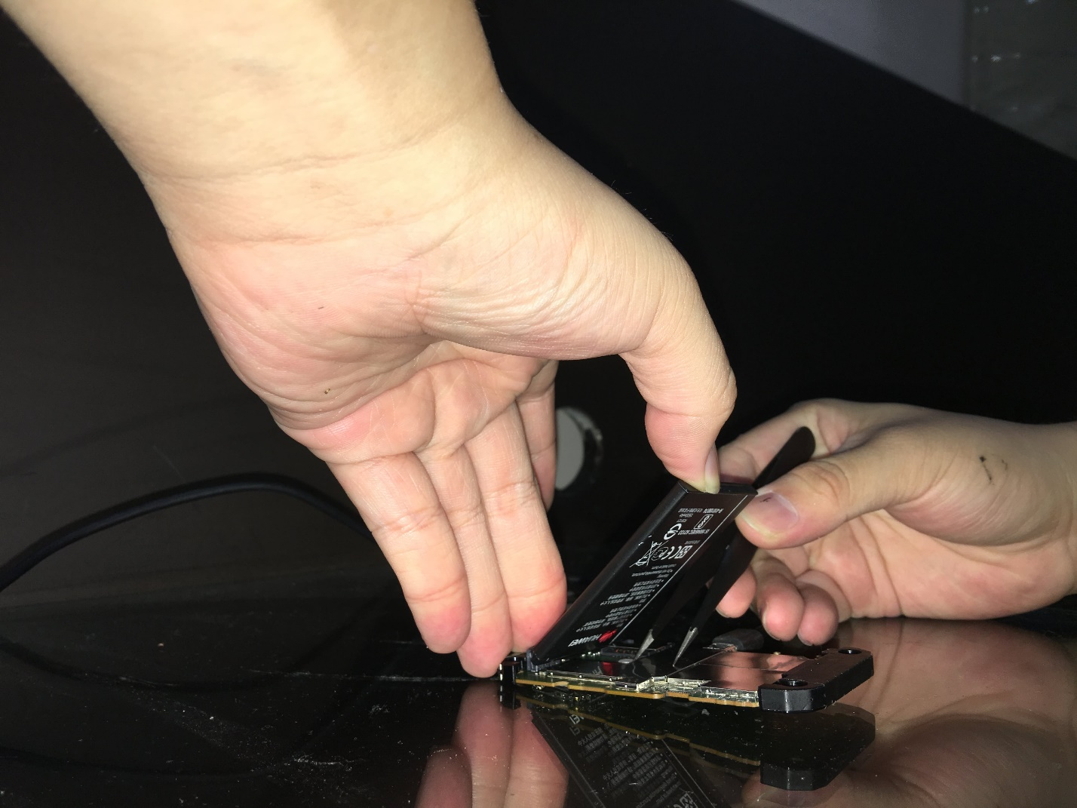
7. If you did it right. You should see "HUAWEI Mobile Connect - 3G PC UI Interface", "FC - PC UI Interface" or something similar under Ports (COM & LPT) on Device Manager. You don't need the tweezers anymore but leave the battery alone.
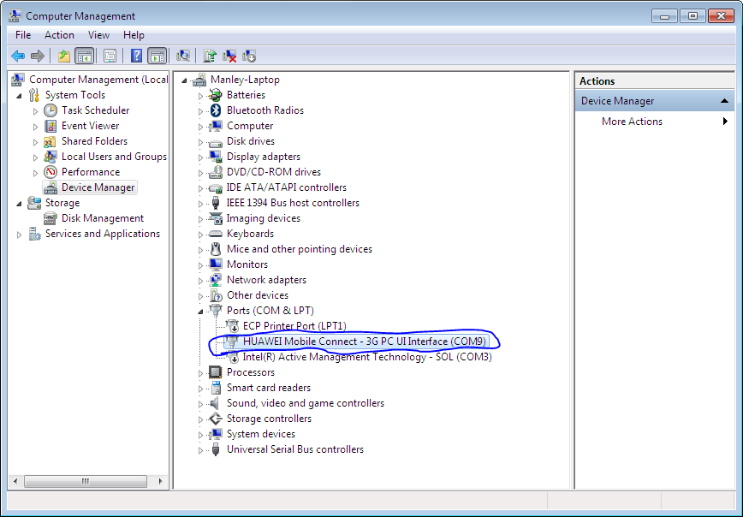
If you're getting a message saying that the last USB device you have inserted can't be recognized, then try connecting using a different cable, port, or even a different computer.
8. Launch Balong USB Loader at "Balong USB Downloader" directory.
9. Click "Detect". Then Press the three dots. Then "Load"
10. It should take about 5-20 seconds for USB Downloader to do its thing. It's normal for the program to freeze, however, when its done. It should return with a full progress bar.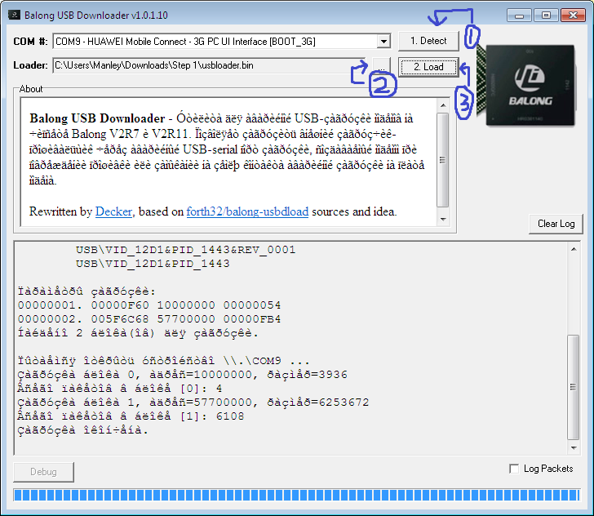
11. Check Device Manager and if you see both "FC - Application Interface" and "FC - PC UI Interface" or something similar, proceed to the next step.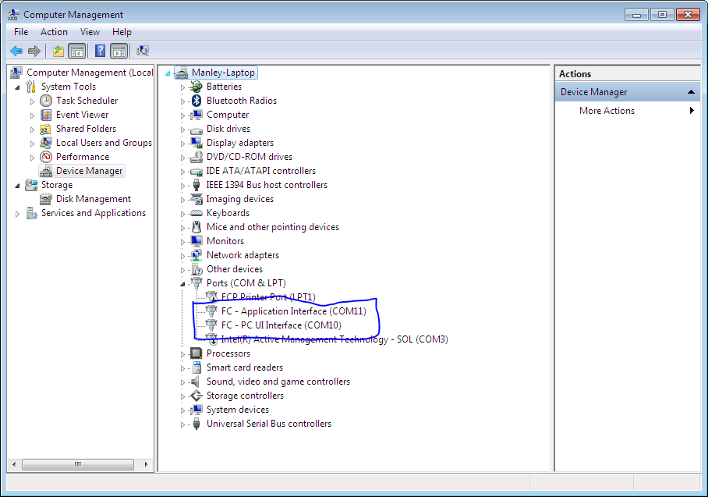
12. Go to "Firmware (21.320.99.05.00)" directory and run "E5573Cs-933_Update_21.320.99.05.00.exe" The go through the wizard.
13. Go to "WebUI (WEBUI_21.100.32.00.03_NE5)" and run "Update_WEBUI_21.100.32.00.03_NE5.exe". Same thing as last step. Go through the wizard.
14. Let go of the battery, disconnect the board, and assemble the modem.
15. Insert a SIM card. (I used a Globe SIM, but any SIM could work.) DON'T SKIP THIS. Doing so will give you an error on DC Unlocker when trying to repair the serial number and IMEI of your modem.
16. Connect the modem to the computer. Then run "dc-unlocker2client_1277.exe" at the "DC Unlocker" directory.
17. Click on the magnifying glass/search.
18. When the modem is found, you'll see that it's already unlocked but we can't use it yet due to not having the correct serial and IMEI.

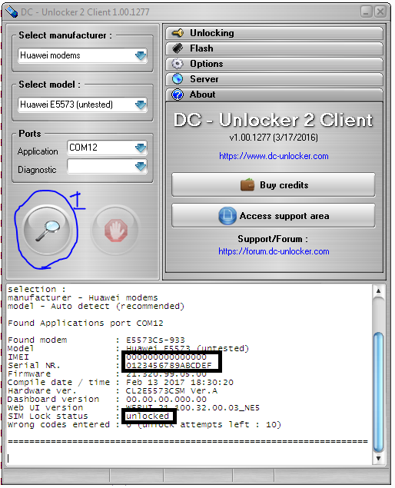
19. Run HxD and type out the serial number on the right side.
20. Now type in this command: AT^NVWR=6,16,** ** ** ** ** ** ** ** ** ** ** ** ** ** ** **
Replace ** with the hex code you got from HxD (copy paste the values in the middle (between the zeros and the serial number you just typed. Press enter. It should say OK.
21. Now type in this command: AT^CIMEI="*****". For example if your imei is 1234567890123456, then you would type: AT^CIMEI="123456789123456"
Replace * with your IMEI. Press enter. It should say OK.

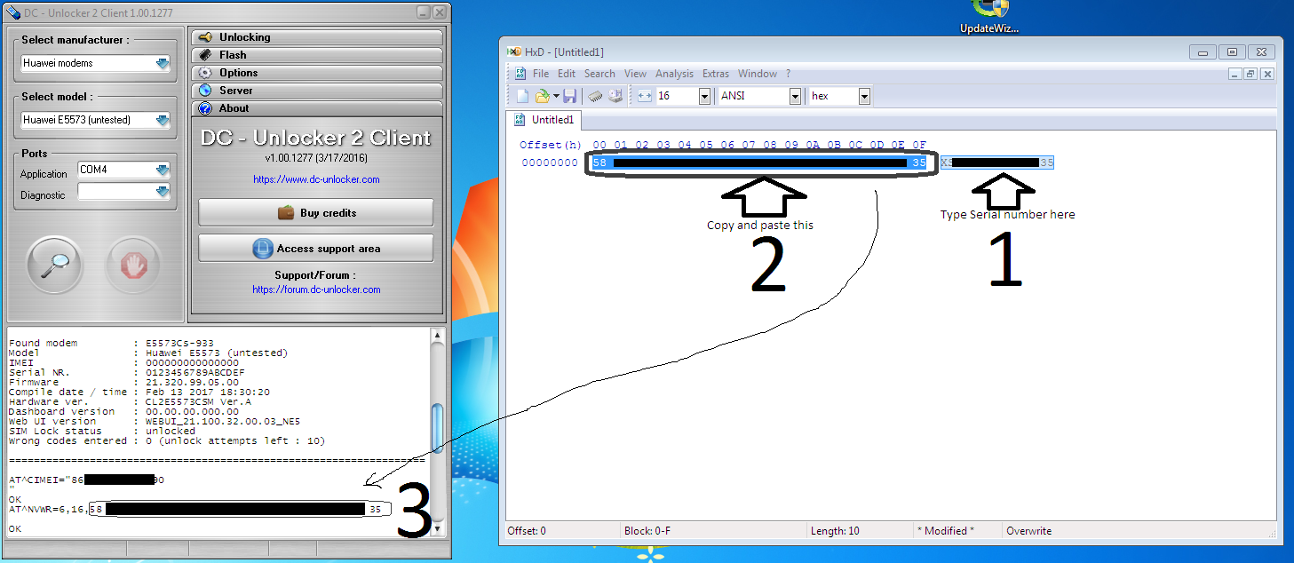
22. Click on the magnifying glass (again) and see if the correct serial number and IMEI shows up. Once done, close out of DC Unlocker.
23. Finally, go to "Firmware (21.326.13.00.00)" directory and run "E5573Cs-933_Update_21.326.13.00.00.exe"
One done. The modem should reboot and should automatically open a web browser, which goes to the Huawei page. If not, open your web browser and go to 192.168.8.1. If it asks you for a username and password. It's "admin" for both. From here, you'll need to setup the network name, password, etc. Just like you would when you first bought the modem.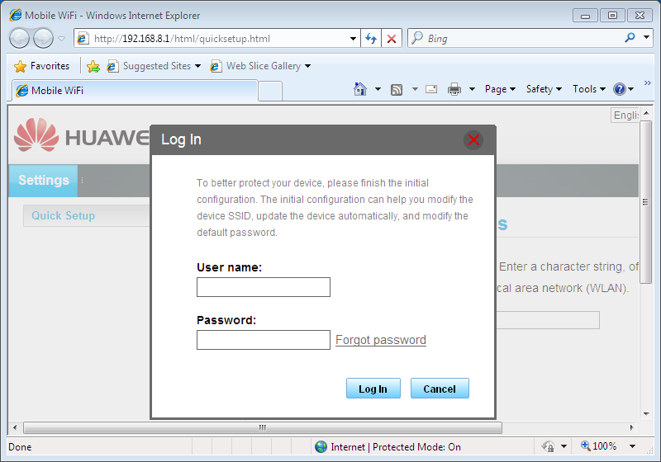

Take note that we don't have the Globe branding anymore.

