1.Backup your ICS using Roadkill
Turn off your Flare, then press Volume down and power button at the same time. once you see the “ENTRY QPST DOWNLOAD”,NOTE: if format sd card prompt please click CANCEL ,,..
open roadkill and click on Store Image Tab, select the disk with 3.61GB, click browse and select the location where you want your backup to be saved, and click start. Once finish proceed to next step.
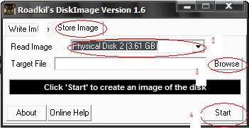
2. Saving IMEI, MAC ID and Serial Number
Write your IMEI1, IMEI2, Wi-Fi Mac, and Serial Number (S/N) in a piece of tissue paper. For MAC ID, turn on your Wi-Fi, and go to Settings > About Phone > Status. For IMEI just dial *#0000# in dial pad.
3. Backup NVRAM
- Run EMMC_DownLoad_V1.2.3.exe ,(Check Download Boot Loader for 1st run)
- Turn device ON (make sure USB Debugging is enable)
- Connect phone thru microUSB cable (Note: Make sure there are no other USB Modem or phone connected to your computer except for Flare)
- Click BackUp_NV.
- Wait until back up is successful.
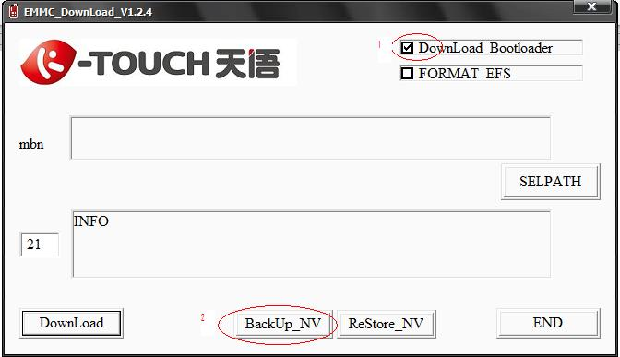
4. Download BP Firmware
- Go to ENTRY QPST DOWNLOAD” Mode (Power + Vol Down)
- Run EMMC_DownLoad_V1.2.3.exe. Click SELPATH select “BP Firmware” Folder.
- Connect phone thru a microUSB cable.
- Check Device Manager for "Qualcomm HS-Usb Diagnostics 9006" Com Port #.
- Look for "Qualcomm HS-Usb Diagnostics 9006" type the Com port # in EMMC Download Box. Click Download.
- Wait until download is successful (Usually it takes 6-12sec). Remove battery. (Do not Close EMMC Download. then proceed to next Step )
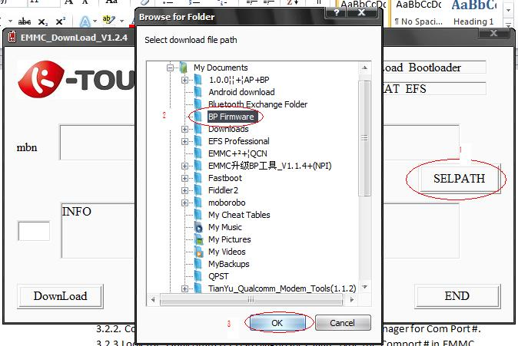
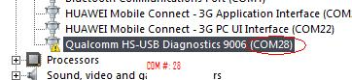
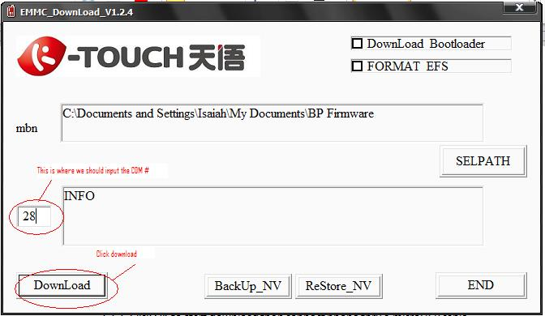
5. Download AP Firmware
- Run QUALFAST2.0.5.exe. Click SELPATH, select AP firmware (“Stock JB Rom” Folder), Check Format Card & Userdata
- Go to Fastboot Mode or Green Screen Mode (Power + Vol Up)
- Click OK to start download then connect phone via a microUSB cable.
- Wait until download is successful. Remove battery.
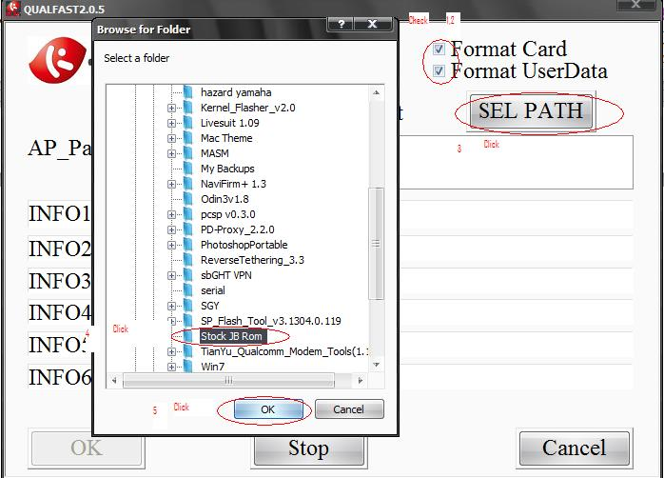
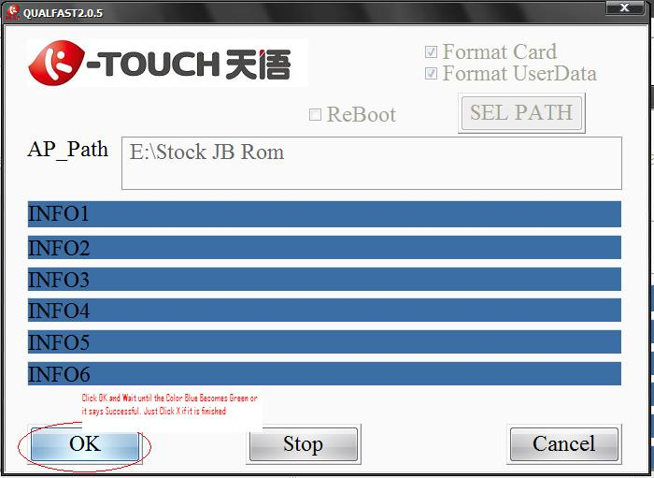
6. Restore NVRAM Backup
- Run EMMC_DownLoad_V1.2.3.exe.
- Turn device ON. (make sure USB Debugging is enable)
- Click Restore_NV. Browse and select bak.qcn file. Connect phone thru microUSB cable.
- Wait until qcn restore is successful. (your IMEI 2 is Null & Wifi Mac Address is set to default. you need to write it again)
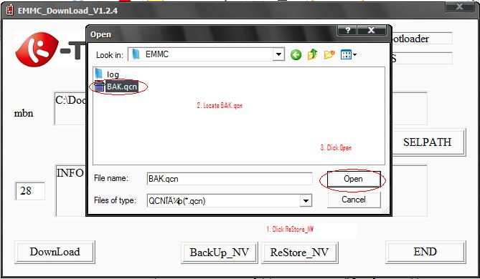
7. IMEI & Wi-Fi MAC Address Writing
- Turn device ON (make sure USB Debugging is enable)
- Locate your modem com port number (Go to Device Manager > Right-click “Tianyu HS-USB Android Modem 9025” > Properties > Advanced Tab > Advanced Port Settings > COM Port # (Ex. 10))
- Open Qualcomm_Modem_Tools_V1.1.2.exe and type com port #
- Write all your backup code, then click Write button. (In my case I have re-entered my IMEI1, IMEI2, S/N (Serial Number), Wi-Fi MAC)
Note: Every after successful entry of IMEI, the phone automatically restarts.
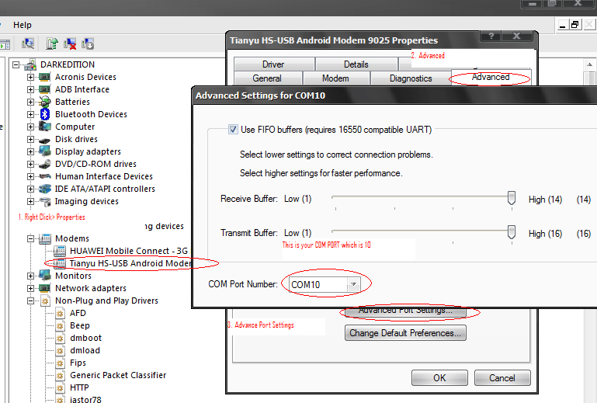
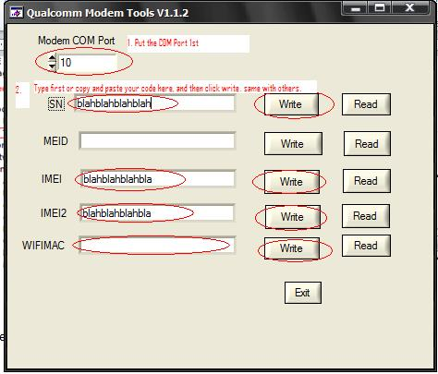
8. Rooting
- Restart Device. Wait until it boot perfectly.
- Copy update.zip to internal memory.
- Reboot to recovery and update from internal sdcard.
- Reboot
- Enjoy.

