ATM (BANKING SYSTEM)

- LOGIN SCREEN

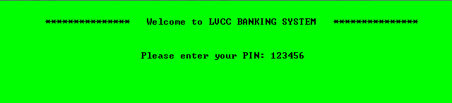

- Wrong PIN



- After 3 FAILED ATTEMPTS

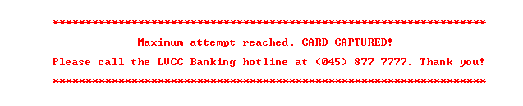

- MAIN MENU SCREEN

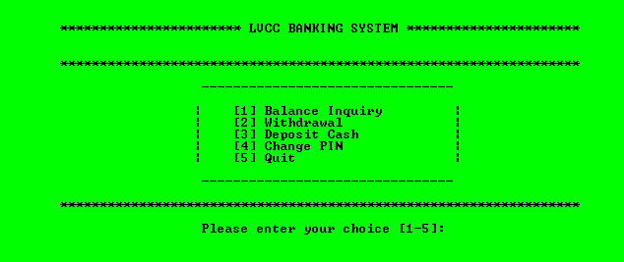

- INPUT is INVALID

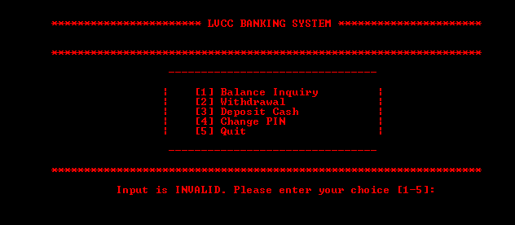
- BALANCE INQUIRY SCREEN

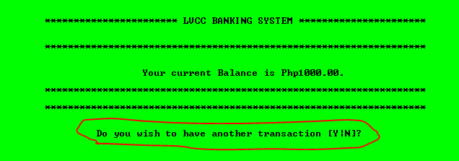

- NOTE: Every after a transaction the user must be asked if he/she want to make another transaction.
  - If YES, the user will be redirected to the MAIN MENU SCREEN
  - If NO, another confirmation will be made.
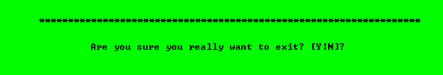
.
  - If YES, the user will be redirected to EXIT SCREEN
  - If NO, the user will then again be redirected to the MAIN MENU SCREEN.

- EXIT SCREEN

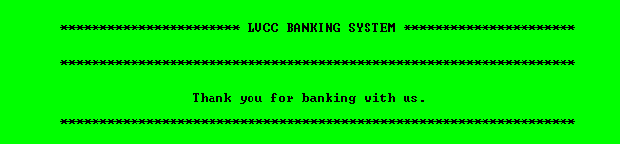

- WITHDRAWAL SCREEN

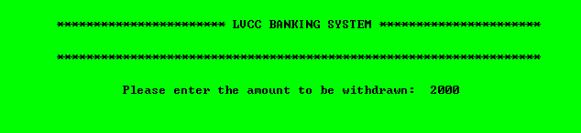

- Amount is higher than the current balance.

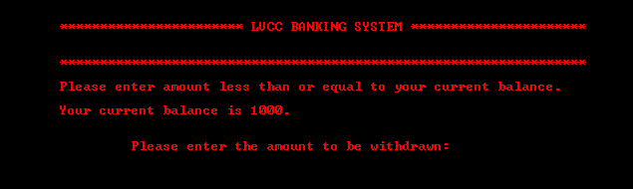
- Amount is higher than the maximum withdrawal amount.

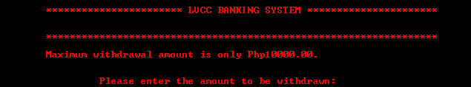

- Amount to be withdrawn is below current balance (Successful transaction)

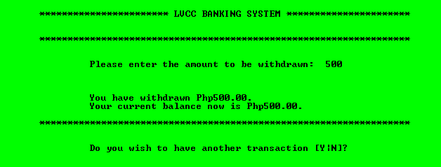

- DEPOSIT CASH SCREEN

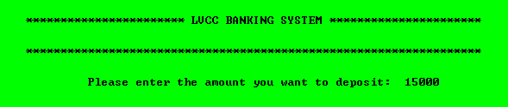

- Amount entered is higher than the maximum allowed deposit amount.

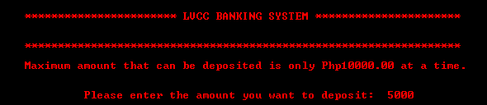

- Amount to be deposited is below 10000.00 (Successful Transaction)

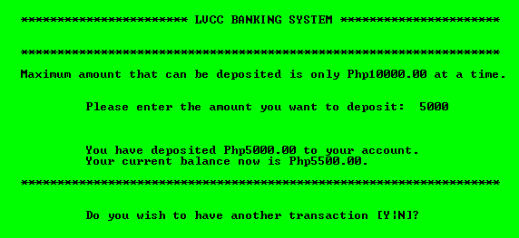

- CHANGE PIN SCREEN

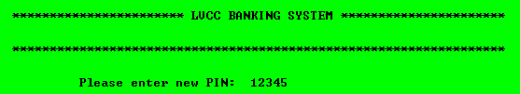

- PIN entered is less/more than 6 digits.

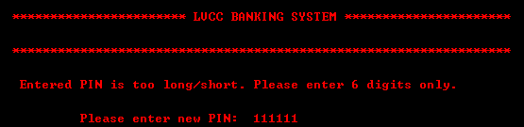

- PIN codes entered don’t match.

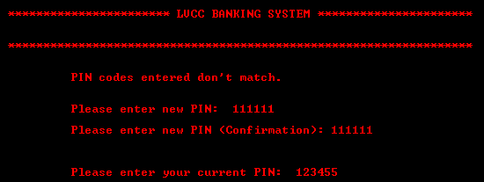

- PIN Code entered is INCORRECT.

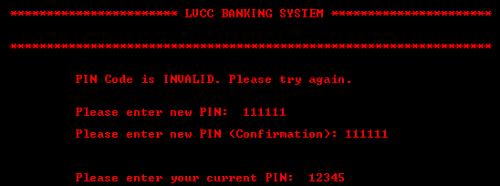

- 3 Failed Attempts (Current PIN)

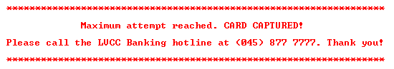

- Successful change of PIN



