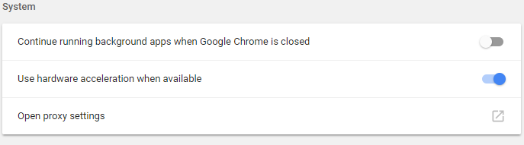
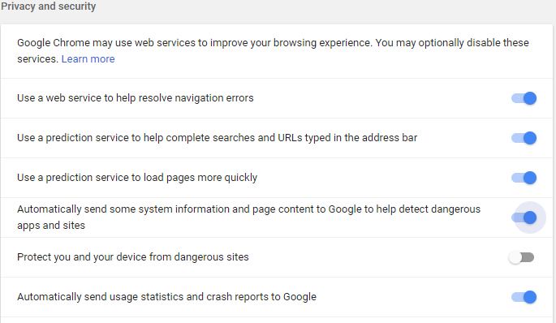
Experimental



