Welcome to Cryptocurrency
Introduction
Hello and welcome, here I have tried to compile a go-to source of all the information and learning that I have found useful. The aim of this is to stop newbies making critical mistakes that cost them money, and to give a good base of learning. If you have any questions or improvement suggestions about anything mentioned here, message me on Telegram (Sign up at https://www.telegram.org/ or search it in your mobile app store) by searching for the user DaveyH20, and I'll be happy to help.
*Please note that quite a lot of sources listed here refer exclusively to the Forex market, but the charting translates to crypto almost flawlessly.
**Also it is important to mention early that scams are rife in this space. Do not ever send funds to anyone unless you know who they are and what you're getting in return. There are many people who claim to give you a massive return on your "investment". These people will disappear forever once they receive your funds.
Getting started
Before going too far, I would advise getting to know the history of the cryptosphere and a general feel for what coins are out there, their categories and what real world use cases they might solve. Here are just a few of the coins out there, and their categories and use cases.

A good starting place is CoinMarketCap, where all coins are listed along with their Market Cap, Price, Circulating Supply, 24 Hour Volume (Across all exchanges), and 24 Hour Change(%) accompanied by a Price Chart covering the last 7 days. Here is a snapshot of today's Top 10 cryptos in order of market capitalization (Tuesday 3rd October 2017), taken from CoinMarketCap.
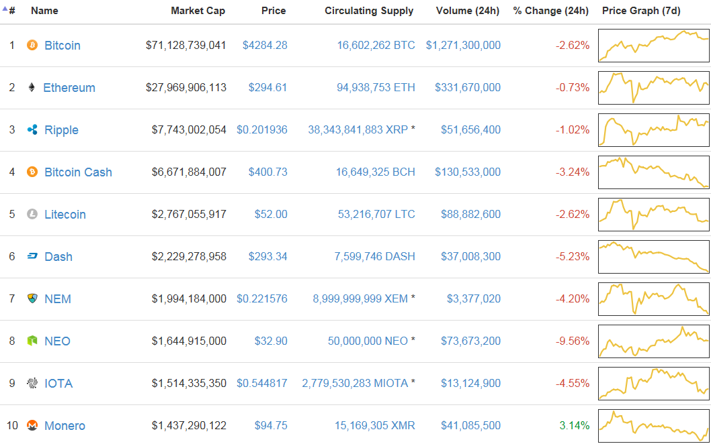
But what does it all mean?! The Market Cap is basically the CURRENT PRICE x CIRCULATING SUPPLY, where the Price is what a single coin would cost to buy, and the Circulating Supply is the amount of coins currently available. The MAX SUPPLY of a coin is to make them DEFLATIONARY (And not inflationary, like fiat currency that is printed at will by Central Banks), and the difference between Circulating Supply and Max Supply is the amount of coins that are still to be mined (We'll touch on mining in just a sec!). Volume is the sum of value (Usually measured in Bitcoin(BTC)) traded in the last 24 hours. Note that both buying and selling contribute to Volume. So if Trader A sells ONE BTC to Trader B, this trade adds TWO BTC to the volume.

Blockchain
You may also want to get a rough feel for what a Blockchain is. A blockchain is by definition 'a digital ledger in which transactions made in bitcoin or another cryptocurrency are recorded chronologically and publicly'
you can find out all about those here
http://www.investopedia.com/terms/b/blockchain.asp

Mining
Mining, is the process of earning a particular coin as a reward for confirming a 'block' on the blockchain and adding it to a ledger. The miner uses their computational power to solve a mathematical equation, which confirms transactions and adds it to the blockchain for everybody to see. That way the coins are always accounted for, they cant be counterfeited and they cant be double spent.

General Information
You will find almost all the information you need at MyCryptoGuide, from history of crypto, to how it was formed and how it can shape the future. The home page has lots of good information, with sub sections that you must register to access.
https://mycrypto.guide/
BlockGeeks is also a good source of info and well worth checking out.
https://blockgeeks.com/guides/how-to-invest-in-cryptocurrencies/

Trading Platforms & Exchanges
Okay, so you've done some market research and you're ready to get started with your first investment. You'll need to head to an exchange! Exchanges are where most trading is conducted. They are like a market place, where you can buy and sell your coins. Some common and reputable exchanges are;
Based in the United States - Bittrex, Poloniex, Bitfinex, GDAX*
Based in Europe - Kraken.
Based in China - Binance.
Between these you can buy almost every coin, from anywhere!
*GDAX is linked to Coinbase, but has no fees!
Making A Deposit
Each exchange has different way of depositing and registration. Have a look around the website of a few exchanges and get a feel for them, you'll locate their account creation section fairly easily. Once you are signed up you can make a deposit.
Here is the dashboard of Bittrex, showing the coins with most volume in descending order.
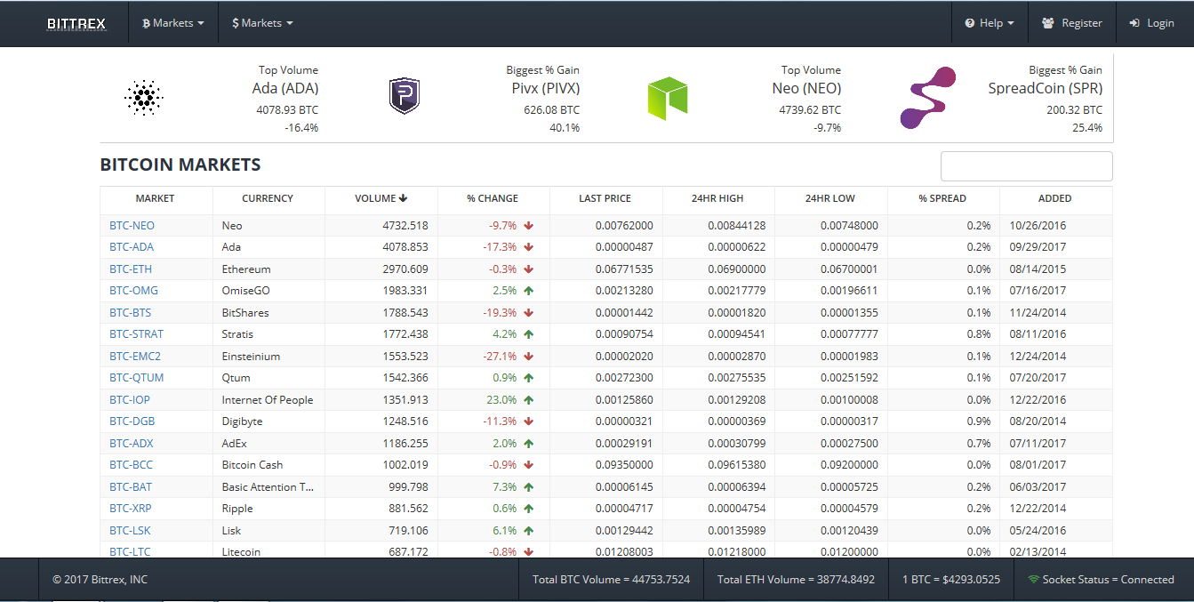
Making a Trade
Clicking on a trading pair will bring up a historical price chart, updating in real time. Here is the trading screen for BTC/RISE pair.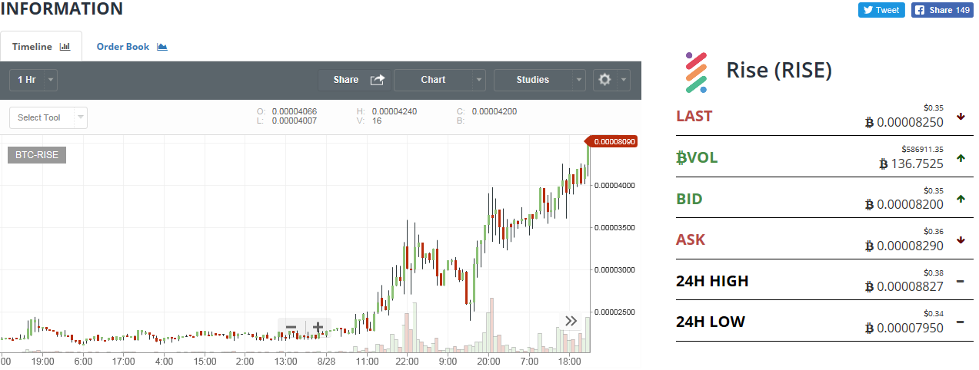
Here you can see the current price of this coin, the 24hour volume (In BTC), the Bid, Ask, the 24 Hour high, and the 24 hour low.

Buying/Selling
You have made your deposit from your bank to your exchange and you're ready to make your first trade. Here you can see the options to buy on the left, sell on the right, and the order book below for the BTC/RISE pair. To buy RISE, you simply enter the amount you wish to buy, and at what price.
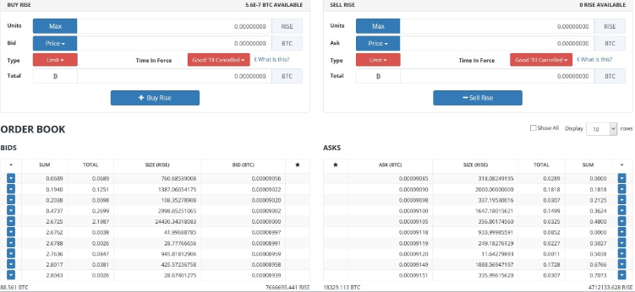
After you click "Buy Rise" your order will then appear in the order book in the BIDS section at the bottom, which is in order of price. If you were selling, it would appear in the ASK order book.
BID Vs ASK
The BID is the highest price a trader is willing to BUY this pair at, and the ASK is the lowest price someone is willing to SELL this pair at. The difference between the BID and ASK is called the SPREAD. As the picture with the chart above shows, the spread is 0.0000090 (Or 90 satoshis). The Bid/Ask is the top entry on the order book, too. (Not in this case as pics were taken at different times)
How the market price changes is a mechanism you will want to know about. You can find a great explanation here;
https://www.thebalance.com/how-market-prices-move-through-buying-and-selling-1031049

Satoshis
What is a satoshi you ask? A satoshi, commonly referred to as "sats" is One Hundred Millionth of a single Bitcoin. It gets its name from the elusive 'founder(s)' of Bitcoin, Satoshi Nakamoto.
1 Satoshi = 0.00000001 BTC
100 Satoshis = 0.00000100 BTC
1,000 Satoshis = 0.00001000 BTC
10,000 Satoshis = 0.00010000 BTC

Blockfolio
You got your first coins! Sweet. You'll want to track the price movements and monitor your Profit/Loss. On your mobile, download Blockfolio. You can manually enter in all of your trades in the "Holdings" tab of each coin, and it keeps track of everything for you in real time, with a news tab and charts available too!
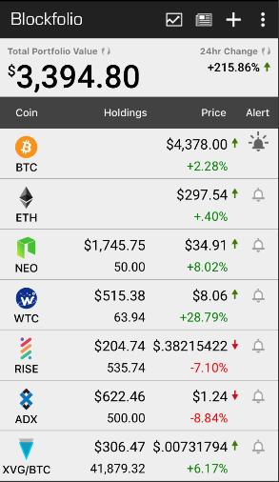

Japanese Candlesticks
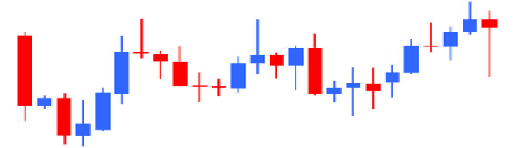
Before diving into anything too complicated, you will want to get a basic understanding of what charts look like, and what they contain. Japanese candle sticks are the formations commonly used on charts. You can learn all about those and common patterns they create here;
http://stockcharts.com/school/doku.php?id=chart_school:chart_analysis:introduction_to_candlesticks

Technical Analysis

Technical Analysis (Commonly called TA) is the use of indicators to help determine future price movements. You must be aware that no single indicator gives a 100% accurate prediction of any market. They are designed to reveal bits of information (E.g. RSI tells you if a market is overbought, or oversold, while Bollinger Bands show volume and volatility), and not the whole picture. DO NOT LEARN ONE INDICATOR AND MARCH INTO BATTLE THINKING IT WILL MAKE YOU MONEY, because it will not. You must combine as many indicators as possible to get a more accurate depiction of what the market is doing. Look for what is called 'confluence', where multiple indicators suggest the same thing.
Another thing to note is TA isn't 100% even if you used every single indicator known to man. Fundamental Analysis (FA) has a lot of power when considering the MASS PSYCHOLOGY of traders. For example, every technical indicator could be suggesting a bullish breakout on NEO/USD, and just as you buy into the market some huge FUD(Fear, uncertainty and doubt) drops (A government has banned Bitcoin, again), the mass psychology of the market will more than likely sell based on the power of that news. Traders that bought in a lot lower will protect their profits and sell (They will hope to buy the dip), this triggers hysteria and more panic selling comes, further affecting the market. So just have some sense about you when using TA, its NOT perfect. Don't think "Okay there is bad news, but my TA says this is a good buy". Wait and see what happens, you may find a better entry point when the selling takes hold, providing the bad news isn't about the NEO market/technology/reputation specifically.

Here are some useful sources of learning for some easier to learn types of TA;
Babypips has a brilliant walk through of the trading markets. But it is designed for Forex trading, so don't pay too much attention to - or even skip - the first course, and maybe the 8th.
I would strongly recommend that anyone serious would go through these courses repeatedly until you know it all. After each course, bring up tradingview (www.tradingview.com) and try to find some of what you learned on the charts as practice.
www.babypips.com/learn
4 Basics tools - MACD, RSI, Moving Averages and Stochastic
https://www.dailyfx.com/forex/education/trading_tips/post_of_the_day/2013/02/08/Four_Highly_Effective_Trading_Indicators_Every_Trader_Should_Know.html
Bollinger Bands
Bollinger Bands are used to map the volume and volatility in a market.
https://www.youtube.com/watch?v=PONc9GkzFrA
Parabolic SAR (Stop And Reverse)
Parabolic SAR maps dots on the chart above or below the candles, showing the potential direction of a trend. They tend to work more accurately on larger time frames. Usually between 3-5
successive dots after a lengthy trend in one direction, suggests a reversal.
https://www.youtube.com/watch?v=2aWopSCGc5Q
Simple Moving Averages
SMA's do as the say, they map the average price over time to show an average. Explained here;
https://www.youtube.com/watch?v=x4nO5yoarM0
Fibonacci Retracements & Extensions
This indicator is mapped by plotting a set of lines horizontally across a chart, from a previous swing high, to the last swing low when a bearish trend ends, and begins an upside, or vice versa. These are very commonly used and very reliable at revealing potential support and resistance levels. Because they are so widely used, they are significantly powerful when taking into account the mass psychology mentioned earlier, as traders that set Buy/Sell Orders ahead of time will use these levels are their targets. This happens en mass causing a lot of the same sentiment in the market.
http://www.fxacademy.com/learn/fibonacci-retracement-levels
https://www.youtube.com/watch?v=SjSHVDfXHQ4
Fibonacci & "Rubberband Man Theory"
This theory humanizes the charts and gives them an energy level. Worth watching.
https://www.youtube.com/watch?v=iu6do5aGr1g
Elliott Wave Theory
Elliott Waves are seen very frequently in trading and can be very useful to identify entry points into the market.
https://www.youtube.com/watch?v=NeQ0GecCr2w
William Delbert Gann (Advanced)
W.D Gann was an incredible mathematician and developed a trading strategy called "The Square Of 9". This is a very complicated and in depth form of TA and i would only suggest looking into it once you have mastered everything listed before it. Here is a brief background;
https://www.educatedanalyst.com/an-introduction-to-ganns-square-of-9/
People using this technique are often referred to as "Gannalysts". I have an eBook on Sq9, if you wish to have it message me on Telegram and ill send you it.
Psychology in Trading
This section is about thinking outside of the box, away from your computer screen and trading platforms. And thinking about yourself, as well as the millions of other people that are trying to do the same thing - make money. It is very important to take into account the phenomenon of mass psychology, but also equally important to consider your own personal mind frame.
Personal Mindset
The psychology of trading is very important and keeping emotions out of your trading will be of huge benefit in the long run. So often traders are holding on for a psychological price milestone, that exceeds what their technical indicators are telling them, causing losses or at best, a minimisation of profits when that milestone doesn't materialize. The same can be said in reverse, traders often watch their portfolio shrink, and shrink, and shrink because of a coin they are emotionally attached to and constantly tell themselves "This is a $1000 coin!" or "The technology and team are amazing!" all while watching it fall down and down. Learning to cut losses, and timing the taking of profits is something you wont master right away. The vast majority of traders lose money before they start making money, but its the learning from these mistakes that separate a good trader from a bad one.
You need to control your emotions when there are dips, because they are natural, and healthy for the progression of the market. Panic selling will more than likely end with you losing money in the short term, which becomes multiplied as the price of the coin recovers. This article highlights some points in ore depth;
http://www.investopedia.com/articles/trading/02/110502.asp
And this will help you decide what type of trader suits you; http://www.investopedia.com/articles/investing/052413/what-type-trader-are-you.asp
This youtube video is 1 hour long, and gets very deep, but it is packed with very intriguing analysis of the human mind in relation to market trading and well worth getting a feel for; https://www.youtube.com/watch?v=n2U2w7jgyV4
Note that if you are not a trader this is mostly irrelevant if you are a long term investor or "HODLer", and have picked a solid project to buy into, but still helps you to understand what is happening when price is moving.
Mass Psychology
The mass psychology is also very important to consider when trading, especially in strong trends, up or down. The psychology of a market is commonly referred to as the "market sentiment", and is affected by both technical and fundamental analysis. The fundamentals are much easier to read, when good news appears, or a successful development or new partnership is revealed, the market reacts positively and buyers start going to work hoping to ride the news into profits. The opposite is also true, bad news, delisting from an exchange, a hacking scandal, bugs in the coding or losing a developer, among many other things can cause a negative market sentiment and you will expect to see large degree of selling.
Technically, market sentiment and working out what the other 99.99% of traders are thinking is much more difficult. Let take Fibonacci for example, here we have mapped our fibs on the NEO/BTC pair, and in hindsight we can see where the fib levels acted as support and resistance with almost pinpoint accuracy.
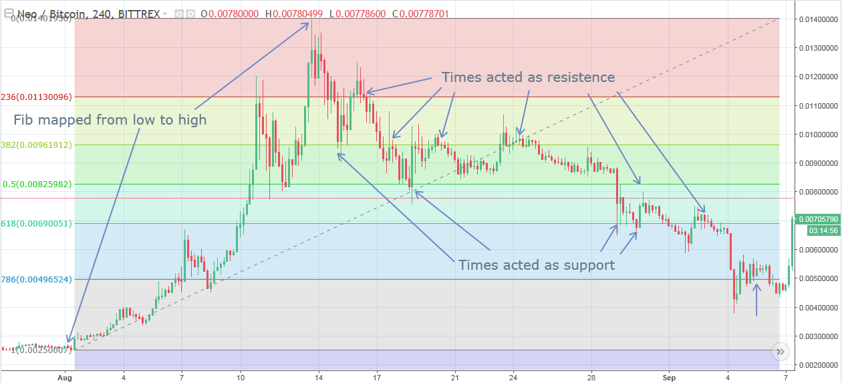
This is because a vast number of other traders have mapped the exact same thing, and know that the price has potential to bounce on those lines. Working out what other traders are thinking will help you decide what you will do yourself. Some point around the 15/16/17th Aug traders would have identified a reversal in trend and drawn their fib retracement lines as shown and it is at this point they would have set their buy/sell orders around those lines. So many traders with orders around the same place, all watching at these key moments as price nears the lines, generates high volatility and volume. Notice at around 19th Aug the price hit the 50% retracement line (Considered one of the prime ratios) at ~825k sats and bounced right off it, reaching as high as ~1.02m sats, an increase of ~22%, before testing the 38% line for a few days, then subsequently making a decline after failing to hold above it. The price dwindles until 4th Sept, where support is found at the 78% line, containing enough buy orders to cause another huge bounce, triggering a reversal in trend and opening the door for profits.
These lines can act as self fulfilling prophecies, when so many traders are all thinking the same, their power is immense. Learning to anticipate these bounces will lead to serious long term profits.

Wallets
You will often hear in the community of people urging you to keep your funds on a wallet, and not on exchanges. This is because in the past exchanges have been hacked, and the funds have vanished never to be found again. Here are some wallets you can use for your various tokens, and some info on how to create them.

IMPORTANT:- Never, ever send or reveal your PRIVATE KEYS to anybody. This will give bad actors access to your wallet and the ability to drain your funds. Keep them safe, and write them down on paper in case damage to your system. Your private keys are the ONLY access you have to your funds.

ERC20 Tokens - https://www.myetherwallet.com/ (Commonly referred to as "MEW")
Verge - https://vergecurrency.com/langs/en/#wallets
Exodus supports a number of coins - https://www.exodus.io/
How to make a Bitcoin Paper Wallet
https://www.youtube.com/watch?v=VTsHeiBhPIM
How to use Ledger Nano S
https://www.youtube.com/watch?v=YI1OntWB7wc
How to use NEON wallet
https://www.youtube.com/watch?v=ZWZFiixYfnM
Sending Funds Between Wallets
You may want to move your funds from your exchange of choice, to a secure wallet, or another exchange. Each exchange is slightly different, but you will need to enter a public key as the withdrawal address (This will be a long alphanumeric number), and I would suggest using your clipboard, or Copy & Paste to be sure you get it 100% right, and check it twice! Remember to consider transaction fees, and also note that NEO for example is NON DIVISIBLE. Meaning you can
only ever transfer a whole number PLUS a transaction fee. For example withdrawals of NEO from Bittrex have a 0.025 NEO fee. So you would need to send 10.025 NEO for this transaction to go through. Or 100.025 NEO if you were withdrawing 100.

Learning Techniques
That was a lot to take in, I hear ya'! I felt the same when I started. Constantly having dozens of tabs open on browsers (and losing them), slowing down the system in an effort to learn as much as possible. But something I found much better is to have things in front of me physically. When learning the common chart patterns, print them off and stick them around the house! On doorframes or places you pass often. Your subconscious mind will learn them quicker this way and you'll start identifying them in charts effortlessly without thinking! Things like this;
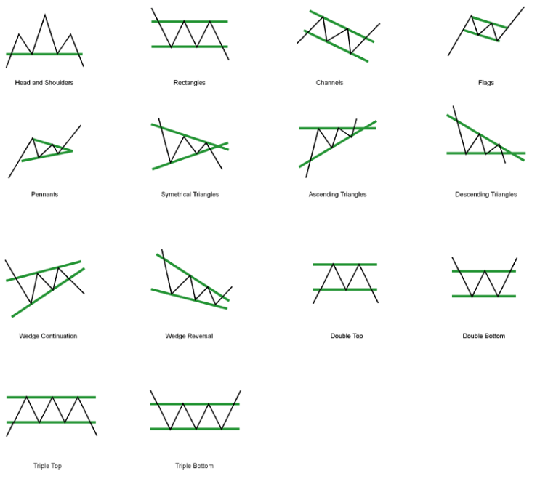
Or to memorise fib levels (23.6, 38.2, 50, 61.8, 76.4 and 100%)
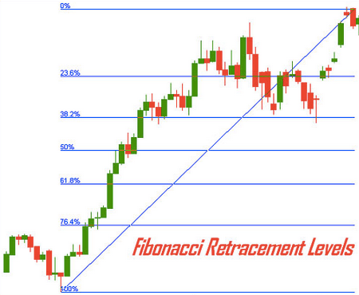

Community

There is a rapidly growing community in the cryptospace and there are many platforms that house the free flowing chat and support of each other, as well as the release of news and updates.
Facebook groups are aplenty and its not hard to find the better ones. Crypto Coin Trader is a great place to start, no question is too noob here.
Twitter is used by all the major coins and exchanges, as well as the development teams and prominent investors in crypto to keep up to date with news and releases.
Telegram also has many channels where cryptomaniacs can chat. Message me here for any questions, I will help you as best I can. Username DaveyH20.
Slack is a good place to interact with coin developers, but beware that Slack is prone to very convincing scams. Do not ever send any funds to anyone on slack, or anywhere else.

Be very wary of groups that promise to tell you what coin is going to explode, for free or for a premium. They will tell you "4 hours till we go to the moon!!!" about a coin that they have targeted, but in those 4 hours they are buying lots of it. Then they tell you what it is, you look, see huge green candles (due to their buying) and buy in, which pushes the price higher. At this point they will sell all of their coins for a huge profit, dumping the coin and leaving you in loss. This is scamming and would be illegal on Wall Street. Do not fall for it. It is commonly known as "Pump and Dump".

Thanks for reading, and I hope you learned something along the way. If you found this useful let me know on telegram and if there is anything I can help you with I'd be happy to assist.

Go forth and prosper!!
And remember...
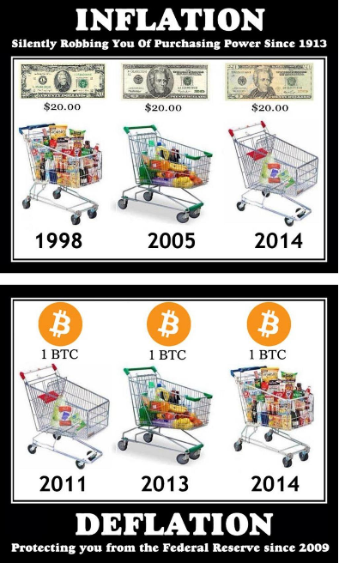

Common Cryptocurrency Trading terms and meaning
#ALTCOIN = Any crypto currency other than bitcoin.
#ASHDRAKED = A situation where you lost all your money.
#BAGHOLDER = A person who buys and hold coins in large quantity hoping to make good profits in the future.
#BEAR/BEARISH = Negative price movement
#BTFD = Buy The Fucking Dip (an indication to buy a coin when it has dumped so hard)
#BULL/#BULLISH = Positive price movement
#DILDO = Long green or red candles
#DUMP = To Sell off a coin
#DUMPING = Downward price movement
#DYOR = Do Your Own Research
#FA = Fundamental Analysis
#FIB = Fibonacci Retracement/Extension
#FOMO = Fear Of Missing Out (A coin is pumping and you get the feeling it's gonna pump more, so you buy high)
#FUD = Fear Uncertainty & Doubt
#HODL = Hold On for Dear Life
#JOMO = Joy Of Missing Out
#LONG = Margin bull position
#MACD = Moving Average Convergence/Divergence
#MCAP = Market Capitalization
#MOON = Continuous upward movement of price
#OTC = Over The Counter
#PUMP = Upward price movement
#SAJ #CANDLE = Huge green candle
#SHITCOIN = A coin with no potential value or use
#SHORT = Margin bear position
#SWING = Zig zag price movement (Upwards and downwards)
#TA = Technical Analysis
#REKT = When you have a bad loss
#REVERSE INDICATOR = Someone who is always wrong predicting price movements.
#RSI = Relative Strength Index
#WHALE = Very Wealthy trader/Market mover

