Thanks sa gumawa nito.
- Connect sa dashboard
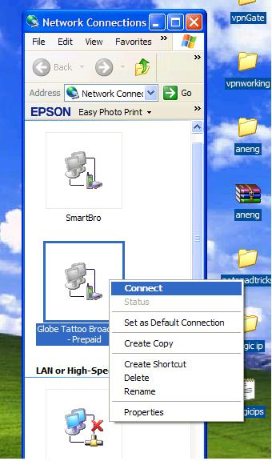
- Click dial
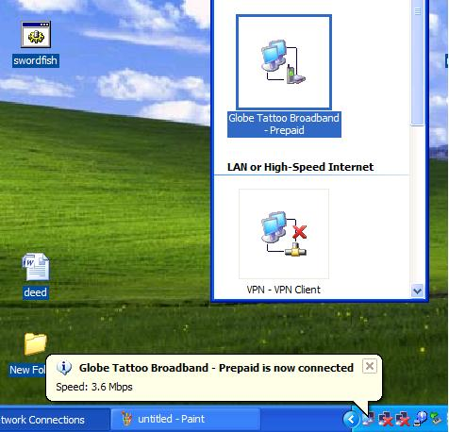
- Open browser Mozilla. Click tools/option/advance/network, then enter the this IP.
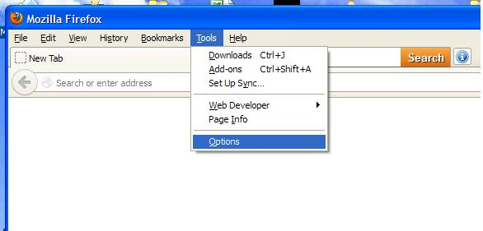
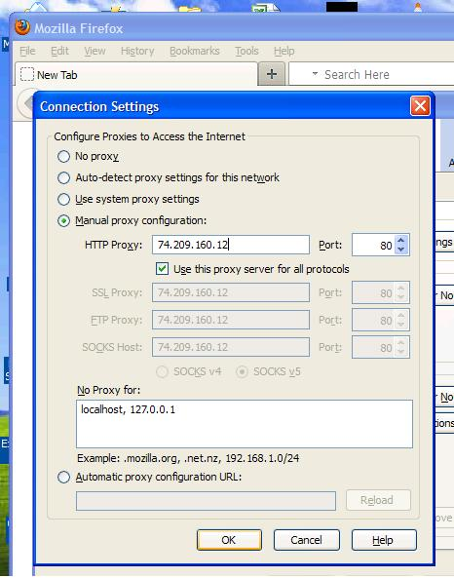
- Click OK button, open url www.youtube.com, www.google.com
Note: omit the https in order you to connect.

This trick is matagal na but still working
Repost by: swordfish

