Na-receive mo ba yung ganitong text message from 8888?
Kasi over na yung Internet data usage on Globe
- Causes (D*wnloading files, Watching Y*uTube videos)
Let's start...
Globe APN's
- myGlobe CONNECT - www.globe.com.ph (Use this APN for d*wnloading)
- myGlobe INET - http.globe.com.ph (Use this APN for browsing)
Under Options > Profile Management
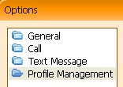
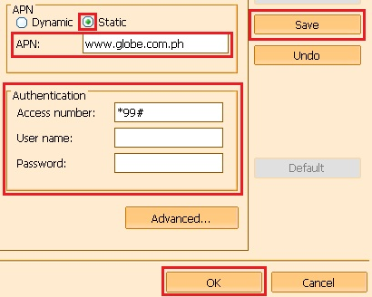
Option 1: Using UltraSurf
Procedures
1. Connect to the Internet with APN: www.globe.com.ph
2. Open UltraSurf
3. Go to Proxy Settings
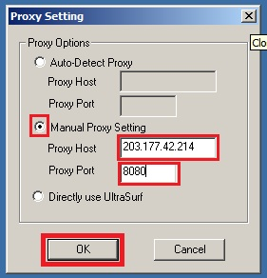
4. Restart UltraSurf
5. Wait until connect to server
6. Okay na yan
Option 2: Using Internet Speed H a c k
Procedures
- D*wnload the attachment "Internet Speed H a c k.rar"
- Connect to the internet with APN: www.globe.com.ph
- Extract the downloaded rar file.
- Run as administrator.
- Choose the "65Mbit/s (max)"
- Click pâtch.
- Go to CMD.
- Type "ping www.google.com -t" without quotes.
- Minimize the CMD. Don't close it.
- You can now browse and d*wnload. Enjoy!
Option 3: Using Web Proxy
Procedures
1. Go to www.filterbypass.me (More Web Proxy on attachments)
2. Type the website that you want to go. (Ex. Y o u T u b e)
3. Watch a video until you bypass 800 mb/1 GB/2 GB limit.
4. Observe if 8888 will message you after you bypassed the limit. Kapag wala kang na-receive na text from 8888, it means okay na yan.
5. Pwede ka na mag-d*wnload want to sawa. Haha
Proxifier Portable (Ready to Use)
[For Online gaming, T o r r e n t, and etc.]
1. D*wnload and extract the *.rar file.
2. Open Proxifier
3. Go to Profile > Proxification Rules...
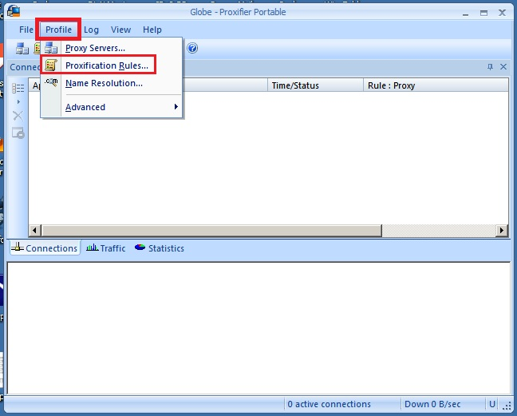
4. Click Add...
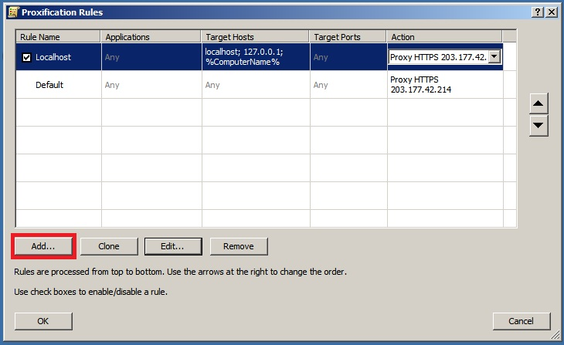
5. Browse the application. e.g.(Online game app, T o r r e n t, etc.)
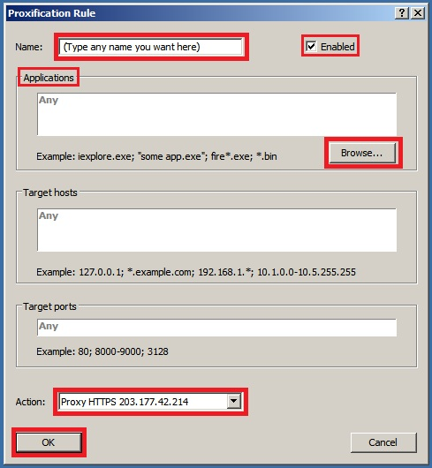
6. Then Click OK > OK
7. You can now open the application. Minimize the Proxifier.

