Mag basa.. Mag basa.. at Unawain para magawa ng maayos.​
This tool will help you unlock your android device (phone/tablet) if you forgot your pattern lock, pin lock or password. Gamitin lang po sa mabuting paraan ha. Huwag ibibigay sa mga phone snatcher.
Tested by me.
Nilagyan ko po ng Spoiler para hindi mabasa ng hindi member for safety. iclick nyo na lang po para makita ninyo yung laman.
Related Thread ==> How To Bypass/Remove Androids Screen Lock (Password, Pin Lock, Pattern Lock) Tutorial 2
Requirements:
- Device Driver (Make sure to have your device driver installed on your computer. In my case Samsung USB Driver).
- Requires root and enable Debug mode or fast boot mode.
- Android Multi Tools or ADB files (files attached)
This program works with any Android device.
Choices 1 - 6, S, H can work with Debug Mode only.
Choices 7 - 9 can work with Fastboot Mode only.
Kung Meron kayong Blue Stacks na naka install. iEnd Process mo muna lahat ng mga processes nya sa task manager para huwag mag conflict.
Using the Multi Tool
Spoiler: Click to View
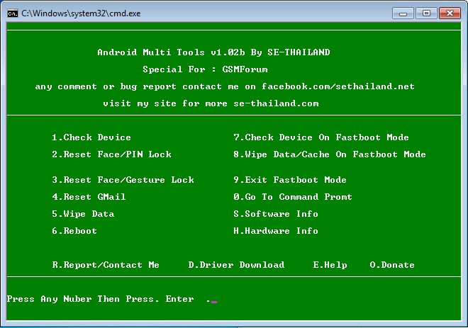
Download Android Multi Tools v1.02b.rar (file attached)
Option A
How to remove pattern lock:
- Connect your device to your computer with your usb cable
- Open "Android Multi Tools v1.02b.exe".
- Para malaman kung nadetect yung device mo, type 1 or para siguradong nadetect nga type s (makikita mo ang model ng device, android os version etc.)
- To remove pattern lock type 3 then hit enter.
- Wait na magreboot ang device bago tanggalin ang usb cable.
- Pagkatapos magreboot makikitang naka lock pa..para maunlock just draw any pattern or just touch one dot and it will be unlocked.
- Done..Mananatiling ganyan yung device mo unless gumawa ka ulit ng bagong screen lock.
How to remove Pin Lock:
- Connect your device to your computer with your usb cable
- Open "Android Multi Tools v1.02b.exe".
- Para malaman kung nadetect yung device mo, type 1 or para siguradong nadetect nga type s (makikita mo ang model ng device, android os version etc.)
- To remove pin lock type 2 then hit enter.
- Wait na magreboot ang device bago tangalin ang usb cable.
- Done..gawa ka na lang ulit ng bagong screen lock.
How to remove Password:
I don’t recommend this step, kung gusto nyong ireset yung password proceed toOption B.​
Note: this step will reset your gmail account and system settings. may hahanapin syang files, yung settings.db-shm at settings.db-wal. Pero hindi lahat ng device ay merong ganong files. Kung meron kang files na ganoon pwede mong gawin ang step na ito pero kung wala, huwag na at baka magka problema pa yung device mo, kagaya ko (pero kung magka problema man just reset your device).
- Connect your device to your computer with your usb cable
- Open "Android Multi Tools v1.02b.exe".
- Para malaman kung nadetect yung device mo, type 1 or para siguradong nadetect nga type s (makikita mo ang model ng device, android os version etc.)
- To remove password type 4 then hit enter.
- Wait na magreboot ang device bago tangalin ang usb cable.
- Done..gawa ka na lang ulit ng bagong screen lock.
Option B ( Another way to unlock your device )
- Connect your device to your computer with your usb cable
- Open "Android Multi Tools v1.02b.exe".
- Type 0 (the number zero) .
- Type adb then hit enter (to start the adb).
- Type adb shell then hit enter.
To remove the pattern lock type rm /data/system/gesture.key then hit enter. (note: importante may space: rm<space>file path).
Kung makita mong may pattern lock parin. Just draw any pattern or just touch one dot and it should unlock.​

To remove the password or pin lock, type rm /data/system/password.keythen hit enter. (note: importante may space: rm<space>file path).
Kung makita mong may password o pin lock parin. Just type any letter or number then Ok or just click Ok. Your device will be unlocked.
​
Another way to unlock you device, mag log in ka lang sa gmail account mo. Syempre kailangan ng internet connection. Yan ay kung naka turned on ang wifi ordata connection mo. Kung hindi sya naka turned on, follow this steps.
To enable wifi or data connection follow this steps:
- Connect your device to your computer with your usb cable
- Open "Android Multi Tools v1.02b.exe".
- Type 0 (the number zero) .
- Type adb then hit enter (to start the adb).
- Type adb shell then hit enter.
To enable wifi connection type svc wifi enable then hit enter.
To enable data connection type svc data enable then hit enter.
You can now log in to your gmail account.​
Using ADB
Spoiler: Click to View
kung hindi gumana o mabuksan ang Multi Tool sa windowns 8 and up. you can still unlock your device using ADB files. pareho lang naman yung steps dun sa itaas. Isetup lang muna yung ADB.​

First download the adb.zip file. (file attached)​
Setting up the ADB:
Punta kayo sa Drive C at gawa kayo ng folder, name it adb (or any name you want). Open the folder then extract adb.zip.
iCopy nyo yung path.
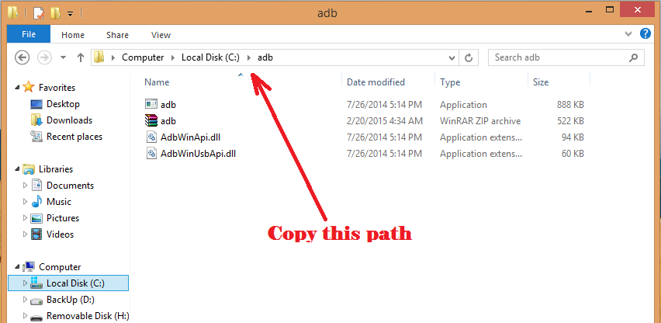
Next right click Computer then Properties then click Advance system settings.
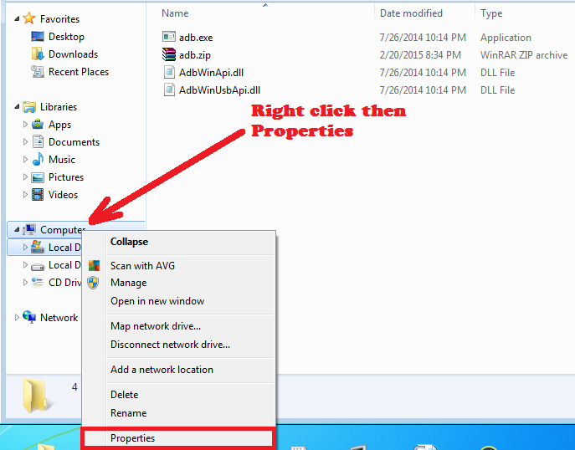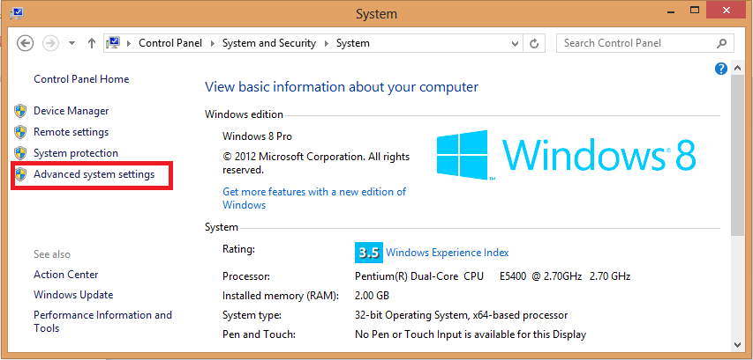
May mag pa popup na window click Environment Variables. Another window will popup
Select Path then click Edit.
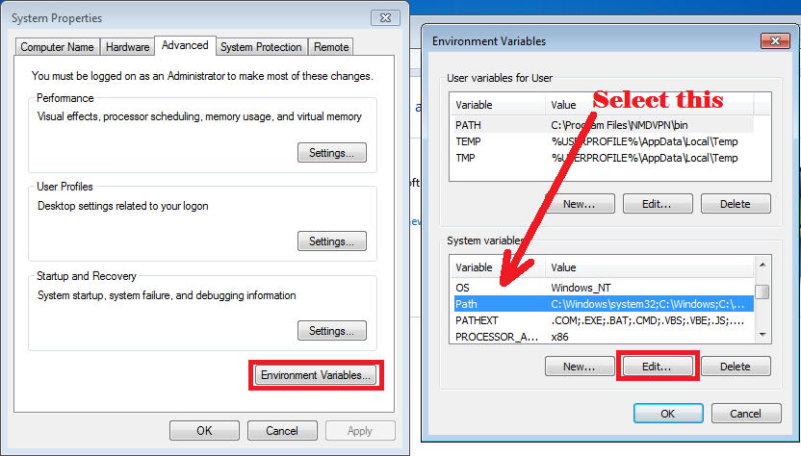
Punta kayo sa dulo ng path. Type ; (semi colon) then paste nyo yung path na kinopya nyo kanina, yung ginawa nyong folder sa C Drive (in my case C:\adb).
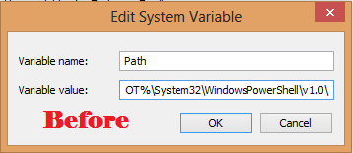 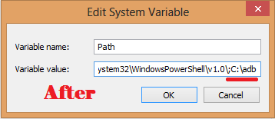
Click OK then OK then OK.
Done..
​

How to remove password, pin lock and pattern lock using adb:
- Connect your device to your computer with your usb cable.
- Open the command prompt (cmd), mas maganda irun nyo as administrator.
- Type adb (to start the adb)then hit enter.
- Type adb shell then hit enter.
To remove the pattern lock type rm /data/system/gesture.key then hit enter. (note: importante may space: rm<space>file path).
Kung makita mong may pattern lock parin. Just draw any pattern or just touch one dot and it should unlock.
To remove the password or pin lock, type rm /data/system/password.keythen hit enter. (note: importante may space: rm<space>file path).
Kung makita mong may password o pin lock parin. Just type any letter or number then Ok or just click Ok. Your device will be unlocked.​

Good Luck!

