How to update colorful motherboard BIOS in dos mode？

- Need Create a Bootable DOS USB Drive
If you cant Create a Bootable DOS USB Drive, pls see here
https://www.howtogeek.com/136987/how-to-create-a-bootable-dos-usb-drive/
- copy all bios files to the u-disk’s the root directory
- enter computer dos mode
-When you enter to dos mode, you can use “CD” or “DIR” The command
CD: can enter the subdirectory
Dir: can view all the files
-you can input the command CD dos
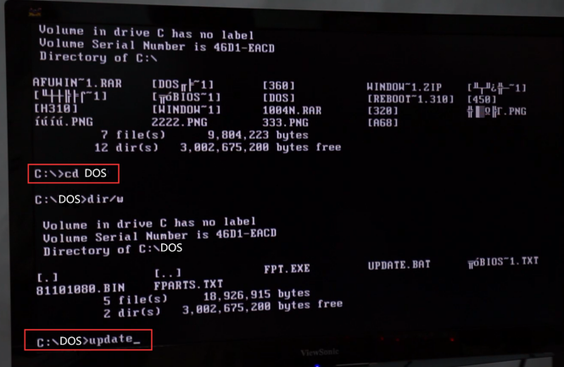
Then enter the DOS folder


Then input the command ‘update’
Then press the key ‘enter’ in the keyboard
Then wait to 100% finish, then finish, then Restart the computer, finished
Pls see here
https://youtu.be/cu-1dbhThBE
https://youtu.be/iEd-cMuX62E

Attention: when you updating the bios, don’t cut off the electricity, at last, may you success.

