



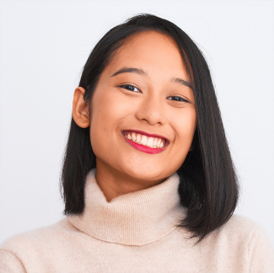
CAREER OBJECTIVE
Human Resources Specialist
Carmelo Apps
2010 - 2012
EXPERIENCE
SKILLS
- Organized and updated employment files for benefits administration.
- Managed paperwork for new employees and jobseekers.
- Helped handle employee complaints and concerns.
- Assisted new hires and led onboarding sessions.
- Supervised a team of seven members and their daily tasks.
- Liaised between staff and management to
facilitate smooth communication.
- Acquired staff members and oversaw their training.
- Monitored implementation of company guidelines and ensured staff compliance.
Human Resources Manager
XYZ Company
2012 - 2022
- Talent Acquisition & Onboarding
- Developing Employment Enrichment Programs
- Employment Law
- Interpersonal Communication
- Payroll Management
Bachelor of Science in Business Administration
Adamson University
2006 – 2012
Human Resources Manager with 12 years of experience on building and implementing strategies on people management. Expertise on recruiting, leadership development, and employee retention. Looking for a dynamic organization that will foster personal career growth as Human Resource Director.
EDUCATION
Rachel Rustia
Phone: 0918-XXXXXXX
Email: rachellrustia@webnet.com
Address: 123 Lourdes Drive, Monteritz Heights, Manila

