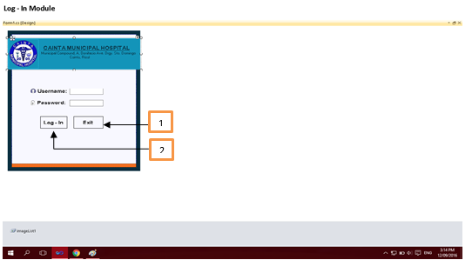

Log-in Form
- Login – button for entering the main menu.
- Exit – button for closing the system.
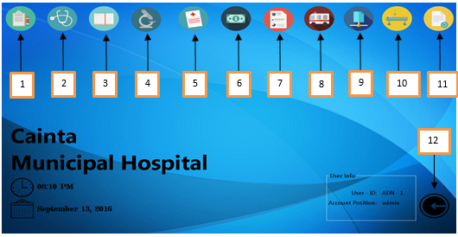

Main Menu
- Register – module for old and new patient registration.
- Doctor – module for doctor’s information.
- View patient – module for viewing and updating patient information.
- Ancillary – module for laboratory procedures including ECG, X-Ray/Ultrasound, CT-Scan.
- Result – module for viewing of results
- Billing – module for billing in admissions and transactions.
- Transaction reports – module for viewing of summary of transactions.
- Emergency – module for entering the emergency room and transferring to admitting.
- Admitting – module for admitting procedures.
- Ward – module for viewing of occupancy within the wards.
- File maintenance – module for overall updates on accounts, prices and etc.

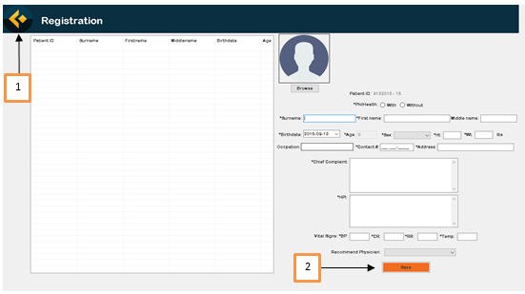
Registration
- Home – button for returning to main menu.
- Save – button for saving the information

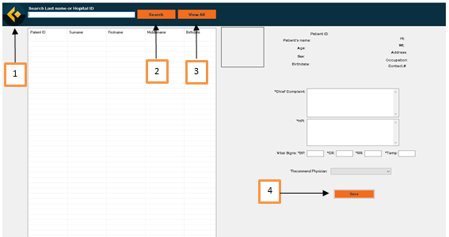
- Home – button for returning to main menu.
- Search – button for searching specific patient.
- View all – button for viewing all data.
- Save – button for saving the new specific data.
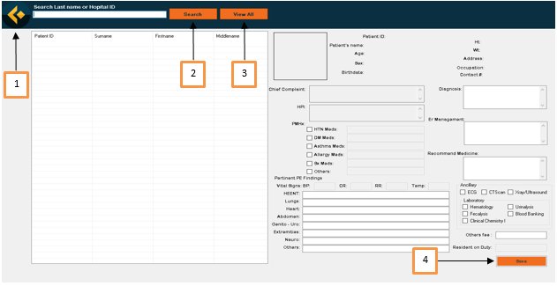
- Home – button for returning to main menu.
- Search – button for searching specific patient.
- View all – button for viewing all data.
- Save – button for saving the new specific data.
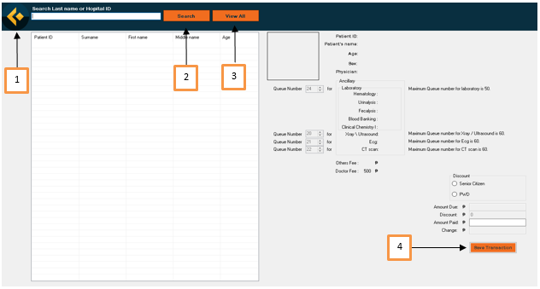
- Home – button for returning to main menu.
- Search – button for searching specific patient.
- View all – button for viewing all data.
- Save – button for saving the transaction.
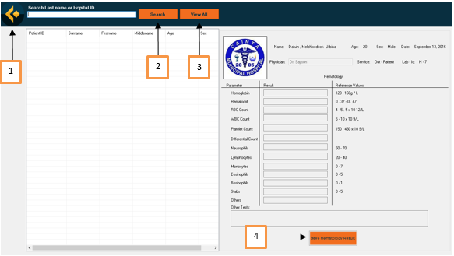
- Home – button for returning to main menu.
- Search – button for searching specific patient.
- View all – button for viewing all data.
- Save – button for saving the new specific data.
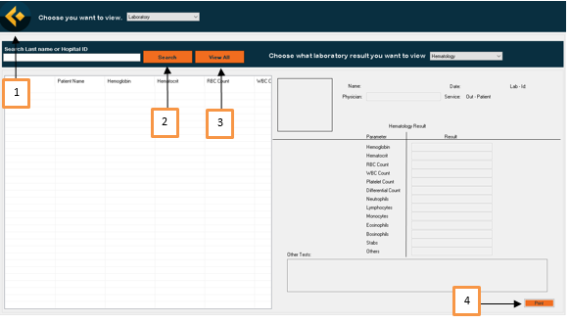
- Home – button for returning to main menu.
- Search – button for searching specific patient.
- View all – button for viewing all data.
- Print – button for printing patient result.
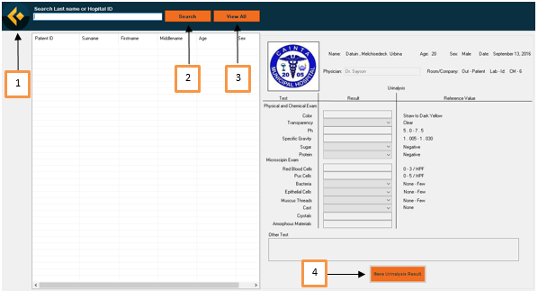
- Home – button for returning to main menu.
- Search – button for searching specific patient.
- View all – button for viewing all data.
- Save Result – button for saving urinalysis results.
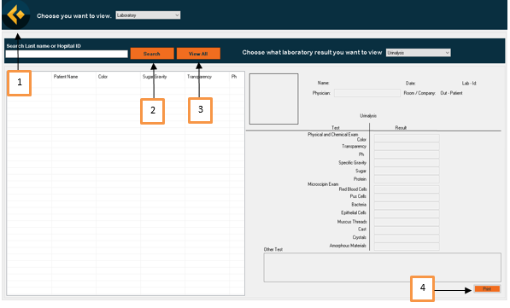
- Home – button for returning to main menu.
- Search – button for searching specific patient.
- View all – button for viewing all data.
- Print – button for printing urinalysis result.
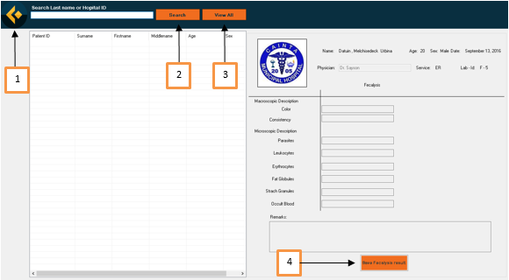
- Home – button for returning to main menu.
- Search – button for searching specific patient.
- View all – button for viewing all data.
- Save Result – button for saving fecalysis results.
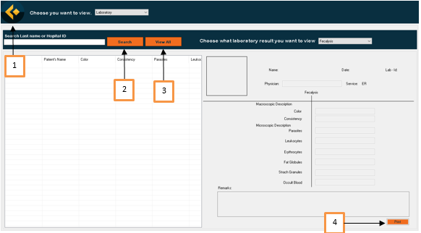
- Home – button for returning to main menu.
- Search – button for searching specific patient.
- View all – button for viewing all data.
- Print – button for printing fecalysis result.
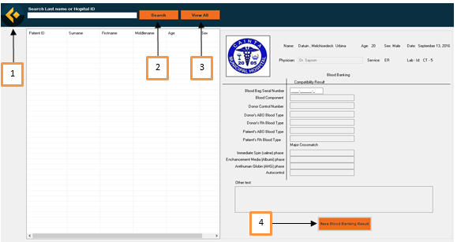
- Home – button for returning to main menu.
- Search – button for searching specific patient.
- View all – button for viewing all data.
- Save Result – button for saving blood banking results.
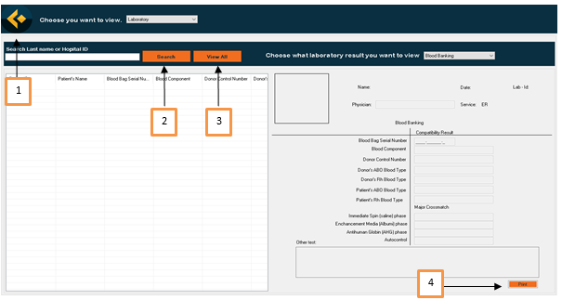
- Home – button for returning to main menu.
- Search – button for searching specific patient.
- View all – button for viewing all data.
- Print – button for printing blood banking results.
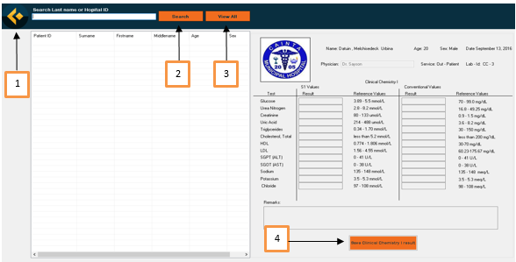
- Home – button for returning to main menu.
- Search – button for searching specific patient.
- View all – button for viewing all data.
- Save Result – button for saving clinical chemistry(1) results
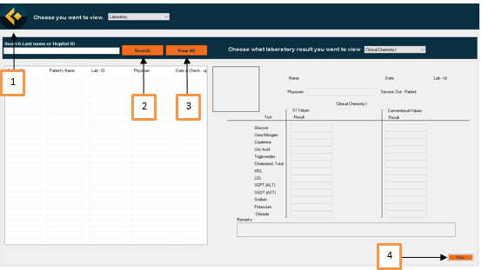
- Home – button for returning to main menu.
- Search – button for searching specific patient.
- View all – button for viewing all data.
- Print – button for printing clinical chemistry(1) results.
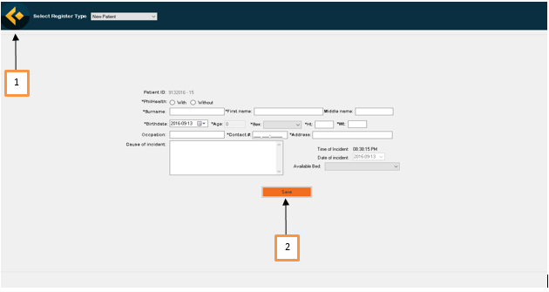
- Home – button for returning to main menu.
- Save – button for saving new patient information for emergency.

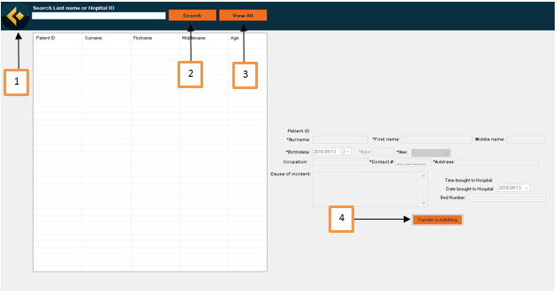
- Home – button for returning to main menu.
- Search – button for searching specific patient.
- View all – button for viewing all data.
- Transfer – button for transferring patients to admitting.
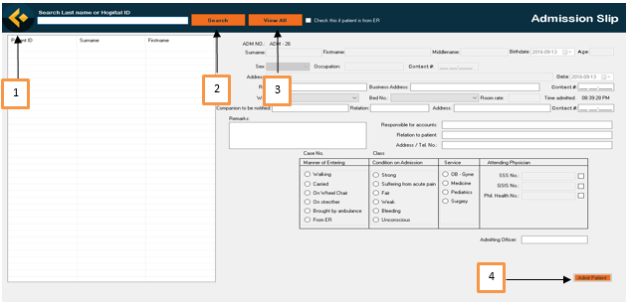
- Home – button for returning to main menu.
- Search – button for searching specific patient.
- View all – button for viewing all data.
- Admit – button for admitting a specific patient.
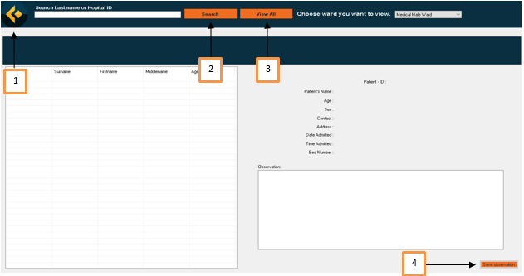
- Home – button for returning to main menu.
- Search – button for searching specific patient.
- View all – button for viewing all data.
- Save observation – button for saving the information for the observations.
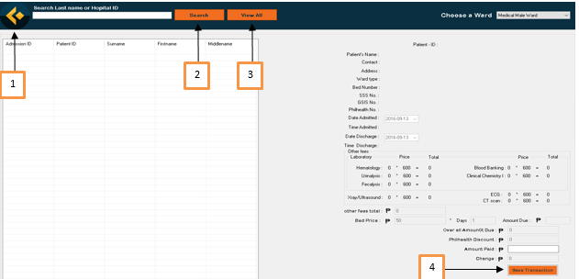
- Home – button for returning to main menu.
- Search – button for searching specific patient.
- View all – button for viewing all data.
- Save – button for saving transaction in the billing.

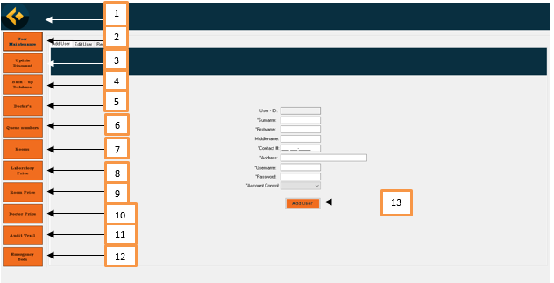
- Home – button for returning to main menu.
- User Maintenance – button for opening the panel for user maintenance.
- Update Discount – button for opening the panel for updating of discounts.
- Back-up Database – button for restoring the database.
- Doctors – button for opening the panel for physician maintenance.
- Queue numbers – button for opening the panel for changing queue numbers.
- Beds – button for adding new beds in the ward.
- Laboratory fee – button for opening the panel for changing the in the laboratory.
- Bed fee – button for changing the bed fees.
- Doctor’s Fee – button for changing the fixed price on doctor’s charge.
- Audit Trail – button for opening the panel for account’s audit trail.
- Emergency beds – button for adding new beds in the emergency room.
- Add user – button for adding a new users.

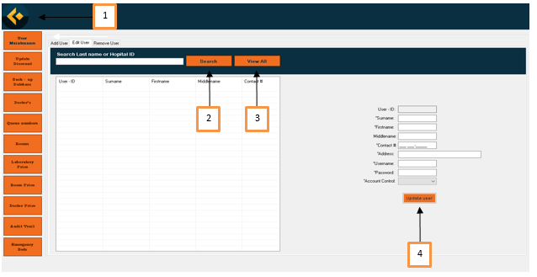
- Home – button for returning to main menu.
- Search – button for searching specific patient.
- View all – button for viewing all data.
- Update user – button for saving transaction in the billing.
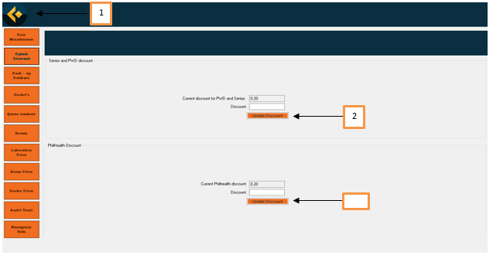
- Home – button for returning to main menu.
- Update discount – button for updating discounts on PWD and Senior Citizen.
- Update discount – button for updating discounts on Philhealth transactions.
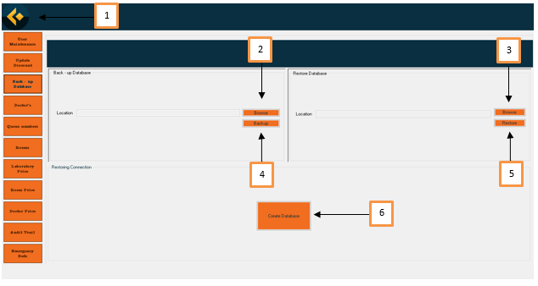
- Home – button for returning to main menu.
- Browse – button for searching the file path for backing-up the database file.
- Browse – button for searching the file path for the database file.
- Back-up – button for backing the database file.
- Restore – button for restoring the database file.
- Create – button for creating a new database.

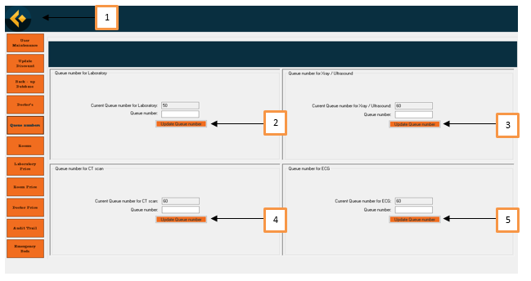
- Home – button for returning to main menu.
- Update – button used for updating or changing the queue number for laboratory.
- Update – button used for updating or changing the queue number for X-ray/Ultrasound.
- Update – button used for updating or changing the queue number for CT-Scan.
- Update – button used for updating or changing the queue number for ECG.

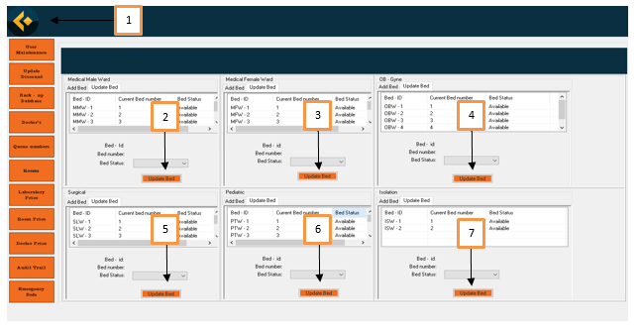
- Home – button for returning to main menu.
- Update bed – button used for updating beds in the medical male ward.
- Update bed – button used for updating beds in the medical female ward.
- Update bed – button used for updating beds in the OB-GYNE ward.
- Update bed – button used for updating beds in the Surgical ward.
- Update bed – button used for updating beds in the Pediatric ward.
- Update bed – button used for updating beds in the Isolation ward.
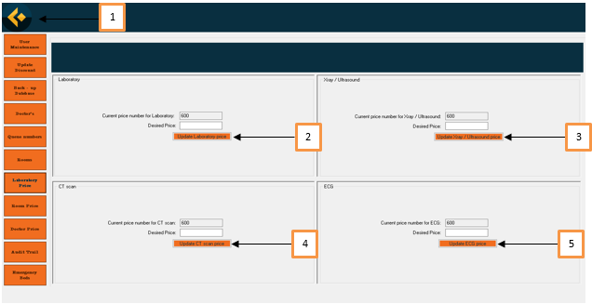
- Home – button for returning to main menu.
- Update – button for updating laboratory fee.
- Update – button for updating X-ray/Ultrasound fee.
- Update – button for updating CT-Scan fee.
- Update – button for updating ECG fee.
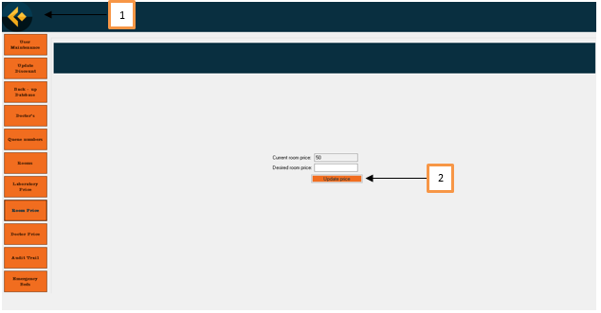
- Home – button for returning to main menu.
- Update – button for updating the price in the ward.
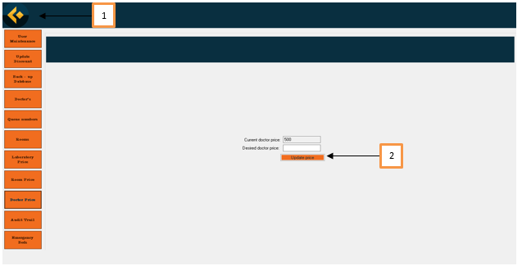
- Home – button for returning to main menu.
- Update – button for updating the doctor’s fee.

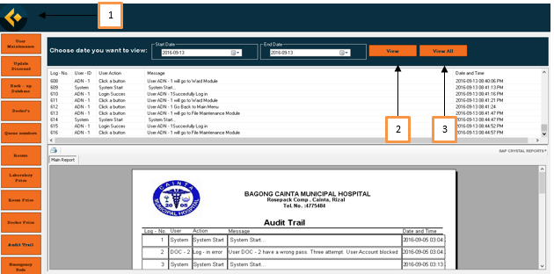
- Home – button for returning to main menu.
- View – button for viewing specific date of records of audit trail.
- View all – button for viewing the overall records of audit trail.

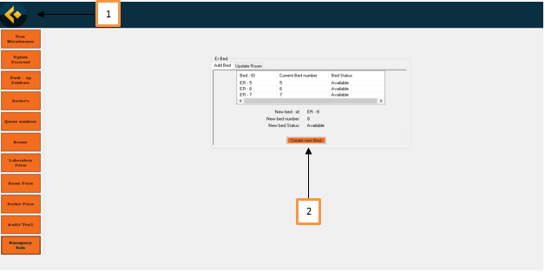
- Home – button for returning to main menu.
- Create new bed – button used for adding new beds in the emergency.

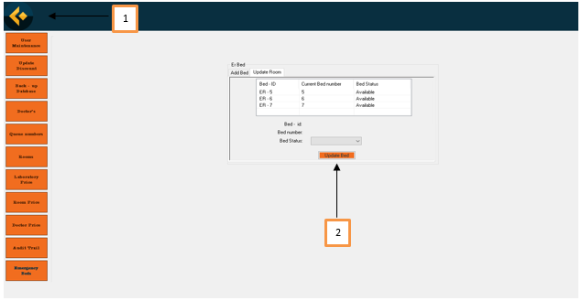
- Home – button for returning to main menu.
- Update bed – button used for updating beds in the emergency.

