Step 1:- Inserting your affected Pen-Drive into computer.
First you have to know the drive latter of your pen-drive by inserting it in your computer. It may very with another computer. When you will insert your pen-drive into computer you can see the drive latter in "Removable Disks" area as like the picture below.
Insert your pen-drive into computer.
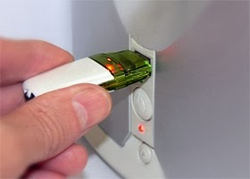

You can see the drive latter like below. You should have to remember it till last.
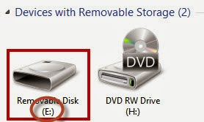

Here "E" is my removable drive latter. Yours may another, whatever remember it.

Step 2:- Opening "Command Prompt" by Run Command.
Run command can be opened by pressing "Windows Logo Key + R" from your keyboard. Once you opened "Run" type this code in it: "CMD" and press enter button.
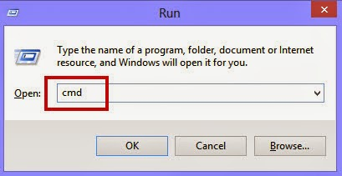

After that "Command Prompt" wizard will appear in your desktop.

Step 3:- Typing the main code of shortcut virus in command prompt
After opening command prompt you have to write a code carefully in it. The code is:
attrib –r –a –s –h /s /d (Drive Word):\*.*

You have to change in (Drive Word) as your drive latter you mentioned earlier. Something look like this:

attrib –r –a –s –h /s /d E:\*.*

Here "E" is your drive latter, Change this latter exactly as it of your pen drive.

After typing this code press enter in your keyboard.

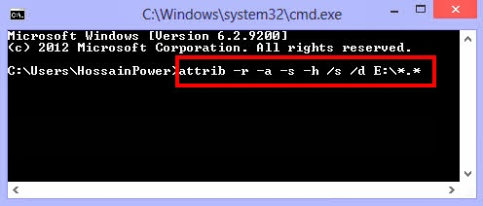

Step 4:- Copping the main files or folders you lost.
After pressing enter button "Open Your Pen Drive" and you can see your lost files and folders along with the shortcut files and folders.
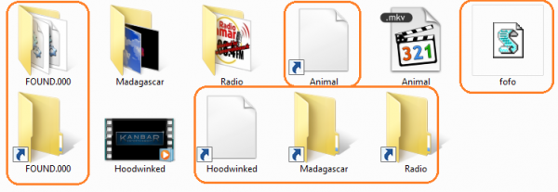
Immediately Copy Your Real Files and Folders From Pen Drive Into Your Computer.
After copying files and folders "Format" your pen drive.
So, That's It. Enjoy your virus free pen drive again.
No more today, I'll back with another post next.

