

“MAKE YOUR OCCASION LIVE YOUR EXPECTATION”

Company Profile
Business Description
Occa Events Company is a full service professional event planning company that specializes, conceptualizes, plan an events and occasions such as weddings, parties, conventions and corporate meetings. We are one of the best and capable when it comes to these events, we make sure what our client's dreams and desire come in reality.
Occa Events Company composed of professional consultant and coordinators that are all well-experienced and passionate, who works alongside our clients from concept to completion, to give them a unique and memorable event.
As one of the best companies, Occa Events Company works with passion and dedication that enables us to exceed client's expectations.
Company Logo and Tagline
The gold lining of the logo represent the importance of events that we are handling because we want to assure that our customers are in good hands.
As you can observe, the letter A in the end of the word Occa is bigger than the sizes of other letters because it represent the words: Assuring an Astonishing Aftermath.
The logo is also made simple and elegant because we wanted to make the customer feel through the logo that even simplicity can give elegance.

“MAKE YOUR OCCASION LIVE YOUR EXPECTATION”

“Make your Occasion live your expectation” This is our tagline inspired by the famous trend expectation vs reality. But to make things different, the event we will create will no longer need the versus because we will give you the best and you will get what you expect.

Vision Statement
To be the most trusted event management business in the Philippines, recognizes for its high level of service quality. To bring the most efficient methods for planning and creating once-in-a-lifetime events, with each event exceeding everyone's expectations, providing continuous growth of both staff and technology.

Mission Statement
To be the instrument in creating and producing client’s events dream while saving their most precious time and money. To provide maximum satisfaction to our valuable costumers.

Objectives
- Experience the quality, memorable, and budget friendly event plans.
- Ensures the client's satisfaction in the outcome of the service.
- Manage all areas of events, from pre-planning through the event day and post- event activities.
- Showcase the client's preferences through creativity and innovations.
- Maintain good rapport with the client through updating and seeking approval about planning of events.

Proposal Letter to the Client

1 November, 2022

Mr. Prince Matthew Barquilla
Owner
PMB Corporation
San Leonardo, Nueva Ecia
09106895413

Dear Mr. Barquilla,

Greetings!

Thank you for entrusting Occa Events Company with such an important day in your life. The Occa Events Company is thrilled to take part in your forthcoming wedding. The business, one of the greatest event planners, will make sure to provide great offers for you. Since the business has been operating in the industry for almost ten years, Occa's has proven its value by going above and beyond to meet all of its clients' expectations and celebrate their important occasions with remarkable services Occa Events Company is one of the most reputable event management companies in the country based on the positive client feedback. The business will do everything in its ability to ensure that the upcoming event will result in the realization of your dreams..

You mentioned during our initial meeting that your wedding will take place on June 18, 2023, 9:00 AM with 150 guests and the theme "Our Love and His Will," at the Casa Granja Events Venue, with a budget allocation of P400,000.

Rest assured that the company will do all possible to please you and your guests and make the event memorable. Occa Events Company is in charge of providing all the goods and services needed for the event, from initial planning and conceptualization to final implementation. You can contact us using the details at the bottom of this letter for any clarifications or further information regarding the event. Thank you, and enjoy your day!

Respectfully yours,
APRIL JOY UBERAS
Event Manager
Occa Events Company

Proposal Letter to the Suppliers

28 November, 2022

Mrs. Janet A. Caymo
Owner
Foodelights
San Leonardo, Nueva Ecia
09369065412

Dear Mrs. Caymo,

Greetings!

On June 18, 2023, the company, Occa Events Company, will oversee a wedding celebration with the theme "Our Love and His Will." 150 guests will be present at the event. At precisely 9:00 AM, the aforementioned event will be held at Casa Granja Events Venue in Gapan City, Nueva Ecija.

We would like to let you know that your shop has been selected as a provider of cupcakes and a three-layer fondant cake. Regarding this, we would want to get a price quote on your programs. The items we require are as follows:

3 Layer Fondat Cake
- White, Blue and Silver colors
- Fresh lavender, gilded leaves and faded pastel blooms
- Brush with mettalic gold
- Bride and Groom Topper

Cupcakes
- Chocolate Flavor
- Vanilla Flavor

You can contact us using the details at the bottom of this letter if you have any questions about this matter. Let's join forces to make this occasion memorable. Thank you, and enjoy your day!

Respectfully yours,
APRIL JOY UBERAS
Event Manager
Occa Events Company

EVENT BRIEF

Contact  Coordinator | Ms, April Joy Uberas  OccaEvents Company  Mallorca, San Leonardo, Nueva Ecija  09157303451  occaeventscompany@gmail.com
Event | Wedding
Name of Event | “Our Love and His will”
Purpose | To celebrate the love and union of two different people.
Theme | Blue and White Formal Attire
Client | Mr. Prince Matthew Barquilla
Day/Date | Sunday/ 18 June 2023
TIME
Church | 9:00 - 12:00 NN
Reception | 12:30 - 3:30 PM
Budget Allocation | 400,000
VENUE AND LOCATION
Church | New Hope Baptist Church
Reception | Casa Granja Events Venue
No. of Guest | 150
Guests/Participants | Family, Churchmates, Friends and Colleague
No. Of Staff | 10
Invitation | It will distributed on month before the wedding.
Permit | It will be secured from Municipal IATF.
Parking Access | Church and Reception Venue’s Parking Area |(with signages)
Directional Signage | Parking Space, Entrance and Exit, Comfort Room and Emergency Exit.
Audio Visual Set- Up | Sound System, Microphone and Projector.
Set- Up | Refer to church and reception floor plan.

EVENT TIMELINE

ACTIVITIES | DATE
Contract Signing to Client (Initial Payment of 50 %) | November 3, 2022
Planning and Preparation | November 10, 2022 - June 13, 2023
Selection of Suppliers | November 28, 2022- December 12, 2022
First Meeting with Suppliers | December 15, 2022
Sending of Contract to Suppliers | December 20, 2022
Contract Signing to Suppliers | December 21, 2022 - December 23, 2022
Second Meeting with Client | December 26, 2022
First Meeting with Working Committee | January 15, 2023
Second Meeting with Suppliers (Payment) | February 18, 2023
Special Permits (IATF) | February 20, 2023
Final Meeting with Client (Payment for 50% remaining) | March 3, 2023
Final Meeting with Working Committee | May 5, 2023
Ingress | June 18, 2023 6AM-9AM
Engress | June 18, 2023 6PM-9PM
Post Meeting with Client | June 20, 2023
Post Meeting with Working Committee | June 22, 2023

BUDGET PROPOSAL
 | AMOUNT
VENUE | P 55,000.00
Space for reception
Space for ceremony
Parking lot & space freight
Generator
Projector & Screen
Stage
CATERING SERVICES | 67,500
Food: 150 pax
Dessert Buffet
Wine & Liquor
Lechon
Table & chairs
Linen, table napkins & skirting, Knives
Waiters
Table Sep Up
Tent
VIDEO/PHOTOGRAPHER | 25,000.00
3 Photographer
1 Videographer
Full edited video
Raw & edited pictures
SDE
- Pre-nup photo shoot
- Files & footage on flash drive
- Photo album
- Free USB
LIGHTS & SOUNDS | 10,000.00
Lights for Venue
Spotlight
Sound system
Sound generator & electrician
Wireless microphone
INVITATIONS | 6000.00
CAKE | 15,000.00
VENUE DECORATION | 28,400.00
Florist
Flowers
Accessories
OTHER ITEMS | 22,500.00
Souvenirs
Balloons
Special Paper
MAKE UP & HAIR STYLIS (PACKAGE) | 15,000.00
ATTIRE | 30,000.00
Bridal Gown
Grooms Tuxedo
Bridesmaid (5)
Groomsmen (5)
Maid of Honor
Best Man
Flower Girl (3)
Bearers (3)
BRIDAL CAR | 3,000.00
HOTEL | 14,000.00
7Days
JEWELRY | 10,000.00
Wedding Ring Paired
TOTAL EXPENSES | P 301,400.00
CONTINGENCY FUND: 15 % | 45,200
TOTAL EXPENSES AND CONTINGENCY FUND | 346,600
PROFESSIONAL FEES: 15 % | 51,990
GRAND TOTAL | 398,590

FLOOR PLAN
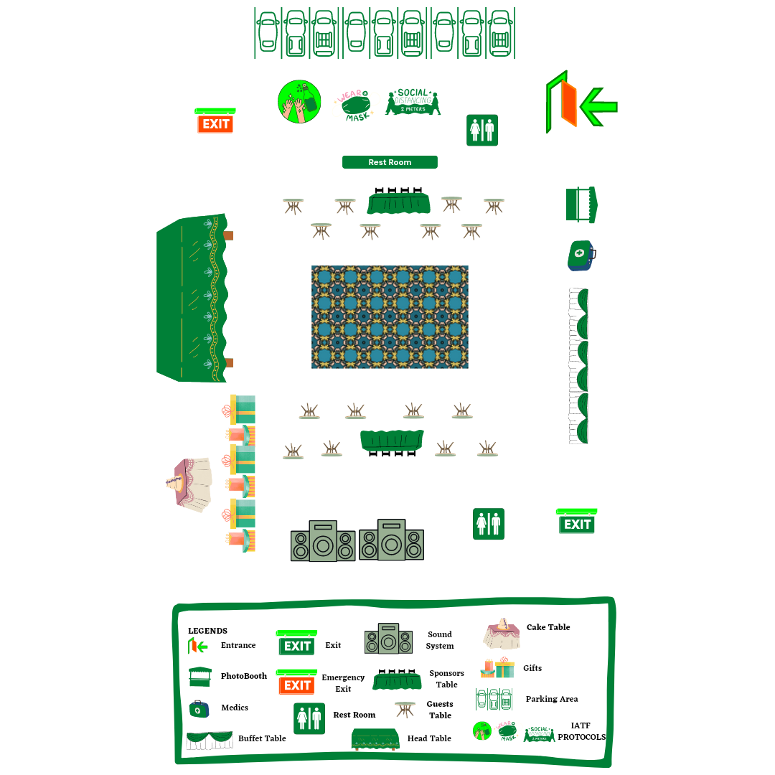

WORKING COMMITTEES
STAFF | AREA | REQUIREMENTS | FUNCTION
Staff 1 | Front Stage | Program Flow | Master of the Ceremony
Staff 2 | Entrance | List of Invitees | Welcoming the Guest
Staff 3 | Entrance | List of Invitees | Assisting the guest and sponsors to their assigned seat.
Staff 4 | Table and Chair Area | Floor Plan | Arranging table seating.
Staff 5 | Medics Area | IATF Protocol | Reminding guests to wear facemask and maintain social distancing.
Staff 6/Technical | Sound System | Program Flow, List of requested musics. | Operator and Technician
Staff 7 | Rest rooms | Cleaning Materials | Maintaining the cleanliness of the restrooms.
Staff 8/ Traffic Enforcer | Parking Area | List of Invitees | Assisting guest in parking area.
Staff 9/Security | Shoreline | Safety and Security Items | Secure the safety of the Guests
Staff 10 | Venue/Exit and Emergency Exit | Program Flow, List of Invitees, Floor Plan, List and contact of supplier. | Assigned to manage any unforeseen event.

LIST OF SUPPLIERS
COMPANY NAMES | SERVICES
Casa Granja Events Venue, Inc. | Reception & Ceremony
Flairs Catering Services | Catering
Local Photography | Photos and Videos
ENO lights and sound systems | Lights and Sounds
Invitations for less | Invitations
Foodelights | Wedding Cake and Cupcake Supplier
Juanita’s Gift Shop | Souvenir Supplier
Party Den Blooms & Event | Venue and Stage Decorations
Makeup Artistry by Matthew Ng | Make Up and Hair Style
Rene Vicencio Bridal Shop | Wedding Dress
Carbnb Booking Page | Bridal Car/ Transportation
Camp Paraiso Hotel and Resort | Honeymoon
Unisilver | Jewelry

LIST OF ALTERNATIVE SUPPLIERS
COMPANY NAMES | SERVICES
Chrishel’s Catering @ Bahay Kawayan Resort | Reception & Ceremony
Server’s Catering Services | Catering
AJ Prints and Videos | Photos and Videos
Soundbox Sound System | Lights and Sounds
Almers Advertising & Printing Supplies | Invitations
Haezzel’s Cups n’ Cakes | Wedding Cake and Cupcake Supplier
Jowies Gift Shop | Souvenir Supplier
Design and Decorations Birthday Party, Debut, Wedding | Venue and Stage Decorations
Margaux Make up Artistry | Make Up and Hair Style
Ate Malou’s Bridal Gown and Barong | Wedding Dress
Nick Motorcycle Gallery | Bridal Car/ Transportation
Marquez Residencia | Honeymoon
Ricel’s Jewellery | Jewelry

\
DETAILED BUDGET PROPOSAL
Event: Wedding Client: Mr, Prince Matthew Barquilla
Budget Alloted: P400,000 Attendees: 150 pax
Day/Date/Time: Sunday, June 18, 2023, 9:00 AM-3:00 PM

VENDOR/LOCATION | SERVICES | PARTICULARS |  | AMOUNT | TOTAL
Casa Granja Events Venue, Inc. | Venue | Space for reception |  | P20,000
Casa Granja Events Venue, Inc. | Venue | Space for ceremony |  | 20,000
Casa Granja Events Venue, Inc. | Venue | Parking lot & space freight |  | 10,000
Casa Granja Events Venue, Inc. | Venue | Generator |  | 2,000
Casa Granja Events Venue, Inc. | Venue | Projector & Screen |  | 1,000
Casa Granja Events Venue, Inc. | Venue | Stage |  | 2,000
P55,000
Flairs Catering Services | Catering Services | Food: 150 pax x 200 |  | 37,000
Flairs Catering Services | Catering Services | Dessert Buffet |  | 4,500
Flairs Catering Services | Catering Services | Wine & Liquor |  | 10,000
Flairs Catering Services | Catering Services | Lechon |  | 6.000
Flairs Catering Services | Catering Services | Table & chairs  Linen, table napkins & skirting, Knives  Waiters  Table Sep Up  Tent |  | 10,000
67,500
Local Photography | Video/Photographer | 3 Photographer
Local Photography | Video/Photographer | 1 Videographer
Local Photography | Video/Photographer | Full edited video
Local Photography | Video/Photographer | Raw & edited pictures
Local Photography | Video/Photographer | SDE
Local Photography | Video/Photographer | Pre-nup photo shoot
Local Photography | Video/Photographer | Files & footage on flash drive
Local Photography | Video/Photographer | Photo album
Local Photography | Video/Photographer | Free USB
25,000
ENO lights and sound systems | Lights & Sounds | Lights for Venue
ENO lights and sound systems | Lights & Sounds | Spotlight
ENO lights and sound systems | Lights & Sounds | Sound system
ENO lights and sound systems | Lights & Sounds | Sound generator & electrician
ENO lights and sound systems | Lights & Sounds | Wireless microphone
10,000
Invitations for less | Invitations | Invitations 75pcs x 80php |  | 6,0000
6,000
Edna’s Cakeland | Cake | 3 layers Fondant Cake |  | 10,000
Edna’s Cakeland | Cake | Cupcakes 100pcs x 50php |  | 5,000
15,000
Juanita’s Gift Shop | Souvenirs | Favors 150pcs x 150php |  | 22,500
22,500
Party Den Blooms & Event | Venue Decoration | Florist |  | 10,000
Party Den Blooms & Event | Venue Decoration | Fresh Flowers |  | 2,400
Party Den Blooms & Event | Venue Decoration | Artificial Flowers |  | 8,000
Party Den Blooms & Event | Venue Decoration | Accessories |  | 8,000
28,400
Makeup Artistry by Matthew Ng | Make Up and Hair Stylist | Complete Package |  | 15,000
15,000
Rene Vicencio Bridal Shop | Attire | Package |  | 30,000
Rene Vicencio Bridal Shop | Attire | Bridal Gown
Rene Vicencio Bridal Shop | Attire | Grooms Tuxedo
Rene Vicencio Bridal Shop | Attire | Bridesmaid (5)
Rene Vicencio Bridal Shop | Attire | Groomsmen (5)
Rene Vicencio Bridal Shop | Attire | Maid of Honor
Rene Vicencio Bridal Shop | Attire | Best Man
Rene Vicencio Bridal Shop | Attire | Flower Girl (3)
Rene Vicencio Bridal Shop | Attire | Bearers (3)
30,000
Carbnb Booking Page | Transportation | Bridal Car |  | 3,000
3,000
Camp Paraiso Hotel and Resort | Hotel | 1 Room for 7 days |  | 14,000
14,000
Unisilver | Jewelry | Wedding Ring Paired |  | 10,000
10,000
TOTAL EXPENSES |  |  | P 301,400.00
CONTINGENCY FUND: 15 % |  |  | 45,200
TOTAL EXPENSES AND CONTINGENCY FUND |  |  | 346,600
PROFESSIONAL FEES: 15 % |  |  | 51,990
GRAND TOTAL |  |  | 398,590

DETAILED PROGRAM FLOW
TIME | FLOW | ALLOTED TIME | IN CHARGE | FUNCTION | REQUIREMENTS
9:00 – 9:55 | Arrival of Participants & Guests ( Wedding Ceremony) | 55 minutes | Staff 2 and 5 | - Welcoming the Guest  - Reminding guests to wear facemask and maintain social distancing. | - List of Invitees  - IATF Protocol  Secure the following:  - Program  - Participants  - Program Host  - Video/Photographer  - Sound System  - Projector  - Traffic Enforcer  - Officiant  - Staffs  - Technical Staff  - Security
9:55-10:05 | Entrance of the Guests | 10 minutes | Staff 3 | - Assisting the guest and sponsors to their assigned seat. | - List of Invitees  - Floor Plan  Secure the following:  - Guests  - Microphones  - Staffs  - Security  - Officiant
10:05-10:20 | Prelude Processional Opening | 15 minutes | Officiant | Officiating the wedding ceremony | Secure the following:  - Microphone  - Program  - Groom  - Bride  - Grooms/Bride Father  - Videographer/Photographer
10:20-10:30 | Rose Ceremony | 10 minutes | Officiant | Officiating the wedding ceremony | Secure the following:  - Program  - Microphone  - Groom  - Brides  - Grooms Mother  - Brides Mother  - Photographer&Videographer
10:30 – 10:3 | Readings | 5 minutes | Officiant | Officiating the wedding ceremony | Secure the following:  - Microphone
10:40-10:45 | Cord Ceremony | 5 minutes | Officiant | Officiating the wedding ceremony | Secure the following:  - Microphone  - Groom  - Bride  - Sponsors  - Cord  - Photographer& Videographer
10:45-10:55 | Coin Ceremony | 10 minutes | Officiant | Officiating the wedding ceremony | Secure the following:  - Microphone  - Groom  - Bride  - Sponsors  - Best Man  - Arras/Coins  - Photographer&  Videographer
10:55-11:00 | Removal of Veil and Cord | 5 minutes | Officiant | Officiating the wedding ceremony | Secure the following:  - Microphone  - Groom  - Bride  - Sponsors  - Photographer & Videpgrapher
11:00-11:15 | Exchange of Vows | 15 minutes | Officiant and Staff 6 | Officiating the wedding ceremony  Operator and Technician | Secure the following  - Microphone  - Groom  - Bride  - Photographer&  - Videographer  - Background Music “A Thousand Years”
11:15-11:25 | Exchange of Rings | 10 minutes | Officiant and Staff 6 | Officiating the wedding ceremony  Operator and Technician | Secure the following:  - Microphone  - Groom  - Bride  - Best Man  - Ring  - Photographer & Videographer  - Background Music “Perfect”
11:25-11:30 | Blessing of the Hand | 5 minutes | Officiant | Officiating the wedding ceremony | Secure the following  - Microphone  - Groom  - Bride  - Photographer&  - Videographer
11:30-11:40 | Lightning of the Unity Candle | 10 minutes | Officiant and Staff 6 | Officiating the wedding ceremony  Operator and Technician | Secure the following  - Microphone  - Groom  - Bride  - Candle  - Photographer&  Videographer
11:40-11:50 | Pronouncement | 10 minutes. | Officiant | Officiating the wedding ceremony | Secure the following:  - Microphone  - Groom  - Bride  - Photographer& Videographer
11:50-11:55 | Closing | 5 minutes | Officiant | Officiating the wedding ceremony | Secure the following:  - Microphone  - Groom  - Bride  - Photographer& Videographer
11:55-12:00 | The Kiss | 5 minutes | Officiant | Officiating the wedding ceremony | Secure the following:  - Microphone  - Groom  - Bride  - Photographer& Videographer
12:00-12:05 | Recessional | 5 minutes | Staff 6 | Operator and Technician | - Background Music “ All you need is Love”  - Photographer& Videographer
12:05-12:10 | Cocktail Hour | 5 minutes | Photographer& Videographer | Capture moments in events. | - Newlyweds
12:10-12:15 | Guests Arrival (Reception) | 5 minutes | Staff 2, 5 and 9 | Welcoming the Guest  Reminding guests to wear facemask and maintain social distancing.  Guides the guests towards the reception hall | - Guests  - Security
12:15-12:20 | Newlywed Arrival (Reception) | 5 minutes | Staff 6 | Operator and Technician | Background Music “ At Last”  - Newlyweds.  - Photographer& Videographer
12:2012:25 | First Dance | 5 minutes | Staff 6 | Operator and Technician | Background Music “All of Me”  - Photographer& Videographer
12:25-12:30 | The Welcome Speech | 5 minutes | Father of the Groom/Bride |  | - Microphone
12:30 – 1:30 | Let’s Eat | 1 hour | Cater | Serve foods to guests. | - Food  - Background Music “Jazz songs”  - Photographer& Videographer
1:30 – 1:40 | Cheers (Heartfelt Speeches for the Newlywed) | 10 minutes | Maid of Honor & Best Man  Staff 6 | Operator and Technician | - Microphone  - Background Music “Romantic Songs”  - Photographer& Videographer
1:40 – 1:50 | Family Dances | 10 minutes. | Event Host  Staff 6 | Hosting of Events  Operator and Technician | - Microphone  - Background Music “Romantic Songs”  - Photographer& Videographer  - Newlywed  - Goom Parents  - Brides Parent
1:50 – 2:20 | Dancing (Bouqet throw/Garter throw) | 30 minutes | Event Host  Staff 6 | Hosting of Events  Operator and Technician | - Microphone  - Background Music “Pop Songs”  - Newlywed  - Bouqet/Garter  - Photographer& Videographer  - Guests
2:20 – 2:35 | Desert Time (Cutting Ceremony) | 15 minutes | Event Host  Cake Supplier  Staff 6 | Hosting of Events  \  Supply cake and cupcakes  Operator and Technician | - Microphone  - Newlywed  - Cake  - Photographer& Videographer  - Background Music “Jazz Songs”
2:35 – 3:05 | Party on | 30 minutes | Staff 6 | Operator and Technician | - Background Music “Pop/Dance Songs
3:05 – 3:30 | The Grand Finale | 25 minutes | Event Host  Staff 6 | Hosting of Events  Operator and Technician | - Microphone  - Background Music “Gratitude Songs”  - Newlywed  - Photographer& Videographer  - Guests

SAMPLE INVITATION
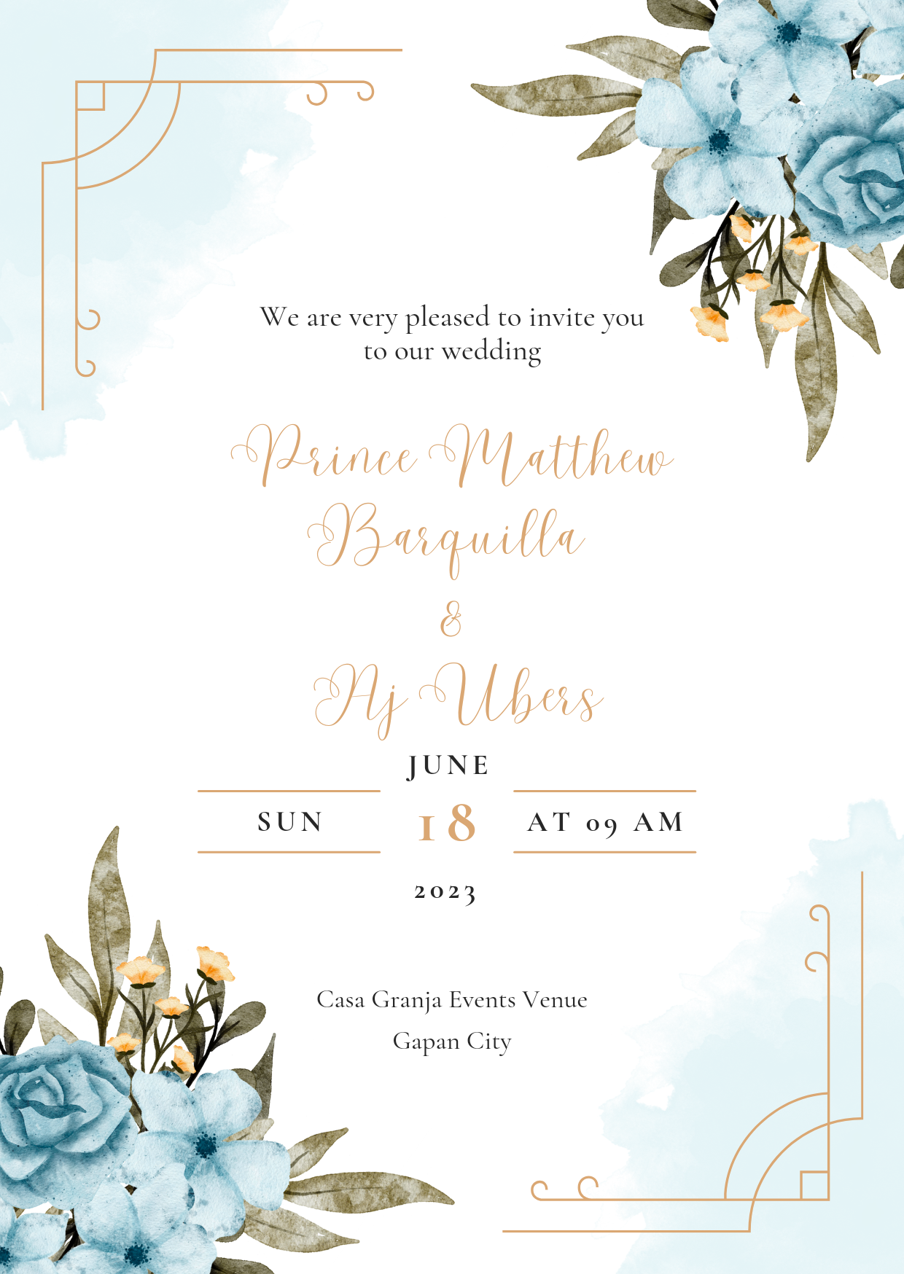
FRONT

BACK
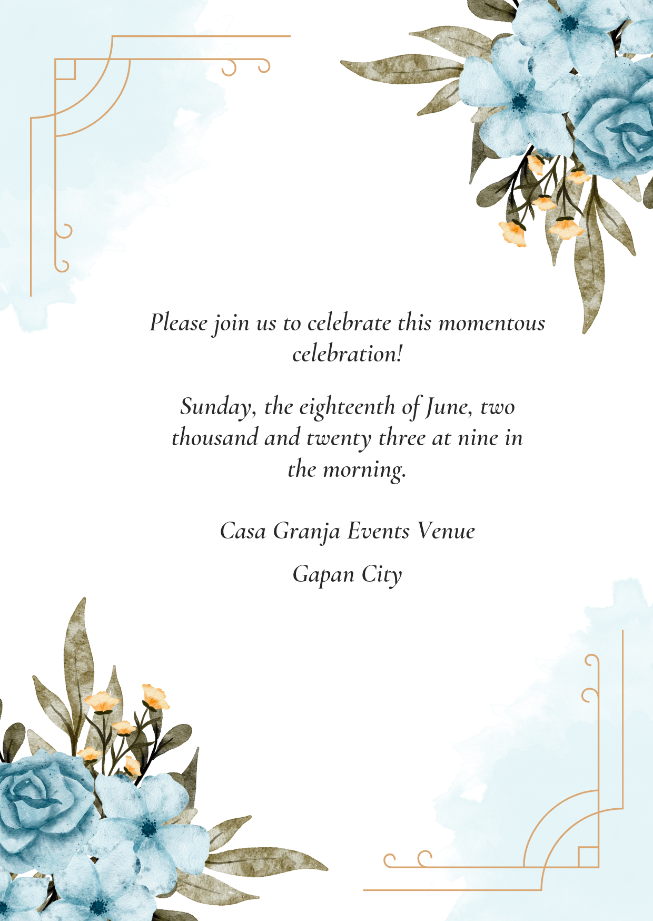

LIST OF MENU
 | SET A  Flairs Catering Services | SET B  Server’s Catering Services | SET C  Plaza Leticia
Buffet Lunch | Plain Rice | Plain Rice | Plain Rice
Buffet Lunch | Beef Caldereta | Calamaris | Chicken Cordon Bleu
Buffet Lunch | Buttered Shrimp | Beef Mushroom | Menudo
Buffet Lunch | Chopseuy | Chpseuy | Beef Caldereta
Buffet Lunch | Fish Fillet | Carbonara | Sizzling Tofu
Buffet Lunch | Chicken Cordon Bleu | Fried Chicken | Buttered Shrimp
Buffet Lunch | Honey Butter Chicken | Pork Spareribs | Chopseuy
Buffet Lunch | Kare-Kare | Tuna Fillet | Pancit
Buffet Lunch | Pork Lumpia | Pork Sisig | Pork Lumpia
Buffet Lunch | Lechon | Lechon | Lechon
Dessert | Fruits | Ice Cream | Leche Plan
Dessert | Coffe Jelly | Milky Gelatin | Mango Tapioca
Drinks | Ice Tea | Lemonade | Pineapple Juice
Drinks | Red Tea | Orange Juice | Lemonade
Drinks | Water | Water | Water
Snacks | Club House Sandwich | Pizza | Fries
Snacks | Nachos | Mini Burger | Chees Roll

RISK MANAGEMENT
RISK | CAUSE | CONTINGENCY PLAN
Absence of Attendees | Emergency Matter | - Call/remind all participants a day before the event.  - In case of absence, have a substitute for the family member
Running out of Food | Large number of unexpected guest | - Use Contingency Fund
Congested Parking | Too much vehicles | - Ensure the parking area upon confirmation of guests.  - Coordinate properly for the estimated guest vehicle
Injury | Accident (Stampede) | - Medic/Ambulance
Sound System | Technical problem | - Back up sound system set
Brawl | People fighting | - Security/Police

