Why To Download Torrent Files With Idm:
1)As Downloading With Internet Download Manager will Give Us Greater Download Speed.
2)IDM speed Doesn’t Depend On Seeder And Leechers but Caching With Zbigz Will Depend On seeders And Leechers.
3)You can also Download Torrents Where Torrent SItes Are blocked.

How To Download Torrent With IDM Via Zbigz.com:
1)Go To A Torrent Site And Download A Torrent,that you want to Download With IDM.
2)Go To Zbigz.com
3)Sign Up For A free Account Or You Can Also Go For A Premium Account.
4)Upload The Torrent To zbigz.com and then Click On Go.
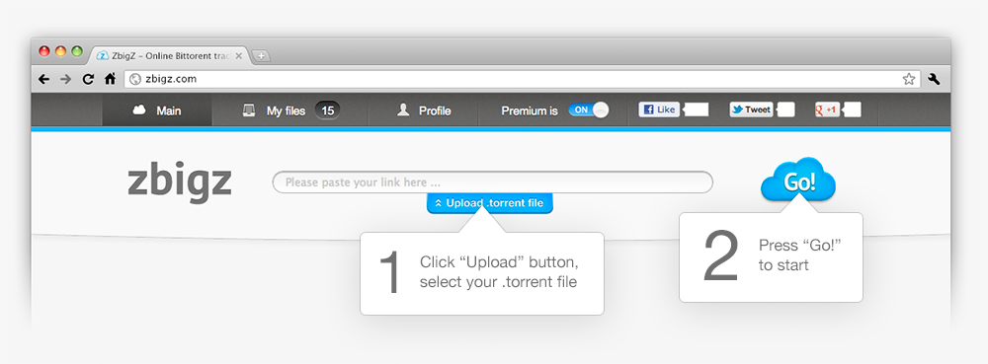

5)Then A window Will open asking FOr Free OR PRemium.
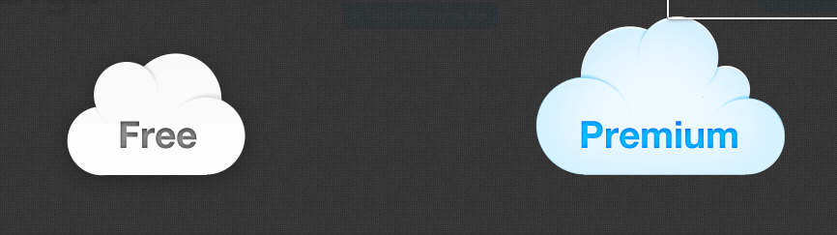
6)GO for Free If you have A free Account.After choosing Free your Torrent Will be Downloaded by High speed Servers at Zbigz.com and will be ready For Download as a Zip.
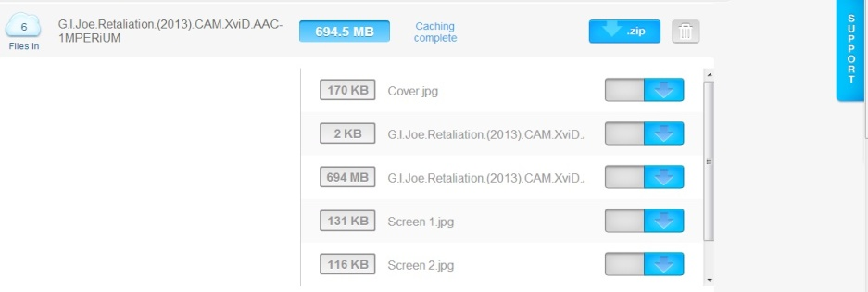
7)Now Just Click On Zip Button And It will Be ready For Download in the Idm
8) Now Torrent Is ready to be Downloaded From Torrent and You Get The Torrent in just A short period Of time Due To IDM Fast Speed and Now You will Not Have To Think About Torrific A Lot.

Dowload Torrent @ www.Kat.ph
Tnx……………..frez0706

