Beginners Guides: Assembling Your Own PC

An illustrated guide to cheating the computer service center kids out of their service fees - Version 1.2.0

Assembling your own PC is not hard. I just want to clear that up from the start, since I'm often surprised when somebody praises me for my computer 'expertise' because I can, for example, install memory in their systems. Installing memory is an exercise roughly comparable in difficulty to cleaning the lint out of a dryer and putting the filter back in the right way.
Modern computer systems are designed to be easy to fit together, and they are. The majority of components are keyed so they will only fit a certain way, for one thing, and everything is standardized. This is not to say that it is foolproof, but perhaps foolresistant would be true.
A couple of years working as a Tech at a computer store taught me that some folks should not ever be allowed near a computer that is not securely locked behind a bombproof enclosure. But for most people I think, building a computer from a pile of components just requires a little guidance to get them on the right track.
The thing is, the majority of non-techie people that I know have this almost superstitious awe of computers which requires them to make pilgrimages to the local computer store every time they want something added, upgraded, or replaced in their machine.
I have to admit that charging $65 for the 10 minutes of labour required (computer must be left for service overnight of course) is somewhat thrilling.... though really not necessary if you know a few basic things about what lies under the hood so to speak.
The key then, is to familiarize people with computers as another appliance that may sometimes need a little attention, and not just as a magic box that enables them to use Photoshop. Building a computer will do this. Call it your own little self-help project. Plus, you can always tip few dollars from the money you'll save on labour to us in gratitude. :)
This guide aims to be a simple guide to building your own home computer from easily available components available from local, or online retailers. Now, let's get started and show just how easy building your own PC really can be.

Where to begin, and ESD worries
If you are a beginner at computers, begin at your local small computer store. For the purposes of buying parts you are much better off dealing with a small store than a large chain or electronic warehouse, provided you get a good feeling about the place when you walk in of course.
Small stores are used to dealing with computers in terms of individual components, so they are better equipped to help you out. Tell them you are planning to build your own PC. They will be able to make sure that the parts you get are compatible, at least. You will have an idea of what you want the computer to do once it's built, so go with that. Once you have all the parts on the list, it's time to start building your computer.
Now, if it seems we've already skipped too many steps for you, I suggest you have a peek at the PCSTATS ShoppingList - this is a list of gear the staff here draw up each month for a few different price ranges. The ShoppingList consists of computer components we'd actually buy ourselves, and of course you're always encouraged to substitute your own choices for what we've listed. At the very least you can use it as a shopping list so you don't begin your project missing that one vital component.
First though, a brief rant about static electricity. This is where things may get a little argumentative. First things first, there is no doubt that Electro-static discharge can destroy computer components. Static Electricity is also known as ESD, or that shock you get when you touch the doorknob after walking across the office carpeting.
The question is, how careful do you have to be? Is it necessary to properly ground yourself with an electrostatic wrist strap before touching computer components, or do you just exercise a few simple precautions?
I have to admit I fall on the latter side, but I'm not the only one. Walk into any of those small computer stores you see by the hundred in any city, and go to the back. I'll bet you the guy up to his elbows in computer parts there is not wearing a wrist-strap, most likely because he is also the guy who is going to come out to the front and try to sell you something too. Yet this store will turn out computers as reliable on average as any other computer store you could walk into.
Sure you could say "what about the big manufacturers? What about Dell? Don't their techs wear wrist straps?" I'm sure they do. The thing is, I don't believe that Dell (as one example) has a parts failure rate that is significantly lower than that of any other major or minor manufacturer, and if there is a minor difference, it is going to be because major manufacturers have a standardized quality control system in place that your local AlphaBetaGamma computer store is not going to be able to emulate. With a few simple precautions, I don't think we need to worry much about ESD.
Simple precautions: Build your computer on a hard surface, away from carpets if possible. Wear shoes and a short-sleeved cotton shirt. Synthetic materials like polar fleece are excellent static generators, so it's best to wear natural fibers which don't create little lightning clouds everytime you shift your feet.
Use the anti-static bags that come with most computer components as mats to rest the components on your workspace. If you often get static shocks in your home, it may be a good idea to plug the power cord into your powersupply and turn the switch at the back to the OFF position. You can then touch the metal case of the power supply (or the unpainted metal area of the computer case if the PSU is already mounted) to ground yourself while you work.
Be sure to unplug the power cord from the power supply before connecting any of the power cables to the components, however.
Handling Components Correctly
When handling computer components like motherboards, videcards, memory, or even a hard drive it is best to hold them by the edges. If you hold that videocard (for example) by the edges the PCB it is less likely that your fingers will even come in contact with any conductors, decreasing the chance of causing any ESD damage further still.
This is not only a good precaution, it is also a good habit as any Electrical Engineer will tell you. Certain electrical components (namely capacitors) can store an electrical charge even after the power has been disconnected for sometime that can deliver a nasty shock, or kill if they are sufficiently powerful enough... Don't worry though, all the components we'll be installing in the computer are more afraid of you, and don't carry enough charge to cause you harm.
Still, grabbing a board of electronics like you would a sandwich puts your fingers in direct contact with the little metal leads from soldered-on electrical components. If for example, your finger came in contact with the leads from a powerful enough charged capacitor you could get a very strong shock. The opposite rings true if you happen to grab a videocard when you're all charged up with static electricity. Instead of receiving a nasty arm-zapping shock, you may just deliver a nasty bolt of static electricity to a sensitive microchip - damaging it in the process.
Obvious precautions: Try not to remove articles of clothing while you work on the computer, for esthetic as well as practical reasons. DO NOT let your cat near the computer parts. Cats are walking static death bombs.
Now that the ESD precautions are out of the way, what do you need to build your computer?
- ATX computer case with at least 350-watt power supply
- Intel or AMD processor with appropriate heatsink
- Computer motherboard compatible with your processor
- 1 or more sticks of RAM (memory) compatible with the motherboard and processor
- 1 or more SATA/IDE hard disk drives
- 1 or more optical (CD) drives
- 1 floppy disk drive
- 1 PS/2 or USB keyboard.
- 1 PS/2 or USB mouse
- at least one video card (ie. PCI Express, 8XAGP, integrated video, etc.) compatible with the motherboard (this may be integrated into the motherboard on some models)
- DVI or VGA monitor (computer screen)
- Sound card (these are generally integrated into the motherboard, though depending on your requirements, this may not be enough)
- 10/100 Ethernet Network Adaptor aka NIC (if you plan to connect the computer to other computers in your household)
- A Phillips-head screwdriver with a long neck, preferably magnetized, because you WILL lose a screw or two during the course of this.
- A flashlight is always a good thing to have. So is a big desk, or table where scratches on the surface aren't a big deal.
Remember, you can also peek at the PCSTATS ShoppingList if you need some current suggestions to this basic list of components.
The system I am going to assemble in the article is a fairly typical Intel processor based midrange system for office use. Nothing too cheap, but nothing too expensive either.

Building the computer, first steps
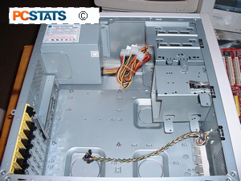
Step 1: Preparing the case.
Remove the empty computer case from its packaging. Unscrew and remove both side panels, and take out any items that may be inside. Lay the case down flat on your workspace, so that the mounting space for the motherboard is facing up (see pic 1

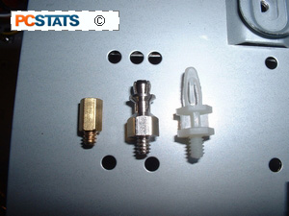
Step 2: Installing motherboard risers.
You need to determine if the case has the appropriate risers installed. Risers, or spacers, keep the motherboard from touching the metal surfaces of the case after it is installed, avoiding a short-circuit and a wrecked computer.
Risers are your friends. Any new case will include some form of riser, metal or plastic. See the picture below for typical examples. They may or may not be pre-installed into the case.

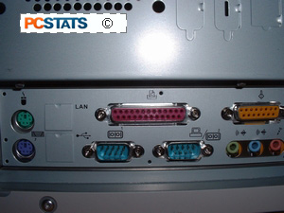
Installing the Motherboard, CPU
Line up the ports on the motherboard (PS/2, USB, etc.) with the appropriate holes in the back panel I/O shield of the case (see pic below).
Once the board is temporarily in place, observe which screw holes in the case line up with the holes in the motherboard. These are where you will need to place risers if they are not already pre-installed. Remove the motherboard and insert the risers in the appropriate screw holes.
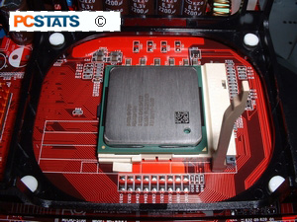
Step 3: Installing the CPU
Place your motherboard flat on top of the anti-static bag it came in. Ensure that the lever on the cpu-socket is upright (open). Holding the CPU gently on the sides with thumb and fingers, lower it into the socket, ensuring that the arrow on the CPU matches the arrow indented into the socket (see pic below). The processor is keyed to fit into the socket a certain way, and only that way.
Very little effort should be required to insert the CPU in the socket. If you cannot get the CPU to sit evenly DO NOT force it. Remove it completely and try again. Ensure that the CPU is sitting flush with the socket on all sides. No pins should be visible. Once you are sure the CPU is correctly seated in the socket, lower the lever until it locks. This will require a small amount of force.
Note: These instructions will work for any recent CPU/motherboard combination except for Intel LGA 775 motherboards and processors. Since the pins are built into the socket not the processor, the installation process is slightly different for these devices. To install an LGA 775 compatible Intel chip, you first unlatch the lever at the side of the socket.
This allows you to open the protective cover over the actual socket and the delicate pins it contains. Be very careful that you do not touch the actual pins within the socket, as they are extremely fragile. With the cover open, you can lower the processor into the socket just as you would any other type of chip. Notches in the socket and an arrow on both the processor and the bottom left corner of the socket help you line the processor up correctly. Once the chip is seated properly in the socket, you can close the protective cover and re-latch the lever.
Otherwise, the orientation of the CPU may be different, but the method of inserting it is the same for older socket chips; whether they be Intel, AMD or VIA processors. This guide does not cover slot-based processors, as they are no longer used.

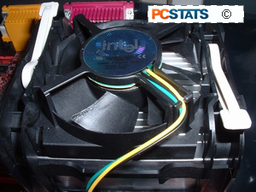
Attaching the Heatsink
Step 4: Installing the heat sink and cooling fan (socket 478)
Cute little guy, ain't it? German Engineering, so I'm told... Make sure the 2 levers on the top of the heat sink are in their default unlocked position. Since Intel processors come with a heatsink, installation is pretty straight forward. Even things like thermal interface materials (pastes, pads, or goo's) are already pre-applied for you.

Lower the heat sink gently into the plastic frame around the processor so that the heatsink metal sits evenly on all sides. Push down on the plastic top of the heatsink until the hooks on each side lock into the heatsink retention mechanism frame on the motherboard. This will require some force. Holding one side of the heat sink securely, pull the lever on the other side over until it locks. Again, this will require some force.
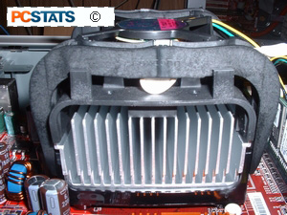
Repeat the procedure for the other lever. Consult your motherboard manual for the locations of the three-pin fan headers. There should be one close to the CPU socket. Plug the fan power cord into that header.
Don't choose a fan header at random, make sure the heatsinks' fan is being powered by the correct header for this purpose. If you get the wrong one, the is a chance the fan may shut off when the computer is in suspended mode - meaning the processor will overheat.
There are many different types of after-market heatsinks for both the Intel Pentium 4 and AMD Athlon processors. We're only covering the installation of the stock Intel heatsink, but the basic principle for installing after-market coolers is the same. Some heatsinks may come with a small package of white silicon-based thermal compound which needs to be applied before the heatsink is installed. If this is the case, only use a very small amount, and spread it over the processor's core only. The thermal compound is only used as an interface between the bottom of the heatsink, and the portion of the processor which it comes in contact with.
Some thermal compounds are made with conductive metals to achieve better thermal conductivity between the heatsink and processor. If you decide to try these types of Thermal Interface Materials (TIM) out, be sure you clean the surface of the processor and base of the heatsink with a soft cloth and Methyl alcohol gently before applying a small amount of the material. Silver-based TIMs are conductive, so do not get them on any electrical components!
Installing LGA 775 (socket 775) heatsinks
Intel’s new heatsink design for the LGA 775 socket is actually less cumbersome and easier to install than the previous designs. In place of the somewhat complex locking mechanism is a simple set of four holes which correspond to four pillar-like fasteners mounted around the body of the heatsink.
Simply lower the heatsink down onto the processor and line each of the fasteners up with the corresponding hole in the motherboard. A hard press on the top of each fastener, four satisfying clicks, and the heatsink is mounted. Attach the 4-pin power cable to the CPU fan header and you are ready to go.
Installing a ‘socket A’ AMD heatsink, or a socket 362/ ocket 7 processor heatsink
The above listed socket types all use essentially the same heatsink fastening mechanism, differing only in the relative fragility of the processors involved. A word to the wise… AMD Athlon, Duron and Athlon XP chips are quite fragile and easily damaged by clumsy heatsink installation. Do yourself a favour and be careful. Any computer shop is going to spot a processor that has been mangled by a careless install and will refuse you warranty service.
These instructions cover the AMD Athlon, Duron and Athlon XP+ Socket A processors, as well as socket-based Intel Pentium 3 processors and older Socket 7 chips by many manufacturers.
The socket has 2 main retention clips, one on each end. Note the raised area at the ‘top’ of the socket, with the socket number written on it. This corresponds to a hollowed-out area on the surface of the heatsink, allowing you to correctly align the heatsink on the socket. If your heatsink does not have this area, the long side of the clip attached to the heatsink should face the raised area. Remember that the heatsink should sit flat and parallel with the surface of the processor when installed correctly.
With the heatsink sitting flat on the processor, hook the short side of the clip to the retention clip on the ‘bottom’ of the socket (the side without the raised area). It should go on easily, as there is no tension on the clip yet. Make sure not to apply any pressure to the heatsink during this operation. Once the clip is attached at one end, push the other end of the clip down gently and examine the way the heatsink sits on the processor. It should be almost exactly parallel and not overlapping the socket. If all looks well, gently but firmly press down on the other end of the clip, so that it attaches to the other retention mechanism. Depending on the heatsink, you may have to use a flathead screwdriver to apply the necessary force to attach the clip. Just be careful not to slip… Once the other retention mechanism is attached, you’re ready to go. Just remember to attach the power cable for the fan!
Installing an Athlon 64/FX heatsink
AMD’s new 64-bit chips have had quite a varied array of sockets so far in their young life. Sockets 754, 939, 940 and AM2 to be specific. Thankfully, the actual installation methods have not changed that much between each of the three designs. Athlon 64 heatsinks clip directly to the plastic retention bracket surrounding the socket. They have a lever on one side of the cooler which also attaches to the bracket and provides extra pressure so the heatsink sits firmly on the processor. The heatsinks are symmetrical so they can fit either way into the retention bracket. Fasten both sides of the heatsink to the clips on the bracket, ensuring that the heatsink stays straight and that you do not put excess pressure on it. Once the ends of the heatsink are fastened, push the lever down firmly so that it grabs onto the clip provided for it.

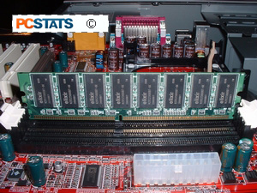
Installing RAM Memory
Step 5: Installing RAM
All modern RAM (memory) is keyed so it can only fit into the DIMM slots a certain way. With modern motherboards, it should not matter which slot you use, though if they are numbered in the manual or on the board, it is always a good idea to go with slot one first. Hold the RAM module next to the slot so that the indentation(s) on the green PCB line up with the bumps in the slot. (see pic below).
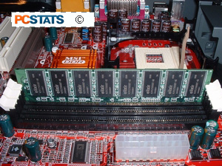
Once you are certain of the orientation of your RAM, open the levers on either side of the DIMM slot and push the RAM module straight down into the slot until both levers snap closed on either side. This will require some force. If it does not seem to be going in with a moderate amount of force, remove the module and re-insert it, making sure that it is exactly lined up with the keyed points in the slot.
Installed properly, the levers on the sides of the DIMM slots will be completely closed and locked into small cutouts on the outer edges of the RAM module.
Mounting the Motherboard
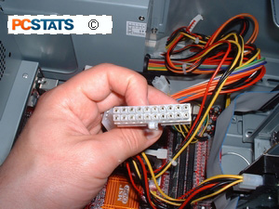
Step 6: Installing the Motherboard
Ensure that the motherboard mounting area in the case is free of obstructions and that all necessary risers have been installed in the right spots. If there is an extra riser that does not line up with a hole in the motherboard, make sure you remove it. Lower the board into the case as in step 2. Screw the motherboard into the risers. Note that some forms of risers will not require screws to be used. You can figure it out. Once the board has been securely attached, plug in the 24 or 20-pin main ATX power connector (see pic).
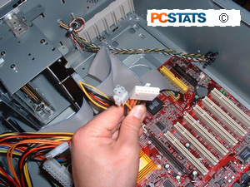
If you are installing an Intel Pentium 4 machine, you will probably be required to connect one or two extra power connectors (see pic).
Plug the 4-pin 12V auxiliary power, and 6-pin power connectors in also. Note: some motherboards may not require the 6-pin connector at all.
Consult your motherboard manual for the correct locations of the 'front panel' power and reset button wires, the power and hard-drive LED wires and the speaker. Note that the power and hard-drive LED wires are sensitive to polarity, so they will only work one way around. In theory, positive and negative will be indicated on the board and the plugs... In practice, doubtful, so... trial and error. You will not cause any damage if you get it wrong, though, the LEDs will just not light up.

Installing a Floppy Drive
Step 6: Installing the floppy drive
I have occasionally tried to get away without a floppy disk drive (FDD) on some of my computers, and without exception, I have regretted not having one at some crucial moment.
Ensure that one of the 3.5-inch bays in your case is open. If your case came with rails for the floppy drive, attach them to the sides of the drive and slide the drive into the front of the computer until it clicks into place. Rails are small metal pieces which clip or screw on to the sides of the drive and allow it to be inserted and removed from the case with minimal effort in case you are wondering.
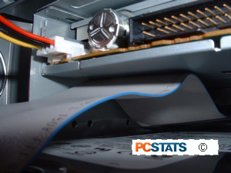
Otherwise, slide the drive into the front of the computer until the faceplate of the floppy drive is flush with the front bezel of the case and the screw holes along the side of the drive line up with the case. When everything lines up, screw the floppy drive in securely on both sides.
Plug in the power cable (see pic to right) carefully, since it is quite possible to miss one of the connectors, which will quite possibly cause some damage when the computer is powered on. Floppy drive power connectors are keyed in most cases, but if not, the red wire should be connected to the pin designated as 1 on the surrounding PCB.
Ensure that the power connector is correctly lined up with all 4 connectors. A flashlight is a good thing to have at this point. The floppy (data) cable is keyed to only fit one way. Note that it is keyed the opposite way to the IDE hard drive and CD drive, so that the red stripe on the cable should be facing the floppy drive power cable.
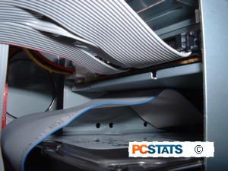
Floppy drive cables are solid ribbon on one end, and the other has a small section of the ribbon cut and twisted around. Ensure you only attach the floppy cable as shown in the picture below (cut portion of the ribbon attaches to the FDD itself).
Connect the data cable between the drive and the 'floppy1' connector on the motherboard.

Adding a Hard Drive
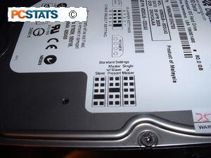
Step 7: Installing the hard-drive
First, we need to ensure that the hard drive is set up to be the master drive on its IDE cable. Each IDE cable can support up to two IDE devices, such as hard-drives, CD-drives, Zip Drives, etc., but in order for this to work, one IDE device must be designated as a master device, and one must be designated as a slave device. You cannot have two master devices or two slave devices on a single cable.
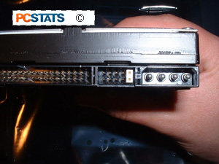
Examine the top of your hard-drive. There should be a chart there depicting the necessary jumper settings to make the drive a master or slave device. Otherwise, the chart will be somewhere on the body of the drive. The set of jumpers will be on the back end of the drive.
Ensure that they are set correctly to enable the drive as a master. You may need a set of tweezers to move the jumpers around if you have been biting your fingernails.
Insert the hard drive into the 3.5" drive-tray and screw it in securely on both sides. Note that hard-drives generally use a different sized screw than CD-ROMs and floppy drives for some completely inexplicable reason.

Hard Drives and Cables
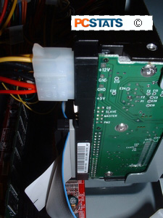
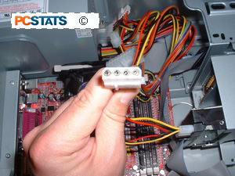
Attach the Molex power cable to the drive. Unlike the floppy drive power plug, these Molex connectors can only fit into the drive one way, so relax, you can't make a mistake here.
Attach the Primary IDE cable to the drive (for any recent motherboard, this should be a 80 wire UDMA cable). It will be keyed to only fit in one way, but to make sure, the red or blue on the cable should be facing the hard-drive power cable.
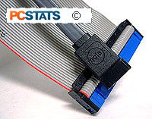
Attach the long end of the cable to the IDE 0 connector on the motherboard first, then if there are other drives attach those IDE cables to the IDE 1 connector. Serial ATA drives are still fairly new, so we will only cover them briefly.
The Serial ATA cable is keyed to fit into the SATA motherboard header, and hard drive in a certain orientation. It is impossible to attach the Serial ATA cables backwards, and since there is only one hard drive per cable we don't need to worry about the master/slave settings of IDE hard drives.
Serial ATA and IDE are not compatible, so to use SATA hard drives the motherboard must have SATA headers. Some motherboards may come with SATA-to-IDE adaptors, but again the motherboard still must have one SATA header per drive.
The SATA hard drive will require either a 15-pin SATA power connector, or standard 4-pin Molex power connector as we described previously.

Adding a CDROM
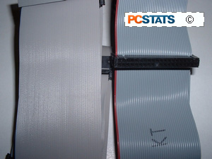
Step 8: Installing optical (CD) drive
Ensure that at least one full sized 5.25" bay is open in the case. Examine the jumper settings on the top of the drive, as you did with the hard-drive. Ensure that the drive is set to 'master'. If your case came with rails, screw them to the sides of the CD drive and insert it into the front of the case until it clicks into place.
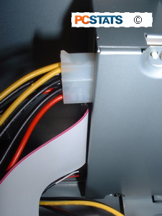
Otherwise, slide the drive into the front of the computer until the faceplate of the drive is flush with the front bezel of the case and the screw holes along the side of the drive line up with the case. Then, screw it in securely on both sides. Attach the power cable (same as the hard-drive power cable) to the drive. Attach your secondary IDE cable to the drive. Note that generally this should be a regular 40-wire IDE cable, not the 80-wire UDMA IDE cable that is used for the hard-drive. Some DVD drives will use the 80-wire cable, however. See the picture below for a comparison of the two IDE cable types.
The drive should be keyed, so the cable will only fit one way, but note that the red stripe on the IDE cable should be facing the CD power cable.
Attach the long end of the cable to the 'IDE1' or 'IDE2' connector on the motherboard.
Getting Sound from a CDROM
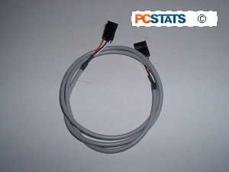
In order to get sound out of the CDROM when playing CD's, we need to attach a special cable between the CDROM and motherboard/soundcard. The CDROM should come with this thin 4-pin cable with flat connectors at either end. If not, be sure to pick one up from the store.
This is the analog audio cable which needs to be connected between the CD drive and your soundcard (or the motherboard if your soundcard is integrated into the board.). This allows Audio CDs to be directly played from your CD-ROM like an audio CD player. Plug the cable from the connector at the back of the CD drive to the 'audio-in' connector on your soundcard or motherboard. The soundcard connector should be fairly obvious, check your manual for the location of the one on your motherboard.

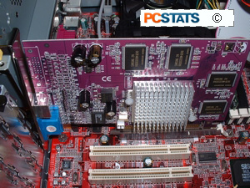
Step 9: Installing the video card
For an AGP videocard: The AGP port is the brown slot at the top of the row of peripheral (PCI) slots that runs down the board. Ensure that the catch (AGP Retention Mechanism) at the far end of the port is open, if it is present.
Insert the card firmly into the AGP slot. It should settle evenly, with just a tiny fraction of the gold traces at the bottom of the card visible. Screw the card into the expansion bracket.
For a PCI videocard: PCI ports are the white slots running in a row down the rear edge of the board. Which port you choose is fairly irrelevant, though with modern video cards, it is always a good idea to leave the slot below the one you install the card in empty to aid in ventilation of heat. Simply insert the card firmly into the slot. It should sit evenly once inserted, with only a fraction of the gold traces on the bottom of the card visible. Screw the card into the expansion bracket.

Adding an Expansion Card
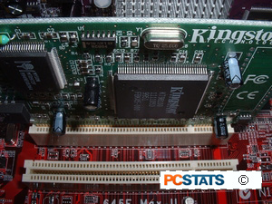
Step 10: Installing PCI expansion cards
All PCI cards are physically installed the same way. With modern motherboards, which slots you decide to use should not matter, but it is a good idea to space your expansion cards out in order to help with case ventilation. Simply insert the card firmly into an empty PCI slot. It should sit evenly once inserted, with only a fraction of the gold traces on the bottom of the card visible.
Screw the card into the expansion bracket.
Step 11: Finishing up
If your motherboard came with any extras, such as Modem or network adaptor riser cards, or additional USB ports on a mounting bracket, now's the time to plug them into the board (consult your manual for the correct locations) and screw them into any free mounting brackets you may have.
Double-check all the wiring. Make sure all connections are firmly attached, and ensure that no wires are running close to the top of the CPU heat sink fan. You do NOT want to jam the CPU heat sink fan, especially with an AMD processor.
Double-check everything again. Now get all those loose screws out.
Step 12: Powering up for the first time
Stand the case upright, if it is not already. Ensure that no wires are touching the CPU heat sink fan. Plug your monitor cable into the video card (VGA) port, and turn on the monitor. Plug your PS/2 (or USB) keyboard cable into the keyboard port. Plug in the power cord and switch the power supply switch to the on (|) position. Press the power button. Suspense.... sparks?
If everything is connected as it should be, all system fans should start spinning, you should hear a single beep, and after about 5-10 seconds, the amber light on the monitor should go green, and you will see the computer start to boot.
Depending on the manufacturer of the Motherboard, you may get a splash screen, or just a memory check. The system will then halt with an error because we have yet to install an operation system. If something has gone horribly wrong, just go straight down to the troubleshooting section. If something is on fire, go to the kitchen. You do have an extinguisher, right?
Now check the front LEDs to see if you plugged them in correctly. Power off and fix the LEDS because you didn't. Test the reset button. Assuming you have got to this point without any problems, put the side panels back on, plug in your mouse and network cables and pop your favourite operating system into the CD drive, then power the system back up again. You are done assembling the computer!

Troubleshooting
The Troubleshooting section here is not intended as a comprehensive guide to troubleshooting computer systems, but rather as a quick checklist to point you in the right direction.
OK, something has gone wrong. Let's run down the list of possibilities.
If you hit the power button and nothing happened:
Is the power cord plugged in? Is it plugged in the other end too? Check the switch at the back of the case. Make sure that you connected the wire from the case power button to the right connector on the motherboard. Make sure the power connector to the motherboard is in correctly. Check the floppy power cable. Double-check all connections. You did use the risers, right?
If none of this makes a difference, next step is to unplug everything from the motherboard with the exception of the power cable, power button wire, video card, memory and processor. If it still will not power up, it's likely that you have one or more defective components. The most likely culprits are the motherboard or the case power supply.
If the system turns on, but does not beep or begin to boot up:
First, double check all connections and try again. Otherwise, the best thing to do in this circumstance is to unplug everything from the motherboard with the exception of the power button wire, video card, memory and processor, then test it again.
If the computer successfully starts at this point, power off and reconnect one component at a time until you find the problem. If you cannot get it to boot up successfully, it is likely that you have one or more defective parts.
System turns on, beeps intermittently, does not boot up:
Check that your memory (RAM) chip is installed correctly. Remove it and re-install it if necessary.
System turns on, gives a sequence of quick beeps, does not boot up:
Check that your video card is correctly seated in its AGP or PCI slot. The AGP slot especially can be unforgiving of a card that is a tiny bit out of position.
There are a number of other error codes indicated by patterns of beeps from the motherboard speaker, but the two above are the most commonly encountered. For more information, see this PCSTATS guide to Computer Error Beep Codes.
Beginners Guides: Computer Error Beep Codes
Since I'm the "computer expert" among my friends and family, I often get those late night phone calls and e-mails asking me what's wrong with their computer. I'll be honest. It does get quite frustrating and annoying at times when people start off with "What did I do?" I understand that they're only asking me because they trust I can do a good job, and they really don't have anyone else to turn to.
When I start fixing a computer, 99% of the problems I see are software related. Most of the time it is you, the user that wrecks, breaks, crashes, or kills your computer. Sorry, I have to be blunt about it, but it's true. New processors, hard drives, video cards, memory and motherboards are just inanimate objects we can lay blame to.
Most of the time the main problem with these broken computers I tend to are due to too many programs loading up at start up. All those little programs add up, and sometimes eat up all the system resources.
Every now and then though, I do see a hardware problem and the first thing I do when I turn the computer on is listen to how it beeps.
When the computer makes those funny sound via the system speaker, it's not doing it because it wants to be heard. The computer is trying to talk to the operator/technician and tell them what's wrong. In testing computer components on and off for the last three to four years, I find that almost all motherboards adhere to the IBM BIOS standard beep codes... I think a few OEM's have developed their own or use Phoenix or AMI beep codes, but for the most part motherboard manufacturers uses the IBM based ones because they are grandfathered in.
Beep Code: | Description of Problem:
No Beeps | Short, No power, Bad CPU/MB, Loose Peripherals
One Beep | Everything is normal and Computer POSTed fine
Two Beeps | POST/CMOS Error
One Long Beep, One Short Beep | Motherboard Problem
One Long Beep, Two Short Beeps | Video Problem
One Long Beep, Three Short Beeps | Video Problem
Three Long Beeps | Keyboard Error
Repeated Long Beeps | Memory Error
Continuous Hi-Lo Beeps | CPU Overheating
So as you can see, if your computer doesn't start up and starts beeping away like a mime you can start the process of figuring out what is wrong by stopping for a second and listening. From a single beep which tells you everything is okay, to three long beeps which indicate a keyboard error to the siren like Hi-Lo beeps that tell you the CPU is overheating - listening to your computer is good!
As you become more and more experienced with computers, friends and family will naturally start to bring sick computers to your door to fix. When that happens, or when your own machine suddenly stops working, try listening to it first and see if it tells you what's wrong. If you are able to diagnose the problem just by listening to it, you will surely impress all your computer friends!

If you have got the system up and running, but are experiencing some problems installing an operating system, here are a couple of common issues:
Your system freezes intermittently while installing the OS:
Could well be a heat issue, especially with AMD processors or older Intel ones. Check that the heat sink fan is spinning and that the heat sink itself is firmly mounted and parallel to the surface of the processor. Assuming you are using a stock heat sink from the manufacturer of the processor, it should be more than adequate to cool the system if properly applied.
You are having problems fully installing the OS due to errors copying files and blue screens:
Errors while copying the setup files, especially with Windows 2000 or XP, are a common indicator of problems with your memory (RAM). It's possible it could also be a hard-drive problem, but if you are getting blue-screens also, especially any ones indicating that a 'page-fault' has occurred, it's time to pop the memory out and haul it back to the store to be tested. And don't leave it there for the night either.

