INTRODUCTION

This is the moment that will give us a chance to mold and enhance our business and entrepreneurial skills as we take into action our small dream of becoming young entrepreneurs. Such as, our capacity and our willingness to develop, organize and manage a business venture along with any of it’s risks in order to make a profit.
Experience is a great award of learning. These experiences that we will undergo will serve as our companion to fully step forward to our destined life. We never learned when we do not fail because in every failure there is another opportunity that waves us to success. To be part of this activity is such a privilege to be admired of. It is not just about trading goods. Hence, it’s about how we handle and create good connection to people around us.
We grab this chance to present our business named “Veggie Empanada” to sell goods that will surely satisfy the desires of our valued customers with affordable fee. Veggie empanada is a pastry turnover famous in the Philippines. Our veggies empanada will be serving healthy & affordable empanadas. To keep food costs down, the menu will be simple, yet creative with many ingredients. Nowadays, the number of single households and dual earner households with limited time for food preparation are increasing and they are seeking affordable and nutritious snacks.

COMPANY INFORMATION

Veggie empanada is the name of the partnership project and is a fast food business managed by 6 partners. These partners represent sales / management and finance / administration areas, respectively. The six partners are interested on producing a creative product (existing product but with a twist) and the proposed product is called veggie empanada. The said partners are also interested on giving customers an empanada that is unique in terms of taste and content of the said proposed product.
The partners will provide funding from their own savings, which will cover start-up expenses and provide a financial cushion for the launching operations. The partners plans, is to build a strong a market position, which is a stall in Channel Ridge view, Babatngon Leyte. The business offers unique and innovated products that are affordable for the target market. The business aims to earn the loyalty and the satisfactions of the customers by serving them with the high quality products that the business offers.
The target markets are the students and the potential buyers such as workers, senior citizen and travelers. However, persons beyond the bracket are also convinced to consume the product. Students is the target market since they are the biggest population and active at the near school, they also want a faster serving of their foods, a tasty, affordable and satisfying that the business will serve. The partnership is aware with it’s market size and what trends is going on in the market.
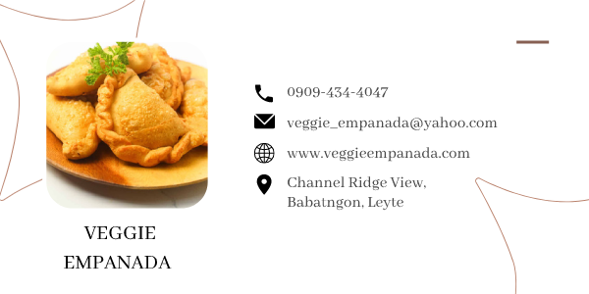
PRODUCT DESCRIPTION

The product will be named “veggie empanada” dish where carefully selected fresh potatoes, carrots, green peas, and chicken were sliced into thin. They are made by folding a sheet of dough producing a unique blend over the filling and sealing it before frying. Empanadas can be found around the Philippines but with our own product veggie empanada you’ll be contented not just because of the taste but because it has an affordable price, for only 15 pesos the taste will satisfies the craving of the customers. So we are glad to introduce a fresh way to enjoy eating veggie empanada & taste it’s benefit. Also, it can serve as the snacks, appetizer and it is also good to serve in any special occasions.

MISSION

We, the entrepreneurs, serve with gladness through our great and delicious food that can surely bring satisfaction to everyone and pursuing the heart of our customers and offering good services is our number one priority.

VISION

We envision a world where food business are more active than before and everyone has access to fresh, healthy, outstanding quality, clean and value food so that we make every customer smile. As starting entrepreneurs that satisfies customer's satisfaction, we also strive to become one of the role models of society with entrepreneurial success.

Benefits of Veggie Empanada
- Ingredients:
Potatoes
Carrots
Green – peas
Chicken

- Potatoes
Are naturally sweet and are a great source of energy for the body because they are a carbohydrate. They are filled with fiber as well as potassium, magnesium, calcium and phosphorus. The fiber content in sweet potatoes helps your digestive system by feeding the tiny microbes in your intestines which helps promote a healthy gut.

- Carrots
Are not naturally sweet as potatoes but they contain many important vitamins such as vitamin k, c, Bb, as well as potassium. They specifically contain antibacterial properties and are a rich source of vitamin c which helps stimulate white blood cells in the body. Fiber also prevalent in carrots and helps reduce blood pressure by pulling excess LDL cholesterol out of the body and eliminating it.

- Green – peas
Peas are a good source of vitamins C and E, Zinc, and other antioxidants that strengthen your immune system. Other nutrients such as vitamins A and B and coumestrol, helps reduce inflammation and lower your risk on chronic conditions, including diabetes, heart disease and arthritis.

- Chicken
Provides vitamins and minerals involved in brain functions, strengthen bones, weight loss, contains nutrients linked with mood, easy to eat, promotes heart health and builds muscle.

EXAMPLES/SUCCESS

Haydee Gavin Cetro, owner of empanada Ahuy in cavite, started making empanadas for her family. From there she sold them online which the customers enjoyed so haydee ventured into making bigger batches.
Empanada they has the filling and flavors that customers couldn’t get enough of. They over nine flavors with each piece sold for ₱25 while a box of 15 at ₱300.
She said that you don’t need a big capital but a big serving of hardwork and determination, break their record and sold over 750 pieces in one day. Haydee couldn’t help but be grateful. From a small-time business, a special homemade empanada business has grown to a full store earning over ₱10,000 a day.
According to Haydee, it doesn’t need a huge capital to start a successful business. Most of the time, what’s important is the dedication and hardwork you put into it. At the start, she didn’t ever have a rolling pin, which is essential when you’re making empanada dough. But, it didn’t stop her, and decided to improvise instead. She used a bottle to roll out her dough. With a ₱250 starting capital, haydee began her special empanada business.


JE MONDEJAR COMPUTER COLLEGE
Brgy 71 Naga-Naga Tacloban City
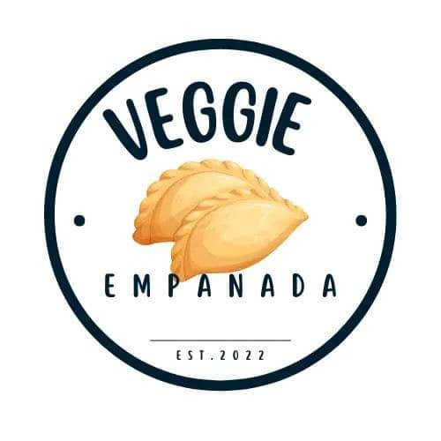
Veggie Empanada is a type of snacks or appetiser which is healthier than other have and will make also the customers cravings satisfied because it has an affordable price. Which is located at Channel Ridge View Babatngon, Leyte.

June 22, 2022
Submitted by: BSBA 3A

Members:
Jeric Regacho
Melody Andig
Mary Jane Antoni
Mebilyn Acuin
Henrich Rosal

Submitted to:
Ms. Dion Macalalag

