ADMIN
2
1
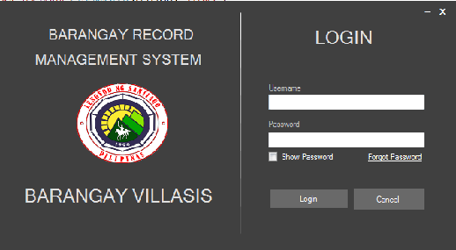

3
4
5

6
7
8

- Minimize Button to Minimize the System
- Exit Button to Exit the System
- This is where the Admin input the Username
- This is where the Admin input the Password
- Forgot Password
- It will show the password inputted
- Login Button to Access the System
- Cancel Button to Cancel Login or Exit the System

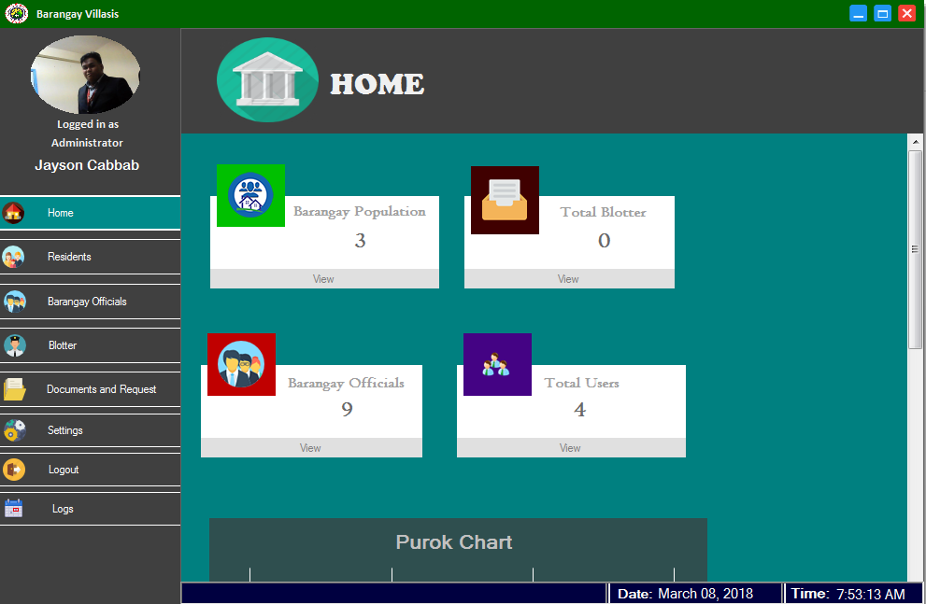
11
10
9
26
25
24
233
12
13
14
22
21
20
19
18
17
16
15
28
27
- Minimize the System
- Maximize the System
- Close/Exit the System
- User Avatar
- User Type
- Name of the Current User
- Button for Viewing Total Population, Blotter’s, Barangay Officials and total user’s
- Button for Viewing Resident Record
- Button for Viewing Barangay Council Chart
- Button for Viewing Blotter Record
- Button for Viewing the list of the Certificate
- Setting Button
- Logout Button
- Button for Viewing Logs
- Button for Viewing Blotter Record
- Button for Viewing Residents Record
- View button to access Manage User’s
- View Button to show Barangay Council
- Current Date
- Current Time
34
35
33
3222
31
30
29
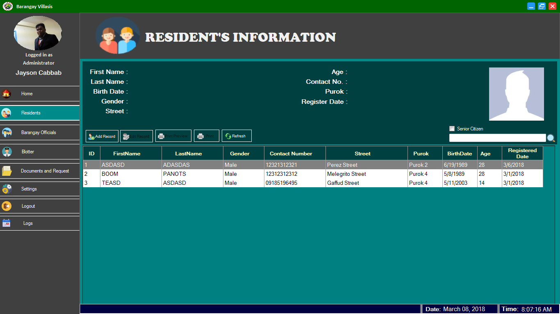

- Button to add new record
- Button to edit the selected record
- Button for print preview
- Button to print the record
- Button to refresh the table
- Checkbox for senior citizen filter search
- Button to search a record

36
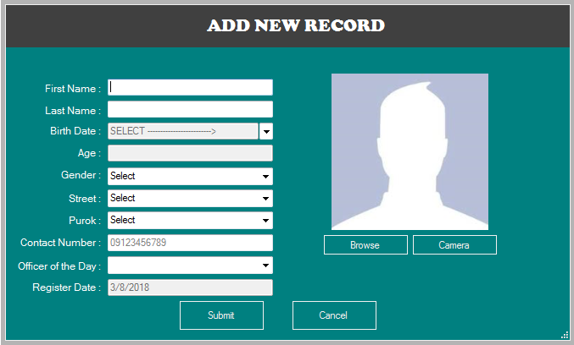
44
43
42
41
40
39
38
37
47
46
45
49
48

- First Name of the resident
- Last Name of the resident
- Birthdate of the resident
- Age of the resident
- Gender of the resident
- Street address of the resident
- Purok address of the resident
- Contact number of the resident
- Officer of the day
- Date of registered
- Button to submit new record
- Button to cancel new record
- Browse image
- Capture image

50
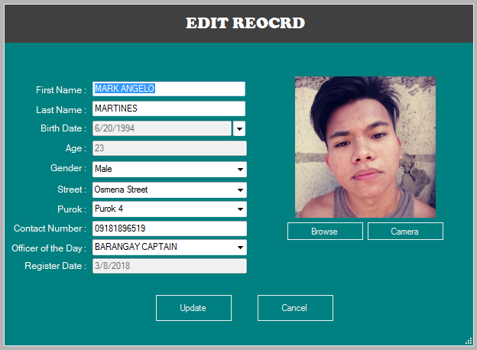
59
58
54
57
56
55
53
52
51
60
61
62
63
- Edit first name of the resident
- Edit last name of the resident
- Birthdate
- Age
- Edit gender of the resident
- Edit street address of the resident
- Edit purok address of the resident
- Edit contact number of the resident
- Officer of the day
- Registered date
- Button to update record
- Button to cancel record
- Browse new image
- Capture image

70
65
64

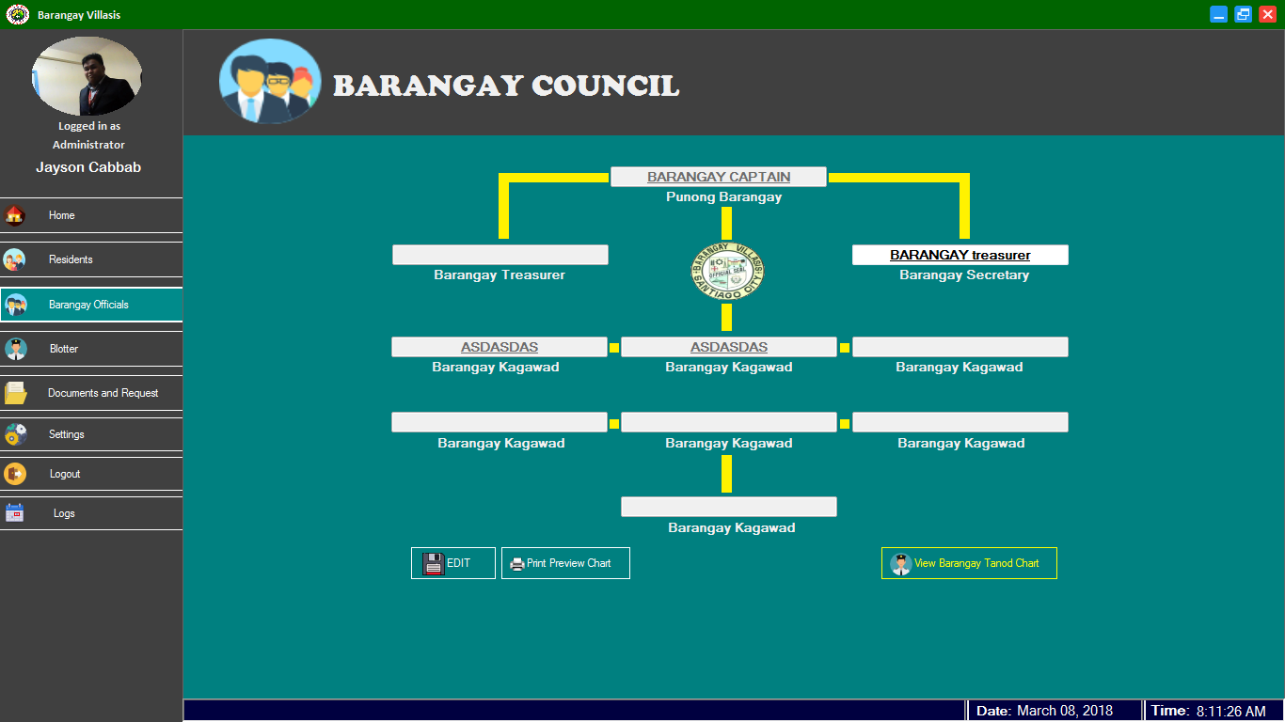
68
69
66
67

- Textbox for barangay treasurer officer
- Textbox for barangay secretary officer
- Button to edit/view the barangay council Record
- Button to print preview the chart
- Textbox for barangay treasurer officer
- View button for the Tanod Chart
- Textbox barangay Captain

75
74
73
72
71
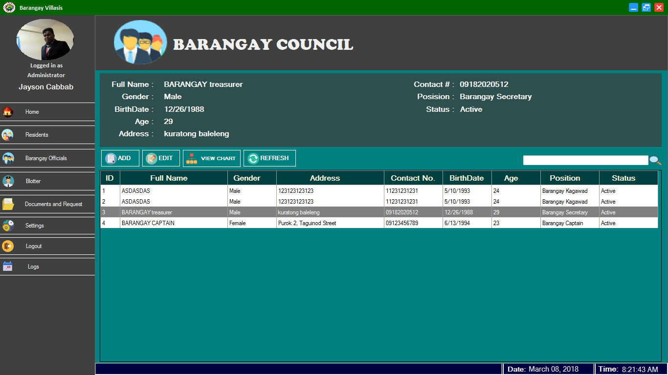

- Button for add new barangay council
- Button for edit the selected record
- View button to view the chart of the barangay council
- Button to refresh the table
- Textbox to search record

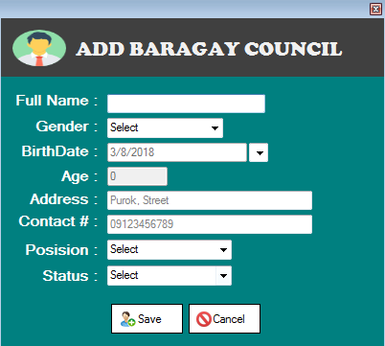
85
86
76
77
78
79
80
81
82
83
84

- Button for close the window
- Full name of the Barangay council
- Gender of the Barangay council
- Birthdate of the Barangay council
- Age of the Barangay council
- Complete address of the Barangay council
- Contact number of the Barangay council
- Position of the Barangay council
- Status of the Barangay council
- Button to save the record
- Button to cancel the record

87
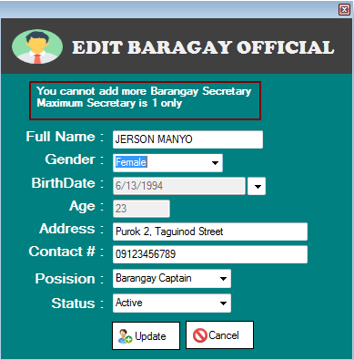
94
93
92
91
90
89
88
97
96
95

- Close button of edit barangay official
- Edit full name of the Barangay council
- Edit gender of the Barangay council
- Edit birthdate of the Barangay council
- Edit age of the Barangay council
- Edit complete address of the Barangay council
- Edit contact number of the Barangay council
- Edit position of the Barangay council
- Edit status of the Barangay council
- Button for update record
- Button for cancel record

98
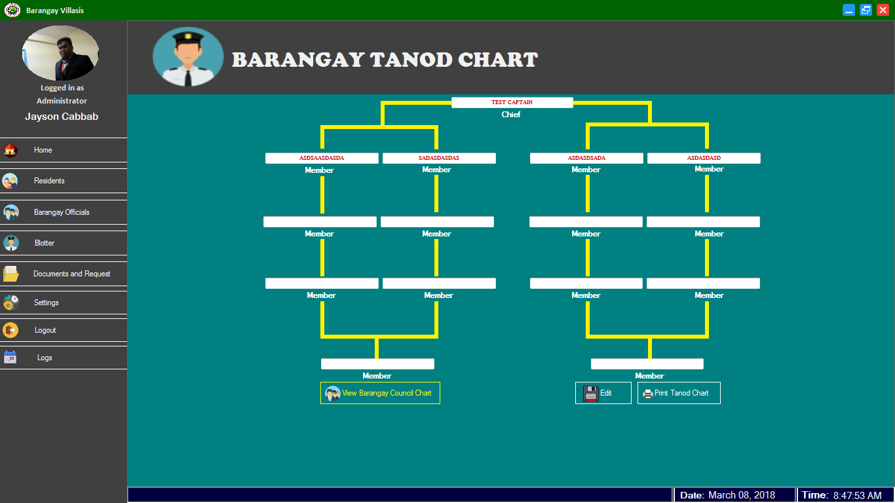
100
102
101
99

98. Textbox for Barangay Tanod chief
99. View button for barangay council chart
100. Textbox for Barangay Tanod Member
101. Button for View/Edit Barangay Tanod Record
102. Button for Print Barangay Tanod chat

103
104
105
106
107
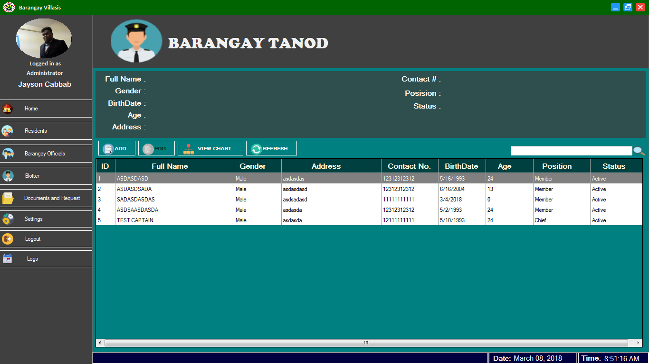
108

103. Button for add new barangay tanod
104. Button for edit selected record
105. View button for Barangay tanod chart
106. Button for the refresh table
107. Textbox to search the record
108. Barangay Tanod Record List’s

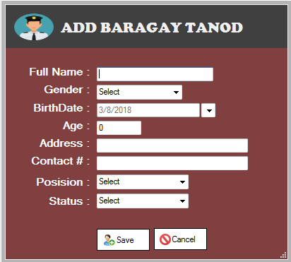
ADD NEW TANOD
116
115
114
113
112
111
110
109
118
117

109. Full name of the tanod officer
110. Birth Date of the tanod officer
111. Address of the tanod officer
112. Position of the tanod officer
113. Gender of the tanod officer
114. Contact Number of the tanod officer
115. Gender of the tanod officer
116. Status of the tanod officer
117. Button to save the record
118. Button to cancel record

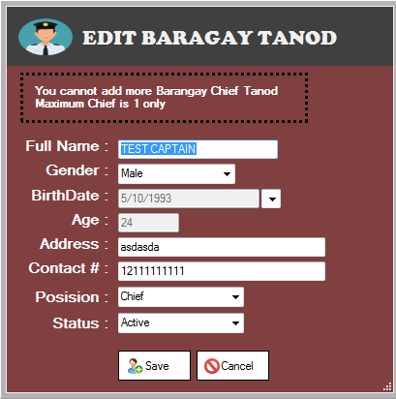
126
125
124
123
119
120
121
122
127
128

119. Edit barangay tanod full name
120. Edit barangay tanod Birthdate
121. Edit barangay tanod Complete Address
122. Edit barangay tanod Position
123. Edit barangay tanod Gender
124. Edit barangay tanod Age
125. Edit barangay tanod Contact Number
126. Edit barangay tanod Status
127. Button to save the record
128. Button to cancel the record

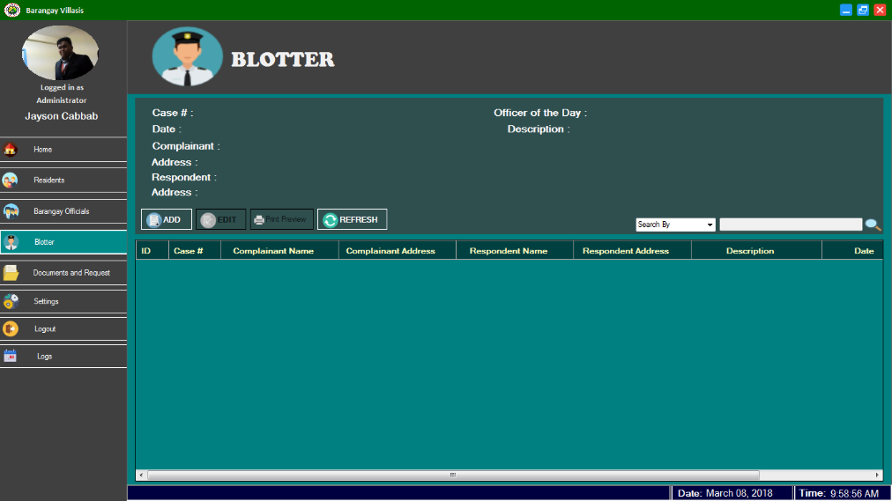
134
133
129
130
131
132

129. Button for Add new record blotter
130. Button for Edit selected record blotter
131. Button for Print Preview record blotter
132. Refresh Table
133. Filter search
134. Textbox to search record

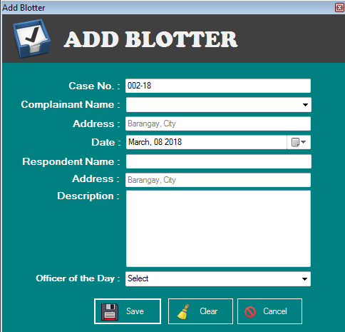
137
139
141
136
138
140
142
143
135
146
145
144

135. Button for close the window
136. Case number of reports
137. Complainant Name
138. Address of complainant
139. Date of blotter
140. Respondent name
141. Address of respondent
142. Blotter Description
143. Officer of the day
144. Button to save record
145. Button to clear textbox
146. Button to cancel record

147
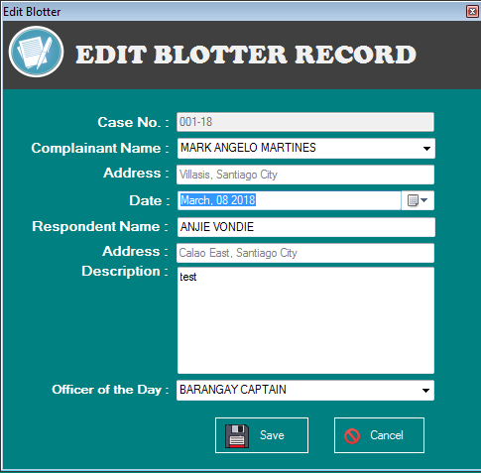
149
151
153
155
154
152
148
150
156
157

147. Button to close the window
148. Blotter Case number
149. Edit complainant name
150. Edit address of complainant
151. Date of blotter
152. Edit respondent name
153. Edit address of respondent
154. Edit Blotter description
155. Officer of the day
156. Button to save the record
157. Button to cancel record

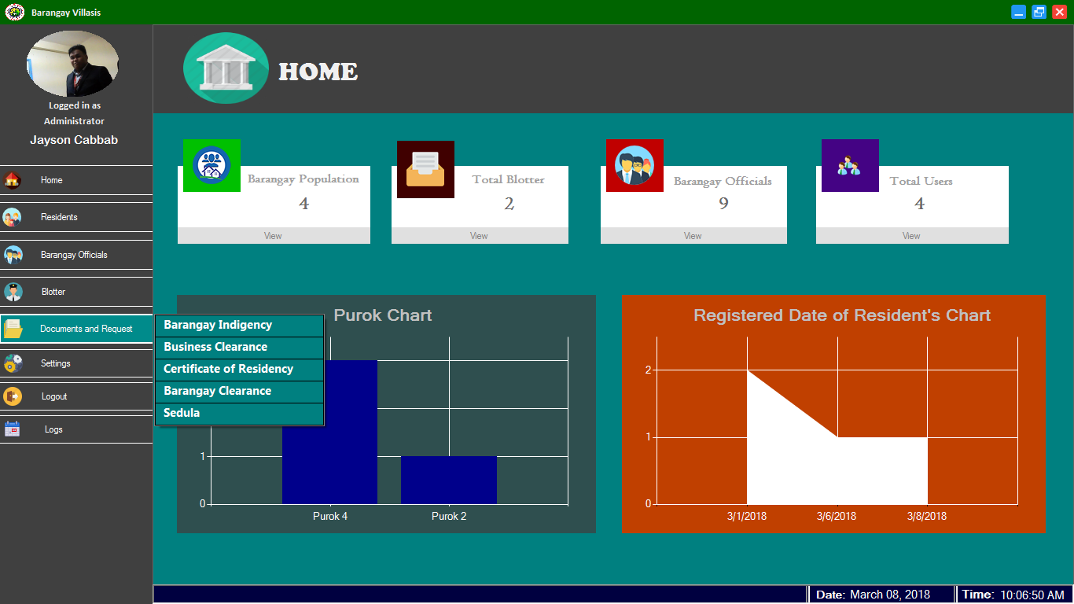
158
159
160
161
162

158. Button for viewing Barangay Indigency Record
159. Button for viewing Business Clearance Record
160. Button for viewing Certificate of Residency Record
161. Button for viewing Barangay Clearance Record
162. Button for viewing Sedula Record

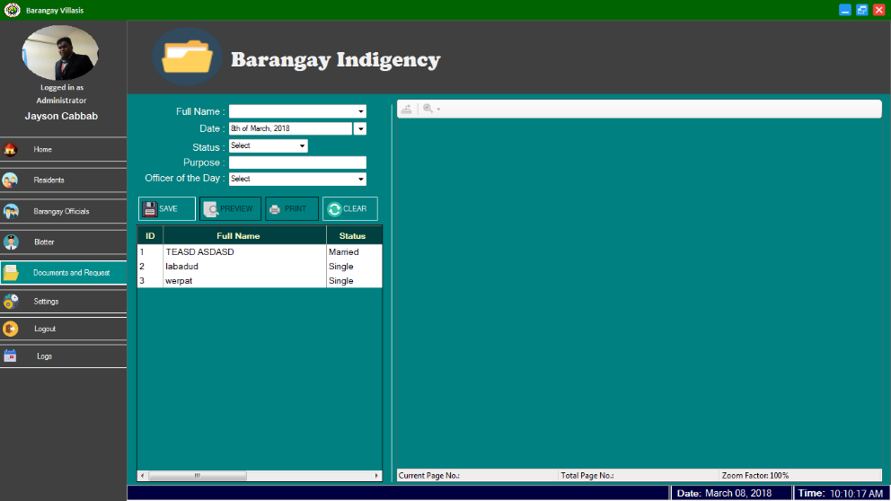
1676
166
165
164
163
172
169
171
168
170

163. Full name
164. Date
165. Status
166. Purpose
167. Officer of the day
168. Button to save record
169. Button to print preview selected record
170. Button to print
171. Button to clear textbox
172. Print Preview

173
179
178
177
176
175
174
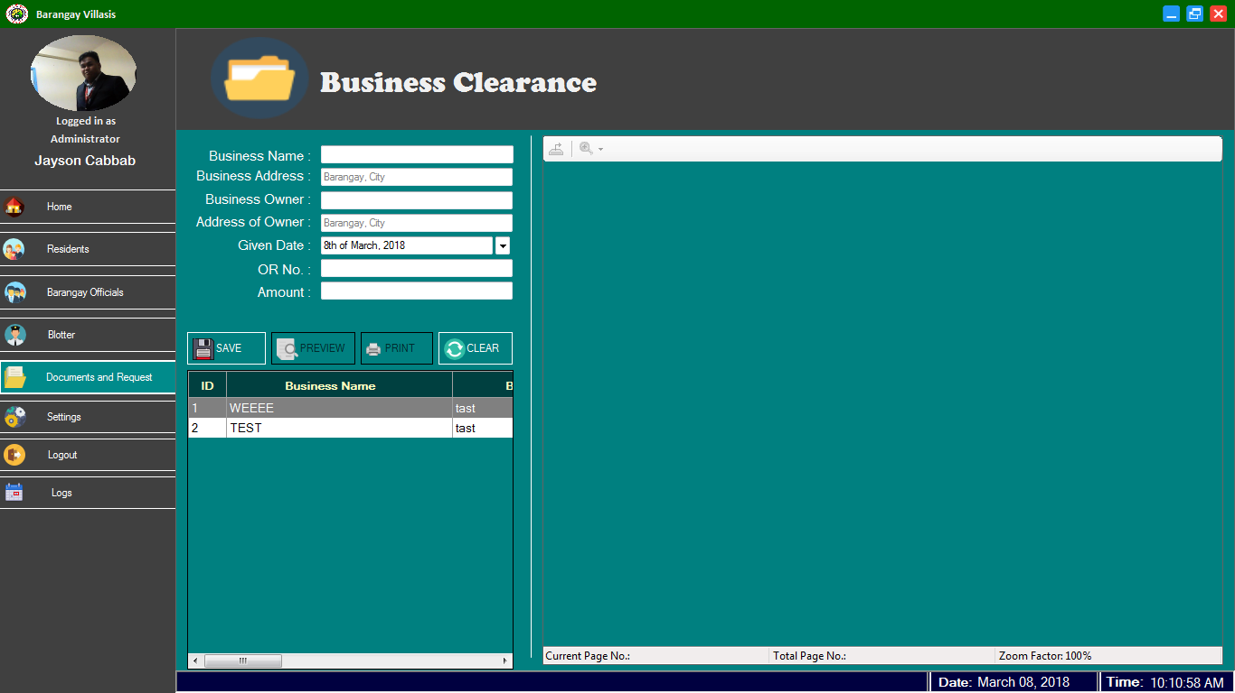
183
184
185
182
180
181

173. Name of business
174. Business address
175. Business owner name
176. Address of the owner
177. Given Date
178. OR Number
179. Amount
180. Button to save record
181. Business Clearance Record’s
182. Button to print preview selected record
183. Button to print selected record
184. Button to clear textbox
185. Print Preview

186
187
188
189
190
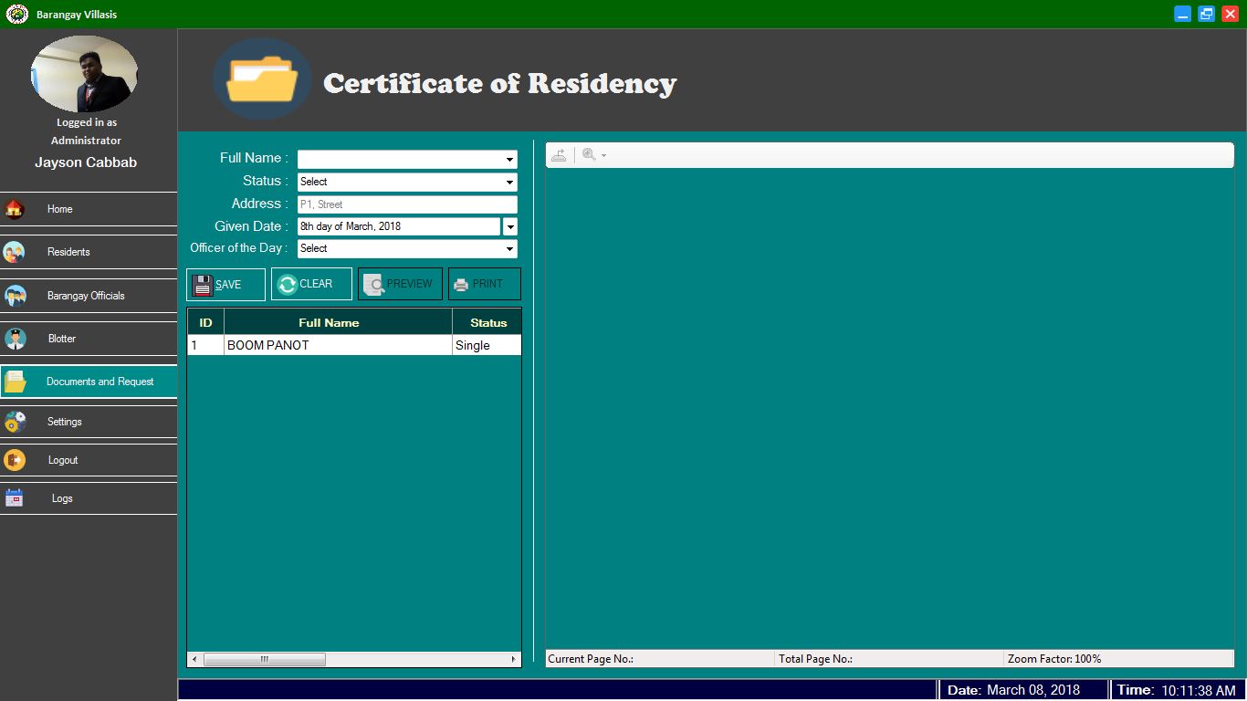
195
196
194
191
192
193

186. Full name
187. Status
188. Address
189. Given Date
190. Officer of the day
191. Button to save record
192. Button to clear textbox
193. Display record
194. Button to print preview selected record
195. Button to print selected record
196. Print preview

