Xenix (a version of Unix) and also collaborated on a BASIC interpreter for the Altair 8800. The company was incorporated in 1981. Microsoft became famous with the release of MS DOS, a text-based command line-driven operating system. DOS was mostly based on a purchased intellectual property, QDOS. GUI-based operating systems of that time included Xerox's Alto, released in 1979, and Apple’s LISA and Macintosh systems, which came later. Microsoft’s die-hard fans referred to such systems derogatorily as WIMPs, which stood for “windows, icons, mouse and pull-down menus (or pointers).
Records management is the supervision and administration of digital or paper records, regardless of format. Records management activities include the creation, receipt, maintenance, use and disposal of records. In this context, a record is content that documents a business transaction. Documentation may exist in contracts, memos, paper files, electronic files, reports, emails, videos, instant message logs or database records. Paper records may be stored in physical boxes on-premises or at a storage facility. Digital records may be stored on storage media in-house or in the cloud.
Since the Current system of Barangay Record Management System in Villasis Santiago, City which is the paper-based in managing and tracking records of daily, weekly and monthly records become less efficient and less accurate because in a manual system the data might be misplaced or lost. Having a manual record management system requires a lot of storage space and filling equipment in the office because hard copies of the files are kept. The process of writing the record manually in a piece of paper, keeping and finding the records of the residents are time consuming slow retrieval of information and transactions.
To make a computerized Barangay Record Management System (BRMS) to easily find the records so that is accurate, complete, accessible and usable. To reduce operating costs including office space, equipment and staff to maintain an organized filling system. To minimize the time in writing the record, to eliminate the use of paper and to improve efficiency and productivity of the employee.
Using the Barangay Record Management System in a computerized way either Windows or Web-based the system will provide user efficiency working environment and generates more output. Also the system has the feature of printing of Certificates like Certificate of Indigence, Blotter Case barangay Clearance and so on for the wind-based. The system also includes friendly user interface resulting in knowing each other and other usability features of the system. It also enables easy searching records so that the employee will not suffer time consuming. It also provides that it maintains an updated record of the residents for easy identification, and updated references. It also provides a backup and recovery utility security. Also, this system provides high level of security for specific people (e.g. administrators and staffs) who can access the system where administrators have the full access using the system while the employee just have the limited access in terms of confidential records. No changes can be made it in until it verifies the user log in id and passwords. The salary of the employee will not covered by the system.

Statement of the Problem
The Study entitled “Windows-based and Web-based Record Management System for Barangay Villasis Santiago City”. The main purpose of the study is to help the Barangay Villasis in saving and managing data or record of residents, printing of records as a whole people of the barangay and/or by purok, also prints Certificates like Certificate of indigence, Barangay Clearance, blotter cases and so on in a computerized and most convenient way.
The study aimed to answer the following:
- What are the processes of the current Barangay Record Management System?
- What are the problems or weaknesses of the current system?
- What are the procedure or system need to be established or developed to improve the current system?
- Who will be the beneficiaries of the study?
- How will the proposed system improve the manual inputting or writing the resident’s record of the Barangay Record Management System?
- How will the Barangay Record Management System be designed, developed and implemented?
- How will the proposed system be effective in terms of the following?
7.1 Accuracy  7.2 Security  7.3 Reliability  7.4 Convenience  7.5 Robustness | 7.6 Integrity  7.7 Efficiency  7.8 Portability  7.9 Usability  7.10 User-friendliness
Objective of the Study
This section discusses the purposes as well as the aim of the researchers in developing the proposed system.
- The purpose of the study is to enhance the current system in terms of managing records.
- To make a Barangay Record Management System to Disseminate paper works in the current system.
- Design and develop a Barangay Record Management System For Barangay Villasis, Santiago City.
- To have a system that can print records or Certificates like Certificate of Indigence, Barangay Clearance and blotter in the most efficient and convenient way.
- To have a System that can Add, Edit and Update Records in a computerized way.
- To have a System that can be saved and update to the database.
- Improve the flow and procedure of the current system.
- To have a user-friendly system.

Significance of the Study
The researchers assessed the process of Managing record, gathering information, Printing, inputting record, the researchers realized that there are a lots of problems on the existing process/system that is why it needs improvement and innovations.
The proposed system aimed to benefit the following:
Barangay Villasis Santiago City. The project will help to organize the residents record, convenient and in a clear and understandable easy to use System in Barangay Villasis Santiago City.
Barangay Captain/Secretary as admin. The project system lessens the time and energy consumed in managing records including the account created by the users also prints records/certificates in a convenient way.
Barangay Staff user. The project system lessens the time and energy consumed in managing records and printing certificates.
Residents. The project system will be faster and efficient in terms of printing of certificates like Certificate of Indigence, Blotter, barangay clearance and so on in a convenient way.
Researchers. Other than fulfilling the researchers’ chosen field, the project system serves as a foundation that the researchers can use as reference in the future and in the researchers’ chosen career with the knowledge acquired during the conduct of this research.
Future Researchers. The study will serve as a basis and guide to improve computerized system of other researchers.

Scope and Limitations of the Study
This study focuses on eradicating the present problems of the current system “Barangay Record Management System” in terms of managing record, printing of certificates like certificate of Indigence, barangay clearance, blotter cases and so on, inputting record and gathering information. It is for these reasons why the proposed system will be supported by windows application. To make sure that the records, reports and activities will be viewed in a convenient and easy way. The proposed systems is designed and work into code to reduced time wasted on manual paper works, error in manual way.
It has also a web-based design system that can disseminate
The scopes of the proposed system includes the following:
- The System is cloud based and has client server architecture.
- The system has the ability to add and edit a certain records.
- The system and the data are hosted on the cloud which means all your information is in safe keeping.
- The system has backup software that makes backing up your data integrity and security.
- Password can be changed with a minimum of 8 and maximum of 14 – combination of numbers and letters.
- The system enables easy searching of records depending on chosen parameters.
- The System can Capture and save photos in the database of the residents and barangay officials
The delimitations of this study include the following:
- The proposed system will not function without electricity.
- The proposed system is only intended for Barangay Villasis Santiago City.
- The system will not fix any malfunction of the hardware to be used.
- The Barangay Council and Barangay Staff cannot change their username in the system.
Hypothesis
To widen the capability and productivity of the proposed system, the researchers realized the following hypotheses:
- The proposed system has the capability of saving records of the residents in a computerized and organized way to disseminate time consuming in a paper-based work through the current system.
- Barangay Record Management System will improve the procedure of current system in terms of managing record, printing of certificates like Certificate of Indigence, Barangay Clearance and so on.
- The proposed system will benefit the Barangay Villasis Santiago City, Barangay Captain/Barangay Council Researchers and the Future Researchers in terms of in managing records, inserting records, printing of certificates, reports as well as Viewing records.
- The system will be developed using PHP: Hypertext Preprocessor (PHP) for the web-based, bootstrap will be used during the designing of the system, Visual Basic VB.Net for the windows-based and with cloud based server.
- The proposed system will be effective in terms of the following:
  - Accuracy - the proposed system will be capable of doing what is instructed to do.
  - Security - the system is designed to provide maximum security against hackers.
  - Reliability – is consistently performs according to its specifications.
  - Conveniency - it will be able to proceed with something with little effort or difficulty.
  - Robustness - the ability of a computer system to cope with errors during execution
  - Integrity - with the proposed system the users will be assured that information can only be accessed or modified by those authorized personnel.
  - Efficiency - it will operate without wasting unnecessary materials.
  - Portability - it can be used in an operating systems without requiring major rework.
  - Usability – the system can be used by the Barangay Captain/Barangay Council.
  - User friendliness - it will be easily operated and understood.

Conceptual Framework
This concept details the systematic procedure in developing the proposed study. This serves as the guide throughout the development of the proposed study and to lessen the difficulties in designing the proposal.
The first step is to determine the current and common problems the respondents encounter on the current Performance Governance System. Second, the researchers will create questionnaires and will conduct a survey at Barangay Villasis Santiago city Barangay Hall Office to evaluate the current systems performance if it satisfies the respondents. Third, is to determine the processes of the manual system and the problems encountered by asking their idea and experiences.
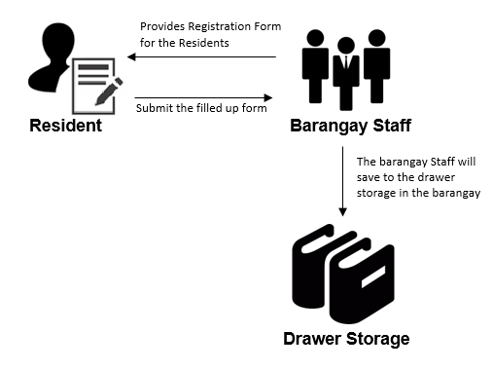
The researcher analyzed all the gathered information and idea about the current system. After analyzing all the gathered ideas and information of the manual system, the researcher conceptualized a proposed system entitled “Winds-based and Web-based Record Management System for Barangay Villasis, Santiago City Isabela”. Those are the concepts that used by the researchers and served as guide in the planning, designing, determining the functions, in developing and implementing the proposed system entitled Windows-based Barangay Record Management System for Villasis, Santiago City, Isabela.

Figure 1.1 Conceptual Framework of current system in gathering and saving the record of the residents

Figure 1.1 shows the barangay Staff will gather information of the residents through census to be filled up the form given by the barangay staff and saved it to the drawer storage in the barangay. The paper-based in managing and tracking records of daily, weekly and monthly records become less efficient and less accurate because in a manual system the data might be misplaced or lost.
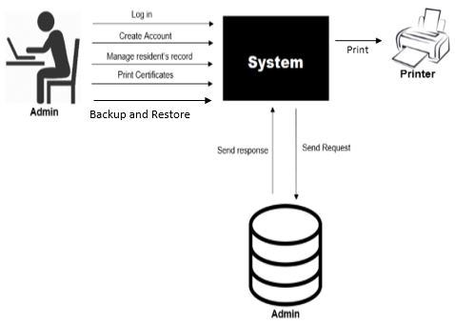
Figure 1.2 Conceptual Framework of the proposed system Barangay Secretary/Captain as admin
Figure 1.2 shows on how to add or create an account on the system. The System only allows the admin account to add an account on the database of the system and if the user has been forgotten his/her account there will be a security question to prove that he/she is the one who is using your account, when the security question Answered correctly the System will show the current password. The Administrator can also add, edit, and Update records and especially print records/certificates like certificate of Indigence, Blotter, Barangay Clearance and so on.
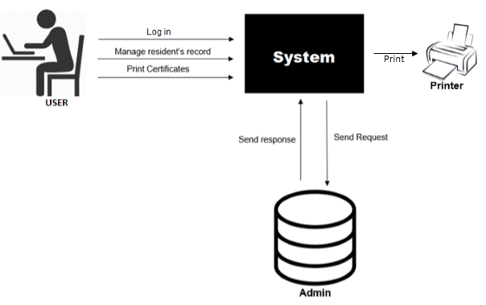
Figure 1.2 Conceptual Framework of the proposed system Windows-based Barangay Staff as User
Figure 1.2 shows the Barangay staff as a user of the System, if the user has been forgotten his/her account there will be a security question to prove that he/she is the one who is using your account, when the Security question Answered Correctly System will show the current password. The User can also add, edit, and Update records and especially print records/certificates like certificate of Indigence, Blotter, Barangay Clearance and so on.

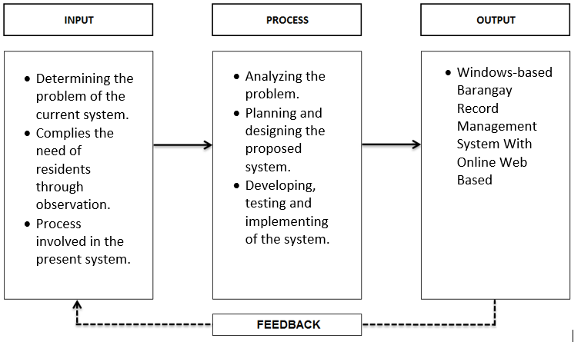

Figure 1.5 Paradigm of the study
The researchers used the Input-Process-Output Model to represent the relationship. Stipulated in the first box are the activities which were done for the development of the system. The Process analyzes the present manual system and identifies the problems and difficulties encountered in Searching, keeping and recording information of the residents of the barangay Villasis, so it takes too much effort and time consuming to do a certain work. And finally, the third in the line box reveals the Output of the study which is a web-based and windows-based Record Management System for Barangay Villasis Santiago City.
Assumption of the Study
The researchers in the beginning initially assumed that:
- The system designed will be user-friendly in terms of the interface.
- It is capable to perform its planned purpose which is to improve the current system in terms of disseminating, creating updating records as well as printing of certifications.
- The proposed system is capable of running though different devices that have a browser for the web-based system and presentable in terms of the design and layout because it will be program using bootstrap studio.
- It is secured by the means of authorization because it has special roles and permissions allowing only the authorized user to access the system and the system are cloud based.
- We the researchers also assumed that the proposed system would be a qualitative asset Barangay Villasis Santiago City in terms of its facilities and confidential Data’s

Definition of Terms
- Technical Terms
Alpha Testing is perform to evaluate whether the functionalities of the system are working properly.
Acceptance Testing is perform as the final stage of the testing phase. This is designed to ensure that the user of the system performs what he or she is supposed and expected to do and accomplish.
Beta Testing is use to gather new ideas, suggestions and comments from the clients and for them to criticize the system for improvement.
Database – A collection of logically related data that supports shared access by multiple users and applications.
Design - to plan and fashion the form and structure of an object,
Work of art, decorative scheme, etc.

Entity Relationship Diagram (ERD) – Is an abstract and conceptual representation of data.
Flowchart. It was used by the researchers to show the graphical representation and the flow or sequence in manual and online system.
Gantt chart. It was served as a planning tool to provide schedule of planned activities throughout the duration of the study until the implementation of the LAN-based system.
HIPO - Hierarchical Input Process Output (HIPO) was used to view the structure of the proposed plan or the system in a logical structure and conceptual framework.
Internet – An electronic communications network that connects computer networks and organizational computer facilities around the world.
Interface - computer hardware or software designed to communicate information between hardware devices, between software programs, between devices and programs, or between a device and a user.
Online – A computer that is connected to a network or to the internet.
Output – It refers to the delivery of the results or processing.
Process - The input data are changed and usually combined with other information to produce data in a more useful form.
Programming Language – An artificial language used to write instructions that can be translated into machine language and then, can be executed by a computer.
Record - All documented information, regardless of its characteristics, media, physical form, and the manner it is recorded or stored. Records include accounts, agreements, books, drawings, letters, magnetic/optical disks, memos, micrographics, etc.
Rapid Application Development (RAD) – A lose term for any software lifecycle designed to give faster development and results and to take maximum advantage of recent advances in development software.
Source Code – In object linking and embedding, the program that creates a source document. Data from a source document is linked or embedded in one or more destination documents.
Software – It is a general term that describes computer programs.
System Software – It is the operating system and utility program used to operate and maintain a computer system and provide resources for application programs such as work processors and spread sheets.
Web Browser - A computer program used for accessing sites or information on a network.

- Operational Terms
Add record button – this will add this will add the record or information of a certain resident.
Citizen - A person who legally belongs to a country and has the rights and protection of that country.
IT Administrator/System Administrator - a person who is responsible for the upkeep, configuration, and reliable operation of computer systems; especially multi-user computers, such as servers.
Login button- logging in to a system.
Logout button- logging out to a system.
Print button – This will print a certain certificate like Certificate of indigence, blotter, and barangay clearance and so on.
Post Announcement – This will make a new post for the announcements in the web-based system for the content.
Respondents – people who are answering/giving some suggestion of the provided questionnaire about the system’s improvement
Search button - this will search a certain records based on the parameters that you have inputted.
System - Set of principles or procedures according to which something is done; an organized scheme or method.
Staff – people who are using the system to log in add, edit and update the record of the residents.
Web Browser – A computer program used for accessing sites or information on a network.

