TOO MANY ERROR
TIPS | TRICKS | TUTORIALS
- HOME
- LINUX»
- WINDOWS
- INTERNET»
- PROGRAMING»
- EBOOKS
- NETWORKING»
- HACKING
- DAILY TIPS
- DISCLAIMER
Home » smart » DV 235t/MYBRO REMOTED 169.. ip add

DV 235t/MYBRO REMOTED 169.. ip add
Labels: smart
DV 235t/MYBRO REMOTED 169.. ip add

DOWNLOAD

winspreader
mybro_FW

I. set static ip

ip 192.168.15.2
sub mask 255.255.255.0
gateway 192.168.15.1
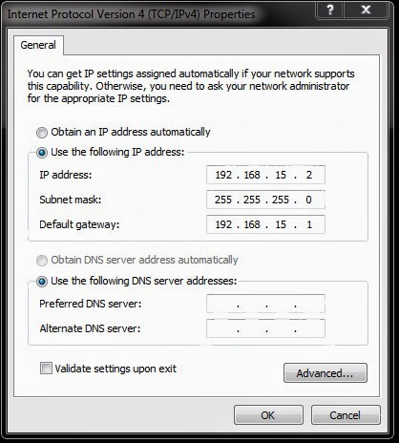
II. plug utp/lan ng dv
open winspreader set all fw and lan card then start
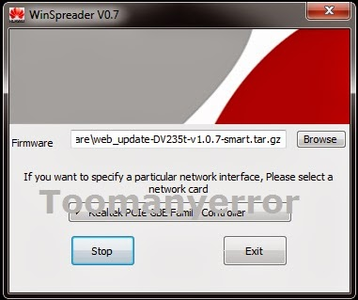
III. plug power adaptor orasan mo ng 1minute

IV. after 1minute remove utp/lan wire then wait 1minute again

V. after 1minute remove power adaptor wait 1minute again

VI. after 1min. plug utp/lan wire and power adaptor

VII. wait 45 secs. iilaw lahat at mapapansin mo yung ilaw ng modem mo patay sindi ng 2secs. interval ang led(pag ganayan ok na modem mo nag fla flash na sya,hintayin mo hangang mag steady lahat ng ilaw,kung wala wifi led lang umi ilaw back step 1)

That's all!

Categories: smart
Share this article :
41
EMAIL THISBLOGTHIS!SHARE TO TWITTERSHARE TO FACEBOOKSHARE TO PINTEREST

1 comments:
- 
Simple & HandyApril 15, 2014 at 7:27 PM
Eto pala. Nakita ko na. Try ko bukas.
Reply
Newer PostOlder Post Home
Subscribe to: Post Comments (Atom)

  - Facebook
  - Twitter
  - GooglePlus
  - Rss
  - Youtube
- Join over 300 people who get free and fresh content delivered automatically.

Get Email Updates

We Respect Your Privacy.
We never encourage SPAM. You can unsubscribe any time.

Powered by Blogger.

Copyright© 2013 Too many error | Powered by Blogger
Design by jhayr | Supported by Designer

