BM622i protection 2009 - 2010
5:57 PM |
Alam nyo ba na ang Firewall ng 622i ay capable of blocking everything, even ICMP, ACS
open your web GUI then Login as "admin"
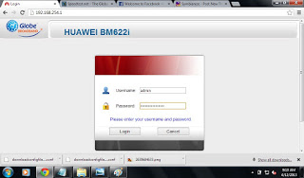

Go to Advance> Firewall

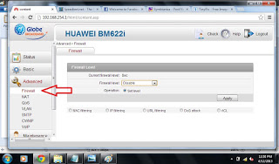
Click on Firewall Level Then Pick Custom then type whatever you want Then Hit Apply

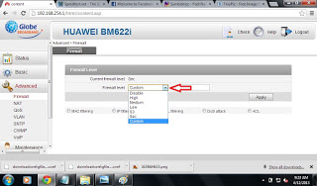

Again Click Firewall Level Then Choose the one that you typed, mine was "new"

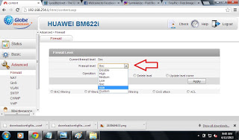
Pick Set Level on Operation Mode then hit apply
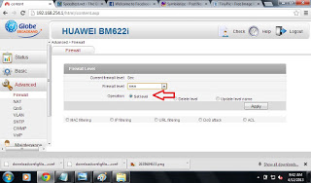
Click ACL "Access Control List"
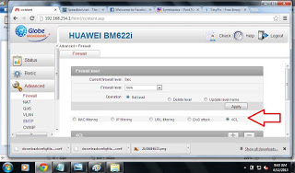
put Check on ACS and ICMP then Hit The negative sign " - "
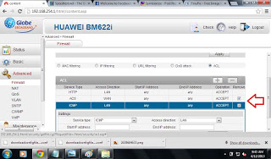
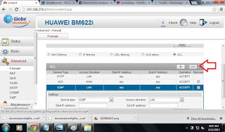
Now Click the ADD sign or Positive sign
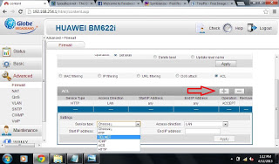
Click Service type then pick TELNET make sure the access direction is "LAN"
then Hit Apply
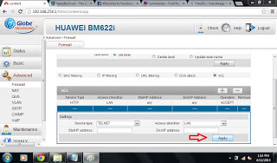
Hit Apply
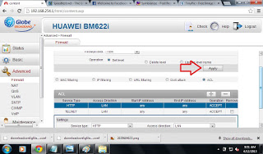
SO yung ginawa natin ay tinanggal natin sa list yung ACS at ICMP, iniwan lang natin yung HTTP at TELNET with Access Direction na LAN , dahil dun, using 622i firewall itself We prevented ACS from accessing our modems to do such an update
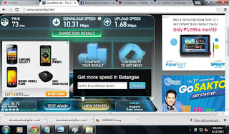
Leave Comments
thank you........

MAnny 'Kratos' Ramos Abella Jr.

