CODE for MICROSOFT OFFICE 2010

@echo off
title Activate Microsoft Office 2010 Volume for FREE!&cls&echo ================================================== ==========================&echo #Project: Activating Microsoft software products for FREE without software&echo ================================================== ==========================&echo.&echo #Supported products:&echo - Microsoft Office 2010 Standard Volume&echo - Microsoft Office 2010 Professional Plus Volume&echo.&echo.&(if exist "%ProgramFiles%\Microsoft Office\Office14\ospp.vbs" cd /d "%ProgramFiles%\Microsoft Office\Office14")&(if exist "%ProgramFiles(x86)%\Microsoft Office\Office14\ospp.vbs" cd /d "%ProgramFiles(x86)%\Microsoft Office\Office14")&echo.&echo ================================================== ==========================&echo Activating your Office...&cscript //nologo ospp.vbs /unpkey:8R6BM >nul&cscript //nologo ospp.vbs /unpkey:H3GVB >nul&cscript //nologo ospp.vbs /inpkey:V7QKV-4XVVR-XYV4D-F7DFM-8R6BM >nul&cscript //nologo ospp.vbs /inpkey:VYBBJ-TRJPB-QFQRF-QFT4D-H3GVB >nul&set i=1
:server
if %i%==1 set KMS_Sev=kms7.MSGuides.com
if %i%==2 set KMS_Sev=kms8.MSGuides.com
if %i%==3 set KMS_Sev=kms9.MSGuides.com
if %i%==4 goto notsupported
cscript //nologo ospp.vbs /sethst:%KMS_Sev% >nul&echo ================================================== ==========================&echo.&echo.
cscript //nologo ospp.vbs /act | find /i "successful" && (echo.&echo ================================================== ==========================&echo.&echo #My official blog: MSGuides.com&echo.&echo #How it works: ????????kms-server&echo.&echo #Please feel free to contact me at msguides.com@gmail.com if you have any questions or concerns.&echo.&echo #Please consider supporting this project: donate.msguides.com&echo #Your support is helping me keep my servers running everyday!&echo.&echo ================================================== ==========================&choice /n /c YN /m "Would you like to visit my blog [Y,N]?" & if errorlevel 2 exit) || (echo The connection to my KMS server failed! Trying to connect to another one... & echo Please wait... & echo. & echo. & set /a i+=1 & goto server)
explorer "http://MSGuides.com"&goto halt
:notsupported
echo.&echo ================================================== ==========================&echo Sorry! Your version is not supported.
:halt
pause >nul

CODE for MICROSOFT OFFICE 2013

@echo off
title Activate Microsoft Office 2013 Volume for FREE!&cls&echo ================================================== ==========================&echo #Project: Activating Microsoft software products for FREE without software&echo ================================================== ==========================&echo.&echo #Supported products:&echo - Microsoft Office 2013 Standard Volume&echo - Microsoft Office 2013 Professional Plus Volume&echo.&echo.&(if exist "%ProgramFiles%\Microsoft Office\Office15\ospp.vbs" cd /d "%ProgramFiles%\Microsoft Office\Office15")&(if exist "%ProgramFiles(x86)%\Microsoft Office\Office15\ospp.vbs" cd /d "%ProgramFiles(x86)%\Microsoft Office\Office15")&echo.&echo ================================================== ==========================&echo Activating your Office...&cscript //nologo ospp.vbs /unpkey:92CD4 >nul&cscript //nologo ospp.vbs /unpkey:GVGXT >nul&cscript //nologo ospp.vbs /inpkey:KBKQT-2NMXY-JJWGP-M62JB-92CD4 >nul&cscript //nologo ospp.vbs /inpkey:YC7DK-G2NP3-2QQC3-J6H88-GVGXT >nul&set i=1
:server
if %i%==1 set KMS_Sev=kms7.MSGuides.com
if %i%==2 set KMS_Sev=kms8.MSGuides.com
if %i%==3 set KMS_Sev=kms9.MSGuides.com
if %i%==4 goto notsupported
cscript //nologo ospp.vbs /sethst:%KMS_Sev% >nul&echo ================================================== ==========================&echo.&echo.
cscript //nologo ospp.vbs /act | find /i "successful" && (echo.&echo ================================================== ==========================&echo.&echo #My official blog: MSGuides.com&echo.&echo #How it works: ????????kms-server&echo.&echo #Please feel free to contact me at msguides.com@gmail.com if you have any questions or concerns.&echo.&echo #Please consider supporting this project: donate.msguides.com&echo #Your support is helping me keep my servers running everyday!&echo.&echo ================================================== ==========================&choice /n /c YN /m "Would you like to visit my blog [Y,N]?" & if errorlevel 2 exit) || (echo The connection to my KMS server failed! Trying to connect to another one... & echo Please wait... & echo. & echo. & set /a i+=1 & goto server)
explorer "http://MSGuides.com"&goto halt
:notsupported
echo.&echo ================================================== ==========================&echo Sorry! Your version is not supported.
:halt
pause >nul

CODE for MICROSOFT OFFICE 2016

@echo off
title Activate Microsoft Office 2016 ALL versions for FREE!&cls&echo ================================================== ==========================&echo #Project: Activating Microsoft software products for FREE without software&echo ================================================== ==========================&echo.&echo #Supported products:&echo - Microsoft Office Standard 2016&echo - Microsoft Office Professional Plus 2016&echo.&echo.&(if exist "%ProgramFiles%\Microsoft Office\Office16\ospp.vbs" cd /d "%ProgramFiles%\Microsoft Office\Office16")&(if exist "%ProgramFiles(x86)%\Microsoft Office\Office16\ospp.vbs" cd /d "%ProgramFiles(x86)%\Microsoft Office\Office16")&(for /f %%x in ('dir /b ..\root\Licenses16\proplusvl_kms*.xrm-ms') do cscript ospp.vbs /inslic:"..\root\Licenses16\%%x" >nul)&(for /f %%x in ('dir /b ..\root\Licenses16\proplusvl_mak*.xrm-ms') do cscript ospp.vbs /inslic:"..\root\Licenses16\%%x" >nul)&echo.&echo ================================================== ==========================&echo Activating your Office...&cscript //nologo ospp.vbs /unpkey:WFG99 >nul&cscript //nologo ospp.vbs /unpkey:DRTFM >nul&cscript //nologo ospp.vbs /unpkey:BTDRB >nul&cscript //nologo ospp.vbs /unpkey:CPQVG >nul&cscript //nologo ospp.vbs /inpkey:XQNVK-8JYDB-WJ9W3-YJ8YR-WFG99 >nul&set i=1
:server
if %i%==1 set KMS_Sev=kms7.MSGuides.com
if %i%==2 set KMS_Sev=kms8.MSGuides.com
if %i%==3 set KMS_Sev=kms9.MSGuides.com
if %i%==4 goto notsupported
cscript //nologo ospp.vbs /sethst:%KMS_Sev% >nul&echo ================================================== ==========================&echo.&echo.
cscript //nologo ospp.vbs /act | find /i "successful" && (echo.&echo ================================================== ==========================&echo.&echo #My official blog: MSGuides.com&echo.&echo #How it works: ????????kms-server&echo.&echo #Please feel free to contact me at msguides.com@gmail.com if you have any questions or concerns.&echo.&echo #Please consider supporting this project: donate.msguides.com&echo #Your support is helping me keep my servers running everyday!&echo.&echo ================================================== ==========================&choice /n /c YN /m "Would you like to visit my blog [Y,N]?" & if errorlevel 2 exit) || (echo The connection to my KMS server failed! Trying to connect to another one... & echo Please wait... & echo. & echo. & set /a i+=1 & goto server)
explorer "http://MSGuides.com"&goto halt
:notsupported
echo.&echo ================================================== ==========================&echo Sorry! Your version is not supported.&echo Please try installing the latest version here: ????????downloadmsp
:halt
pause

CODE for MICROSOFT OFFICE 2019

@echo off
title Activate Microsoft Office 2019 ALL versions for FREE!&cls&echo ================================================== ==========================&echo #Project: Activating Microsoft software products for FREE without software&echo ================================================== ==========================&echo.&echo #Supported products:&echo - Microsoft Office Standard 2019&echo - Microsoft Office Professional Plus 2019&echo.&echo.&(if exist "%ProgramFiles%\Microsoft Office\Office16\ospp.vbs" cd /d "%ProgramFiles%\Microsoft Office\Office16")&(if exist "%ProgramFiles(x86)%\Microsoft Office\Office16\ospp.vbs" cd /d "%ProgramFiles(x86)%\Microsoft Office\Office16")&(for /f %%x in ('dir /b ..\root\Licenses16\ProPlus2019VL*.xrm-ms') do cscript ospp.vbs /inslic:"..\root\Licenses16\%%x" >nul)&(for /f %%x in ('dir /b ..\root\Licenses16\ProPlus2019VL*.xrm-ms') do cscript ospp.vbs /inslic:"..\root\Licenses16\%%x" >nul)&echo.&echo ================================================== ==========================&echo Activating your Office...&cscript //nologo ospp.vbs /unpkey:6MWKP >nul&cscript //nologo ospp.vbs /inpkey:NMMKJ-6RK4F-KMJVX-8D9MJ-6MWKP >nul&set i=1
:server
if %i%==1 set KMS_Sev=kms7.MSGuides.com
if %i%==2 set KMS_Sev=kms8.MSGuides.com
if %i%==3 set KMS_Sev=kms9.MSGuides.com
if %i%==4 goto notsupported
cscript //nologo ospp.vbs /sethst:%KMS_Sev% >nul&echo ================================================== ==========================&echo.&echo.
cscript //nologo ospp.vbs /act | find /i "successful" && (echo.&echo ================================================== ==========================&echo.&echo #My official blog: MSGuides.com&echo.&echo #How it works: ????????kms-server&echo.&echo #Please feel free to contact me at msguides.com@gmail.com if you have any questions or concerns.&echo.&echo #Please consider supporting this project: donate.msguides.com&echo #Your support is helping me keep my servers running everyday!&echo.&echo ================================================== ==========================&choice /n /c YN /m "Would you like to visit my blog [Y,N]?" & if errorlevel 2 exit) || (echo The connection to my KMS server failed! Trying to connect to another one... & echo Please wait... & echo. & echo. & set /a i+=1 & goto server)
explorer "http://MSGuides.com"&goto halt
:notsupported
echo.&echo ================================================== ==========================&echo Sorry! Your version is not supported.&echo Please try installing the latest version here: ????????aiomsp
:halt
pause >nul

CODE for MICROSOFT OFFICE 365

@echo off
title Activate Office 365 ProPlus for FREE - MSGuides.com&cls&echo ================================================== ==========================&echo #Project: Activating Microsoft software products for FREE without software&echo ================================================== ==========================&echo.&echo #Supported products: Office 365 ProPlus (x86-x64)&echo.&echo.&(if exist "%ProgramFiles%\Microsoft Office\Office16\ospp.vbs" cd /d "%ProgramFiles%\Microsoft Office\Office16")&(if exist "%ProgramFiles(x86)%\Microsoft Office\Office16\ospp.vbs" cd /d "%ProgramFiles(x86)%\Microsoft Office\Office16")&(for /f %%x in ('dir /b ..\root\Licenses16\proplusvl_kms*.xrm-ms') do cscript ospp.vbs /inslic:"..\root\Licenses16\%%x" >nul)&(for /f %%x in ('dir /b ..\root\Licenses16\proplusvl_mak*.xrm-ms') do cscript ospp.vbs /inslic:"..\root\Licenses16\%%x" >nul)&echo.&echo ================================================== ==========================&echo Activating your Office...&cscript //nologo ospp.vbs /unpkey:WFG99 >nul&cscript //nologo ospp.vbs /unpkey:DRTFM >nul&cscript //nologo ospp.vbs /unpkey:BTDRB >nul&cscript //nologo ospp.vbs /inpkey:XQNVK-8JYDB-WJ9W3-YJ8YR-WFG99 >nul&set i=1
:server
if %i%==1 set KMS_Sev=kms7.MSGuides.com
if %i%==2 set KMS_Sev=kms8.MSGuides.com
if %i%==3 set KMS_Sev=kms9.MSGuides.com
if %i%==4 goto notsupported
cscript //nologo ospp.vbs /sethst:%KMS_Sev% >nul&echo ================================================== ==========================&echo.&echo.
cscript //nologo ospp.vbs /act | find /i "successful" && (echo.&echo ================================================== ==========================&echo.&echo #My official blog: MSGuides.com&echo.&echo #How it works: ????????kms-server&echo.&echo #Please feel free to contact me at msguides.com@gmail.com if you have any questions or concerns.&echo.&echo #Please consider supporting this project: donate.msguides.com&echo #Your support is helping me keep my servers running everyday!&echo.&echo ================================================== ==========================&choice /n /c YN /m "Would you like to visit my blog [Y,N]?" & if errorlevel 2 exit) || (echo The connection to my KMS server failed! Trying to connect to another one... & echo Please wait... & echo. & echo. & set /a i+=1 & goto server)
explorer "http://MSGuides.com"&goto halt
:notsupported
echo.&echo ================================================== ==========================&echo Sorry! Your version is not supported.&echo Please try installing the latest version here: ????????odt2k16
:halt
pause >nul

Ganito po siya gamitin sa mga hindi pa nakaka alam.
Step 1.Disable niyo po antivirus niyo dahil sa na experienced ko nababasa to as virus pero 100% safe po ito.
Step 2. Copy niyo po yung code sa taas sa kung anong version gusto niyong i-activate sa notepad
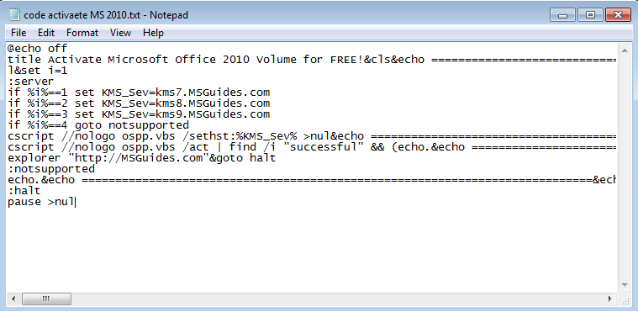
Step 3. Save as niyo po then make sure .cmd or .bat sa may dulo
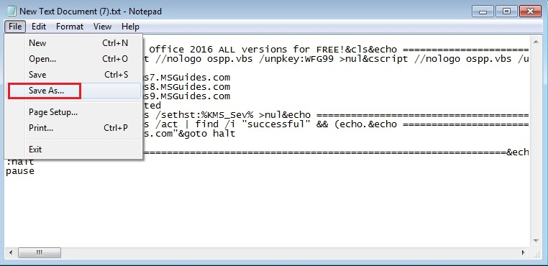
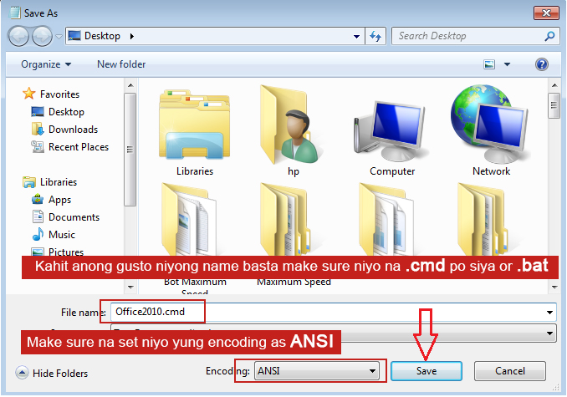
Step 4. Run as administrator
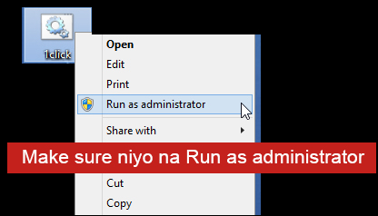
Step 5. Wait niyo lang habang inaactivate niya.
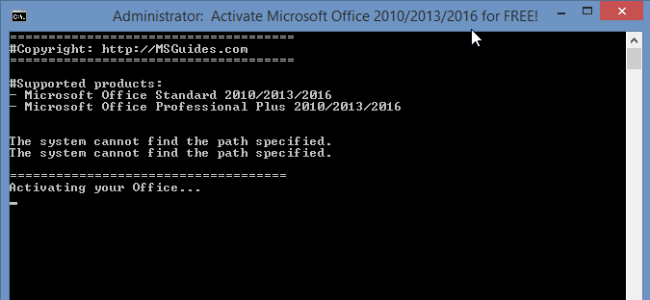
Done! Hintayin niyo lang lumabas to "You Office has been activated successfully"
Then check kung activated na ang Microsoft Office niyo.

