1.Open your web browser.
You will need one which allows you to view the source code for a website. 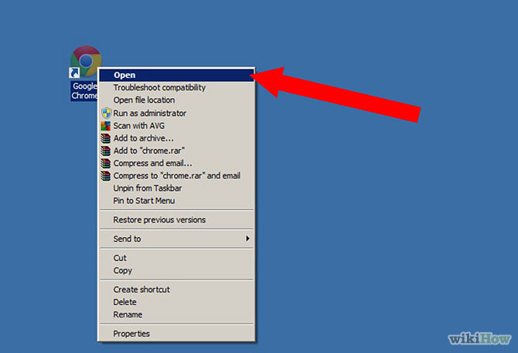

2.Navigate to your homepage/timeline

3.View the source code. In Google Chrome, you can simply right click the background and choose "View page source". 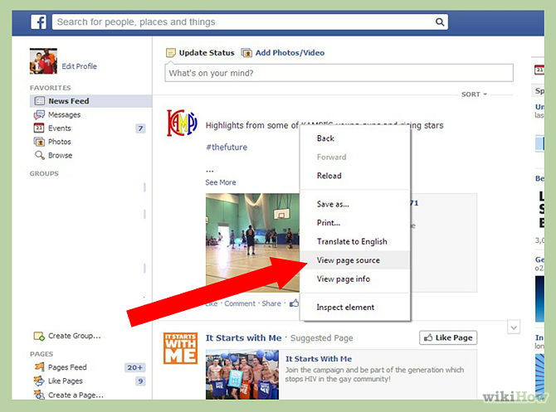Other browsers usually have this option under the "View" menu.
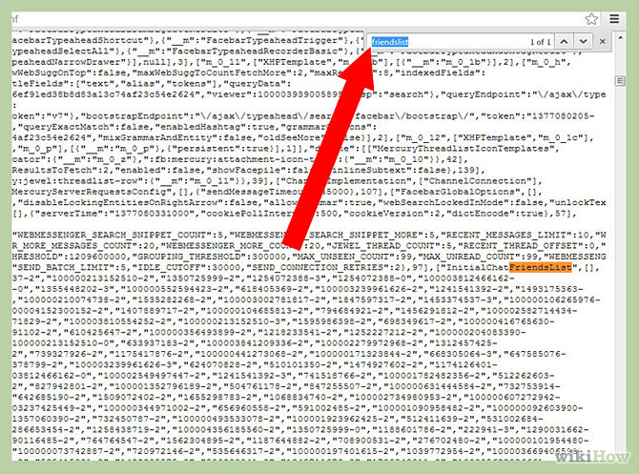
4.Use the webpage search function. In Chrome and Firefox, click Control/Command+F to open the search box. This will search all of the text on any given page for the term you type in. You will want to search for "Friendslist" or "InitialChatFriendsList".
5.Look up the individual profiles. The numbers which immediately follow are the identification numbers of the profiles of your friends. You will see a string of numbers, each set in quotations and followed by a -2 or a -3, and so on. Copy the string without the - and the final number. Paste this after the ".com/" when looking at the main Facebook page. This will bring up the profile so you know who it belongs to.
- The profiles in the list are listed in order by who visits your timeline most recently
- .

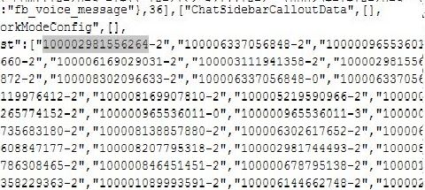
ex

Note: kung ano ang pinakauna na code sa list ay ang recently na nagvisit sa profile mo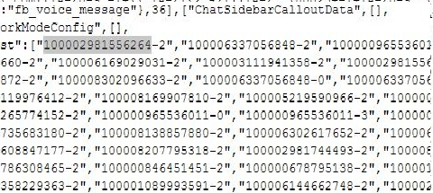
6. copy mo tulad nyan and hit enter na lang po

