How to use HTTP Proxy Injector 101
(Android Version)
Prepared by: 7Deadly seener ayesu
Step 1 Open your Http Injector App. (see the ss below)
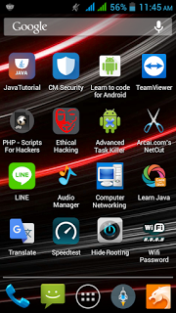
Step 2 Click the 3 Dots in the Upper Right Side to import the config. (see the ss below)
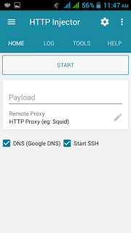
Step 3 Click Config. (see the ss below)
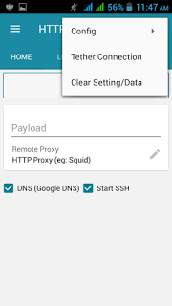
Step 4 Click Import Config. (see the ss below)
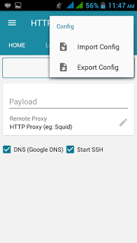

Step 5 Find your downloaded Configs(.ehi’s) in your SD Card/Phone Memory.
In my case because I am the maker? I have a 3rd Option which is Http Injector Folder. (see the ss below)
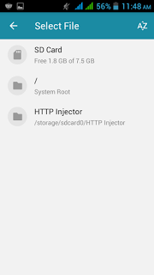
Step 6 My folder have full of mess, well just pretend you don’t see it ok? Lol :D
So what we gonna do now is to find/choose whatever configs(.ehi’s) we want to use to connect in the world wide web. for this tutorial I will use Luxembourg. (see the ss below)
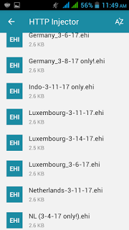

Step 7 When we click the chosen configs(.ehi’s) it will auto Imported. (see the ss below)
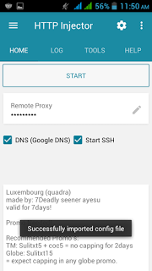
Step 8 Now before we start injecting? Make sure you guys/gals registered to the recommend promo’s
You can check it in my Threads or inside my Configs.
Now let’s say you are now registered to those promo? This is the right time to open our Data Connection.. (see the ss below)
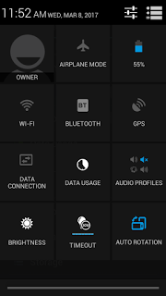

Step 9 You can now start injecting, by Clicking the Start button. (see the ss below)
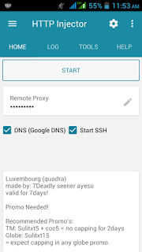
Step 10 If this pop-up? Just tick the [box] and click “OK” to proceed (see the ss below)
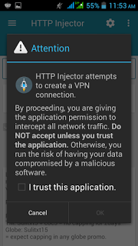

Step 11 Now it’s Connecting… wait for a few seconds. (see the ss below)
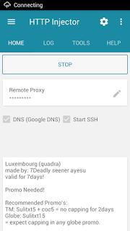
Step 12 and when you have seen the cloud have been fully white? That means you are now connected!
(see the ss below)
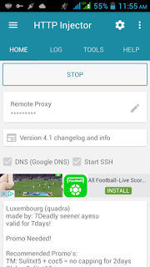

Step 13 Congratulate yourself! You have now Internet Connection, tell it to your Neighbourhood that you don’t need to crack their wifi password anymore! haha For free connection Lol
(see the ss below)

Good Job Guys/Gals for finishing this Mini Course of mine! :D
Have a nice Day all!

Prepared by: 7Deadly seener ayesu

