In this laboratory exam, you will be given a network address that must be subnetted to complete the addressing of the network shown in the Topology Diagram. This activity is a point score per number, you should answer the question/s in each step. And also save the topology done in packet tracer. Filename is LastnameMidtermExam
1. Create a topology in packet tracer based on the given diagram below.
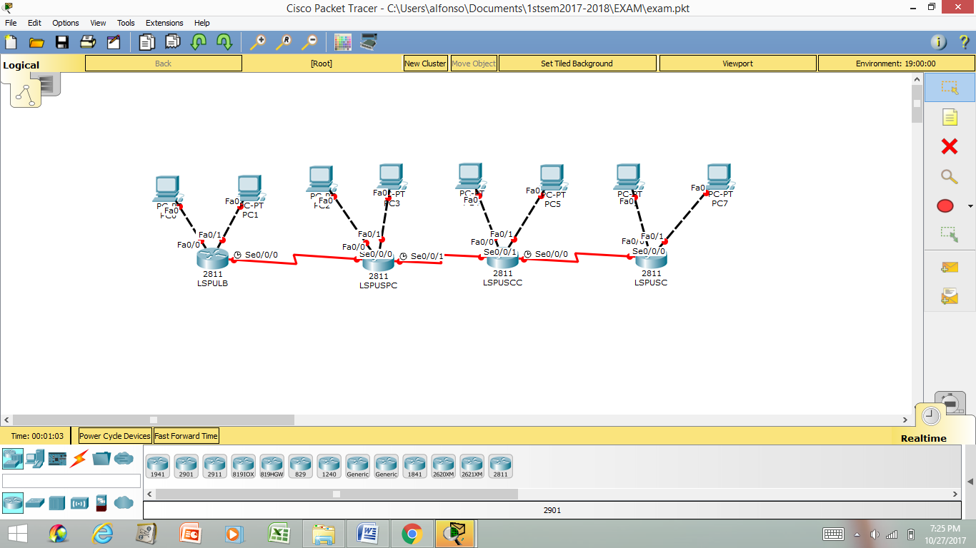
2. Write your answer to the addressing table below. (100 points)
a.) You need to assign the first subnet by using the first host address computed attached to LSPULB and second host address to LSPUSPC using 10.0.0.0/13.
b.) You need to assign the zero subnet by using the first host address computed attached to LSPUSPC and second host address to LSPUSCC using 12.168.0.0/17.
c.) You need to assign the second subnet by using the first host address computed attached to LSPUSCC and second host address to LSPUSC using 121.0.0.0/18.
d.) You need to assign second subnet by using the first host address computed attached to fa0/0 of LSPULB and second host address to PC0 using 193.10.10.0/25.
e.) You need to assign third subnet by using the first host address computed attached to fa0/1 of LSPULB and second host address to PC1 using 193.10.10.0/25.
f.) You need to assign second subnet by using the first host address computed attached to fa0/0 of LSPUSPC and second host address to PC2 using 195.20.10.0/26.
g.) You need to assign third subnet by using the first host address computed attached to fa0/1 of LSPUSPC and second host address to PC3 using 195.20.10.0/26.
h.) You need to assign second subnet by using the first host address computed attached to fa0/0 of LSPUSCC and second host address to PC4 using 196.30.10.0/27.
i.) You need to assign third subnet by using the first host address computed attached to fa0/1 of LSPUSCC and second host address to PC5 using 196.30.10.0/27.
j.) You need to assign second subnet by using the first host address computed attached to fa0/0 of LSPUSC and second host address to PC6 using 196.30.10.0/27.
k.) You need to assign third subnet by using the first host address computed attached to fa0/1 of LSPUSC and second host address to PC7 using 196.30.10.0/27.
Device | Interface | IP Address | Subnet Mask | Default Gateway
LSPULB | Fa0/0 | 193.10.10.129 | 255.255.255.128 | N/A
LSPULB | Fa0/1 | 193.10.10.193 | 255.255.255.128 | N/A
LSPULB | S0/0/0 | 10.8.0.1 | 255.248.0.0 | N/A
LSPUSPC | S0/0/0 | 10.8.0.2 | 255.248.0.0 | N/A
LSPUSPC | S0/0/1 | 12.168.0.1 | 255.255.128.0 | N/A
LSPUSPC | F0/0 | 195.20.10.65 | 255.255.255.192 | N/A
 | F0/1 | 195.20.10.97 | 255.255.255.192 | N/A
LSPUSCC | S0/0/1 | 12.168.0.2 | 255.255.128.0 | N/A
LSPUSCC | S0/0/0 | 121.0.0.65 | 255.255.192.0 | N/A
LSPUSCC | F0/0 | 196.30.10.33 | 255.255.255.224 | N/A
 | F0/1 | 196.30.10.49 | 255.255.255.224 | N/A
LSPUSC  PC0 | Fa0/0 | 196.30.10.33 | 255.255.255.224 | N/A
LSPUSC  PC0 | Fa0/1 | 196.30.10.49 | 255.255.255.224 | N/A
LSPUSC  PC0 | S0/0/0 | 121.0.0.66 | 255.255.192.0 | N/A
PC0 |  | 193.10.10.130 | 255.255.255.128 | 193.10.10.129
PC1 |  | 193.10.10.194 | 255.255.255.128 | 193.10.10.193
PC2 |  | 195.20.10.66 | 255.255.255.192 | 195.20.10.65
PC3 |  | 195.20.10.98 | 255.255.255.192 | 195.20.10.97
PC4 |  | 196.30.10.34 | 255.255.255.224 | 196.30.10.33
PC5 |  | 196.30.10.50 | 255.255.255.224 | 196.30.10.49
PC6 |  | 196.30.10.34 | 255.255.255.224 | 196.30.10.33
PC7 |  | 196.30.10.50 | 255.255.255.224 | 196.30.10.49

3. Configure the router hostname. Put your answer below in each interface. Screenshot is okay but you need to show it clearly.

4. Configure the interfaces for Fast Ethernet and Serial.
Put your answer below in each interface. Screenshot is okay but you need to show it clearly.

5. Ping the connections per router. Screenshot is okay but you need to show it clearly

